CT vs MRI Video
CT:
- Provides 3D xray images and is the FIRST LINE.
- Used to visalize BONES AND BLOOD
- It is lower resolution but if you don’t know what image to order always pick CT***
- It needs iodine contrast so assess renal function first as well as allergies.
- Contraindicated in pregnancy.
- Takes about 10 mins and fast to get one! However not as detailed as an MRI and there are multitpe different kinds of CTs.
- Must drink +++ water beforehna na hold metformin.
- Mainly for extracranial concerns
- Use us clinically unstable, trauma, acute neuro change and think may have a bleed/stroke
- CT angio only shows you blood vessels/chambers so resevre for cardiac related conditions
MRI:
- Uses magmnetic resonance and water to provide high resolution image.
- Used to visualize TISSUE, abscess, and fluid pockets
- It takes a long time to get one and is expensive so reserve only when needed.
- Can order a CT first to see if an MRI is needed or not.
- First line if peds and pregnancy.
- Weight limit of 350lbs
- Mainly for intracranial
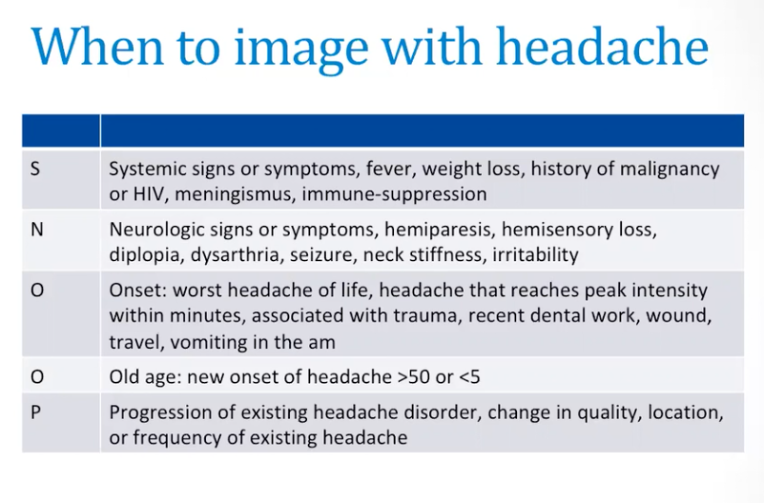
- Use if CN issues, cerebellum, or brain stem concerns

Examples…remmeber bone and blood is CT, tissue/abcess is MRI
- Sinusitis? MRI (tissue)
- Vertigo? Start with CT then consider MRI since many causes
- Skull fracture? CT (bone)
- Face trauma? CT (bone/blood)
- Unexplained hearing loss? MRI (CN is MRI)
- Oral cavity/larynx? MRI (tissue is MRI)
- Stroke? CT

AHAD WEEK 2: HEENT

Blepharitis
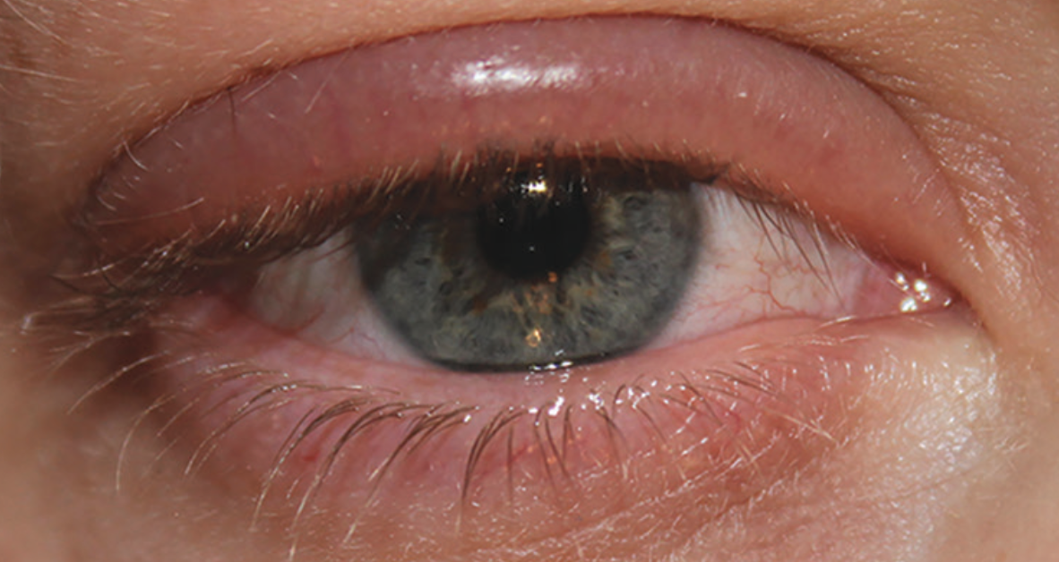
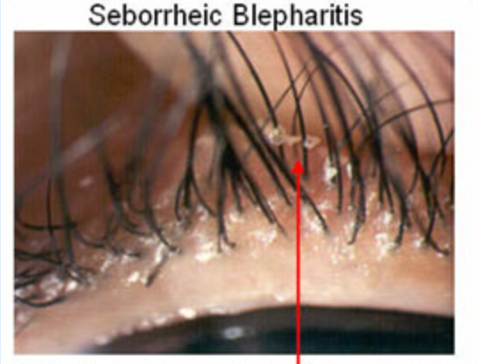
Inflammation of the palpebrae. The palpebrae has the appearance of red, scaly, and greasy flakes with crusted lid margins. Blepharitis can be caused by seborrheic dermatitis or a staphylococcal infection of the lid edge.

1.Seborrheic: excessive shedding of skin cells and blockage of glands.
2. Staphylococcus: most common colonizing bacteria
3. Commonly seen with inadequate flow of oil and mucus into the tear duct.
History]
Bilateral, gradual onset; no pain
changes in soaps/creams/lotions etc.
Risk Factors
Predisposing Factors  - Diabetes.  - Candida. | - Seborrheic dermatitis.  - Acne rosacea.
Physical Exam
Common Findings- burning and itching, lacrimal tearing, photophobia, recurrent eye infections, styes of chalazions, dry and flaky secretions on lid margins and eyelashes, dry eyes/reddened eyes.

Inspection:
1. Inspect eyes, noting extraocular movements (EOMs) of eyes
2. Examine sclera, pupil, iris and fundus
3. Examine eyes for red reflex
4. Note erythema or oedema on lid margins, note dryness, scaling, and flakes
5. Assess vision based on age, using Snellen chart for children older than 3 years
6. Visual fields may be assessed with the parent holding the child in his/her lap.

Subjective
- Elicit onset and duration of signs and symptoms.
- Note sensations of itching, burning, or pain in the eye.
- Ask, what makes signs and symptoms worse? What makes signs and symptoms better?
- Any change in soaps, creams, lotions, or shampoos?
- Has the client had similar signs and symptoms in the past?
- Note any visual change or pain since the last eye examination.
Note contributing factors involved, if present.
Diagnostic Tests
None
Differentials
Blepharitis-Bacterial infection, inflammatory skin conditions/diseases, meibomian gland dysfunction
Conjunctivitis
Eyelid malignancy
Hordeolum (stye) or chalazion
Upper respiratory infection, sinusitis
Epidemiology
Most commonly seen eye condition.
Need for Referral
Consider referral to an eye specialist for recurrent episodes of blepharitis.

Cataract
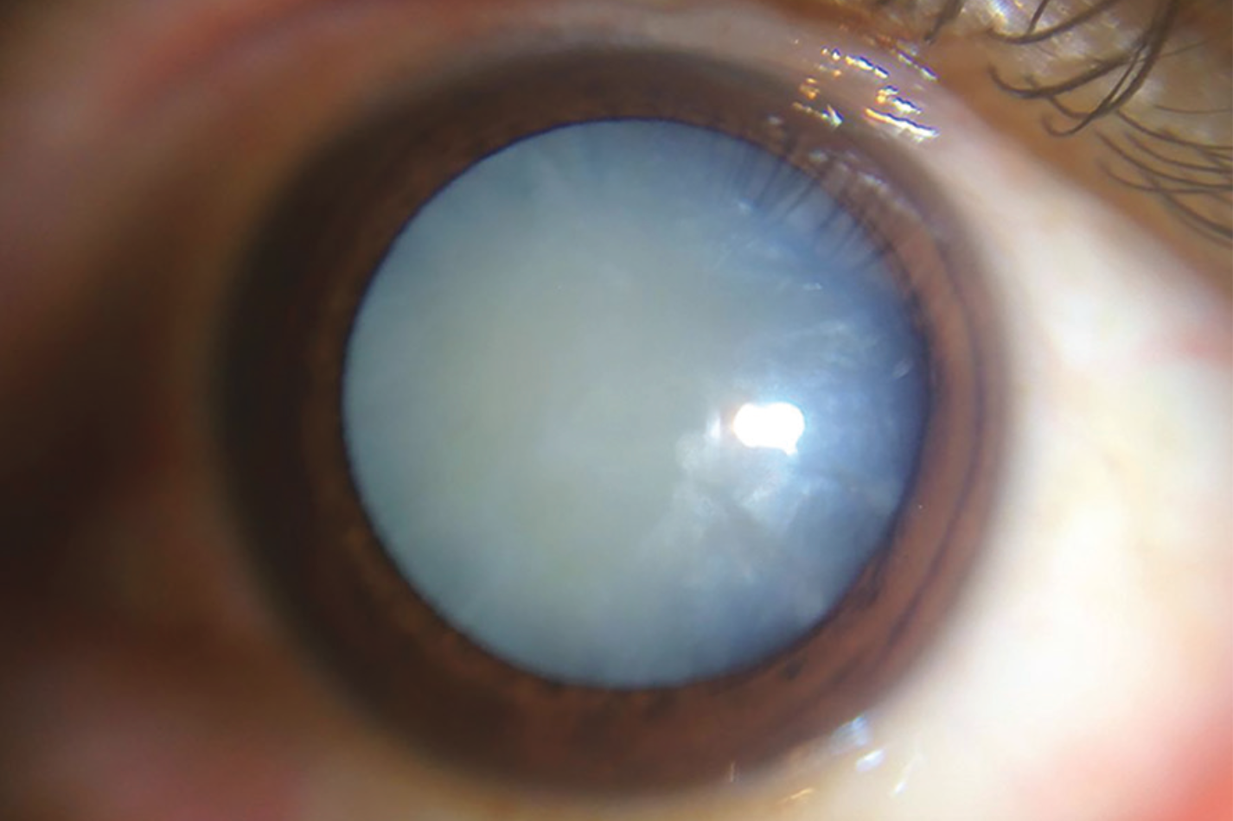
A cataract often has a pearly gray appearance and occurs when the lens loses its transparency. Causes include drug reactions, injuries, and radiation. Senile cataracts are the most common type. The most frequently performed surgery in the geriatric population is cataract surgery. Removal of cataracts and replacement with a synthetic lens allow individuals to appreciate the detail and beauty that nature has to offer. Chronological age should not be a deterrent for not performing cataract surgery. Can be senile (age 70+), congenital in children, traumatic, or due to prolonged corticosteroid use.
History
Common Findings
- Decreased vision.
- Blurred or foggy vision, “ghost” images.
- Inability to drive at night.
- Typically bilateral but unequal in progression
Other Signs and Symptoms,’
- Initial visual event can be a shift toward nearsightedness.
- Visual impairment can be more marked at distances, with abnormal visual acuity examinations.
- Severe difficulty with glare can occur.
- Altered colour perception may be noticed.
- Frequent falls or injuries may occur.
Physical Exam
Subjective Data
- Review the onset, course, and duration of visual changes including altered day or night vision and nearsighted versus farsighted vision.
- Assess whether involvement is in one or both eyes (typically affect both but not at same rate)
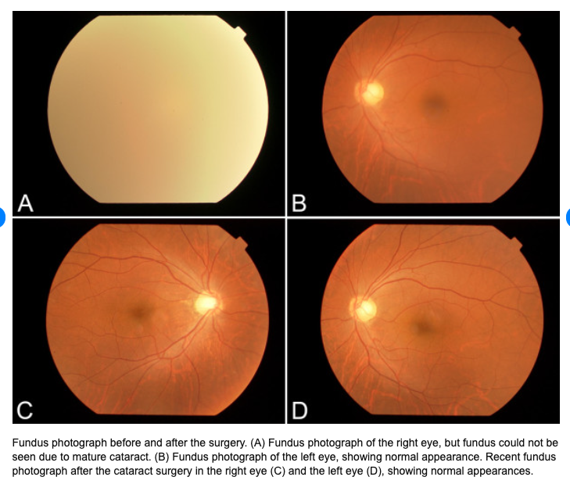
- Determine what improves vision—use of glasses or use of extra light.
- Review the client’s medical history and current medications.
- Review the client’s history for traumatic injury.
- Discuss the client’s occupation and leisure activities to determine exposure to UV rays.
Conduct a funduscopic examination:
a. Check red reflex and opacity:
i. A bright red reflex is seen in the normal eye.
ii. Cataract formation is seen by the disruption of the red reflex (looks dark)
iii. Lens opacities appear as dark areas against the background of the red–orange reflex…see photo
b. Examine the colour of opacity. For brunescent cataracts, the nucleus acquires a yellow–brown colouration and becomes progressively more opaque.
c. Check retinal abnormalities, haemorrhage, scarring, and drusen (small yellow deposits).
d. Leukocoria= silver/white pupillary light reflex on examination

Diagnostic Tests
Perform visual acuity examination.
Perform peripheral vision examination (to see how advanced it is).
Differentials
- Glaucoma.
- Age-related macular degeneration (macular degeneration causes central vision loss that is symptomatically similar to cataracts, after age 50).
- Diabetic retinopathy.
- Temporal arteritis.
Epidemiology
1. Cataracts are the most common cause of blindness in the world.
2. Ninety-five percent of people older than 60 years have cataracts without visual disturbance.
3. Fifty percent of people older than 40 years have significant visual loss due to cataracts.
Red Flags
- Surgical removal is indicated if the visual disturbance is interfering with the client’s life, such as causing falls or prohibiting reading.
Need for Referral
A. Refer client for ophthalmologic consultation.
B. Clients should be followed by an ophthalmologist to monitor the cataract for increased size and progressive visual impairment.
C. Contact a social worker or community resources as needed.

Cellulitis (Orbital, Periorbital)
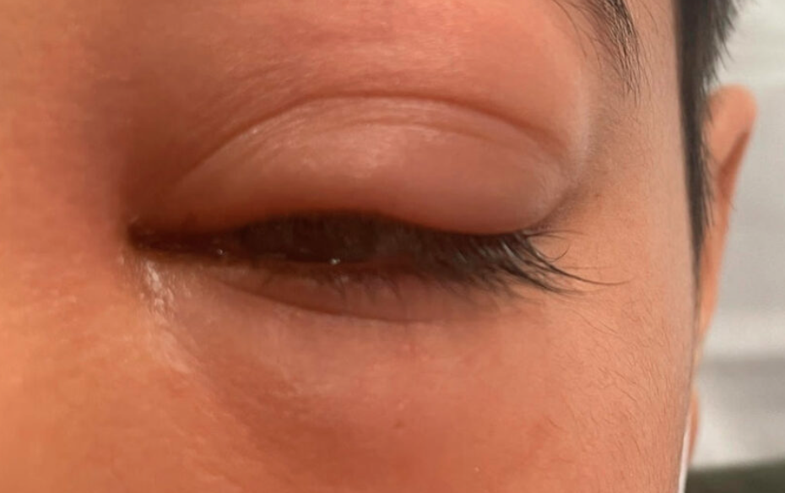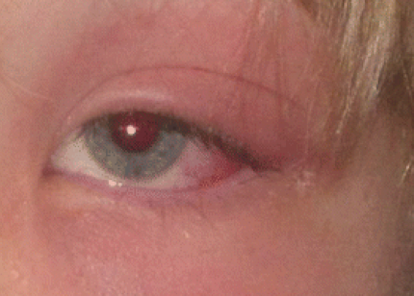
History
Unilateral; pain, swelling
Physical Exam
Periorbital Cellulitis (eyelid)
- Unilateral eyelid swelling
- Redness
- Fever
- Hotness
- Conjunctiva is clear, eye moves freely and vision is not impaired
- No PAIN with eye movements
Orbital Cellulitis (affects muscles and fat within the orbit)
- Unilateral eyelid swelling
- Limited vision
- Fever
- Pain with eye movements
- Exam reveals: ptosis, chemosis, and conjunctivitis
- Limitation of extraocular movements
- Patient appears ill
- Life threatening and requires immediate intervention
Diagnostic Tests
- Periorbital: CBC, leukocytosis, blood cultures
- Orbital: CBC, blood cultures, CT scan, life threatening
- CT Scan to determine presence and extent of an abscess or localize the site of infection in the periorbital region
Differentials
- Endocrine dysfunction - Thyroid-associated orbitopathy.
- Idiopathic inflammation - Orbital myositis, orbital pseudotumor, granulomatosis with polyangiitis (formerly called Wegener’s)
- Carotid cavernous fistula.
- Allergic Conjunctivitis
- Drug reaction
- Antioedema
Epidemiology
Orbital cellulitis is more common in young children than in older children or adults. Orbital cellulitis is an uncommon complication of bacterial rhinosinusitis, but rhinosinusitis is the source of most cases of orbital cellulitis; coexisting rhinosinusitis is present in 86 to 98 percent of cases of orbital cellulitis. Ethmoid sinusitis and pansinusitis are the forms of rhinosinusitis most likely to lead to orbital cellulitis.
Red Flags
Limitation of eye movement requires immediate attention
Need for Referral
Orbital cellulitis is a medical emergency and requires immediate referral and hospitalization.
Periorbital cellulitis can often be managed in an outpatient setting but should be referred to if severe or not improving with treatment.

Conjunctivitis AKA Pink Eye (Bacterial, Viral, Allergic, Chemical)
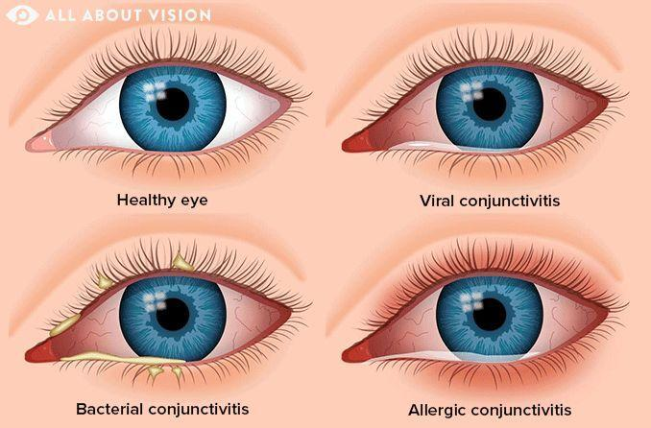
Conjunctivitis is inflammation of the conjunctiva covering the white area of the eye. Primarily three types of conjunctivitis are seen:
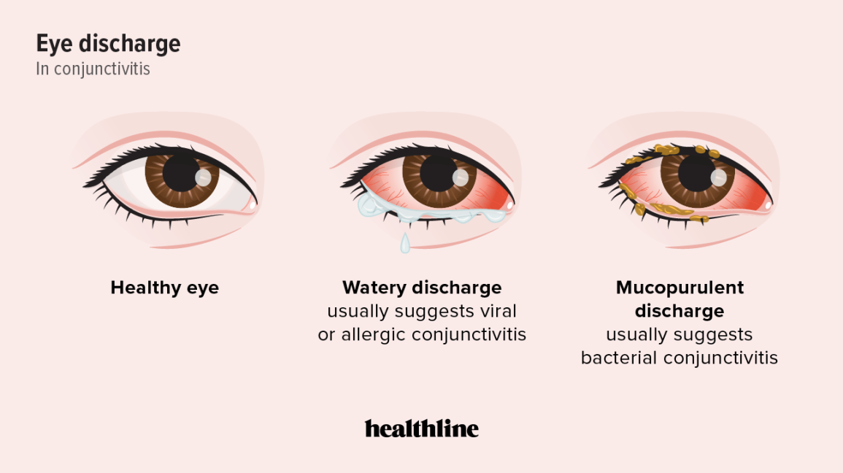
1. Bacterial
2. Viral
3. Allergic
4. Chemical

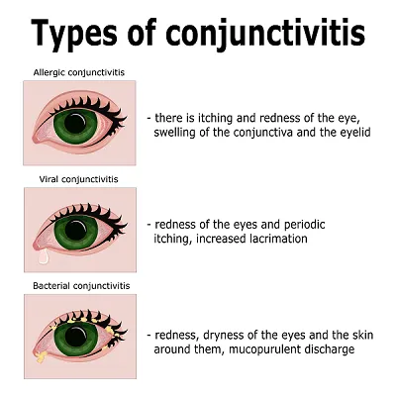
Common Findings
- Red eyes.
- Eye drainage.
- Itching (with allergic conjunctivitis).

Other Signs and Symptoms
- Bacterial: (Haemophilus influenzae, Streptococcus pneumoniae, Streptococcus aureus, Neisseria gonorrhoeae, and Chlamydia).
  - Fast onset, 12 to 24 hours of copious purulent or mucopurulent discharge.
  - Burning, stinging, or gritty sensation in eyes.
  - Crusted eyelids upon awakening, with swelling of eyelid.
  - Usually starts out unilateral; may progress to bilateral.
  - Bacterial conjunctivitis may present as beefy-red conjunctiva.
- Viral: (adenovirus, coxsackievirus, HSV, HPV, and enteric cytopathic human orphan [ECHO] viruses).
  - Gradual onset
  - Symptoms may begin in one eye and progress to both eyes.
  - Tearing of eyes.
  - Sensation of foreign body.
  - Systemic symptoms of upper respiratory infection (runny nose, sore throat, sneezing, and fever).
  - Preauricular or submandibular lymphadenopathy.
  - Photophobia, impaired vision.
  - Primary herpetic infection: Vesicular skin lesion, corneal epithelial defect in form of dendrite, uveitis.
- Allergic: (seasonal pollens or allergic exposure).
  - Itchy, watery eyes, bilateral.
  - Seasonal symptoms.
  - Oedema of eyelids without visual change.
  - With allergic conjunctivitis, hyperaemia of eyes is always bilateral and giant papillae on tarsa may be seen.
  - May also see eczema, urticaria, and asthma flare.
- Chemical: Iatrogenic (miotics, preservatives, contact solution), occupational, irritative
History
Viral- Gradual onset, unilateral early, bilateral late, scratchy (no pain)
Bacterial- the above symptoms and photophobia
Physical Exam
Subjective
- Elicit the onset, duration, and course of symptoms.
- Question client regarding the presence of discharge upon awakening (Bacterial)
- Elicit changes in vision since symptoms began.
- Determine whether there has been any injury or trauma to the eye.
- Assess whether these symptoms have appeared before.
- Rule out exposure to anyone with conjunctivitis.
- Ask client about any new events, such as use of contact lenses, change in contact lenses or solutions, or cosmetic products.
- Review client and family history of allergies.
Physical Exam
- Check temperature.
- Inspect:
  - Observe eyes for colour and foreign objects. Perform complete eye examination.
  - Note lid oedema.
  - Assess pupillary reflexes.
  - Examine skin.
  - Snellen eye chart and CN
  - Inspect ears, nose, and throat.
- Auscultate heart and lungs.
- Palpate:
  - Palpate preauricular lymph nodes and anterior and posterior cervical chain lymph nodes.
Diagnostic Tests
- Gram stain testing for discharge/exudate extracted from eyes if gonococcal infection is suspected and/or all neonates.
- Culture for chlamydia, if suspected.
- Perform fluorescein stain of eye if foreign body or corneal abrasion/ulceration is suspected.
- Test visual acuity with the Snellen chart. Assess peripheral vision and extraocular movements (EOMs).
Differentials
- Conjunctivitis:
  - Viral: Consider herpetic keratoconjunctivitis.
  - Bacterial: Consider gonorrhoea, chlamydia.
- Corneal abrasion.
- Blepharitis.
- Drug-related conjunctivitis.
- Iritis.
Epidemiology
Viral conjunctivitis is the most common type; conjunctivitis occurs in 1% to 12% of newborns.
Red Flags
If client continues to have symptoms or if different symptoms appear, then follow up with the primary provider is recommended.
Need for Referral
Refer if the client is suspected of having periorbital cellulitis, herpes virus infection, vision change, eye pain or if not responding to treatment.

Chalazion
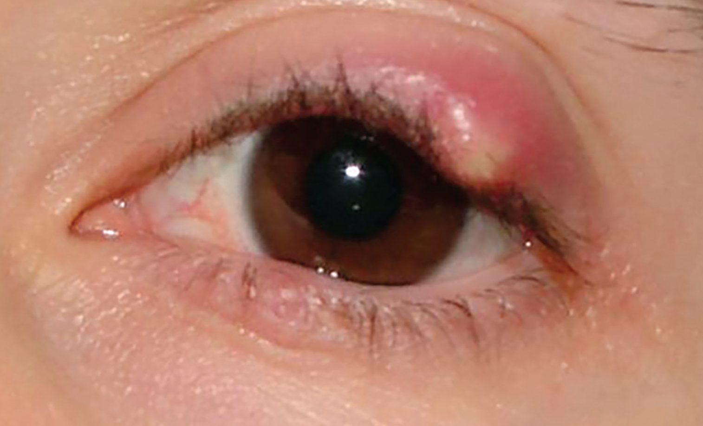
Chalazion is a chronic lipogranulomatous inflammation of a meibomian gland located in the eyelid margin. Inflammation occurs from occlusion of the ducts.

Common Findings: Swelling, nontender palpable nodule, usually pea-sized, inside lid margin or eye. Discomfort or irritation due to swelling.
History
- Review the onset of symptoms, their course and duration, and any concurrent visual disturbance.
- Question the client regarding possible foreign body or trauma to the eye.
- Elicit the quality of pain or tenderness of the eyelid.
- Review the past eye problems and the treatment received.
Physical Exam
- Temperature.
- Inspect:
  - Inspect the eye, sclera, and conjunctiva for a foreign body.
  - Check for red- or gray-coloured subconjunctival mass.
- Palpate:
  - Palpate the eyelid for masses and tenderness. Usually a hard, nontender nodule is found on the middle portion of the tarsus, away from the lid border; it may develop on the lid margin if the opening of the duct is involved. Some chalazia continue to increase in size and can cause astigmatism by putting pressure on the eye globe.
  - Chalazia may become acutely tender; however, note the difference between the chalazia and the hordeolum (stye), which is found on the lid margin.
  - Check for preauricular adenopathy.
Diagnostic Tests
- Perform visual acuity examination.
Differentials
- Chronic dacryocystitis.
- Hordeolum (Stye).
- Blepharitis.
- Xanthelasma.
- Cellulitis of the eyelid.
Epidemiology
- Commonly seen, though the incidence is unknown.
Need for Referral
For large infected chalazion, follow up with the client in one week and then evaluate the client every two to four weeks.
If the chalazion does not resolve spontaneously, incision and curettage by an ophthalmologist may be necessary.

Corneal Abrasion
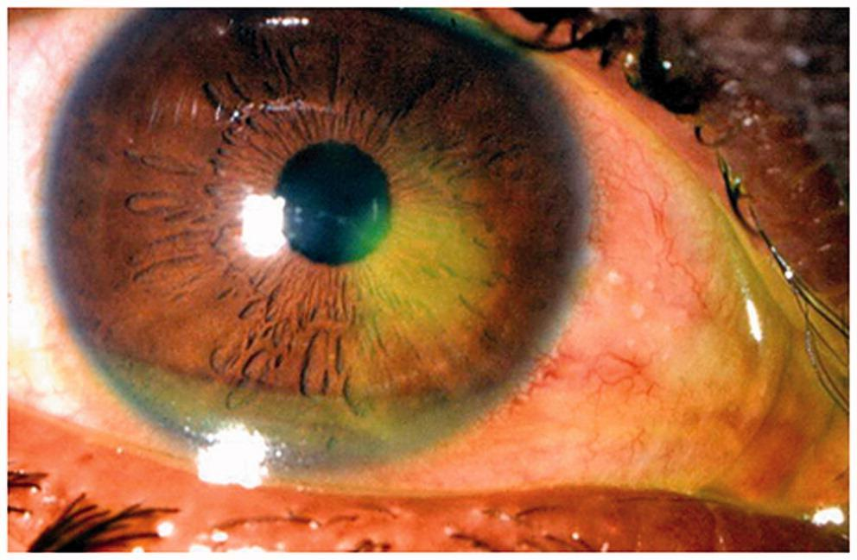
A corneal abrasion is the loss of epithelial tissue, either superficial or deep, from trauma to the eye.
History
Unilateral; pain; photophobia
Physical Exam

Subjective Data
- Elicit the onset, duration, and course of symptoms; note any past history of similar symptoms.
- Question the client regarding visual changes (blurred, double, or lost vision, or loss of a portion of the visual field).
- Question the client regarding the mechanism of injury and how much time has elapsed since the injury (minutes, hours, or days). Ask, What is his or her occupation, and what sports or activities are involved? Were goggles being worn and are they routinely worn during the sport or activity?
- Review the client’s history of exposure to herpetic outbreaks.
- Determine the degree of pain, if any; headache, photophobia, redness, itching, or tearing.
- Ascertain whether the client wears contact lenses or glasses and for what length of time.
- Ask whether the client has tried any treatments before presentation to the office. If so, what?

Rule out the presence of any other infections, such as sinus infection. Conjunctival discharge signifies an infectious aetiology. Common Findings
- Sudden onset of eye pain.
- Foreign-body sensation in the eye.
- Watery eye.
- Mild photophobia.
- Blurred vision.
- Headache.

Other Signs and Symptoms
- Change in vision.
- Redness, swelling, and inability to open the eye.
Vital signs - temperature
Inspect:
-observe both eyes
-test visual acuity and pupil reactivity and symmetry
-observe the corneal surface with direct illumination noting any
shadow on the surface of the iris.
-funduscopic examination
-evert eyelids for cornea inspection
-inspect for foreign body and remove if indicated
-fluorescein stain to visualize changes in epithelial lining,

Diagnostic Tests
Perform fluorescein stain test: An epithelial defect that stains with fluorescein is the hallmark sign.
Differentials
- Corneal foreign body.  - Acute-angle glaucoma.  - Herpetic infection (herpes simplex virus [HSV]): HSV is associated with decreased corneal sensation. | - Recurrent corneal ulceration.  - Ulcerative keratitis.  - Corneal erosion.
Epidemiology
- In the United States, approximately 2.4 million eye injuries occur annually.
- Corneal abrasions account for approximately 10% of new admissions to eye emergency units.
Red Flags
Immediate referral to an ophthalmologist is required for large or central lesions, or deep or penetrating wounds.
Need for Referral
- Re-evaluate the client within 24 hours. The cornea usually heals within 24 to 48 hours.
- Ophthalmic ointment or drops should be continued for four days after re-epithelialization occurs to help in the healing process.
- If the client is still symptomatic in 48 hours, consider referral to an ophthalmologist.

Diabetic Retinopathy
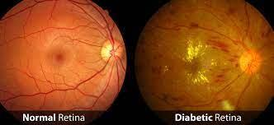
Diabetic retinopathy is a retinovascular disease that occurs in two forms. Nonproliferative retinopathy (the first stage) is characterized by microaneurysms, macular edema/thickening, lipid exudates, and intraretinal hemorrhage.
In proliferative retinopathy, blood vessels regenerate on the retina causing scar tissue, can cause retinal detachement. The patient may be asymptomatic or have decreased vision or floaters. It progresses with the duration of diabetes.

-if hemoglobin A1C of 7.2% or below reduces risk of retinopathy, elevated levels will increase risk
-excess sugar in the blood makes the vessels more permeable and cause them to leak and this affects the photoreceptors in the retina and decreases visual acuity
-Non-proliferative Retinopathy:
-damaged small blood vessels cause the blood and plasma to
Leak and macular edema
characterized by: microaneurysms, macular edema, lipid
exudates, intraretinal hemorrhages.
-Proliferative Retinopathy:
-retina deprived of oxygen and nutrients and new vessels
Develop and cause hemorrhaging and scaring and eventually
retinal detachment.
-blood vessels regenerate on the retina causing floaters or
decreased vision

History
Gradual bilateral vision loss
Risk Factors
The primary risk factors for development and progression of diabetic retinopathy are:
- Duration of diabetes.
- Level of glycemic control.
Additional risk factors include
- Hypertension.
- The presence of other microvascular complications, such as diabetes-related nephropathy and neuropathy.
- Dyslipidemia.
- Pregnancy, which transiently increases risk and progression.
Physical Exam
Symptoms of diabetic retinopathy
- gradually worsening vision. If Macular Degeneration then loss of vision will be central.
- sudden vision loss.
- shapes floating in your field of vision (floaters)
- blurred or black patchy vision, reduced acuity.
- eye pain or redness.
Screening
- Screen/evaluate for retinopathy annually beginning 5 years after the onset of diabetes in all patients with type 1 diabetes (at or after age 15).​
- Screen for retinopathy in all patients, including children and adolescents, at the time of diagnosis of type 2 diabetes. Follow-up every 2 years unless severity dictates more frequent evaluation tailored to the severity of the retinopathy.​
- Evaluate patients with diabetes during pregnancy planning, in the first trimester, throughout the pregnancy as needed and within the first year postpartum.
Diagnostic Tests
- Dilated eye exam
- A1C, CBC
Differentials
- Corneal Abnormalities
- Glaucoma
- Cataracts
Epidemiology
Diabetic retinopathy is one of the most important causes of vision loss worldwide and is the principal cause of impaired vision in patients between 25 and 74 years of age.
Red Flags
S Sudden loss of vision/changes
Need for Referral
Screening should be performed by an optometrist or ophthalmologist every 1-2 years regardless of symptom presence, unless severity dictates increase in screening.
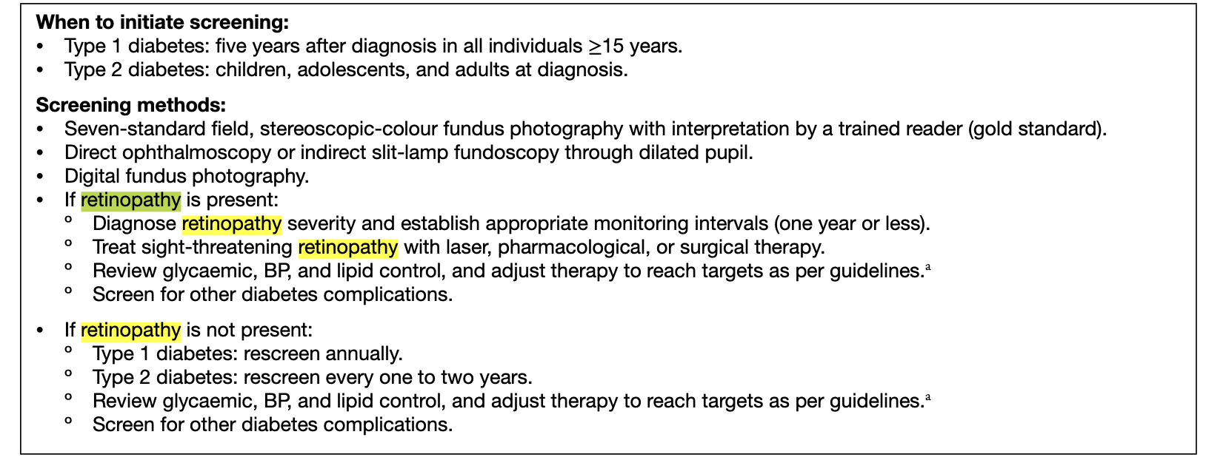

mpletely reworded version of the information with no direct overlap from the original wording:
Category | Details
Definition | A varicocele is the enlargement of veins located in the scrotum, typically above the testicles, which can impair testicular function. While some cases are obvious and can be treated surgically, the condition itself does not automatically require surgery. The size of the varicocele does not correlate with the level of infertility.
Risk Factors | Typically presents at the beginning of puberty.
Screening & Classification | Varicoceles are graded as follows:  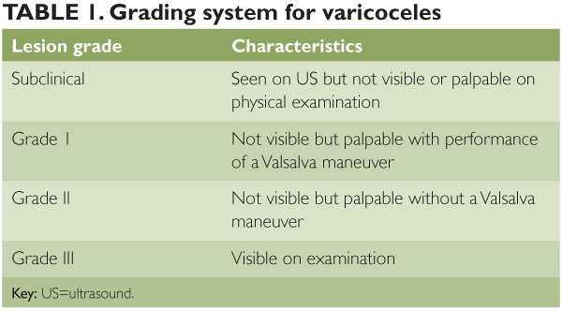
Symptoms | Often, varicoceles do not cause noticeable symptoms unless infertility is being evaluated. If symptoms do occur, they might include:  - Pain or a dull ache in the scrotum  - Sensation of heaviness or fullness in the scrotum  - A "worm-like" feel with visible bluish veins.
Key Questions | - When did you first notice the symptoms?  - Have you noticed any changes in the appearance or texture of the scrotum?  - Do you feel any heaviness or aching in the scrotum, especially after physical activity?  - Is there any swelling or enlargement of the veins in the scrotum that you can see or feel?  - Have you experienced any changes in sexual function, such as reduced libido or erectile dysfunction?  - Have you had any previous treatments or interventions for the varicocele?  - Is there a history of similar symptoms in your family, such as infertility or varicoceles?  - Has the varicocele grown over time?  - Does it shrink when sitting or lying down?  - Is there any discomfort, and is there a history of infertility?
Physical Exam | - Inspection  - Look for visible swelling, enlarged veins, or asymmetry.  - Varicoceles shrink if laying down/sitting  - Assess how the varicocele responds to changes in position.  - It may shrink or become less prominent when the patient is in the supine (lying down) position.  - Large Varicoceles Are Visible; Smaller Can Be Felt on Palpation/Valsalva  - Abdo (Full Exam)  - Conduct a full abdominal exam to rule out any masses or tenderness that could suggest an underlying issue.  - Auscultate scrotum for bowel sounds  - Varicoceles dont transilluminate  - Perform transillumination by shining a light through the scrotum.  - Varicoceles do not transmit light, helping to differentiate them from conditions like hydroceles, which do.  - Digital Rectal Exam (DRE) to Assess Prostate  - Perform a rectal exam to check for prostate enlargement or abnormalities.  - Palpate the prostate and seminal vesicles to rule out conditions such as benign prostatic hypertrophy or infection.
Red Flags | -Unilateral  -does not shrink when lying down
Differential Diagnosis | inguinal hernia (which may present as a palpable scrotal mass), epididymitis (which causes scrotal pain, swelling, and tenderness), hydrocele (which transilluminates and causes scrotal swelling), testicular tumor (a painless mass that does not shrink when lying down), spermatocele (a fluid-filled cyst in the epididymis with a different location and feel), and testicular torsion (which causes sudden, severe pain and requires urgent intervention).
Diagnostic Tests | - U/S with color Doppler  -CT scan
Referrals | Urology especially if surgery needed.
Follow-Up Care | - Post-surgery follow up with PCP in 1-2 weeks, with specialist in 3-6 months
This version is fully reworded with unique phrasing while keeping the key details intact. Let me know if you'd like any further refinements!

Foreign Body (Eyes, Ears and Nose)
History
Often the patient (or witness in the case of a child) will give a history of a foreign object entering the ear.
Physical Exam
Foreign body in the eye: eversion of eyelid is necessary to detect a possible foreign body, illuminating the cornea, fluorescein staining
Foreign body in the ear: visualize foreign body in the ear canal with otoscope, conductive hearing loss may detect foul odor.
Foreign body in nose: pain with percussion and palpation, no transillumination, septal deviation.

Ear- Patients may experience pain, which may be dull or severe, a feeling of fullness or pressure in the ear, and loss of hearing.
- Swelling
- Redness
- Otorrhea
- Foul smell (ear)
Eyes
- Gritty sensation, pain, scratchy sensation
- Recent injury
- Contact lens use
Nose
- Nasal discharge
- Epistaxis
- Nasal obstruction
- Mouth breathing
Diagnostic Tests
Visual inspection. Do not remove foreign objects protruding from the eye.
Fluorescein staining
Differentials
Eyes- blepharitis, corneal abrasion, conjunctivitis
Ears- Cholesteatoma, acute otitis media with perforation
Nose- Sinusitis, upper RTI, allergic rhinitis
Epidemiology
Foreign bodies in the ear canal occur more frequently in children than adults.​
Red Flags
Sharp objects can perforate the eardrum.
Organic objects may swell and occlude the canal.
Need for Referral
Foreign bodies that might have penetrated the tympanic membrane and caused damage to middle ear structures require immediate attention. Cotton-tipped applicators (e.g., Q-tips), pencil points, tree branches, and hair pins are frequent culprits. Worrisome signs that warrant prompt specialty consultation with an otolaryngologist include:
- Ear pain
- Vertigo
- Nystagmus
- Ataxia
- Otorrhea
- Facial nerve paralysis
- Hearing loss
Otolaryngology referral is warranted for the following nasal FBs:
- Posterior FBs (i.e., not readily visualized by anterior rhinoscopy)
- Impacted FBs associated with marked inflammation, especially button batteries, magnets, or superabsorbent beads, which warrant urgent removal
- Penetrating or hooked FBs
- Any FB that cannot be removed at initial attempt due to poor cooperation, bleeding, or limited instrumentation

Glaucoma
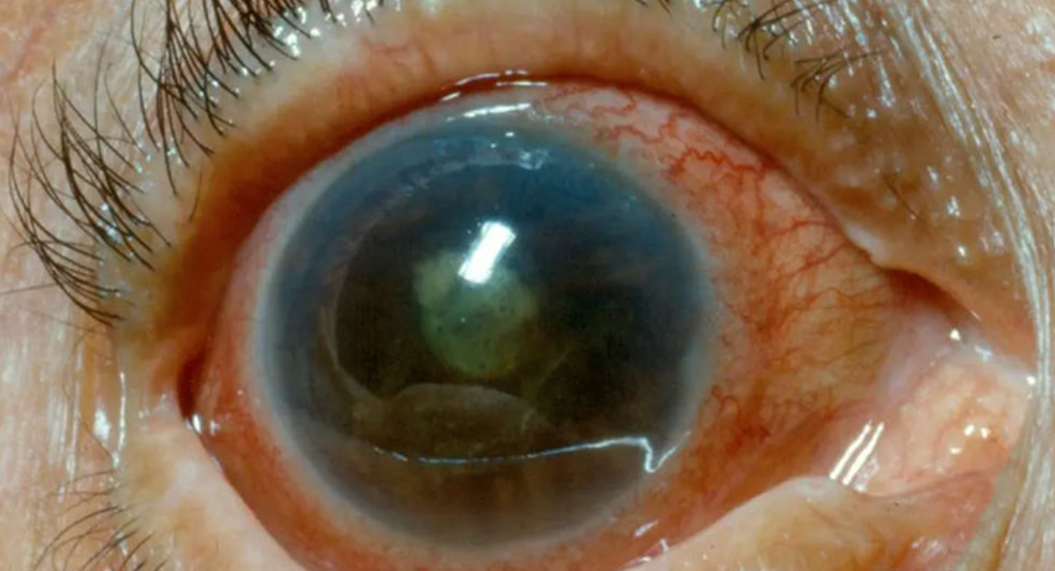
Caused by increased ocular pressure and causes optic nerve damage. If left untreated, it can result in blindness, usually starting at peripheries. Testing for glaucoma includes measuring the intraocular pressure in the anterior chamber, where it pushes against the inner surface of the cornea. A tiny blast of air is bounced off the surface of the eye and measured; measuring the deflection allows the practitioner to measure intraocular pressure. Normal intraocular pressures range from 12 to 21 mmHg. If aqueous humour cannot enter the canal of Schlemm, the fluid pressure rises, distorting soft tissues within the eye.
This ocular emergency is caused by elevations in intraocular pressure (IOP) that damage the optic nerve, leading to loss of peripheral fields of vision; it can lead to loss of central vision and result in blindness.
Incidence/Prevalence
Acute angle-closure glaucoma is the fourth leading cause of blindness in Canada with approximately 300,000 people affected.
Patho/Causative Organism
The essential pathophysiologic feature of glaucoma is an IOP that is too high for the optic nerve. Increased IOP increases vascular resistance, causing decreased vascular perfusion of the optic nerve and ischemia. Light dilates the pupil, causing the iris to relax and bow forward. As the iris bows forward, it comes into contact with the trabecular meshwork and occludes the outflow of aqueous humour, resulting in increased IOP.
History

Common Findings
- Ocular pain (no pain, slower progression= open angle; sudden pain closed angle)
- Blurred vision, decreased visual acuity, “cloudiness” of vision.
- “Halos” around lights at night.
- Neurologic complaints (headache, nausea, or vomiting).
- Peripheral vision loss

Other Signs and Symptoms
- Red eye with ciliary flush.
- “Silent blinder” causes extensive damage before the client is aware of visual field loss.
- Dilated pupil.
- Hard orbital globe.
- No pupillary response to light.
- Increased IOP >30 (normal IOP is 10–20 mmHg) *Considered an emergency; hospital referral

Open angle: no pain and progressive loss of peripheral vision, gradual onset, optic disk cupping
Closed angle: sudden ocular pain and loss of vision, headache, nausea/vomit

Subjective Data
- Review the onset, course, and duration of symptoms; note visual changes in one or both eyes.
- Review medical history and medications.
- Review family history of glaucoma.
- Determine whether there has been any difficulty with peripheral vision, any headache photophobia, or any visual blurring.
- In children, ask about rubbing of eyes, refusal to open eyes, and tearing.
- Rule out presence of any chemical, trauma, or foreign bodies in the eye.
- Review any recent history of herpes outbreak.
- Ask the client whether this has ever occurred before, and if so, how it was treated.
Physical Exam
- Blood pressure.
- Inspect:
  - Examine both eyes.
  - Rule out foreign body.
  - Inspect for redness, inflammation, and discharge.
  - Check pupillary response to light.
  - Redness noted around iris, pupil is dilated, and cornea appears cloudy.
  - Inspect anterior chamber of eye by holding penlight laterally and direct toward nasal area. Shallow chamber will cast a shadow on the nasal side of the iris.
- Palpate: Palpate the globe of the eye, which will feel firm on palpation.
- Funduscopic examination: This may reveal notching of the cup and a difference in cup-to-disc ratio between the two eyes. THIS SHOWS OPEN ANGLE GLAUCOMA (normal is 0.1-0.4, greater is glaucoma)
  - red flags= asymmetry between eyes, elevated ratio (bigger inner cup margin), change from previous exam ratio, irregular shape (should be round)
- Tonometer pressure (8-21mmHg) but not required to make a diagnosis; not always indicative of disease or ruling out damage definitively
Risk Factors
- Narrow anterior ocular chamber.
- Prolonged periods of darkness.
- Drugs that dilate the pupils (i.e., anticholinergics).
- Advancing age: Older than 60 years.
- African American heritage.
- Family history.
- Trauma.
- Neoplasm.
- Corticosteroid therapy.
- Neovascularization.
- Female sex.
Diagnostic Tests
- Check visual acuity and peripheral fields of vision
- Measure IOP with a tonometer. Normal level is 10 to 21 mmHg; acute angle-closure glaucoma IOP is >50 mmHg. Tonometer examination is not recommended if external infection is present.
- Slit-lamp examination: Oedematous and/or cloudy cornea.
Differentials
- Acute iritis.
- Acute bacterial conjunctivitis.
- Iridocyclitis.
- Corneal injury.
- Foreign body.
- Herpetic keratitis.
Epidemiology
- Paediatrics: Infants with tearing, rubbing of eyes, and refusal to open eyes should be referred to a paediatric ophthalmologist for immediate care.
- Adults:
  - Women normally have slightly higher IOPs than men.
  - Asians may have higher IOPs than African Americans and Caucasians.
  - Individuals older than age 40 years should have their IOP measured periodically. Every three to five years is sufficient after a stable baseline is established for the client.
- Geriatrics: Incidence increases with age, usually in those older than 60 years.
Red Flags
Sudden severe eye pain- refer to Emergency
Need for Referral
All clients should be referred to an ophthalmologist immediately for measurement of IOP, acute management, and possible surgical intervention (laser peripheral iridectomy). As well as annual follow up to measure IOP. Send to hospital if you are not able to take IOP and it is higher, or patients present with sudden onset pain.

Hordeolum (Stye)
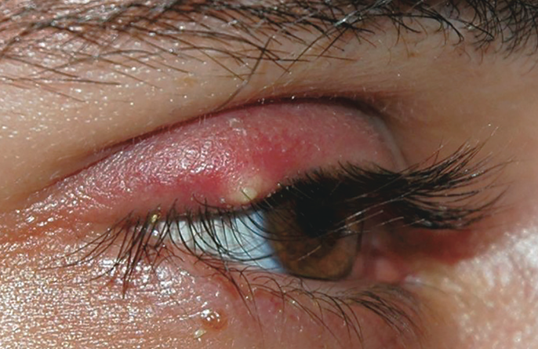
Caused by a staphylococcal infection of the hair follicles at the lid margin, resulting in an erythematous, painful, swollen pustule at the palpebral margin.

- Hordeolum is an infection of the glands of the eyelids (follicle of an eyelash or the associated gland of Zeis [sebaceous] or Moll’s gland [apocrine sweat gland]), usually caused by Staphylococcus aureus.
- If swelling is under the conjunctival side of the eyelid, it is an internal hordeolum.
- If swelling is under the skin of the eyelid, it is an external hordeolum.
History
Unilateral pain
Risk Factors
- More common in the pediatric population.
Physical Exam
Common findings:
- Eye tenderness
- Sudden onset of a purulent discharge
- Redness and swelling of the eye

Subjective Data
- Review the onset, course, and duration of symptoms.
- Determine whether there is any visual disturbance.
- Note whether this is the first occurrence. If not, ask how it was treated before.
- Evaluate how much pain or discomfort the client is experiencing.
- Review the client’s history for chemical, foreign body, and/or trauma aetiology.
- Review the client’s medical history and medications.

Physical Examination
- Inspect:
  - Examine both eyes; note redness, site of swelling, and amount and colour of discharge.
  - Evert the lid and check for pointing.
  - Assess sclera and conjunctivae for abnormalities.
  - Inspect ears, nose, and throat.
- Palpate:
  - Palpate eye for hardness and expression of discharge.
  - Evaluate for preauricular adenopathy.
Diagnostic Tests
- Test visual acuity.
- Discharge can be cultured but is usually treated presumptively.
- If repeated, screen for diabetes due to poor immune system/delayed healing.
Differentials
- Chalazion: The main differential diagnosis is chalazia, which are on the conjunctival side of the eyelid and do not usually affect the margin of the eyelid.
- Blepharitis.
- Xanthoma.
- Bacterial conjunctivitis.
- Foreign body.
Red Flags
Change in vision
Severe eye pain
Need for Referral
- Hordeolum may produce a diffuse superficial lid infection known as preseptal cellulitis that requires referral to an ophthalmologist.
- If hordeolum does not respond to topical antimicrobial treatment, refer the client to an ophthalmologist.
Teaching
- General interventions: Contain the infecting pathogen. Crops occur when the infectious agent spreads from one hair follicle to another.
- Client teaching:
  - Refer to Client Teaching Guide: Eye Medication Administration
  - Reinforce good handwashing.
  - Instruct on proper eyelid hygiene.
  - Clients should discard all eye makeup, including mascara, eyeliner, and eye shadow.

Iritis/Uveitis
https://www.youtube.com/watch?v=4OFEKLm1fBE
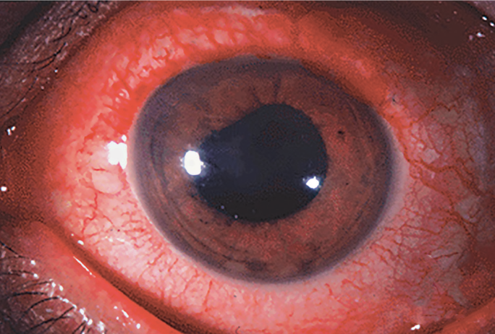
Typical patient complaints include photophobia, throbbing pain, red eye, blurred vision, and a constricted pupil. On a physical exam, there are findings of a deep, dull red halo encircling the iris and cornea. The pupil may be irregular from swelling of the iris.
History
Unilateral; moderate to throbbing aching pain; photophobia, blurred vision
Risk Factors
- Hx back pain, GI, chronic diarrhoea , arthritis
- Have a specific genetic alteration. People with a specific change in a gene that's essential for healthy immune system function are more likely to develop iritis. This change is labeled HLA-B27.
- Develop a sexually transmitted infection. Certain infections, such as syphilis or HIV/AIDS, are linked with a significant risk of iritis.
- Have a weakened immune system or an autoimmune disorder. This includes conditions such as ankylosing spondylitis and reactive arthritis.
- Smoke tobacco. Studies have shown that smoking contributes to your risk.
Physical Exam
- Tearing, affected pupil smaller; cornea normal; ciliary flush
- Deep, dull, red halo encircling the iris and cornea
- Pupil irregularity from swelling. Examine for anisocoria (unequal pupil size). In iritis, the affected eye may have a smaller or irregular pupil due to inflammation.
- Consensual photophobia (pain in the affected eye when light is shone in the other eye)
- Fundoscopy
Diagnostic Tests
- Slit-lamp examination: Cells and flare in the anterior chamber (indicating inflammation).
- Fundoscopy
- Dilate eye and tonometer
- REFER!!
Differentials
- Conjunctivitis
- Keratitis
- Blepharitis
- Seasonal allergies
- Glaucoma
- Hordeolum (stye)
- Chalazion
- Corneal abrasion, blunt trauma
- Subconjunctival hemorrhage, inflamed pterygium, pinguencula
Red Flags
Extreme unrelenting eye pain
Decreased vision
Need for Referral
Requires immediate referral. If left untreated can lead to glaucoma.

OTITIS EXTERNA (swimmer’s ear)
Common, acute, self-limiting inflammation or infection of the external auditory canal and auricle
Relevant History | Onset; duration; intensity; history of ear infections; hearing loss; recent swimming; ear cleaning practices; recent ear canal trauma
Physical Exam | Patient presents: itching, otalgia, red/swollen external canal; purulent discharge; hearing loss due to edema; plugged ear sensation; tenderness to tragus palpation  - VITALS= Take patient temperature  INSPECT  - Otoscope inspection for tenderness  - Ear for redness, swelling, otorrhea, and debris  - Tympanic membrane (may appear normal)  - Nose and throat  AUSCULTATE  - Heart and lungs  PALPATE  - Gentle pressure to tragus, pinna manipulation, cervical lymph nodes  - Pulling the pinna is extremely painful (less so in OM)
Diagnostic Tests | Ear scrapings--> under microscope; look for hyphae if fungal is suspected  Culture--> vesicular lesions for viruses (not routinely indicated)  IF REPEATED THEN ASSESS IF DIABETIC***
Differentials | Otitis media; foreign body; mastoiditis; hearing loss; wisdom tooth eruption; herpetic otitis externa (vesicular lesions in the ear canal); necrotic/malignant otitis externa; cranial nerve palsies or periostitis of the skull base, skin cuasing rendess like eczema or psoriasis
Epidemiology | Seen in all ages; incidence increases during summer months, not including necrotizing  Predisposing factors...  - Ear trauma; humid climate; frequent swimming; hearing aid use; eczema; debilitating disease
Pathophysiology | Most commonly caused by pseudomonas*, staph, and strep (fungal also possible)  - Bacterial or fungal= preceded by trauma to ear canal (cleaning, submersion)  Acute, chronic, eczematous, and necrotizing types  - Necrotizing= invasive pseudomonas--> skull osteomyelitis (diabetes, immunocompromised)
Red Flags | Foul, green discharge--> osteomyelitis of the skull base
Plan | Irrigation and insertion of a cotton wick to allow for drops instillation  TEACHING  - Keep out of water for 4-6 weeks; do not swim until symptoms resolved/wick out  - Block water passage with cotton/Vaseline for bathing/showering  - dry the ears asap after swimming  PHARM THERAPY  - If pruritis --> 1:1 alcohol and vinegar solution as a drying agent  - Mild infection--> topical aluminum acetate (2-3 drops, 3-4x/day)  - Moderate infection--> acidifying, antibiotic, glucocorticoid therapy, cortisporin  - Adults= 4 drops, 4x/day for 7 days  - Suspension > solution if tympanic membrane integrity is questioned  - Fungal? Nystatin or clotrimazole topical solutions  - Resistant infections--> oral antibiotics and antifungals  Concurrent: acetaminophen and ibuprofen
Follow-Up | Within 48 hours to assess improvement, and then again in 1-2 weeks  - More frequent (daily or multiple x/week) if using wick to instill drops
Referral? | Necrotizing otitis externa= parenteral antibiotics  If osteomyelitis is suspected, refer (risk in geriatric patients)

OTITIS MEDIA (ACUTE)
Inflammation of the middle ear associated with acute bacterial infection of the middle ear.
Relevant History | Onset and duration of symptoms; recent viral URI; changes in hearing; ear drainage; risk factors; otitis media history
Presentation | Patient presents: ear pain, pulling of the ears, fever in some cases, decreased hearing  - Sleeplessness, decreased appetite, fussiness, acute hearing loss, URI, mastoiditis (swollen, red mastoid)  - Perforated tympanic membrane  - Sudden, severe pain with immediate relief upon fluid drainage  - Cholesteatoma  - Sac-like structure in the middle ear accompanied by white, shiny, greasy debris  Risk: environmental tobacco smoke, daycare attendance, pacifier use and bottle feeding in the supine position, orofacial abnormalities, immunodeficiency, children of First Nations or Inuit ethnicity
Physical Exam | VITALS= Temperature, pulse, respirations, BP  INSPECT:  Canal and auricle--> redness, deformity, drainage, foreign bodies  Tympanic membrane--> position (neutral or landmarks visible/retracted/bulging/full)  - light reflex should be in the anterior inferior position on each ear  Ears--> tympanic membrane mobility  Nose/mouth/throat  AUSCULTATE:  Heart and lungs  Lymph nodes  a loss of landmarks on otoscope examination, and an opaque, bulging, and inflamed tympanic membrane; poor mobility with pneumatic pressure application; purulence in external canal if TM rupture.
Diagnostic Tests | If unsure, recurrent, systemic S/S, hearing loss…  Pneumatic otoscopy--> decreased mobility ***Strongly recommended  Tympanogram--> flat or type B curve  Hearing test--> done if there is persistent otitis media lasting more than 3 mos  CBC--> if patient appears toxic with high fever
Differentials | Otitis media with effusion; dental abcess, red tympanic membrane from crying; URI; mastoiditis; foreign body present; otitis externa
Epidemiology | Occurs at any age; most common in children (accounts for 1/3 of all pediatric visits)  Predisposing factors...  - <12 months; recurrent otitis media (>3x in 6 mos) or previous episode in last month; T21/AIDS/CF/cleft palate/craniofacial anomalies  - Indigenous, smoke/pollution, day care, bottle propping, family allergies, pacifier use
Pathophysiology | Eustachian tube obstruction leads to middle ear effusion and infection  - Middle ear fluid contamination from backed-up nasopharyngeal secretions  CAUSATIVE= strep pneumoniae, Hemophilus influenza, Moraxella catarrhalis
Red Flags | Significant hearing loss
Referral? | - Patients < 6 weeks old  - Septic presentation  - Mastoiditis  - If persistent otitis media with hearing loss 20dB+; ENT specialist
Plan | Pain relief--> acetaminophen, ibuprofen; topical in children >3  TEACHING  - Avoid smoking and do not prop up bottles during feedings  PHARM THERAPY  - Amoxicillin or beta-lactamase antibiotic for resistance, treatment failure, or recent antibiotic use in last 30 days  - Persistent otitis media may require 21 days of treatment  - treat with antibiotics if no improvement in 2-3 days  Children <2= treat for 10 days; children >2= treat for 5-7 days  If asymptomatic; consider observation if >2 years and follow-up in 48 hours
Follow-Up | Check on patients in 2-3 weeks or if fever/complaints persist for >48 hours after antibiotic therapy has been started

OTITIS MEDIA (WITH EFFUSION)
Asymptomatic middle ear fluid without signs of bacterial infection
Relevant History | Otitis media with effusion (OME) is defined as the presence of fluid in the middle ear without signs and symptoms of an acute ear infection, and should be distinguished from AOM (acute onset, purulent middle ear infusion and inflammation)  Onset and duration; history of URI and otitis media; hearing loss; frequency of OM
Physical Exam | Patient presents: ear pain, increased pressure sensation, recent hearing loss, sense of fullness  - VITALS= Temperature, pulse, respirations, BP  INSPECT  - Ears; fluid level, serous middle fluid, translucent/amber/gray membrane with decreased mobility  - Nose, mouth, throat  - Perform whisper test or Rinne and Weber tests to assess hearing loss.  AUSCULTATE  - Heart and lungs  PALPATE  - Head, neck, lymph nodes
Diagnostic Tests | If unsure, recurrent, systemic S/S, hearing loss…  Pneumatic otoscopy--> decreased mobility ***Strongly recommended  Tympanogram--> flat showing little motility
Differentials | Cerumen impaction; AOM; foreign body in ear  - In absence of URI, rule out nasopharyngeal mass
Epidemiology | Occurs in clients of all ages; 70% of children with acute OM have fluid after 2 weeks  Predisposing factors...  - Recurrent OM, concurrent URI
Pathophysiology | Can be sterile fluid--> due to URI and defective eustachian tubes  Can be residual fluid--> after AOM episode
Red Flags | Face weakness, paralysis, vertigo, hearing loss, post auricular swelling, meningitis, masoittitis.  Refer to ENT for any, recurrent, TM preformation
Plan | Monitor for resolution withOUT treatment over several weeks  - Persistent: risk of hearing and speech loss, language and learning disorders  TEACHING  - OME is not treated with antibiotics (no actual infection)  - Suspect infection if symptoms change; notify provider  - Do not routinely use antihistamines and decongestants  PHARM THERAPY  - In special cases, amoxil for 10-14 days BUT not recommended  - Not recommended: nasal glucocorticoids, antihistamines or decongestants
Referral? | Children with persistent OME--> refer to ENT for hearing evaluation and tympanostomy tubes
Follow-Up | After 4-6 weeks to assess effectiveness

-

***TINNITUS
Any sound heard in the ears or head (“to ring”)
Relevant History | Onset/duration/course; unilateral vs bilateral; frequency and quality of sound; medication review; trauma history; noise exposure, sinus/oral/ear infections; previous occurrences; work, hobbies, music habits; date of last hearing exam; use of cotton swabs or small objects for cleaning  Inquire about how tinnitus is affecting daily living using the Tinnitus Handicap Inventory
Physical Exam | Patient presents: ringing/roaring/buzzing/clicking/hissing; hearing loss or muffled hearing; changes in own voice (lower pitch)  - VITALS= Temperature (if infection suspected)  INSPECT  - External ear: discharge, colour, odour  - Otoscopic exam of auditory canal for cerumen or foreign bodies  - Tympanic membrane for colour, landmarks, contour, perforation, AOM  *Landmarks= visible on normal exam  *Tympanic membrane= pearly gray in colour & translucent  Bulging= conical with loss of landmarks; retracted= concave, accentuated landmarks  AUSCULTATE  - Skull for bruits if the origin is obscure (how?)  PALPATE  - Auricle and mastoid process (tenderness, swelling, nodules); TMJ, lymph nodes  VISUAL EXAM  - Assess for nystagmus if patient reports vertigo  NEUROLOGIC EXAM  - CN8--> response to questions; tone and volume of voice; Rinne & Weber tests
Diagnostic Tests | First line: Audiogram--> performed by PHCP (check for association with respiration, drugs, vertigo, noise trauma, or ear infections)  Tympanometry  CT/MRI--> after referral to an ENT  Posterior fossa myelography  Referral for comprehensive audiometric testing to determine degree of hearing loss:  o Audiography  o Speech discrimination testing  o Tympanometry  •CBC, TSH, B12, lipid profile  •If suspected venous or mass lesion, CT or MRI
Differentials | Cerumen impaction; foreign body; AOM; otitis externa; acoustic trauma; vascular aneurysm; TMJ syndrome; otosclerosis; ototoxicity; Meniere’s disease; presbycusis; CNS lesion
Epidemiology | Affects 40% of Canadians  Predisposing factors...  - Cerumen impaction; tympanic membrane perforation; middle ear fluid; AOM; acoustic trauma  - Ototoxic drugs  - Sulfas, aminoglycosides, salicylate, indomethacin, propranolol, levodopa, carbamazepine  - Vascular aneurysm; jugular bulb anomaly; anemia; TMJ syndrome; HTN
Pathophysiology | A nonspecific manifestation of inner ear, CN8, or central auditory pathology
Red Flags | dissiness/falls, fainting, vision chnages , deafness or an abnormal ear condition, pulsatile tinnitus, , persistent ( > 3 months) unilateral tinnitus
Plan | TEACHING  - Do not place small objects into the ear (cotton applicators for external ear cleaning only)  INTERVENTIONS  - Address underlying conditions  - Provide coping strategies or refer to behavioural therapy  PHARM THERAPY  - Vasodilators, tranquilizers, antidepressants, and seizure medications  - Placebos also effective therapeutically
Follow-Up | Not required unless identifying a treatable problem
Referral? | ENT as needed; refer anxious clients to ensure no serious underlying condition  - Refer if history of head trauma: may be associated with AV fistula or aneurysm of intrapetrous portion of the internal carotid artery  Associated deafness or an abnormal ear condition  Pulsatile tinnitus, unless associated with an acute inflammatory ear condition  Persistent ( > 3 months) unilateral tinnitus  Persistent intrusive tinnitus

PHARYNGITIS
Inflammation of the pharynx and the lymph tissue surrounding it
Relevant History | Onset/course/duration; dysphagia and dyspnea; mouth lesions/rhinorrhea/cough/drooling/fever; malaise/headache/fatigue/fever (mono symptoms); sexual history; decreased fluid/food intake; heart disease history, chronic allergies, asthma, emphysema; rash; UTI and pyelonephritis symptoms; herpes, immunosuppressive disorders, steroid use; immunization history
Physical Exam | Patient presents: sore/scratchy throat; fever; headache; malaise  - Oral vesicles, beefy red throat with or without exudate, lymphadenopathy, fatigue, dysphagia, abdominal pain, vomiting  - VITALS= temperature and blood pressure  INSPECT  - General appearance  - Mouth/pharynx/tonsils/hard and soft palate  - Vesicles, ulcers, candidal patches, redness, hypertrophy, exudate, stomatitis  - Gum and palate--> petechiae?--> mono  - Tongue--> colour and inflammation  - Ears/nose/throat--> patency  - Skin--> rashes  - Pastia’s line= petechiae in a linear fashion along skin folds (GAS)  - Erythema marginatum= GAS; pink rash on the trunk & extremities  - Can be brought by heat exposure; nonpruritic  AUSCULTATE: Heart and lungs  PERCUSS: Abdomen (spleen area) and chest  PALPATE  - Lymph nodes (anterior & posterior cervical, axilla, groin)  - Abdomen for organomegaly and suprapubic tenderness  - Costovertebral angle (CVA) tenderness  NEUROLOGIC EXAM  - Nuchal rigidity and meningeal irritation
Diagnostic Tests | Rapid Strep Test--> if negative; throat culture and sensitivity (GOLD STANDARD)  Modified Centor Score  Monospot test--> if mononucleosis is suspected  CBC with differential;  _____________________________  Gonorrhea culture;  blood culture if sepsis suspected  XRAY of neck--> if possible trauma
Differentials | Stomatitis; rhinitis; sinusitis with postnasal drip; epiglottitis; peritonsillar abscess; mononucleosis; HSV; Coxsackie A virus; C. diphtheria; Vincent’s angina; trench mouth; C. albicans; HIV, GERD, common cold/influemza
Epidemiology | 2-4% of all primary care clinic visits in Canada  - Rheumatic fever is more common in pediatric cases of GAS URIs  Predisposing factors...  - Cigarette smoking; allergies; URIs; oral sex; drug use (antibiotics, immunosuppressants); debilitating illnesses like cancer
Pathophysiology | Can be bacterial, viral, or fungal in nature; environmental irritants also possible  VIRAL= coxsackievirus, ECHO viruses, Epstein-Barr  BACTERIAL= GAS, Neisseria gonorrhea, Corynebacterium diphtheriae  FUNGAL= candida albicans  Non-infectious= allergic rhinitis, post-nasal drip, mouth breathing, trauma  *80-90% is not GAS infection
Red Flags | If untreated, may lead to...  - Suppurative adenitis with tender/enlarged lymph nodes  - Scarlet fever; peritonsillar abscess; glomerulonephritis; rheumatic fever
Plan | INTERVENTIONS  - Immediate treatment in clients with rheumatic fever hx and those with a household member + for GAS (no need for testing)  - Not to insert instruments into the airway if epiglottitis is suspected  PHARM THERAPY  - First-line= Penicillin V & amoxicillin  - If rash with penicillin--> cephalexin  - If anaphylaxis with penicillin--> clindamycin/clarithromycin/erythromycin/azithromycin  Recurrent bacterial pharyngitis: avoid long-term antibiotic use without identifying causative organism  Pharyngeal gonorrhea= ceftriaxone  Pharyngeal candidiasis= oral nystatin suspension or clotrimazole troche
Referral? | To otolaryngologist if peritonsillar abscess is noted OR client has dysphagia or dyspnea that is severe indicating airway obstruction
Follow-Up | Re-assess symptoms in 3-4 days (if no improving, recheck client)  - Treat sexual partners of clients with pharyngeal gonorrhea

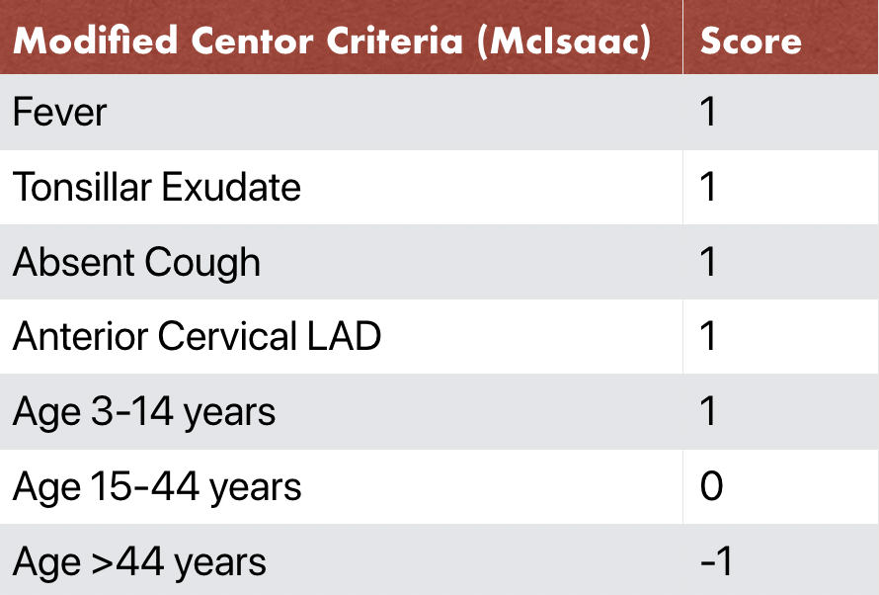

CERVICAL ADENITIS (Lymphadenopathy)
Enlargement of the lymph nodes; manifested in benign, self-limiting diseases AND those that are incurable/fatal
Relevant History | *This is a common presenting symptom  Comprehensive and detailed history is required  - Onset, course, duration; location, tenderness, painfulness; risky behaviours; hobbies/occupation; medications; fever or valvular heart disease; associated S&S; recent infection exposure; immunizations; cat scratches; travel; sexual partners; weight loss; alcohol intake
Physical Exam | Patient presents: sore throat, fever, fatigue, malaise, loss of appetite/weight, swollen and painless lumps the neck/axilla/supraclavicular areas  - May be otherwise well  - Skin rash, petechiae or bruising, pruritis, erythema on skin/scalp, skin eruption, night sweats, abdo pain, joint pain  Thorough physical exam to be completed  - VITALS= temperature, pulse, respirations, BP, weight  INSPECT  - Fundoscopic examination; eyes, ears, nose, throat; dermal exam  AUSCULTATE: heart and lungs  PALPATE  - Abdomen; clinical breast exam; check mucous membranes for inoculation site  - Nodal areas for lymphadenopathy; scalp for tender arteries in elderly pts  - Neck for thyroid tenderness or masses  MSK EXAM  - Assess for bone and joint swelling, tenderness, and warmth  - Examine for phlebitis, asymmetric swelling, calf tenderness, and palpable cord  PERCUSSS  - Sinuses for tenderness; transilluminate for sinusitis  GENITO-RECTAL EXAM  - Evaluate for herpetic lesions, masses, discharge, redness, chancroid, scabies, pediculosis  - Examine urethra; note folliculitis  - FEMALES--> cervical discharge, motion tenderness, adnexal tenderness, masses or heat in the pelvis  - MALES--> prostate and testes for tenderness/masses, penis for rash/discharge  - Rectal exam for discharge, tenderness, masses, fistulas
Diagnostic Tests | For localized lymphadenopathy  - CBCD and targeted testing- based on risk factors, exposure, ad high suspicion differentials  Cervical lymphadenopathy and URTIs: close follow-up, as lymphadenopathy should resolve with the viral illness
Differentials | - Infections  - Mono, AIDs, toxoplasmosis, secondary syphilis  - Hypersensitivity reactions  - Serum sickness, phenytoin and other drugs  - Metabolic diseases  - Hyperthyroidism, lipidoses  - Neoplasia  - Leukemia, advanced Hodgkin’s lymphoma, Non-Hodgkin's  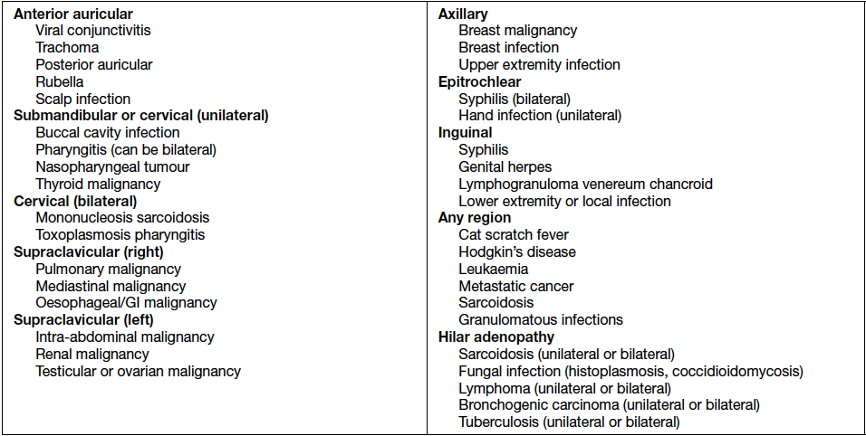
Epidemiology | Age--> <30= benign in 80% of cases; >50= benign in 40% of cases  In children--> typically caused by benign, self-limiting disease like viral infection  - Palpable anterior cervical trianngle in children is suggestive of infection  Predisposing factors...  - Factors increasing risk for HIV infection (homosexuality/bisexuality, iv drug abuse, hemophilia or conditions requiring transfusions, prostitution, Hatian)  - Occupational exposures; pharyngitis hx; animal exposure; bird droppings; gardening lacerations; TB exposure; STIs; tobacco abuse; cancer  - Medications: anticonvulsants, antihypertensives, antibiotics, para-amino salicylic acid, gold/allopurinol/quinine/pyrimethamine  - Travel: southwest USA, south America, Africa, Asia, India, Mediterranean
Pathophysiology | There are about 600 lymph nodes in the body  TYPES of lymphadenopathies...  - Localized adenopathy: spread of disease from the area of drainage  - Hilar adenopathy  - Generalized lymphadenopathy  - Other (lymphangitis, lymphadenitis, lymphoedema)  Left Supraclavicular Node= sentinel node  - Contact with thoracic duct; drains most of abdominal cavity  Right Supraclavicular Node= mediastinum, lungs, esophagus
Red Flags | Normal examination: only the lymph nodes in the neck, axilla, and groin are palpable  - Abnormal= palpable in any other region or >0.5cm in size  Supraclavicular lymphadenopathy= most common association with malignancy  In elderly--> regional lymphadenopathy may be a sign of carcinomas metastasizing to the nodes  Metastasis= hard, fixed nodules
Referral? | Admission for observation as needed  Refer to appropriate specialists as needed (e.g., oncologist if malignancy suspected)
Plan | INTERVENTIONS  - Assess to establish palpable masses  TEACHING  - Based on the underlying cause  PHARM THERAPY  - Dependent on diagnosis
Follow-Up | Follow to evaluate resolution

MONONUCLEOSIS (Epstein-Barr Virus)
Acute, infectious viral disease caused by EBV/human herpesvirus 4.
Relevant History | Signs/symptoms, course, duration; triad symptoms; URI and sore throat; contact with known mono-infected individuals; history of family members with similar symptoms; medication review (can be induced by phenytoin, carbamazepine, antibiotics)
Physical Exam | Classic triad= fever, tonsillar pharyngitis, lymphadenopathy  - fever  - tonsillar pharyngitis (exudate white, gray-green, necrotic)  - lymphadenopathy (posterior cervical, anterior cervical and symmetric)  - Fatigue can last months  - General aches; appetite loss; headache; hepatosplenomegaly; otitis media & abdominal complaints/diarrhea in infants and children; URI in young infants  Pharyngitis= with exudate; white/gray-green appearance, necrotic  Lymphadenopathy= posterior cervical chains, symmetric  INSPECT  - ENT; focus on tonsils and palate  - Pharynx--> hyperplasia, erythema, edema  - Tonsillar exudate--> 50% of cases  - Petechiae at soft/hard palate junction  - Kissing tonsils compromise the airway  - Oral hairy leukoplakia: on lateral portions of tongue, white, painless plaques that cannot be scraped from the surface (with HIV too)  AUSCULTATE: heart and lungs  PALPATE  - Lymph nodes--> anterior/posterior cervical, axilla, groin  - Firm/tender/mobile= mono (lymphadenopathy= symmetrical; post>ant)  - Abdomen--> spleen***  PERCUSS: abdomen, particularly the spleen area  NEUROLOGIC EXAM  - CN7 (facial nerve) palsies; meningitis symptoms (kernig and brudinski)
Diagnostic Tests | CBC WBC count with differential and heterophile test  - + heterophile antibody test= DIAGNOSTIC OF EBV  Throat swab--> rapid strep (culture if –ve)  Monspot test--> not recommended for general use (does not confirm absence of EBV)  - Heterophile antibodies often not present in children…order if monospot negative but still think its mono  Viral capsid antigen (VCA)--> IgM early (<4-6wks); IgG lasts lifetime  - EBV antigen appears 2-4mos after onset; stays + for life  - Antibody levels are not diagnostic of recent infection  Cold agglutinin titer--> elevated in hemolysis cases  LFTs--> in the presence of pharyngitis, abnormal LFTs strongly suggest mono (80-90% of cases)  Abdominal U/S--> assess for splenomegaly if indicated
Differentials | GAS pharyngitis; viral syndromes; Hodgkin's lymphoma; hepatitis; CMV; secondary syphilis; chronic fatigue syndrome; acute HIV; toxoplasmosis; adenovirus; rubella; HHV-6/roseola; HHV-7
Epidemiology | All populations show antibodies to EBV (90-95% of adults are +)  - Incidence unknown; more common in adolescents and young adults (15-24)  Predisposing factors...  - Age 12-40; exposure through kissing, coughing, or shared food; roommates; intrafamilial transmission to siblings
Pathophysiology | Spread through intimate contact with susceptible persons and asymptomatic EBV shedders (saliva passage)  - Oral shedding may occur for 6 mos after symptom onset before latency occurs  - Linked to B and t-cell lymphomas and Hodgkin’s lymphoma  - Possible link to sexual transmission (cervix and seminal fluid) and breastmilk
Red Flags | Splenic Rupture--> abdominal pain, falling hematocrit levels  - Occurs on day 4-21 of symptomatic illness (may be presenting symptom)
Plan | INTERVENTIONS  - Rule out upper airway obstruction  - Treat concurrent infections; isolation & bed rest not required  TEACHING  - Handwashing and preventing spread of pharyngeal secretions  - Communicability can last up to 12 months/1 year  - Signs of splenic rupture  PHARM THERAPY  - Acyclovir is NOT recommended  - Antibiotics only in the case of concurrent infections  - NSAIDs and acetaminophen for fever, aches and malaise  - Corticosteroids in the presence of overwhelming infection (obstructed airway, severe hemolytic or aplastic anemia)
Follow-Up | -Schedule follow-up visits as needed, typically in 2-4 weeks, to monitor recovery progress and reassess symptoms.  Examine clients every 1-2 weeks; initial monospot test may be negative  Splenomegaly--> schedule re-evaluation before releasing for contact sports (rupture risk)  Classic triad--> diagnostic test for strep as well due to similar presentation
Referral? | Specialist= marked tonsillar enlargement >2 weeks (emergent otolaryngologist consult)

STOMATITIS APHTHOUS
https://www.youtube.com/watch?v=6BLqCKEmYp0&t=76s&ab_channel=OsmosisfromElsevier
Tender, round, oval, shallow 1-5mm ulcers in the oral cavity
Relevant History | History of aphthous stomatitis; prodrome of burning or stinging; previous illness/trauma
Presentation | Ulcers= gray, white, or yellow; non-keratinized skin surrounded by red halos  - Common on the labial and buccal mucosa and tongue  Major recurrent (RAS)= deeper, larger ulcers recurring up to 4x per year, leaving scars  Patient presents: painful sores in the mouth  - Burning sensation for 1-2 days before lesions appear
Physical Exam | VITALS= temperature, pulse, respirations, BP  INSPECT  - Mouth (ulcers); ENT  - skin (palms and soles for lesions= hand/foot/mouth)  AUSCULTATE: heart and lungs  Lymph Nodes  Front of mouth: HSV  Back of mouth: coxsackie HFM
Diagnostic Tests | HSV if virus is considered for diagnosis  *No diagnostic test for stomatitis  Biopsy if unresulved in 2 weeks
Differentials | Herpetic stomatitis; Behcet’s disease; Crohn’s; HIV; Kawasaki syndrome; hand/foot/mouth, trauma ulcer
Epidemiology | 20-50% of population (Common in North America)  Predisposing factors...  - Trauma; history of RAS; nutritional deficiency (iron, folic acid, zinc); hormonal changes
Pathophysiology | Cause is poorly understood
Red Flags | Lesions lasting >3 weeks
Referral? | If ulcers are deeper than 1-5mm; Kawasaki disease suspected; no improvement with treatment  Lesions lasting >3 weeks= send to dentist or oral surgeon to rule out cancer  Refer to oral maxilophacial doc
Plan | INTERVENTIONS  - PAIN MANAGEMENT AND HYDRATION (lidocaine mouthwash)  - Avoid spicy/salty/hot foods; cold food, fluids  - Avoid hard/sharp food  - Use soft-bristle toothbrush  TEACHING  PHARM THERAPY  - Diphenhydramine mouthwash with bismuth subsalicylate/sucralfate and viscous lidocaine 3-4x/day (no lidocaine for children) *do not swallow*  - Glucocorticoid gel; sucralfate for comfort; Orabase with/without triamcinolone acetonide
Follow-Up | If unresolved in 2-3 weeks biopsy to rule out HSV or cancer

ALLERGIC RHINITIS
Chronic/recurrent condition; nasal congestion, clear discharge, sneezing, nasal/oropharynx itching, conjunctival itching, excess tearing.

TRIAD: ASTHMA, AR, AD
Relevant History | Onset/frequency/duration; characteristics of nasal discharge; exposure to others with these symptoms; seasonal impact; other diseases due to allergens; pregnancy; birth control; irritant exposure; nasal/facial trauma; ADLs; smoking; swimming/diving; fever, weight loss, myalgias, cough; medication & recreational drug use
Presentation | Patient presents: nasal congestion, sneezing, clear rhinorrhea, coughing from postnasal drip, sore throat, itchy/puffy eyes, asthma/atopic dermatitis  - Dry mouth from snoring; itchy nose; loss of smell/taste; eczema rash; SOB/wheezing; headache; halitosis
Physical Exam | - VITALS= temperature, BP, pulse, respirations  INSPECT  - Face for Dennie’s lines under the eyes and allergic salute crease across nose  - Eyes: tearing and allergic shiners (congestion causing dark circles under eyes)  - ENT for otitis media, nasal redness/swelling, cobblestone appearance of pharynx/tonsils as seen in chronic allergies, otoscope for frontal sinus cavity and maxillary sinus cavity to assess for fluid (healthy= symmetrically lights up)  PALPATE: face and sinuses for tenderness; neck for lymph node enlargement  PERCUSS  - Sinus cavities, mastoid bone, chest (consolidation), teeth for dental abscesses  AUSCULTATE: heart and lungs  With allergic rhinitis symptoms, it would be important to assess if there are any skin symptoms.
Diagnostic Tests | *Can make diagnosis based on history and physical*  - CBC with increased eosinophils  - Allergy skin tests  - Enzyme-linked immunosorbent assay (ELISA) test for IgE
Differentials | URI; medication-induced; sinusitis; otitis media; deviated septum; nasal polyps; endocrine conditions (hypothyroidism); influenza; substance-induced; nonallergic rhinitis
Epidemiology | Occurs after exposure to allergens; seasonally or perennially in 40% of the population  Predisposing factors...  - Allergic predisposition; exposure to allergic stimuli
Pathophysiology | Allergic= IgE mediated reaction of the nasal mucosa due to histamine release, Type 1 reaction  - Vasodilation, mucosal edema, and increased mucous production  Often co-exists with asthma and atopic dermatitis
Red Flags
Referral? | To an allergist if symptoms continue and interfere with daily activities (may prescribe immunotherapy)
Plan | INTERVENTIONS: avoid allergens, keep bedroom free of allergens; saline nose rinse  TEACHING  PHARM THERAPY  - Decongestants and second-generation antihistamines (H1 antagonists) as first line treatment  - Steroid sprays to decrease nasal inflammation; saline spray to liquefy secretions  - Petroleum jelly into nasal opening to prevent dryness
Follow-Up | In 2-3 weeks; or earlier if symptoms worsen after 2-3 days of treatment

NON-ALLERGIC RHINITIS
Inflammation of the nasal mucous membranes with nasal discharge and edema with NO correlation to specific allergen exposures.
Relevant History | Onset/duration/course; colour/characteristics of nasal discharge; discomforts/exposure to people with same symptoms; seasonal impact; pregnancy; birth control; prescription and OTC drug use; illicit drug use; medical history of respiratory problems; investigate presence of foreign object in nares  A. A. Ask about the onset, duration, and course of symptoms.  B. Inquire about the colour and other characteristics of nasal discharge.  C. Ask about other discomforts and exposure to people with similar symptoms.  D. Inquire about seasonal impact on symptoms, previous treatments, and results.  E. Rule out pregnancy. Ask female clients about birth control method, specifically contraceptives.  F. Ask about use of prescription drugs, over-the-counter (OTC) drugs (especially ASA), and illicit drugs (cocaine).  G. Review medical history for other respiratory problems such as asthma, emphysema, or chronic bronchitis.  E. With children, investigate possibility of a foreign object in nostrils  TYPES  A. Vasomotor and perennial nonallergic rhinitis results from hyperreactive nasal mucosa.  B. Atrophic and geriatric rhinitis results from progressive degeneration and atrophy of the mucous membranes and bones of the nose.  C. Overuse of topical nasal decongestants can worsen symptoms and cause severe rebound congestion.  D. Cocaine abuse causes nasal congestion and discharge.  E. Rhinitis in pregnancy results from hormonal increase; congestion abates with delivery.
Presentation | Patient presents: nasal congestion, sneezing, clear rhinorrhea, coughing, sore throat, itchy/puffy eyes
Physical Exam | - VITALS= temperature, BP, pulse, respirations  INSPECT  - Face for Dennie’s lines under the eyes and allergic salute crease across nose  - Eyes: tearing and allergic shiners (congestion causing dark circles under eyes)  - ENT for otitis media, nasal redness/swelling, cobblestone appearance of pharynx/tonsils as seen in chronic allergies, otoscope for frontal sinus cavity and maxillary sinus cavity to assess for fluid (healthy= symmetrically lights up)  PALPATE: face and sinuses for tenderness; neck for lymph node enlargement  PERCUSS  - Sinus cavities, mastoid bone, chest (consolidation)  AUSCULTATE: heart and lungs
Diagnostic Tests | Referral for allergy skin testing if rhinitis persists
Differentials | Allergic rhinitis; URI; foreign body; sinusitis; otitis media; deviated septum; nasal polyps; endocrine conditions; drug use (contraceptives, ASA, alpha-adrenergic blockers, cocaine, nasal decongestants)
Epidemiology | Predisposing factors...  - Adulthood  - Changes in temperature, odours, and emotional stress  *Pregnant individuals, cocaine drug users, elderly  Drug use 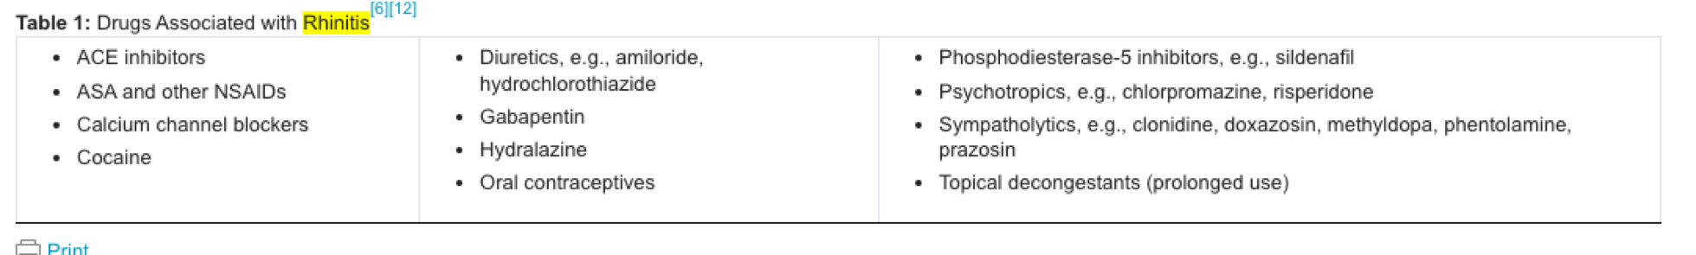
Pathophysiology | Types= vasomotor, perennial, atrophic, geriatric, drug-induced, rhinitis of pregnancy  Vasomotor & perennial--> hyperreactive mucosa  Atrophic & geriatric--> degeneration/atrophy of the membranes and nasal bones  Pregnancy--> due to hormonal increase  Can be induced by cocaine use; symptoms may worsen with overuse of decongestants
Red Flags
Referral? | To allergist if treatment fails
Plan | INTERVENTIONS  - Avoid changes in temperature, odours, and emotional stress  - Identify triggers  TEACHING  - Triggers are significant; avoid smoking, sprays, perfumes, etc.  - Daily use of neti-pot to cleanse sinuses to remove inhaled particles  - Viral rhinitis should resolve in 10 days untreated  PHARM THERAPY  Vasomotor--> inhaled ipratropium bromide  Atrophic--> dextromethorphan  Saline spray 3x/day  Decongestants for 2-3 days at a time (risk for rebound congestion)
Follow-Up | Return in 2-3 weeks and for bi-annual examinations (or PRN)

EPISTAXIS https://www.youtube.com/watch?v=XmpOtclH9Eg&ab_channel=ZeroToFinals
Nosebleed or hemorrhage from the nose
Relevant History | Amount, duration, frequency; oral anticoagulant use; recent/current URIs; family history of bleeding; recent surgery or trauma; LMP; pregnancy status; foreign body; cocaine use; occupational exposure to irritants; previous treatment; blood clotting abnormality investigations; bruising or bleeding easily, melena, tarry stools, heavy menstrual bleeding; family history of bleeding disorders; nasal spray use
Presentation | Patient presents: unusually severe or frequent nosebleeds  ANTERIOR  - Unilateral, continuous and moderate bleeding from the septum of the nose  POSTERIOR  - Brisk arterial bleeding flowing into the pharynx
Physical Exam | VITALS= temperature, BP for orthostatic hypertension, pulse, respiration  INSPECT  - Airway patency when sitting and leaning forwards; rash/purpura/petechiae to skin & mucous membranes & conjunctiva; eye examination; nose for ulceration; nasal discharge (foul discharge= foreign body); nasal mucosa for colour/masses/ discharge/lesions/swelling AFTER bleeding stops  AUSCULTATE: heart and lungs  PALPATE: lymph nodes in neck to rule out sarcoidosis, TB or malignancy  PERCUSS: sinuses
Diagnostic Tests | *Only in the presence of severe blood loss  - Drug screen; hematocrit/hemoglobin; CBCD; platelets, prothrombin time, partial thromboplastin time; sinus films if recurrent pain/tenderness/bleeding  - If posterior: Take hematocrit, hemoglobin, blood type & crossmatch, BP
Differentials | Foreign body; anatomical (septal deformity); tumour, bleeding d/o, enciromental factors like dry air or irritant like chemicals or smoke  perforated nasal septum; coagulation disorder; nasal tumors; drug-induced coagulopathy; HTN; pregnancy
Epidemiology | Occurs at least once in 60% of the population  Predisposing factors...  - Local trauma; acute inflammation; nose blowing; inhaled chemical irritants; drying/crusting of the septum; trauma; cocaine use; pregnancy; neoplasms; systemic (disorders of bleeding, HTN, arteriosclerosis, renal disease)  Elderly= risk of spontaneous posterior hemorrhage
Pathophysiology | Caused by the disruption of nasal mucosa (mostly due to irritation & self-limiting)
Red Flags | Posterior nasal bleeding originating in the turbinates or lateral nasal wall  Hypovolemia or hemorrhagic shock signs; anticoagulant drug use
Referral? | Immediate referral to otolaryngologist if posterior bleeding is present
Plan | ANTERIOR  Sit & lean forwards; pinch nasal alae; apply pressure for 5-10 minutes at bleed site  Medications...  - 1:1 mix of oxymetazoline HCl and 2% lidocaine with pressure x 5-10 min  - Silver nitrate stick to bleeding site for 5-10s (painful)  - If not stopping; oxidized regenerated cellulose to artery or pack petroleum gauze strip in nasal vestibule x24h. Apply ice.  POSTERIOR  Sit & lean forwards; control bleeding with topical anesthetic and vasoconstrictor; apply pressure; CLIENT REQUIRED EMERGENCY CARE IMMEDIATELY  - Take hematocrit, hemoglobin, blood type & crossmatch, BP
Follow-Up | For anterior bleeding--> refer to otolaryngology if unable to stop hemorrhage  For posterior bleeding--> admission to hospital and refer to otolaryngologist

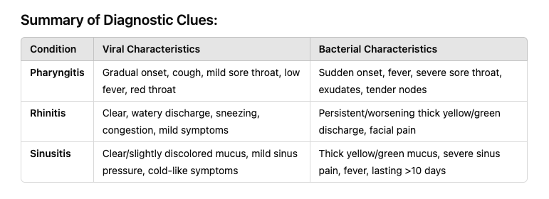
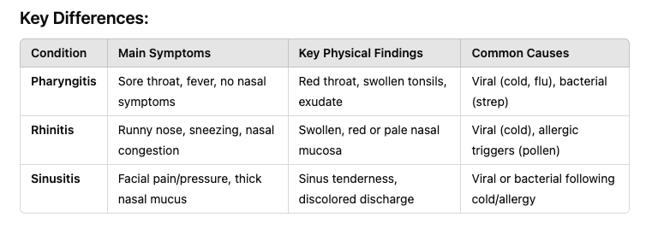
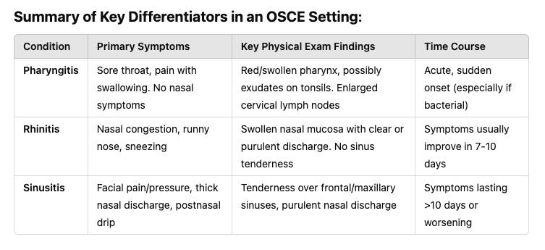
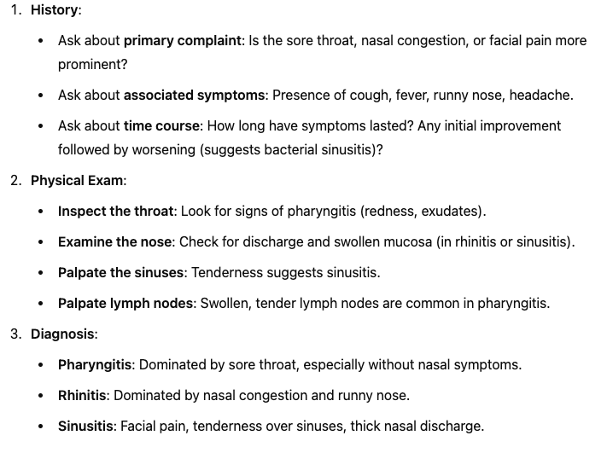

`RHINOSINUSITIS (Acute Sinusitis)
Inflammation of the mucous membranes lining the paranasal sinuses; almost always accompanied by inflammation of the nasal mucosa (hence Rhinosinus-)

A diagnosis of acute bacterial sinusitis may be more likely when : TWO or MORE MAJOR symptoms are present (ONE of which is nasal obstruction or nasal purulence/discoloured postnasal drainage). Other Major Symptoms: Facial pain/pressure/fullness; hyposmia/anosmia. In addition, the symptoms have not improved after 7 days or have worsened after 5 to 7 days

PODS: Pain, nasal Obstrcution, Discharge, Systemic S/S
Relevant History | Onset/duration/course; seasonal affect; recent URIs and treatment; allergies; dental problems; home therapies; airplane travel; foreign objects; swimming and diving; symptom change with position; halitosis, eye pain, fever, fatigue, headache, weight loss; infection exposures; CF, asthma, respiratory problems and nasal abnormalities  Are you experiencing nasal congestion or blockage?  Do you have facial pain or pressure? If so, where is the pain located (e.g., forehead, cheeks, behind the eyes)?  Are you experiencing a decreased sense of smell or taste?  Colour of d/c
Presentation | Do you have a history of allergies, asthma, or chronic sinus issues?  Recent URI  Are you currently taking any medications, particularly nasal sprays or antihistamines?  Cough? Worse at night?  Acute= abrupt onset of infection with resolution after therapy (lasts < 4 weeks)  - Subacute= persistent purulent nasal discharge despite therapy  - Chronic= episodes of prolonged inflammation, repeated inadequate treatment of infections  Patient presents: yellow/green discharge, fever, sore throat, facial pain, pressure that worsens when bending over, headache, toothache  - Loss of smell; nasal congestion; cough that is worse when lying down; periorbital edema in the morning; malaise/fatigue; halitosis; snoring/mouth breathing; nasal speech  - Cough: Often worse at night due to postnasal drip.  - Fever: May occur, especially with bacterial sinusitis.
Physical Exam | VITALS= temperature, BP, pulse, respirations  INSPECT  - Eyes: periorbital swelling, allergic shiners, orbital cellulitis (edema, drooping lids, decreased extraocular motion, vision loss)  - Ears; nose; transilluminate frontal and maxillary sinuses; mouth and pharynx, tonsils, teeth, retro pharynx  AUSCULTATE: heart and lungs  PALPATE  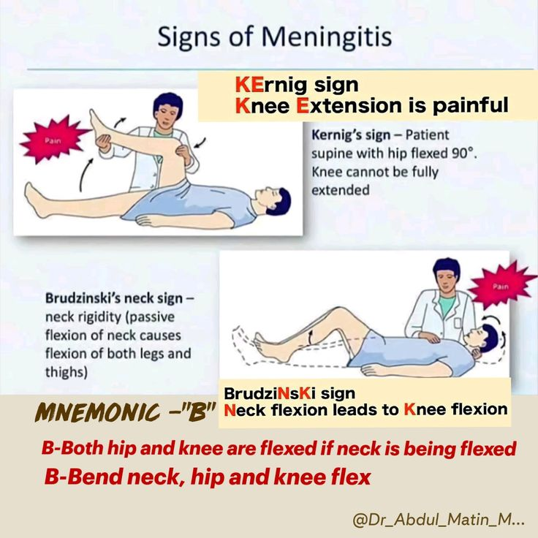  - Neck for lymphadenopathy  Sinuses (do not press on eyes)  - Frontal sinusitis= pain over lower forehead, worse when bending over, purulent discharge from middle meatus of turbinates  - Maxillary sinusitis= pain over cheeks from inner canthus to teeth; hard palate edema in severe cases; purulent drainage from middle meatus  - Ethmoid sinusitis= frontal/orbital headache, tenderness over lateral aspect of nose  - Sphenoid sinusitis= *uncommon; frontal/orbital headache, facial pain to top of head and deep into eyes  PERCUSS: maxillary teeth, maxillary and frontal sinuses; chest if needed  NEUROLOGIC EXAM  - Signs of meningeal irritation  - Brudzinski’s sign, Kernig's sign, nuchal rigidity
Diagnostic Tests | *Mostly made through history and physical exam  - X-rays to show air-fluid levels and thickened mucous membranes for chronic or recurrent complicated cases (3-views)  - CT if chronic, recurrent, allergic fungal, or osteomeatal complex occlusion
Differentials | Headache; rhinitis; nasal polyp; tumor; URI; trigeminal neuralgia; pregnancy
Epidemiology | Most cases= viral, lasting < 10 days  - Incidence increases in allergy seasons (spring and fall) & cold winter seasons  Predisposing factors...  - Recent URI; allergies; nicotine & smoke exposure; air pollutants; deviated septum; adenoidal hypertrophy; dental abscess; diving & swimming; neoplasms; CF; trauma; medical disorders; flying/rapid altitude changes
Pathophysiology | Can be acute bacterial, subacute, or chronic (bacterial in only 2% of cases)  Causes= obstruction of mucous flow, anatomical abnormalities, exposure to pathogens after URI, dental abscesses, fungal infection in diabetics or those with leukemia; common cold  Pathogens= staph aureus, Hemophilus influenza, pneumococci, streptococci, Bacteroides
Red Flags | Requiring immediate ENT referral...  Stiff neck (meningitis); orbital cellulitis; altered mental state; limited ocular motion; frontal/retro-orbital headache  Black necrotic tissue or black discharge  Mucormycosis (fungal infection)  Altered mental status, abnormal neurological exam, meningeal signs meningitis, intracranial abscess, cavernous sinus thrombosis  Decreased visual acuity, orbital edema/erythema orbital cellulitis
Referral? | Fever, orbital cellulitis, mental changes--> hospital  Chronic sinusitis clients--> otolaryngologist if not improved in 4 weeks  Suspected neoplasm, abscess, osteomyelitis, meningitis, sinus thrombosis--> specialist
Plan | INTERVENTIONS  - Prevention, log triggers, investigate for autoimmune diseases  TEACHING  - Avoid smoking exposure; drink fluids; use medications as prescribed; avoid antihistamines and use decongestants with caution; warm, moist face compresses; humidifier use; nasal saline 3x/day; gargle with saltwater  PHARM THERAPY  - Antibiotics only if symptoms persist longer than 1 week, start to improve and then worsen, or are very severe (if needed; amoxicillin)  ORAL/TOPICAL DECONGESTANTS  - Correct underlying edematous mucosa  STEROID SPRAYS  - Decrease nasal inflammation
Follow-Up | Recheck in 3-4 days if signs/symptoms have not improved with treatment  - Symptoms should improve in 3 days regardless of treatment duration

AHAD WEEK 3: Integumentary Part 1

Review of Skin Condition Terminology:
Primary lesions:
- Macule <1 cm, nonpalpable
- Patch >1 cm, Nonpalpable circumscribed skin colour change
- Papule <1 cm, palpable
- Plaque >1 cm, Solid, elevated, palpable but superficial lesion
- Nodule <1-2 cm, solid, elevated, palpable
- Tumor >2 cm, Solid, may be elevated and movable, palpable, extending into dermis
- Vesicle <1 cm, fluid-filled
- Bulla >1 cm, Fluid filled elevated lesion
- Wheal, Transient white or pale pink lesion due to edema
- Comedone (blackhead), Follicular plug of sebum
- Burrow, Linear thread-like lesion, slightly palpable
- Vitiligo: absence of melanin pigment in patchy areas on face, neck, hands, feet, body folds, around orifices, normal finding

Secondary lesions:
- Excoriation: Traumatic loss of tissue
- Pustule: Pus filled elevated lesion, often follicular
- Abscess: Pus filled lesion below surface
- Crust: Adherent dried body fluid
- Fissure: Crack in skin, usually epidermis
- Scale: Flakes of keratinized epithelial cells
- Lichenification: Normal skin markings accentuated with thickening
- Scar/Keloid: Fibrotic replacement of destroyed tissue
- Atrophy: Normal skin markings lost with thinning
- Ulcer: Circumscribed loss of skin layers

Clinical Pearls…
- Flexor surfaces= atopic dermatitis, extensor surfaces= psoriasis

Abscess, folliculitis, furuncles, carbuncles
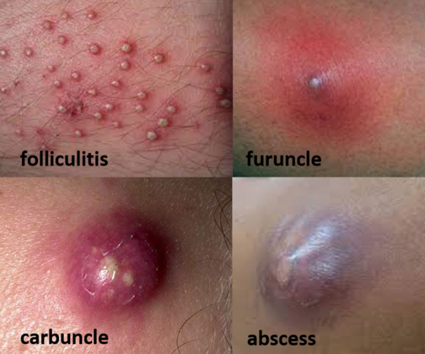
Deeper skin infections can follow traumatic inoculation into skin and or the extension of infection into hair follicles.
Abscess: acute or chronic localized inflammation, associated with a collection of pus accumulated in a tissue. Inflammatory response to an infectious process or foreign material.
Folliculitis: infection of the hair follicle +/- pus in the ostium of the follicle in groin, axilla, waistline, or buttocks. Tender and firm
Furuncle: Acute, deep-seated, red, hot, tender nodule or abscess (boil) that evolves from a staphylococcal folliculitis
Carbuncle: deeper infection composed of interconnecting abscesses usually arising in several contiguous hair follicles, fever and chills is possible
Epidemiology and Etiology
S. Aureus (MSSA and MRSA)
Predisposing Factors
A. Break in the skin tissue.
B. Use of razors on skin.
C. Poor hygiene.
D. Diabetes.
Clinical Manifestations
Abscess- initially a red tender spot, pus collects within a central space
Folliculitis- non-tender or slightly tender, may be pruritic
Furuncle- firm tender nodule with abscess formation +/- central pustule
Carbuncle- composed of several to multiple, adjacent and coalescing furuncles
Assessment
Subjective Data
- Elicit the initial outbreak of lesions and onset and progression of lesions.
- Identify what makes the lesions better or worse.
- Ask the client what medications, soaps, or lotions have been used on the lesions.
- Complete a medical history. Ask whether the client has had an outbreak similar to this before.
- Describe systemic symptoms if they have occurred (fever, chills, etc.).
- Does the client have a beard, shave face,or use a razor frequently?
- Is there a recent history of use of a hot tub? (Commonly seen one to four days after use of a hot tub, whirlpool, or swimming pool.)
- Does the client wear tight pants/jeans or use oils that clog pores in the groin area?
- Is the client currently being treated with antibiotics for acne? (May see flare of Gram-negative folliculitis with chronic use of antibiotics.)

Physical Examination
- Check temperature, pulse, respirations, and blood pressure.
Inspect skin for lesions and describe.
Palpate lesions and associated lymph nodes.
- Consider the area it is in: wet/moist areas like back, under arms, groin, under breasts is usually a cyst or abscess

Diagnostic tests
- Culture and sensitivity to verify appropriate antibiotic coverage.
- Gram stain.
- Potassium hydroxide (KOH)/wet preparation if you think it's fungal.
- Fungal culture hair if fungi are suspected (tinea of scalp).
- Skin biopsy for the diagnosis of malassezia folliculitis.
- Ultrasound if think lipoma/tumour
Diagnositics
- Microscopy and Gram stain
- Bacterial culture (standard, anaerobic, and at low temperature)
- Biopsy of adjacent tissue
Differentials
Acne, contact dermatitis, milia, atopic dermatitis, insect bites
Clinical Pearls
Folliculitis can be cured by laser hair removal.

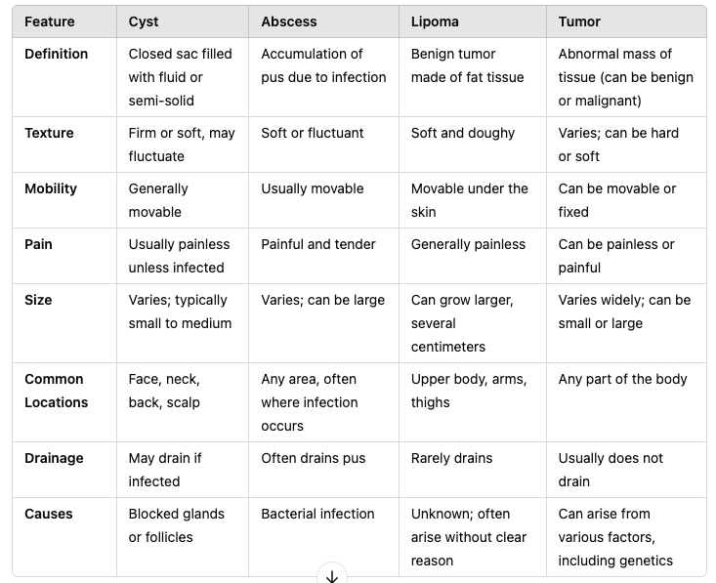

Acne
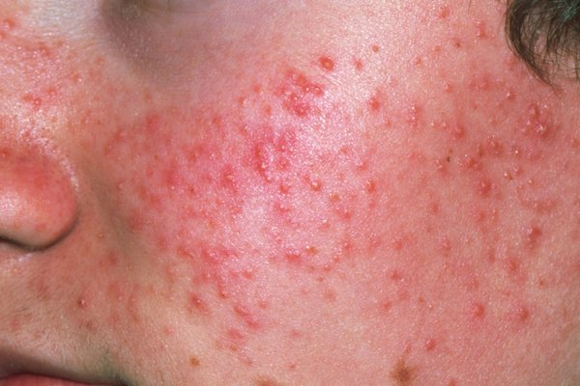
Acne vulgaris is a disorder of the sebaceous glands and hair follicles of the skin that are most numerous on the face, back, and chest. The sebaceous glands become inflamed and form papules, pustules, cysts, open or closed comedones, and/or nodules on an erythemic base. In severe cases, scarring can result.
Epidemiology
- Occurrence: very common, 85% of young people
- Age of Onset: puberty
- Sex: more males
- Race: lower in Asians and Africans
- Genetics: most with cystic acne have parents with cystic acne
Clinical Manifestations
- Duration of lesions: weeks to months
- Season: worse in fall/winter
- Symptoms: Painful Lesions
- Skin lesions: Comedones (white and blackheads), papules and papulopustules, nodules or cysts, sinuses , scars
Assessment
Subjective Data
- Elicit the age of onset of outbreak, duration, and course of symptoms.
- Determine what makes the lesions worse or better.
- Ask whether there are certain times of the month or year when lesions are better or worse.
- Identify the client’s current method of cleanser or moisturiser treatment.
- Ask whether the client has ever been treated by a provider for this problem. If so, determine the treatment and results of the treatment.
- Assess whether other family members have this same problem.
- Ask the client for a description of his or her environment and occupation.
- Explore with the client any current stress factors in his or her life.

Objective Data
- May see a variety of non-inflammatory lesions.
- Papules or pustule, larger/painful nodules, comedones (whiteheads are closed and blackheads are open). There may be scarring present from healed lesions.
- In severe cases, you would see burrowing sinus tracts called acne conglobate; an ulcerative condition known as acne fulminans; or acne inversa which is a chronic, severe, painful condition.

Physical Examination
- Inspect:
1. Observe skin for location and severity of lesions.
2. Rate severity of lesions as mild, moderate,or severe
  - a. Mild: Few papules/pustules, no nodules.
b. Moderate: Several papules/pustules, rare nodules.
  - c. Severe: Many papules/pustules with many nodules.
- 3. Take a picture of areas of affected skin for chart and document date. Use this for future appointments as a reference to compare results for follow-up visit

Diagnostics
- Comedones are required for diagnosis of any type of acne.
- If severe, maybe free and total testosterone, LH, FSH, and DHEA-S (to exclude PCOS and hyperandrogenism)

Diagnostic Tests
No tests are generally required. You can culture lesions to rule out Gram-negative folliculitis with clients on antibiotics. Consider hormone testing if other primary causes of acne are taken into account (follicle-stimulating hormone, luteinizing hormone, testosterone levels).
Differentials
Face: S. Areus folliculitis, rosacea, dermatitis
Trunk: Malassezia folliculitis
Clinical Pearls
May be helpful to use grading scales to classify the disease. Mostly rely on the presence or absence of non-inflammatory lesions, pustules/papules, comedones, and nodulo-cystic lesions.
Treatment
Treatment: goal of therapy is to prevent scarring and control lesions
Counseling/Education: proper cleansing routine-mild soap or soapless cleanser BID; discuss potential stressors which exacerbate acne
Non-pharm therapies: exercise, face cleansing,
Consult dermatology if tx unsuccessful after 10-12 weeks of therapy or if acne is severe
Follow up Q6-8 wks for evaluation and adjust dose of meds

Candidiasis
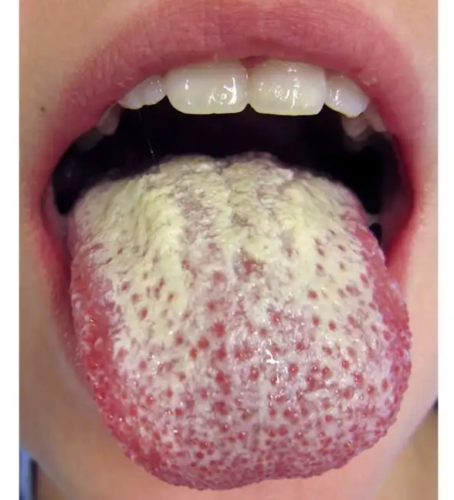
A fungal infection of the mucous membranes and/or skin; candidiasis is caused by the Candida albicans fungus.

Epidemiology
Most commonly caused by the yeast Candida albicans. Less often by other Candida species. Dimorphic Fungus.
Predisposing Factors
- Immunosuppression.
- Use of antibiotics.
- Hyperglycaemia.
- Chronic use of steroid.
- Frequent douching by women.
- Use of dentures.
Assessment
- Pruritus, tenderness and pain
- Question the client about onset, duration, and location of lesions.
- Determine whether the client has a history of previous infections.
- Inquire into medical history and current medications.
- Rule out the presence of any other current medical conditions.
Objective/Physical Exam
Occurs in moist, occluded sites. Sharply demarcated, polycyclic, erythematous, eroded patches with small pustular lesions.
Inspect:
- Assess skin and mucous membranes for discharge and lesions.
- Observe location and severity of lesions.
- Usually occurs in the inguinal creases; white-tipped papules and scaling boarders
Palpate:
- Palpate lymph nodes in neck and groin.
Diagnostics
Direct microscopy, Culture to identify species of Candida.
Vaginal or genital wet preparation/potassium hydroxide (KOH) 10% solution.
Oral scraping for KOH preparation to visualize yeast cells and hyphae under the microscope.
Culture may be done if necessary, particularly in recurrent cases.
STD swab if genital
Differentials
Intertrigo, diaper rash, folliculitis
Oral candidiasis: Leukoplakia, Stomatitis, Formula (for newborns).
Diaper area: Candidiasis, Contact dermatitis, Bacterial infection
Genital area. Candidiasis, Bacterial infection, Bacterial vaginosis, Chlamydia, Gonorrhoea, Trichomoniasis.
Clinical Pearls
Confirm by direct microscopy or culture. KOH Preparation or Wet Mount Prep.
Therapeutic Goals (Oral Candidiasis)
Resolve infection or reduce acute candidal overgrowth to a level that can be controlled by the host's defenses and thereby prevent complications (e.g., progression to esophageal candidiasis)​.
Prevent recurrences by managing any underlying risk factors (e.g., use of inhaled corticosteroids, poor dental hygiene, uncontrolled diabetes mellitus) and instituting antifungal prophylaxis if warranted.
Immunocompromised Patients
It is estimated that 25–75% of healthy, immunocompetent adults carry Candida species as part of their normal oral flora. However, when the normal flora is compromised (e.g., by weakened host defense mechanisms), Candida overgrowth, direct tissue invasion, and regional or systemic progression may occur, leading to the development of opportunistic disease.​ Oral candidiasis, also known as oral thrush, oral candidosis, pseudomembranous candidiasis or moniliasis, is a mucocutaneous opportunistic infection caused by Candida species.

Oral candidiasis is the most common fungal infection found in both immunocompetent and immunocompromised populations, with prevalence greatest among infants and the elderly.​ It is often denoted as a “disease of the diseased,” since it selectively occurs in individuals with weakened host defense mechanisms.​ Host factors are believed to play a more significant role than the virulence of Candida in the pathogenesis of disease

Cellulitis
Epidemiology
Most common pathogens are S. Aureus and GAS.
Less commonly Group B,C, or G.
In children: pneumococci, Neisseria meningitidis group B (periorbital). H. Influenzae type b (Hib).
Risk Factors
Diabetes mellitus, drug use, alcohol abuse, cancer, lymphedema, previous cellulitis, peripheral vascular disease
Clinical Manifestations
- Fever, chills (associated with GAS)
- Local pain and tenderness, warmth
- Severe pain and systemic symptoms (associated with necrotizing infections)
- Common on the lower extremities
- Red, hot, edematous, and shiny plaque originating with portal of entry
- Extensive, cutaneous soft tissue necrosis develops
Assessment
History of trauma, surgery, insect bite, scratch or scrap, or some other entry portal. Area is red, itchy, painful, increasing in size, hot to touch. May have had fever, chills, and malaise. If they utalize a public gym, worry about MRSA.

Distribution:
Adults- lower extremity most common
Trunk-operative site
Face- following rhinitis, conjunctivitis or colonization of nares

Purulent description is usually staph, not strep
Ususally unilateral
Can lead to fever and leukocytosis can occur

Inspect all aspects of the integumentary system to rule out localised vs generalised cellulitis. Palpate to assess if edema is pitting.
Diagnostics
Clinical diagnosis is made based on morphologic features of lesion and the clinical setting i.e. underlying disease, travel history, animal exposure, history of bite, age. Confirmed by culture in only 29% of immunocompetent patients. Suspicion of necrotizing fasciitis requires immediate deep biopsy and tissue culture.

- DON'T PRESCRIBE ABX FOR BILATERAL CELLULITIS SINCE BILATERAL ISN'T COMMON WITH CELLULITIS. Consult derm.
- Culture isn't always suggested, can diagnose with hx. and physical but can order culture if suspicious.
- Biopsy, gram stain, VDRL (syphilis), KOH (fungal), dermoscope
Differentials
Cellulitis-Erysipelas, DVT, urticaria, insect bite, fixed drug eruption, erythema, acute gout, erythema migrans
Necrotizing- vasculitis, occuslive vasculopathy, PVD, calciphylaxis, warfarin necrosis, traumatic injury, pyoderma gangrenousum

Dermatitis: Contact
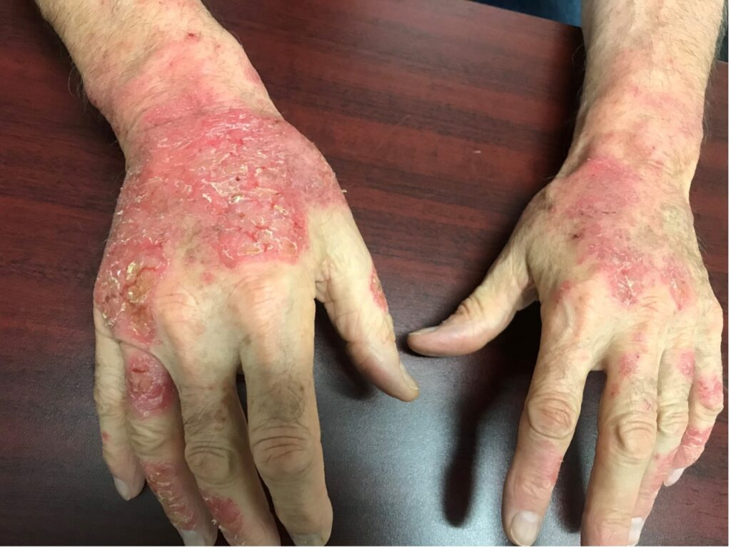
Contact dermatitis is a generic term applied to acute or chronic inflammatory reactions to substances that encounter the skin. There is irritant contact dermatitis (ICD), whereas allergic contact dermatitis (ACD) is caused by an antigen that elicits a type IV HS reaction. ACD only occurs in sensitized individuals.

*If you touch other parts of your body after contact, the rash can develop there as well due to spreading the agent around if its still on your skin.****
Epidemiology
ICD is one of the most common forms of occupational skin disease.
ACD accounts for 7% of occupational related illnesses. All ages but uncommon in children and >70 years.
Risk Factors
Use of etiologic agents e.g. abrasives, cleaners
Predisposing factors: atopy, fair skin, temperature (low), climate (low humidity), occlusion, mechanical irritation
Occupational exposure (hairdresser, nurse)
Common allergens include poison ivy, poison oak, sumac, nickel jewellery, hair dye, rubber and leather chemicals (latex gloves), cleaning supplies, harsh soaps, detergents, and topical medicines.
Clinical Manifestations
IRRITANT CONTACT DERMATITIS
Common Irritants: Detergents, soaps, solvents, acids, alkaline substances, frequent hand washing.
Onset: Immediate or shortly after exposure (hours).

- Delayed type symptoms may not occur until 8-24 hours after exposure
- Lesions range from erythema to vesiculation and caustic burn with necrosis
- Lesions do not spread beyond site of contact
- No papules
- Configuration is often bizarre or linear (dripping)
- Distribution- isolated, localized or generalized
- Duration- days, weeks, depending on tissue damage
- Fast onset
ALLERGIC CONTACT DERMATITIS (posion ivey, sumac, nickle)
Common Allergens: Nickel, poison ivy, fragrances, preservatives, rubber/latex, and certain chemicals.
Onset: Delayed (usually 24-72 hours after exposure).

- Intense pruritus
- Well-demarcated erythema and edema with papules or non umbilicated vesicles
Chronic Dermatitis:
1. Erythema with thickening.
2. Scaling.
3. Fissures.
4. Inflammation; with chronic dermatitis, lichenifica- tion may occur with scales and fissures.
Diaper dermatitis:
1. Prominent red, shiny rash on buttocks. Often mistaken with candidiasis diaper rash which is a bright red rash with satellite lesions at margins.
Assessment
- Burning, stinging, or smarting can occur within seconds
- Ask the client when irritation began and how it has progressed.
- Elicit history of exposure to allergens.
- Question the client regarding activity and skin contact with irritants before outbreak (cleaning agents, walking in woods, hobbies, change in soap/laundry detergent, shaving cream, lotions, etc.).
- List occupation and family history of allergens.
- Review medication list, including prescription, over-the -counter (OTC), and herbal medicines, to evaluate an inter- action.
- List medications used to relieve symptoms and results.

Physical Examination
- Check temperature (if indicated).
- Inspect:
  - Skin, noting types of lesions and location of lesions. Note the pattern of inflammation. The shape of irritation may mimic the shape of the irritant, such as the skin under a ring or watch.
  - Determine progression of lesions.
  - Differentiate between primary and secondary lesions.
Diagnostics
- Patch Testing: Usually not needed for ICD, but may be done to rule out allergic contact dermatitis (ACD) if there’s uncertainty.
- Consider none if the source is known.
- Wet mount (potassium hydroxide [KOH], saline) to rule out fungal infection if candida is suspected.
- Culture/sensitivity of pustules
Differentials
- Irritant Contact Dermatitis
- Allergic Contact Dermatitis
- Diaper Dermatitis
- Candida
- Tinea Pedis, Corporis, Cruris
- Drug Reactions
- Pityriasis Rosea
- Scabies
- Atopic Dermatitis
- Seborrheic dermatitis
- Psoriasis
- Epidermal dermatophytosis

Atopic Dermatitis (Aka IgE dermatitis, Eczema)
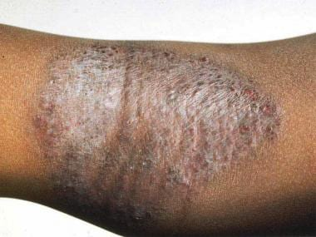
An acute, subacute, or chronic relapsing skin disorder. Characterized by dry skin and pruritis (itch-scratch cycle). This pattern of skin inflammation has clinical features of erythema, itching, scaling, lichenification, papules, and vesicles in various combinations. Currently, the term “eczema” is used interchangeably with “dermatitis.” Most common vari- ants are atopic dermatitis and atopic eczema. Classification is done by cause, either endogenous or exogenous.
*The atopic triad= AAA (allergic rhinitis, atopic dermatitis, asthma)
Epidemiology
Very common in infancy. 60% of adults with AD had children with AD.
Risk Factors
- Associated with history of AD, allergic rhinitis and asthma.
- Family history of atopic triad: Dermatitis, asthma, and allergic rhinitis.
- Exposure to allergens:
  - Common foods: Cow’s milk, nuts, wheat, soy, and fish.
  - Common environmental allergens: Dust, mold, cat dander, and low humidity (dry air).
  - Exposure to topical medications, most commonly neomycin, lanolin, and topical anesthetics like benzocaine.
  - Skin irritants: Harsh soaps; skin-care products with perfumes, chemicals, and alcohol; fabrics containing wool; and tight clothing.
  - Stress
Assessment
Subjective Data
- Determine whether the onset was sudden or gradual (should be more gradual…sudden is contact).
- Ask the client whether the skin is itchy or painful
- Assess whether there is any associated discharge (blood or pus).
- Ask whether the client has recently taken any antibiotics, other oral drugs, or topical medications.
- Ask the client about the use of soaps, creams, or lotions.
- Assess for any preceding systemic symptoms (fever, sore throat, anorexia, vaginal discharge).
- Ask the client about recent travel abroad
- Rule out insect bites.
- Rule out any possible exposure to industrial or domestic toxins.
- Elicit what precipitates itching.
- Evaluate for increased stress level at home, work, in rela- tionships, and so on.

Physical Examination
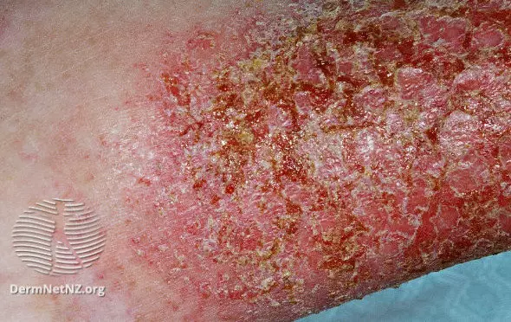
- Will likely see dry skin and pruritus that causes rash (Usually on flexor areas, and can be lichenified)
- Check temperature (if indicated).
- Inspect skin for lesions: Recognize bacteria-infected eczema—Staphylococcus aureus is the most common pathogen. It appears with acute weeping dermatitis, crusted and small superficial pustules.
- Dennie Morgan Lines- the Dennie sign is seen in cases of eczema (increased % of eczema patients with this)
Clinical Manifestations
Skin changes: Itching, impossible to relieve, Dryness, Discolouration, lichenification, scaling, Skin thickening, associated bleeding and oozing
Diagnostics
- Laboratory Testing: Typically not required but may include skin prick tests or specific IgE tests if allergies are suspected. In cases of suspected secondary infection, a swab for bacterial culture may be done.
- May involve allergy testing (e.g., skin prick tests or serum IgE levels) to identify associated allergens.
- Culture skin lesions to determine viral, bacterial, or fungal etiology.

Patch Testing: To identify potential allergic contact dermatitis
Skin Prick Testing: To evaluate for IgE-mediated allergies. (useful if allergic contact dermatitis is suspected
Serum IgE Levels
Complete Blood Count (CBC):To check for eosinophilia.
Skin Biopsy: To rule out other conditions

Differentials
- Contact Dermatitis (Acute or Chronic)
- Seborrhoeic Dermatitis
- Ichthyosis Vulgaris
- Bacterial/Fungal Infections
- Neoplastic Disease
- Immunologic and Metabolic Disorders
- SD, ICD, ACD
- Psoriasis
- Nummular Eczema
- Dermatophytosis
- Mycosis fungoides
Education:
Skin Care and Lifestyle Modifications:
- Moisturizers: Regular use of emollients or thick moisturizers, especially after bathing, to lock in moisture and repair the skin barrier.
- Bathing: Limit bathing to once daily with lukewarm water; avoid hot water, which can dry out the skin. Use mild, fragrance-free soaps or cleansers.
- Clothing: Wear soft, breathable fabrics (e.g., cotton); avoid wool or synthetic materials that can irritate the skin.
- Avoid Triggers: Identify and avoid environmental or dietary triggers whenever possible.

Seborrheic Dermatitis
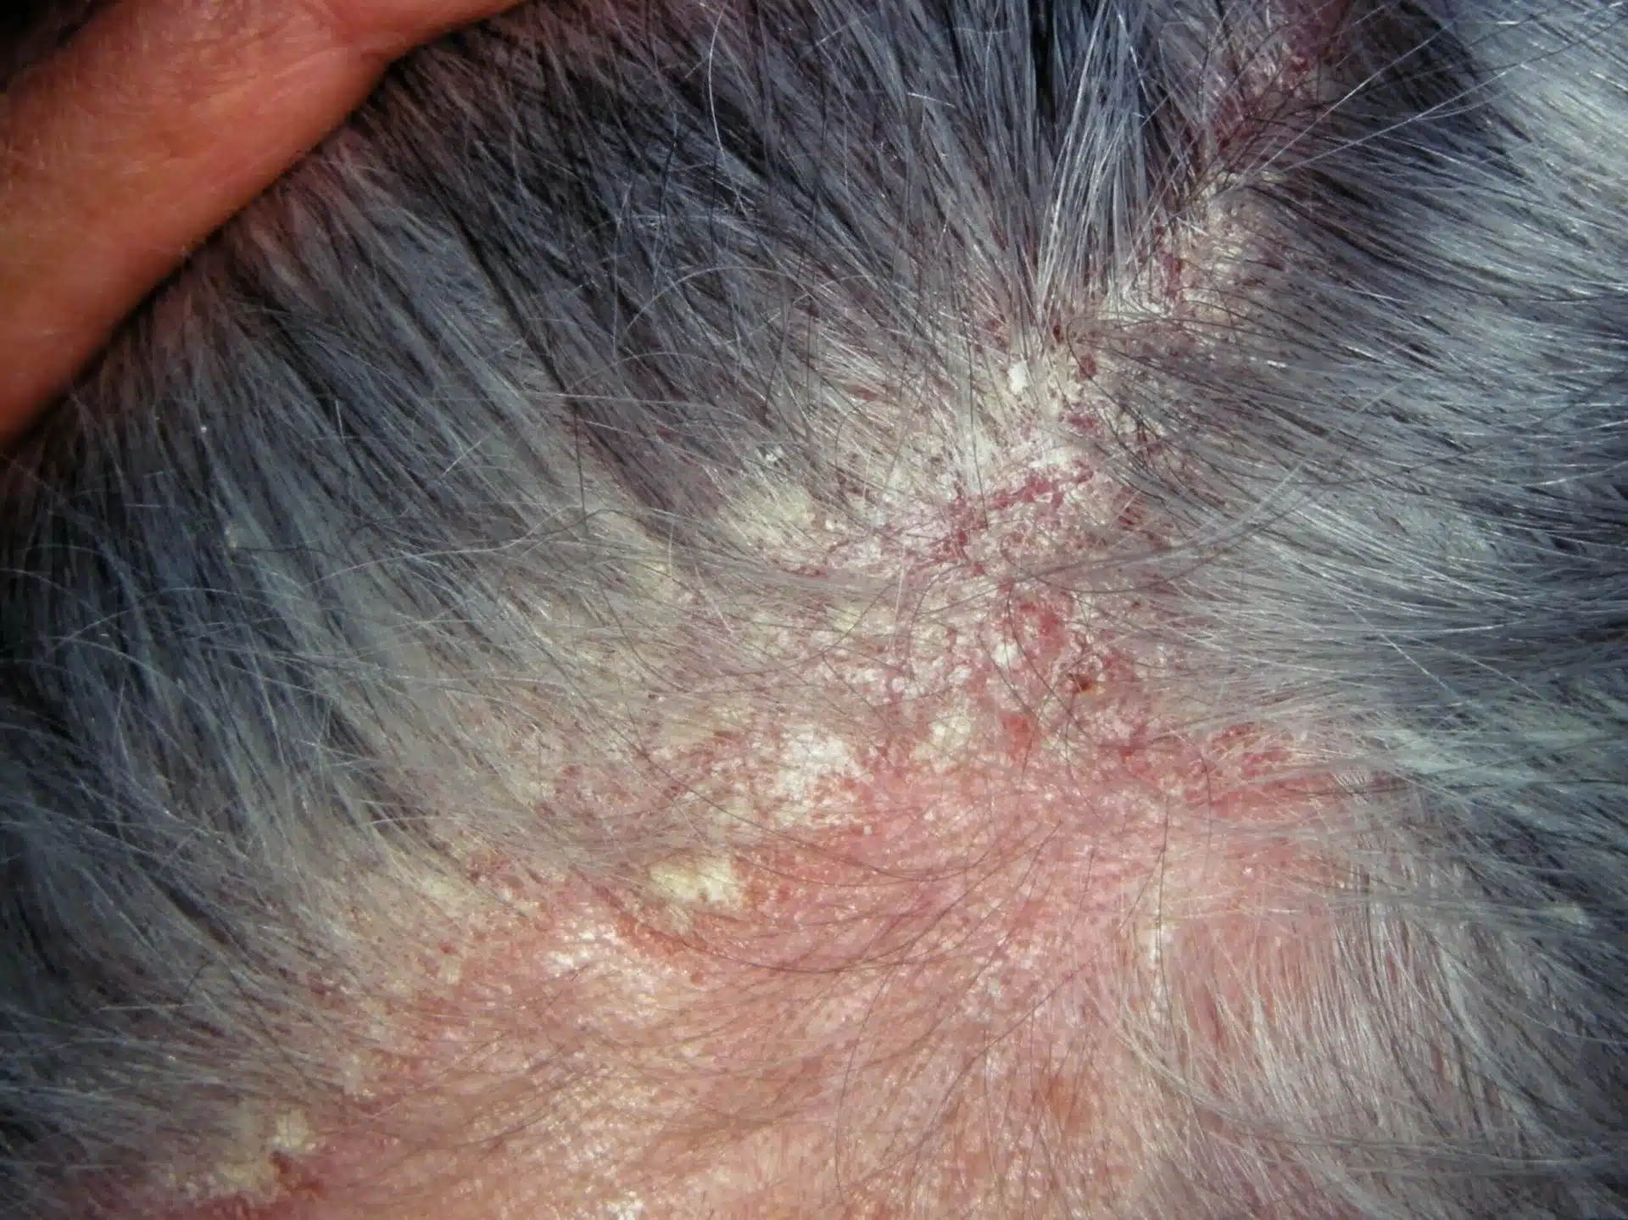
A very common chronic dermatosis characterized by redness and scaling, which occurs in regions where the sebaceous glands are most active, such as the face and scalp, the presternal area, and in the body folds. Associated with Malassezia furfur.
Epidemiology
Infancy (aka cradle cap), puberty, more common in males. Incidence is higher in HIV-infected individuals.
Risk Factors
Increase incidence in Parkinson’s disease and immunosuppressed patients, possible familial link.
Clinical Manifestations
Gradual onset. Some pts are worse in winter/dry environments.
Pruritus is variable
Skin lesions orange-red or gray-white with greasy or white dry scaling macules, papules, rather sharply marginated and marked scaling.
Common findings:
- Infants: “Cradle cap.”
- Adults: “Dandruff,” dry flaky scalp.
- Rash with “sticky flakes
- Variable pruritus, often increasing with perspiration and in winter
- Oily, flaking skin on erythemic base around ears, nose, eyebrows, and eyelids
- Red, cracking skin in body folds; axilla; groin; or anogenital, submammary, or umbilical areas
- Primary lesions: Plaques
- Secondary lesions: Erythema, scales, fissures, exudate, and symmetric eyelid involvement
- Lesions with drainage or crusting may indicate secondary bacterial infection
Assessment
Subjective Data
- Identify location, onset, and progression of symptoms
- Ask the client to describe symptoms; ask if the skin is itchy or painful
- Assess lesions for any associated discharge (blood or pus)
- Elicit information regarding use of topical medications, soaps, creams, or lotions; ask about any oral medications
- Determine if there were preceding systemic symptoms (fever, sore throat, anorexia, or vaginal discharge)
- Rule out possible exposure to industrial or domestic toxins
- Ask what improves or worsens the condition
Physical Examination
- Inspect:
  - Skin: Note areas of lesions and distribution
  - Eyes: Check for blepharitis
  - Ears and nose
- Palpate skin, noting texture and moisture
Diagnostics
- None required
- Consider fungal culture in children and adolescents to rule out fungal infection
- Consider possible skin biopsy to rule out other conditions
- Skin scraping
Differentials
- Atopic Dermatitis
- Candidiasis
- Dermatophytosis
- Histiocytosis X
- Psoriasis Vulgaris
- Rosacea
- Systemic Lupus Erythematosus
- Tinea Capitis
- Tinea Versicolor
- Vitamin Deficiency
- Impetigo
- Eczema

Epidermal Inclusion Cysts
**Couldn’t really find much info about this in the textbooks.. Google says tx would be conservative - leave it alone but if required, incision & drainage. Filled in what I could.
https://www.youtube.com/watch?v=cJymnDl6T1g&ab_channel=Medfin
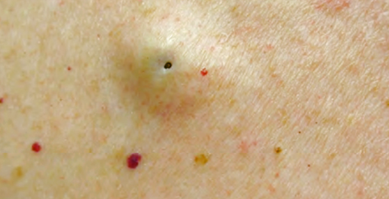
Most common cutaneous cysts, derived from epidermis or the epithelium of the hair follicle, become filled with keratin and lipid-rich debris.

Also called a Wen, sebaceous cyst, infundibular cyst, epidermal cyst, epidermoid cyst.
Epidemiology
Occurs in young to middle aged adults on the face, neck, upper trunk, and scrotum.
Risk Factors
Clinical Manifestations
Usually solitary but may be multiple. Dermal to subcutaneous nodule 0.5 to 5 cm which often connects with the surface by keratin-filled pores.
Epidermal- like wall, the content of the cyst is keratinaceous material- cream colored with a pasty consistency and the odor of rancid cheese. Scrotal lesions may calcify.
-Rounded nodule within dermis with an opening (not always visible) in which keratinous material can be expressed (cream colored with pasty consistency and odor of rancid cheese); Usually solitary but may be multiple
-Face, neck, upper trunk, scrotum
-Cyst wall is thin and if ruptured, contents will initiate an inflammatory reaction enlarging the lesion manifold
Diagnostics
Made on clinical criteria.
Differentials
Infection, abscess, tumour, carbuncle, furuncle, limpoma
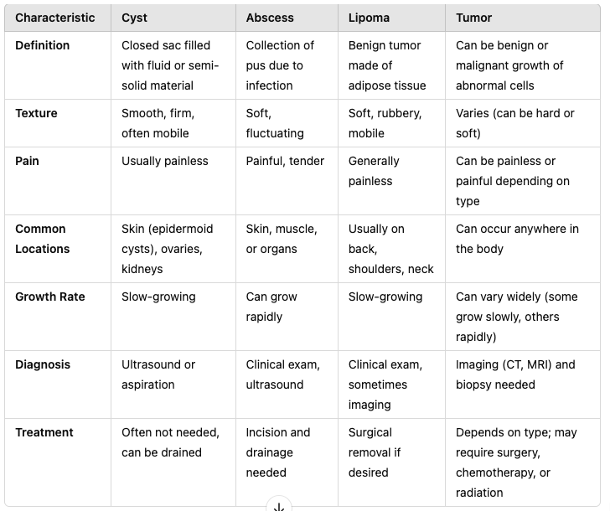

Herpes Simplex
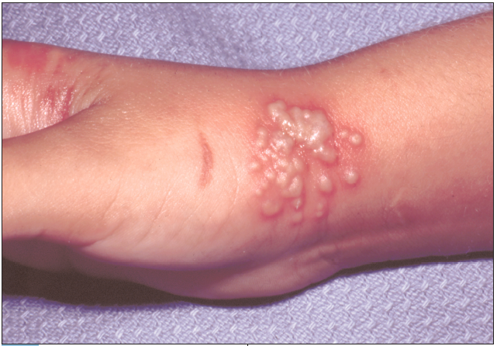
Classically with grouped vesicles arising on an erythematous base on keratinized skin or mucous membrane. Can also be atypical with patches of erythema, small erosions, fissures or subclinical lesions that shed HSV.

Epidemiology and Etiology
HSV-1 and HSV-2
Labialis: HSV-1 (80%) and HSV-2 (20%)
Urogenital: HSV-2 (80%)
Herpetic whitlow (finger): HSV-1 (60%)
Neonatal: HSV-2 (80%)

Contact transmission; incubation period is 2-14 days
3 stages:
- Primary - first episode
- Latent - virus remains dormant in sensory ganglia for life
- Recurrent infections - virus can be reactivated and travel along affected nerve route and produce recurrent lesions. HSV1 can be stored in trigeminal ganglia; HSV2 is stored in the sacral ganglia.

Risk Factors
In healthy individuals, recurrent infections are asymptomatic or minor, resolving spontaneously with antiviral therapy. With host defence defects, mucocutaneous lesions can be extensive, chronic or disseminate to skin or viscera. HIV.

Clinical Manifestations
Primary HSV: asymptomatic is common. Symptomatic primary HSV is characterized by vesicles at the site of inoculation and may be associated with regional lymphadenopathy. They often have painful lips, gums, and oral mucosa.
- Erythematous papules quickly evolve to grouped vesicles. Vesicles rupture to form erosions.
- Common sites: mouth, anogenitalia, hand/fingers
- Primary herpetic gingivostomatitis: oral mucousa involved in primary HSV infection anywhere in the oropharyngx
- Trigeminal Nerve HSV infections: perioral, ocular, herpetic facial paralysis, herepes gladiatorum (wrestlers herpes)
- Herpetic folliculitis (hair follicles)
- Herpetic whitlow: infection of finger or thumb
- Recurrent episodes: fever, blisters with prodrome of itching, burning, and tingling sensation at the site before vesicles appear
Other Signs and Symptoms
- Primary lesion: Fever, blisters on lips, malaise, and tender gums
- Recurrent episodes: Fever blisters with prodrome of itching, burning, and tingling sensation at the site before vesicles appear
Assessment
Subjective Data
- Ask about the location, onset, and duration of lesions
- Elicit a description of prodromal symptoms
- Ask if systemic symptoms occur with vesicular outbreaks
- Determine when the initial outbreak of lesions occurred (commonly seen in childhood)
- Inquire about exposure to anyone with similar lesions
- If lesions are recurrent, ask if stress, skin trauma, or sun exposure triggers outbreaks
Physical Examination
Inspection:
- Examine the oral cavity for vesicular lesions or ulcers in oral herpes.
- Inspect the genital area for vesicular lesions, erosions, and crusting in genital herpes.
Palpation:
- Check for tender lymphadenopathy in the inguinal or cervical regions.
Diagnostics
  - Polymerase Chain Reaction (PCR): best one, highly sensitive.
  - Viral Culture: Useful for detecting HSV in active lesions, although sensitivity decreases as lesions heal.
  - Antigen Detection Fluorescent Antibody (DFA): useful if needs tests now
  - Serologic Tests: useful in asymptomatic cases.
  - TZanck Smear (not very sensitive/specific)

Antigen Detection Fluorescent Antibody (DFA): A sample from a vesicular lesion is stained with fluorescent-labeled antibodies and examined under a microscope for ANY herpes infx.
TZanck Smear (not very sensitive/specific)
Confirmed by viral culture or antigen detection (may take 2-6 weeks for antigens to develop).
Differentials
- Impetigo: Amber-colored vesicular lesions with crusting
- Stomatitis: Erythemic or erosive lesions in the mouth and lips
- Herpes Zoster: Vesicles along a single dermatome
- Stevens–Johnson Syndrome (SJS)
- Herpangina: Vesicles on the soft palate, tonsillar area, and uvula; usually caused by coxsackievirus
- Primary Intraoral HSV Infection: aphthous stomatitis, HFMD, herpangina, erythema multiforme
Treatment: anti-virals, lidocaine 2% for comfort, tylenol
Counseling/Education: teach re: transmission to others; hand-wash frequently; expect recurrences; avoid sharing utensils etc.
Non-pharm therapies: ice to reduce swelling, vaseline
Refer if treatment unsuccessful or further complications arise
None needed to follow up if resolved without complications

Herpes Zoster (Shingles)
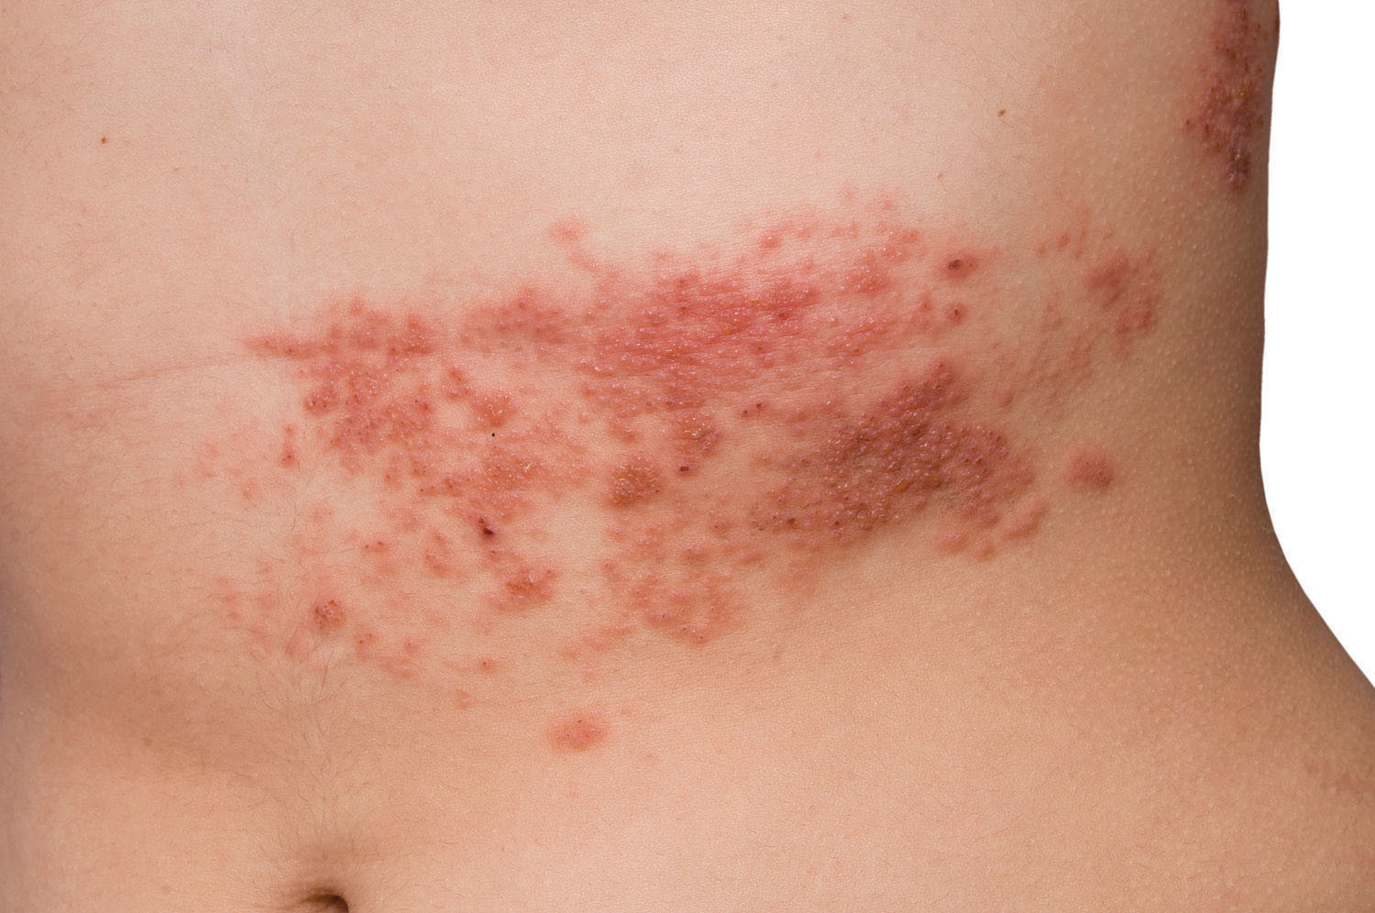
An acute dermatoma infection associated with reactivation of VZV. Characterized by unilateral dysethesia- a vesicular or bullous eruption limited to a dermatome(s) innervated by corresponding sensory ganglion. Postherpetic neuralgia is a major morbidity.
Epidemiology
In varicella, VZV passes from lesions in the skin and mucosa via sensory fibers centripetally to sensory ganglia. In the ganglia, the virus establishes lifelong latent infection. Reactivation occurs in those ganglia. Infection may occur at any age; however, it is more com- mon in older adults and the elderly.
Risk Factors
- Immunosuppression
- Trauma
- Tumour
- Irradiation
- Older Adult
Clinical Manifestations
- HZ has three distinct clinical stages:
  - Prodrome: pain, tenderness and paresthesia in the involved dermatome precedes the eruption, flu like symptoms
  - Active Infection: Papules (24h) then vesicles (48h) then pustules (96h) then crusts (7-10 days). Malaise, fever, headache, or pruritic rash on the skin.
  - Postherpetic Neuralgia (PHN): a chronic pain condition with continuous burning, aching, or stabbing pain in the area where the shingles rash occurred
- Clusters of vesicles on an erythemic base that burst and produce crusted lesions. These are most commonly found on the chest and back area, but they may also occur on the head and neck area or extremities. Distribution of lesions typically appears along a single dermatome.
- Mucous membranes
- Lymphadenopathy
- Motor or sensory nerve changes and weakness
- Ophthalmic zoster
- Delayed contralateral hemiparesis
- Prodromal stage- suspect zoster in older or immunocompromised patients with unilateral pain
Assessment
Subjective Data
- Determine onset, location, and progression of rash
- Ask about prodromal symptoms: burning, itching, tingling, or painful sensations before lesions appear
- Evaluate client status regarding immunosuppressive agents, diseases, etc.
Physical Examination
- Check temperature, pulse, respiration, and blood pressure
- Inspect:
  - Observe skin for lesions: Note characteristics and distribution
  - Facial nerves and hearing to r/u ramsay hunt CN 5 and 8
  - Examine ears, nose, and throat
  - Vision loss is a complcation so assess eyes
  - Inspect eyes to rule out herpes in the eyes (huchinsons sign)
- Auscultate heart and lungs
- Palpate lymph nodes
Diagnostics
- Usually none.
- Polymerase Chain Reaction (PCR): Most sensitive and specific for confirming the diagnosis
- Direct Fluorescent Antibody (DFA) test: fast results
- DFA or viral culture to r/o HSV infection

- Young clients with herpes zoster—consider test for HIV.
- Active vesiculation- clinical findings usually adequate may be confirmed by Tzanck test, DFA or viral culture to r/o HSV infection
- Prodromal stage- suspect zoster in older or immunocompromised patients with unilateral pain
- Active vesiculation- clinical findings usually adequate may be confirmed by Tzanck test, DFA or viral culture to r/o HSV infection
- Postherpetic pain syndrome- by history and clinical findings
Differentials
Prodromal stage/localize pain: can mimic migraines, cardiac or pleural disease
Dermatomal eruption: HSV infection, photoallergic, dermatitis, erysipelas, and necrotizing fasciitis

Others:
- Varicella
- Poison Ivy
- Herpes Simplex Virus (HSV)
- Contact Dermatitis
- Coxsackievirus
- Postherpetic Neuralgia
Red Flags
-Monitor for potential complications- postherpetic neuralgia (occurs in 15% of elderly patients, chronic pain), Guillain-Barre syndrome (muscle weakness), motor weakness, secondary infection, meningoencephalitis, ophthalmic and facial palsy, corneal ulceration and so forth
-Ramsay Hunt syndrome - occurs when a shingles outbreak affects the facial nerve near one of the ears > can cause facial paralysis and hearing loss in affected ear
-Hutchinson’s sign: Rash on the tip of the nose, suggests that the virus may also involve the eye, increasing the risk of keratitis, uveitis, and other serious eye conditions affecting vision > must refer to ophthalmologist
Treatment: Anti-virals should be initiated within 24-48h after outbreak (MUMS says 72 hrs); OTC pain meds; avoid steroids as they may increase risk of dissemination
Counseling/Education: prevent transmission to others- virus contagious to those who haven’t had chicken pox; rash should last 1-2 weeks; shingles vaccine for patients >50 regardless of whether they’ve had shingles or chickenpox before
Non-pharm therapies: calamine lotions;
-Instruct client to F/U if S/S worsen or don’t improve or signs of bacterial infx occur

Impetigo
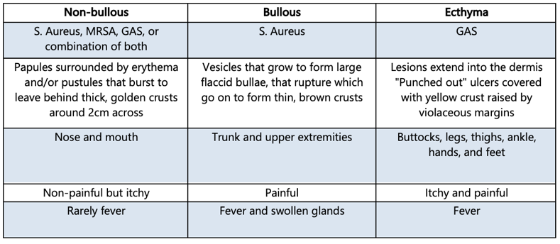
Impetigo is a bacterial infection of the skin, most commonly caused by Staphylococcus aureus or Streptococcus pyogenes, or both.
DOES NOT go into mouth, on2ly on outside
Ecthyma= DEEP impetigo; caused by the same pathogen
VESSICLES**
Causative Microorganism
S. Aureus or GAS
Epidemiology
Occurs equally in males and females and is most commonly seen in children, especially those 3 to 5 years of age. An alteration in the skin integrity allows bacterial inva- sion into the epidermis, causing an infection. Small, moist vesicles ranging from red macules to honey-coloured crusts or erosions occur singly or grouped together. Most common organisms are S. aureus and Group A beta-haemolytic S. pyogenes.
Risk Factors
Minor breaks in skin, facial lesions, wounds, poor hygiene, warm climate.
Clinical Manifestations
- Tender sores around the mouth and nose area in which the lesions continue to spread and worsen, despite over-the-counter (OTC) medication treatment.
- Honey coloured crusts on nose/face.
- Ecthyma may be painful and tender
Assessment
Subjective Data
- Elicit onset, progression, duration, and location of lesions
- Ask if the client has had contact with others who have similar lesions
- Assess for any other symptoms, especially systemic ones (fever, malaise, etc.)
- Elicit what treatments have been tried, if any
Physical Examination
- Check temperature
- Inspect:
  - Skin: Note types of lesions and skin involvement
  - Ears, nose, mouth, and throat
- Auscultate lungs and heart
Diagnostics
Non required but may confirm by culture if recurrence, or failure of oral antibiotic (usually suggests MRSA or GAS)
Differentials
- Varicella
- Folliculitis
- Erysipelas
- Herpes Simplex
- Second-Degree Burns
- Pharyngitis or Tonsillitis: Throat erythema with tonsillary hypertrophy and exudate; lymphadenopathy of anterior cervical chain
- Ecthyma: Severe case of impetigo with lymphadenitis
- Insect Bites
- Necrotizing Fasciitis
- Contact Dermatitis
- Scabies
- Excoriation: contact dermatitis, herpes simplex, epidermal dermatophytosis and scabies
- Intact bullae: acute contact dermatitis, insect bites, thermal burns, PCT
Treatment:
Mupirocin and retapamulin ointment; systemic antimicrobial if MRSA/GAS
Counseling/Education:
Hygiene + handwashing
Non-pharm therapies:
Wash crusts with mild soap 3-4x/day
Follow up in 10-14 days to ensure resolution

Insect Bites
The bites of insects and other arthropods may be a minor nuisance or may lead to serious medical problems, including transmission of insect-borne illnesses and severe allergic reactions. Insect bites are different from insect stings. Stings involve the injection of venom into the victim and may cause reactions ranging from local irritation to life-threatening anaphylaxis.
Epidemiology
Arthropod-borne infections: Lyme borreliosis, tularemia, bubonic plague, scrub typhus, murine typhus, spotted fevers, human granulocytic anaplasmosis, tick-borne meningoencephalitis, sleeping sickness or Chagas disease, malaria, babesiosis, filariasis, river blindness, and loiasis
Secondary lesions: may become secondarily infected with S. Aureus
Risk Factors
Summer months, exposure to areas of heavy insect infestations. outdoor exposure with bare feet, bright clothes, use of perfumes and/or colognes, previous sensitization.
Clinical Manifestations
Mites (scabies) | - Live in hair follicles and cause demodicidosis. Occurs on wrists or between finger webs
Food Mites | - Dermatitis
Ticks | - Erythema, febrile illness, paralysis, swelling  - Erythema migrans (Lyme disease)
Spiders | - Mild local urticarial reactions to full-thickness skin necrosis  - Widow spiders- produce neurotoxin that produces bite reactions and varying degrees of systemic toxicity
Insects (mosquitos, horse flies, bot flies) | - Mosquitos- Papular urticaria  - Black flies- Itching, erythema and edema  - Horse flies- Painful bites with papular urticaria  - Botfly- painful lesions that resemble pyogenic granuloma or abscess, larvae use bite as a portal of entry into the skin, develops into a central nodule with a pore  - Bedbugs- grouped papular urticaria in “groups of 3”, brown streaks on sheets  - Fleas- papular urticaria at bite site and more dispersed. Looks like a bed bug however not in groups of 3, rather all over.  - Bee, hornet, or wasp- immediate burning/stinging, followed by intense local erythematous reaction with swelling and urticaria  - Caterpillar/moth- burning itching sensation with papular urticaria
Assessment
Common Findings
- Local Reaction: Pain, swelling, and redness at the site after an insect bite
- Toxic Reaction: Local reaction plus headache, vertigo, gastrointestinal symptoms (nausea, vomiting, diarrhea), syncope, convulsions, and/or fever
Subjective Data
- Did the client see what bit or stung them?
- If the client felt the bite or sting, was it a single incident or multiple?
- How long ago did the incident occur?
- Where was the client when the injury occurred (environment)?
- Has the client been bitten or stung before? If so, did they have a reaction, and what was the treatment?
Physical Examination
- Check temperature, pulse, respiration, and blood pressure; observe overall respiratory status
- Inspect:
  - Site of injury for local reaction; note erythema, rash, or edema
  - Ear, nose, and throat
- Auscultate: Assess heart and lungs
- Palpate:
  - Injured site
  - Nodes for lymphadenopathy
  - Perform abdominal examination, if appropriate
Diagnostics
- None required
- Consider taking a skin scraping to evaluate under a microscope
- Consider culture if infection is suspected
- In endemic tick geographical areas, consider:
  - Drawing Lyme disease bacterium antibodies at 2 to 4 weeks and then at a 6-week interval for either an acute or convalescent stage
  - Two-tiered serological testing incubation period (3–30 days) includes:
    - Enzyme-linked immunosorbent assay (ELISA) screening test
    - Confirmatory immunoblot (IB) test if the ELISA is positive or equivocal
- Clinical diagnosis, at times, confirmed by lesional biopsy
Differentials
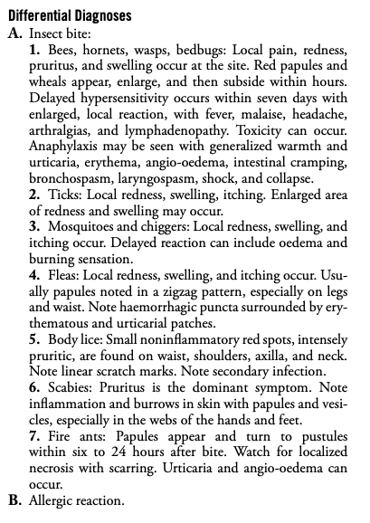
Folliculitis, herpes zoster, Lymphomatoid papulosis, Eosinophilic dermatoses of hematologic malignancy (EDHM), Pityriasis lichenoides et varioliformis acuta (PLEVA), Erythema multiforme, Drug use, Delusional infestation, insect bites
Treatment
Analgesics
Antihistamines (corticosteroids)
Counseling/Education:
Prevention
Non-pharm therapies:
Wound care/cleansing
Ice Packs
Elevate
Refer if pt is anaphylaxis
Follow up in 2 weeks to ensure treatment effective

Keratosis
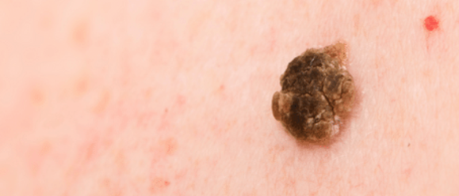
Single or multiple, discrete, dry, rough or adherent scaly lesions on the habitually sun-exposed skin of adults, usually on a background of dermatoheliosis (sun exposed skin). Can progress to squamous cell carcinoma.
Epidemiology
Middle age, although in Australia and Southwestern USA may occur in persons <30 years.
More common in males.
More common in light skinned individuals.
Occupation- outdoor workers.
Risk Factors
Prolonged sun exposure leads to cumulative damage to keratinocytes by the action of UVR, UVB.
Clinical Manifestations
Lesions may be tender, painful if excoriated.
Adherent hyperkeratotic scale is removed with difficulty and pain.
Rough like coarse sandpaper.
Most commonly <1 cm, oval or round.

- Seborrhoeic keratosis: Waxy papule with a stuck-on appearance is seen in adults; they appear symmetric, 0.2 to 3.0 cm in size, with a well-demarcated border, and in a variety of colours (tan, black, and brown); benign
- Keratosis pilaris: is perifollicular hyperkeratosis with little, spiny hyperkeratotic follicular papules of normal skin colour either grouped or disseminated, mostly on the extensor surfaces of the extremities; in childhood, also on cheeks. Do not hurt or itch.
- Actinic keratosis: rough, scaly patch or bump on skin caused by UV damage and can turn into squamous cell skin cancer

Assessment:
- ABCDE
- Rule Is the spot Asymmetric? One side does not look at the other; symmetrical =benign mole
- Does it have uneven Borders? Ragged or uneven edges
- Does it contain different Colours? More than one colour present; streaks of tan, brown, black, red, blue and white
- Is it larger than 6mm in Diameter? Larger than size of pencil eraser (6mm) or has changed shape
- Is there an Evolution in growth? Elevation or evolution, raised appearance or rapid enlargement
Diagnostics
Made on clinical findings.
Highly hyperkeratotic lesions and SPAK may required a biopsy to rule out SCC (in situ or invasive) or LM.
Differentials
Chronic cutaneous lupus erythematosus; seborrheic keratosis, flat warts, SCC (in situ), superficial BCC.
Refer to derm is appears malignant

LICHEN PLANUS
DEFINITION | An acute or chronic immune mediated inflammatory dermatosis affecting the skin and mucous membranes BOTH**. Appears as a flat-topped, shiny, violaceous/purple pruritic papules with lacy lines on the skin and milky-white papules in the mouth  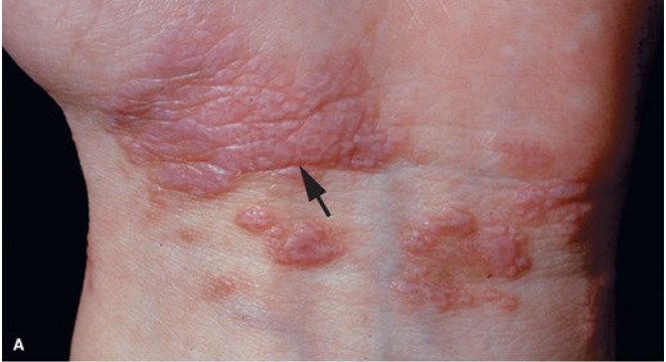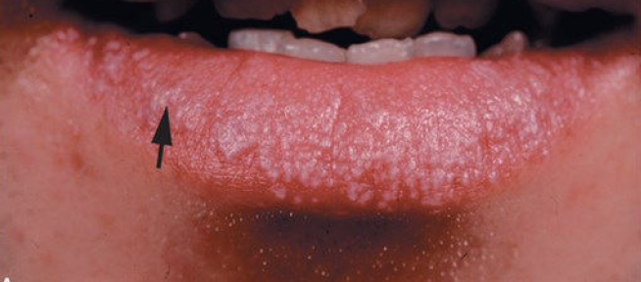
Pathology | Cell-mediated immune response; most cases will remit within 7 years  - Lesions can heal with postinflammatory hyperpigmentation
Epidemiology | Affects 1% of the population; 50% of cases have oral involvement (more persistent)  - No increased incidence in certain races; more common in ages 30-60 in females more than males
Risk Factors | ● Emotional stress; certain drugs can induce it
Screening
Clinical Presentation  (Subjective Symptoms & Objective Signs) | HALLMARK: primary lesions are small, flat-topped papules that are polygonal, lightly scaly, and purple in appearance; secondary lesions are erythematous, scaly, and can cause erosions; oral lesions are white lines/patches, redness, ulcers, dryness, pain and cause a metallic or burning taste  The 4 Ps: papule, purple, polygonal, pruritic  Other signs and symptoms:  - Distributed on the volar aspect of wrists, ankles, mouth, genitalia and lumbar region  - Causes Wickham’s striae (white, lace-like pattern on the surface)  - Atrophic skin with alopecia on the scalp  - Destruction of the nail fold/bed on the big toe  - Men can have lesions on the glans penis; women on the labia/vulva
Key Questions  Subjective | OPQRST: sudden or gradual onset (should be gradual); is the skin itchy/painful?  - Identify location, complete drug history including topical medications/creams  - Presence of fever, sore throat, anorexia, vaginal discharge  - Exposure: environmental toxins, colour-film developing chemicals, sexual contact with HIV/STI-infected individuals, contact with others with skin disorders  Rule out→ insect bites
Physical Exam  Objective | INSPECT  - Skin for lesion distribution  - Mucous membranes (buccal, tongue, lips)  - Hair & nails; genitalia
Diagnostic Tests | - Biopsy
Red Flags
Differential Diagnosis | Lichenoid drug eruptions; leukoplakia; graft vs host disease; candidiasis; lupus erythematosus; contact dermatitis; bite trauma; secondary syphilis
Diagnostics:  Labs & Imaging | Usually based on exam but can do…  Laboratory tests  ● HIV/STI testing; include hepatitis C due to correlation with lichen planus  Diagnostic tests and/or Imaging  ● Deep shave or punch biopsy of developed lesions
Treatment | Counseling/Education  - AVOID TRIGGERS IF KNOWN  - Disease can be chronic & most cases resolve spontaneously  - Avoid emotional distress, avoid scratching to prevent infection  - Lichen planus is NOT contagious  Complementary Therapies (non-pharmacological)  - Oral antihistamines ***for pediatric cases with severe itching  - Medium/high potency topical corticosteroids  - Oral prednisone= RARE; only for short courses
Referrals | ● If no response to initial treatment, refer to dermatologist
Follow-up | ● See client in 1 week for evaluation of treatment
References | Cash & Glass, p. 88-89; Fitzpatrick’s, p. 375

LIPOMA (incomplete)
Definition | Single or multiple benign, subcutaneous tumors that can occur anywhere  - Soft, rounded/lobulated & moveable against the skin
Pathology | Lipoma= fat cells that have the same morphology as normal fat cells within the connective tissue framework  - Fatty tissue encapsulated by a thin fibrous capsule  Angiolipomaa= a vascular component; can be tender in the cold or with compression
Epidemiology | ●
Risk Factors | ●
Screening | Often found in breast exams; common here
Clinical Presentation  (Subjective Symptoms & Objective Signs) | HALLMARK: primarily found in the neck, trunk and extremities. Painless, slow-growing, doughy feel  ● Common findings:  ○ Often yellow in colour, mostly small but can grow to be >6cm
Hx/Key Questions | ●
Physical Exam | Tumor has a smooth, well-defined, fluctuant/bouncy consistency
Diagnostic/  Special Tests | - Biopsy to determine cell pathology  Can be excised if the client wants
Red Flags | ● Neurologic symptoms in the presence of a lipoma over the spine/back
Differential Diagnosis | ●
Diagnostics:  Labs & Imaging | Laboratory tests  ●  Diagnostic tests and/or Imaging  ● ultrasound?
Treatment/ Management
Medical management | ●
Advise clients when to RTC or call for help
Referrals | ●
Follow-up | ●
References | Fitzpatrick’s, Myrick & Karosas, Dains et al

LYME DISEASE
Definition | A multisystems infection that can be acute or chronic; the most common tick-borne infection in Canada  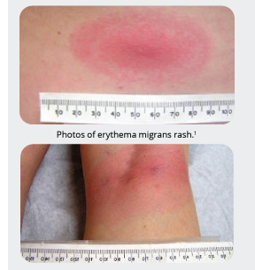
Pathology | Pathogen→ Borrelia burgdorferi; spirochete bacterium carried by black-legged ticks  - Vector transmission usually occurs from deer ticks to humans (rodents and pets can also harbor these ticks)  - Tick feeds, spirochete enters bloodstream and incubates for 3-32 days (1-3 weeks after the bite)  - Late manifestations can occur months to > 1 year after the bite
Epidemiology | Endemic in 6 Canadian provinces; seasonal increase between April and Oct  - Ontario is a moderate risk province overall with areas of very high risk  - >50% of cases occur in june and july  - North America: highest instance in children age 5-9 & adults aged 45-54  Can affect persons of any age
Risk Factors | Recreational exposures (hiking, golfing, hunting); gardening; rodent exposure
Screening
Clinical Presentation  (Subjective Symptoms & Objective Signs) | HALLMARK: 80% develop an expanding erythematous rash called erythema migrans, beginning as a red macule at the site of the tick bite. Forms larger annular lesion with red outer rings (bull’s eye shape) that is painless and non-pruritic; expands within 48 hours, >5cm in diameter, and found near skin folds. The rash may develop on additional sites (DIAGNOSTIC if present). Bulls eye does NOT develop at site of tick. Usually seen on armpit, groin, back of knees. Can take up to a month to show up  ● Common findings:  ○ Flu-like symptoms, fatigue, headache, joint pain, swollen lymph nodes  Other signs and symptoms:  Stage 1→ the acute, early localized reaction  - Rash, body aches, fever/chills, swollen lymph nodes  - 3-30 days after the bite  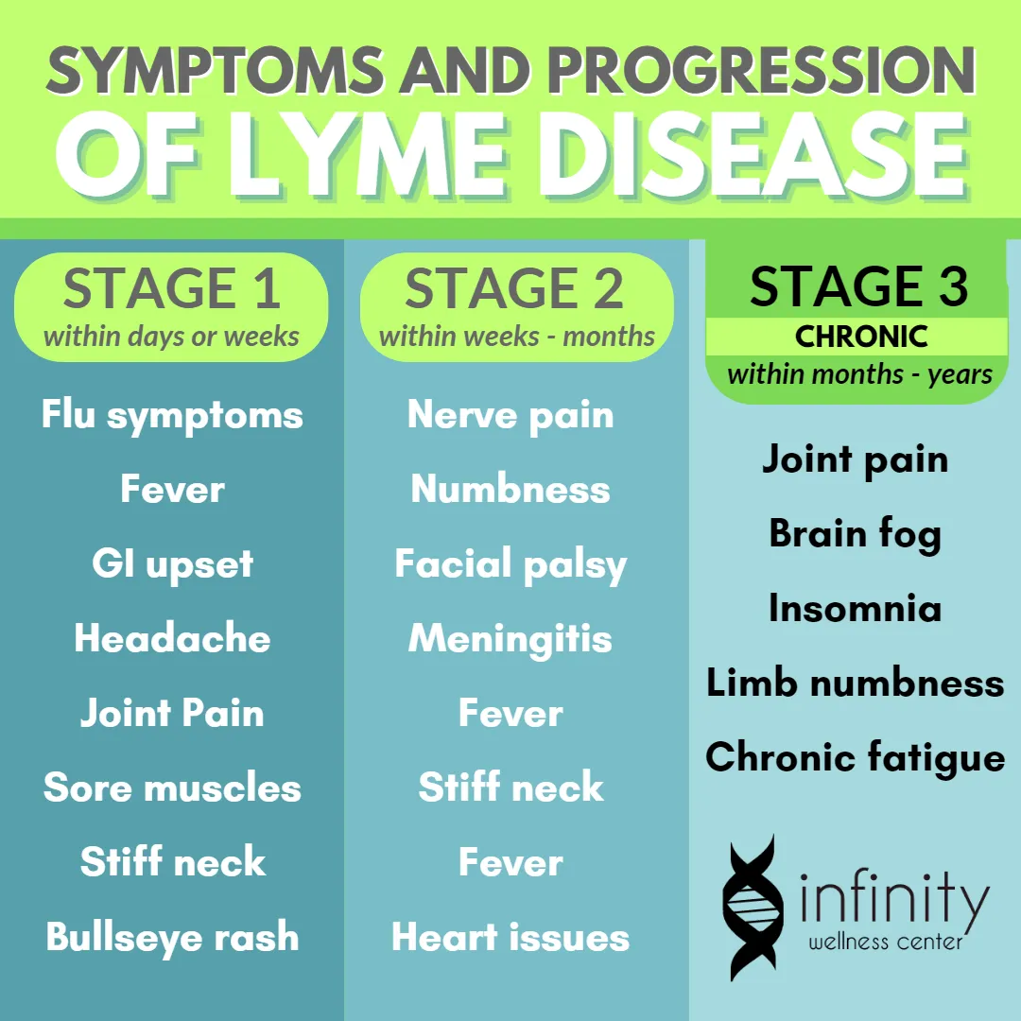  Stage 2→ early disseminated infection  - Malaise, debilitating fatigue, headache, photophobia, mild neck stiffness, muscle/joint pain, diffuse rash  - ARTHRITIS, CUTANEOUS SIGNS, NEUROLOGIC SIGNS, FASCIAL PALSY  - 1-3 months after bite  Stage 3→ late disease  - Prolonged arthritis; neurologic deficits; distal paresthesia; radicular pain; memory loss  - Arthritis and neuropathy  - >3 months after bite  - 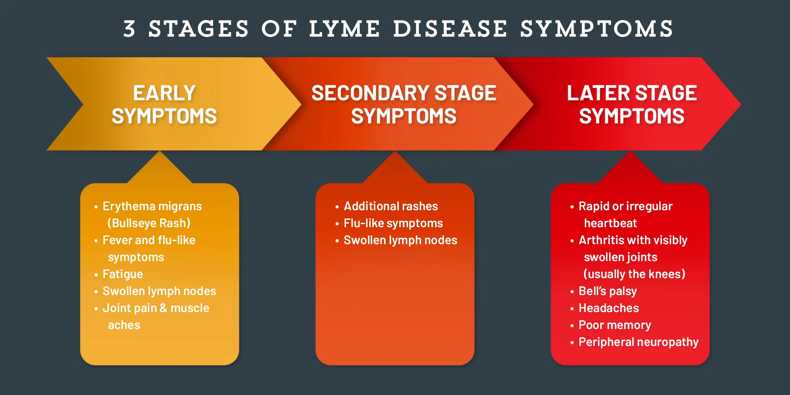
Key Questions  Subjective | OPQRST  - Recent outdoor activities (more important than hx of tick bites)  - Have they been in woody, grassy areas  - Other family members have similar symptoms?  - Medication history; rash course and spread; arthritis, memory loss, paresthesia (late Lyme disease symptoms)  - Previous treatment for lyme disease or Rocky Mountain spotted fever (RMSF)
Physical Exam  Objective | VITALS: temp, pulse, respirations, BP  INSPECT:  - General appearance; rash pattern and type; skin for bull's-eye appearance  PALPATE: lymph nodes, mastoid bones, joints for tenderness/swelling, ROM  AUSCULTATE: heart and lungs  Fascial cranial nerves to rule out palsy  MSK to rule out arthritis  NEURO EXAM:  - Evaluate for meningeal irritation  - Brudzinski’s Sign→ supine, flex head upwards; if this results in reflex flexion of the hips, knees, and ankles, sign of meningeal irritation  - Kernig’s Sign→ supine, flex one hip/knee to 90 degrees and lower the other leg; would result in pain/spasm of the hamstring from meningeal stretch and feels resistance to extension
Red Flags | Transient heart block; Bell’s palsy; mild encephalopathy (stage 2 signs)
Differential Diagnosis | Insect or spider bite; RMSF; cellulitis; arthritis; bacterial meningitis; chronic fatigue syndrome; viral syndrome; nummular eczema; ringworm. SYPHALLIS
Diagnostics:  Labs & Imaging | Laboratory tests  - ELISA (Enzyme-Linked Immunosorbent Assay): The initial screening test for Lyme disease.  - Western Blot: Used as a confirmatory test if the ELISA is positive or indeterminate.  - Serology may not be positive in the early localized stage of the disease, as antibodies can take weeks to develop.  - CBCD; sedimentation rate (inflammation);  - Lyme titre or culture for spirochete (will be + after 20 days of S&S)  - Arthrocentesis for joint effusion  - PCR testing  - Liver enzymes (ALT/AST may be elevated)  - Creatine phosphokinase  - LP for meningitis manifestations
Treatment/ Management | Counselling/Education  - Long-term antibiotic therapy is not recommend; not effective  - Headache, Bell’s palsy, photophobia and third-stage symptoms may not all fully resolve but this does not mean ongoing active infection  - Do not donate blood (once treated, will be able to)  - Antibiotic courses dependent on stage of Lyme disease (doxycycline)
Referrals | To ID specialist if…  - Evidence of Lyme but failure to respond to treatment  - Clients have refractory neurologic deficits or debilitating arthritis  Rheumatologist→ persistent arthritis or fibromyalgia after Lyme disease
Follow-up | ● Repeat titre 1-2 months to determine need for continued antibiotics
Common Complications | Jarisch-Herxheimer reaction (increased chills, fever, malaise) can occur transiently with antibiotic therapy; should treat with NSAIDs and continue antibiotic treatment
1° and 2° Prevention | Primary prevention: prophylactic therapy after tick bites is not recommended  - Can start if bite is swollen
References | Cash & Glass, p. 457-459; CEP Early Lyme Disease resource

URTICARIA/HIVES
Definition | Well-demarcated, disseminated eruption; evanescent over minute to 24 hours (simple) or 7-21 day (complex)  - Aka hives, or an eruption of itching wheals  - Can be simple or complex depending on associated fever
Pathology | An IgE mediated reaction caused by mast cell degranulation
Epidemiology | One of the most frequently reported drug rashes
Risk Factors | Drugs associated  - ASA, ACE inhibitors, penicillins, NSAIDs, opioids, contrast media, sulfonamide antibiotics (simple, no fever)  - Bupropion, cefaclor, minocycline, penicillins, rituximab, sulfonamide antibiotics (complex with fever)  - Certain food allergies, or physical factors like the cold or pressure
Screening
Clinical Presentation  (Subjective Symptoms & Objective Signs) | HALLMARK: asymmetric distribution; a rounded, flat-topped, pale red/white papule or plaque that is evanescent and disappears in 24-48h due to edema of the dermis. Wheals can be round, gyrate, or irregular and change rapidly in size and shape due to shifting papillary edema  Common findings:  - Angioedema  - Wheals that are pink or red in colour (can be difficult to see in dark skin)  - Lesions last less than 24 hours  Other signs and symptoms: indicative of anaphylaxis  - May be associated with nausea/vomiting, hypotension, wheezing/stridor
Hx/Key Questions | OPQRST  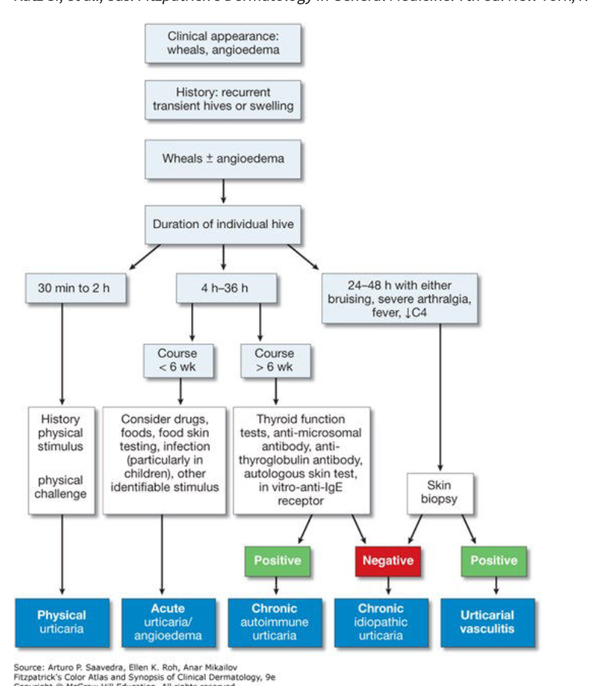
Physical Exam | Vital signs→ fever? Take temperature  INSPECT: site for characteristics of rash, tenderness, etc.  R/U anaphylaxis: N/V abdo assessment, rest/cardiac or hypotension/stridor
Diagnostics:  Labs & Imaging | Diagnostic tests and/or Imaging  ● Skin tests for allergies, especially if the causative agent is penicillin
Treatment/ Management | Counseling/Education  - Avoidance of triggers
Medical management | Antihistamines, antipyretics
Advise clients when to RTC or call for help | Fever associated; risk of anaphylaxis
References | eCPS- Drug-Induced Skin Reactions

MOLLUSCUM CONTAGIOSUM
Definition | Self-limiting epidermal viral infection that will resolve spontaneously in healthy individuals  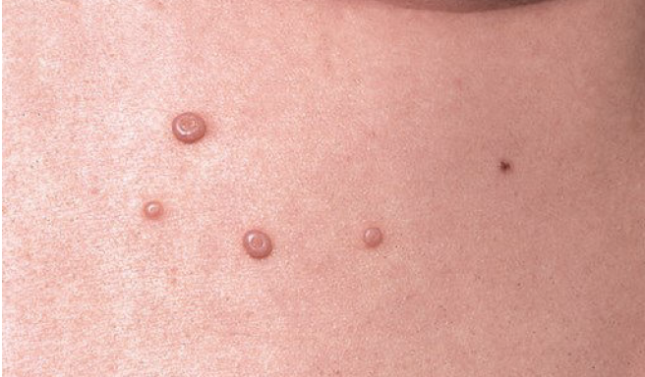
Pathology | The molluscum contagiosum virus has 4 subtypes that cause 90% of cases (type 1, 2, 3, 4) by colonizing the epidermis and infundibulum of the hair follicle  - Transmission occurs with direct skin-to-skin contact; many healthy adults are subclinical carriers of the virus  - Different from other pox viruses as it causes an epidermal tumor NOt a necrotic “pox” lesion  - Infected cells rupture and cause discharge at the crater of the lesion
Epidemiology | More common in children and sexually active adults  MCV-1 (98% of cases) is mostly seen in children, while MCV-2 is mainly responsible for skin lesions in people living with HIV
Risk Factors | HIV→ hundreds of small mollusca or giant mollusca can occur on the face and other sites of the body
Screening
Clinical Presentation  (Subjective Symptoms & Objective Signs) | HALLMARK: firm, pearly papules that are often umbilicated  Common findings:  - Papules, nodules and tumors with central depression  - Skin-coloured, round/oval/hemispherical  - Can cause isolated lesions, scattered lesions, or mosaic plaques  - Larger mollusca have a central keratotic plug→ umbilication  - Gentle pressure will extrude the central plug
Key Questions | ● OPQRST
Physical Exam | Any site can be infected  - Assess naturally occluded sites (axilla, antecubital/popliteal fossa, anogenital folds, face and chest)  Inflammatory halo forms around the mollusca as the host immune system reacts, and eventually causes regression
Diagnostic Test | Usually make diagnosis on clinical findings  Mineral oil can accentuate it to see better
Red Flags | Multiple facial mollusca indicates defect in host defenses
Differential Diagnosis | Many small papules→ Flat warts, condylomata acuminata, syringoma, sebaceous hyperplasia.  Large, solitary molluscum→ squamous cell carcinoma, basal cell carcinoma, epidermal inclusion cyst  Multiple facial→ invasive fungal infection
Diagnostics:  Labs & Imaging | Laboratory tests  ● Dermoscopy is usually enough  Biopsy and look for infected cells have Henderson-Patterson bodies (large, intracytoplasmic inclusions)  Diagnostic tests and/or Imaging  ● biopsy if disseminated invasive fungal infection is the differential
Treatment/ Management | Counseling/Education  Most will last up to 6 months and then spontaneously regress without scarring. DO NOT SQUEEZE as it is contagious. Stick to your own bedding and towels is living in a shared space
Medical management | Curettage, cryosurgery, cantharidin, and electrodessication
References | Fitzpatrick’s, p. 774-778

PEDICULOSIS (LICE)
Definition | Infestation of the louse on human beings in either the head, pubic area, or body  - Capitis, pthirus pubis, corporis
Pathology | Transmission= direct contact from person to person  - Sharing hats, combs, brushes, etc.  A hatched parasite lives on humans by sucking the blood through the skin  Adult louse lives 9-10 days; nits/eggs can survive up to 3 weeks after removal from the host (body lice lay eggs in clothing seams)  Pubic lice→ found at the base of the hair shaft; transmitted via sexual contact
Epidemiology | CAPITIS= Most common in children; more common in girls  PUBIS= more common in adults
Risk Factors | - Head- Exposure to crowded areas (schools); iInability to launder clothes/bed linens  - Pubic- sexual contact with infected individuals  - Poor hygiene
Screening
Clinical Presentation  (Subjective Symptoms & Objective Signs) | HALLMARK: itching and scratching of the head/body/genital area  - Other signs and symptoms:  - Excoriated skin from scratching; papules w/ erythematous base  - Nits or lice on the eyelashes of children
Key Questions  Subjective | - Exposure to others with lice  - Attendance in crowded environments like daycares, schools  - Has the client seen any lice or nits  - Has there been symptoms of itching, scratching, etc.  - Social habits of cleaning, laundry, etc.
Physical Exam  Objective | VITALS: temperature to rule out infections  INSPECT:  - Hair, body, pubic area and clothing seams for nits/lice  - Skin for excoriation, eyelashes of children, skin for bacterial infection
Diagnostic/  Special Tests | None exist; would consider culturing the skin if there was a secondary bacterial infection
Differential Diagnosis | Scabies, dermatitis
Treatment/ Management | Counseling/Education  - Place potentially contaminated items in plastic bag for 2 weeks, or if possible into a hot dryer or hot water for 15 minutes  - Maintain good hygiene; do not share brushes or hair accessories  - Remove lice, then use lice shampoo, then refrain from washing hair for another 1-2 days after treatment regimen  - NEVER use pediculicides on eyelashes; use petroleum jelly 3-4x/day for 8-10 days  Complementary Therapies (non-pharmacological)  - No published trials for home remedies
Medical management | ● Treat immediately with pediculicides; remove each nit and louse with a fine-toothed comb
Referrals | ● May refer to public health or community nurse for home evaluation if it is a repeated problem
Follow-up | ● None required; keep in mind increasing resistance to treatments
1° and 2° Prevention | Primary prevention: good personal hygiene; individually assigned combs, hair accessories, etc.
References | Cash & Glass, p. 87-88

PITYRIASIS ROSEA
Definition | An acute, self-limiting, benign skin eruption consisting of a herald patch followed by widespread papulosquamous lesions  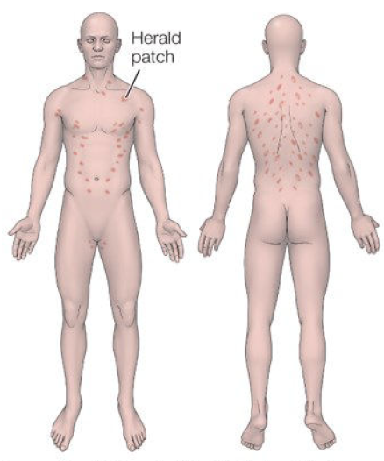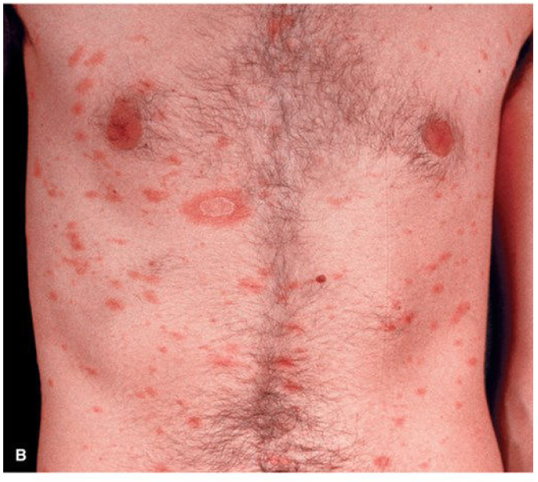
Pathology | An idiopathic disease that may have viral or autoimmune origins  - Most likely linked to human herpesvirus 6 and 7 reactivation
Epidemiology | Relatively common condition; 75% f cases occur from age 10-35  - Slightly more common in women  - More frequent during the spring and autumn  RARE to see in geriatric patients; consider other diagnoses
Risk Factors | - Recent acute infection
Screening
Clinical Presentation  (Subjective Symptoms & Objective Signs) | HALLMARK: salmon-pink or tawny coloured lesions that are usually concentrated in the trunk. Has a preceding herald patch in 80% of patients that is 2-10cm in diameter with central clearing resembling ringworm (appears abruptly days to weeks before rash erupts). Is pruritic.  Common findings:  - May see lesions on the arms or legs; rarely on the face  - Mild pruritus  - More likely to see facial and distal extremities rash in pediatric patients (consider impetigo infection risk from itching)  Other signs and symptoms:  - Early lesions are papular; can progress to 1-2cm oval plaques  - Long axes of oval lesions run parallel to each other (called a ‘christmas-tree’ distribution
Key Questions  Subjective | - Occurrence of initial, single 2-10cm round/oval lesion  - Contact with similar symptomatic individuals  - Small epidemics identified in fraternity houses & military bases
Physical Exam  Objective | VITALS: temperature to rule out infection  INSPECT:  - All body surfaces while client is unclothed to look for lesions and assess distribution.  - Mucous membranes, palms and soles (these sites are usually spared)
Diagnostic/  Special Tests | Typically not required…  - Potassium Hydroxide wet preparation can distinguish herald patches from tinea corporis
Red Flags | ●
Differential Diagnosis | Nummular eczema; tinea corporis; tinea versicolor; viral exanthems; drug eruptions (captopril, bismuth, barbiturates, clonidine, metronidazole); secondary syphilis, lichen planus
Diagnostics:  Labs & Imaging | Laboratory tests  - If unable to identify herald patch, should do serologic testing for syphilis; often clinically indistinguishable  - Potassium hydroxide preparation to rule out fungal  - WBC count is normal; no lab markers exist for pityriasis rosea
Treatment/ Management | Counseling/Education  - Disease is self-limiting, clears in 1-3 months spontaneously  - Not a contagious rash; no isolation required  Complementary Therapies (non-pharmacological)  - Direct sunlight exposure can hasten disappearance of lesions and decrease itching  - Consider topical steroids if +++ pruritic
Referrals | To additional provider if infection lasts > 3 months
Follow-up | Not required unless a secondary infection results
References | Cash & Glass

PSORIASIS
Definition | A common, benign, chronic, inflammatory skin disorder characterized by whitish, scaly patches commonly seen on the knees, scalp and elbows  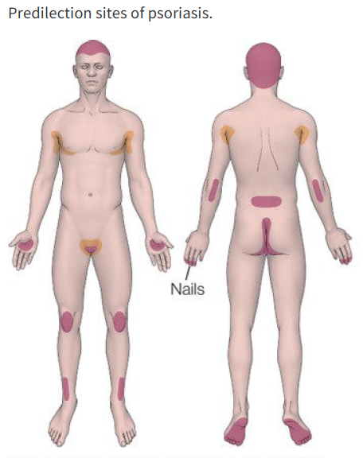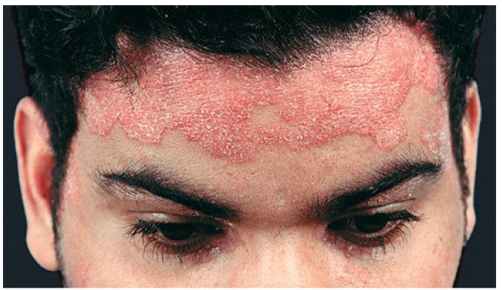  Images from Fitzpatrick’s Derm Textbook
Pathology | Genetic links; hyperproliferation of the epidermis with inflammation of the epidermis and dermis; 6-9x increase in epidermal transit time  - T-cell mediated dermal immune response can occur due to microbial agents or an autoimmune process
Epidemiology | Can occur at any age; peak onset age 15-30 (affects 2% of the population)
Risk Factors | Family history; stress; local trauma/irritation; strep infections; alcohol and tobacco use; HIV-linked if onset is abrupt  Drugs→ lithium, beta-blockers, NSAIDs, antimalarial drugs, sudden withdrawal of corticosteroids
Clinical Presentation  (Subjective Symptoms & Objective Signs) | HALLMARK: a dry, scaling rash causing silvery scales on erythematous plaques. Commonly found on elbows, knees, scalp, and lower back.  Eczema: Often appears as dry, itchy patches that can ooze or crust over. Typically found in scalp and extensor areas (e.g., behind the knees, inside elbows).  Other signs and symptoms:  - Pruritic or painful lesions  - Onset if typically Guttate psoriasis: small, scattered, teardrop papules and plaques after a streptococcal infection in children or young adults  - Larger, chronic lesions occur later in life  - Small pits or yellow/brown oil spots on the tongue  - Stippled nails and pitting in 50% of clients  - Joint pain, swelling of the small finger/toe joints
Key Questions  Subjective | - Predisposing factors, changes to symptom course, seasonal involvement (worse in winter, better in summer), is the skin itchy or painful, is there discharge from the lesions, is there any use of new soaps/creams/lotions recently?  - Rule out industrial/domestic toxins  - Ask about STIs and recent sexual contacts  - Close contact with others with skin disorders  - Any systemic symptoms like fever, sore throat, or anorexia  - GOUT HX? Flare up??
Physical Exam  Objective | VITALS: temperature if indicated  INSPECT:  - Skin for lesion type and distribution; assess oral mucosa, nails/nail beds  - Joints  - Inspection:  - Examine the skin: Look for well-defined, red plaques covered with silvery scales, particularly on common areas (elbows, knees, scalp, lower back).  - Scalp  - Check for nail changes: Pitting,yellow discoloration, or onycholysis.  - Check tongue: Small pits or yellow/brown oil spots on the tongue  - Palpation:  - Assess for tenderness and thickness of the plaques.  - Look for signs of psoriatic arthritis: joint swelling or tenderness, particularly in the fingers or toes.  PALPATE: joints for tenderness
Diagnostic Tests | Auspitz Sign= punctate/pinpoint bleeding when the scale is removed  - None indicated unless HIV infection is suspected  Skin Biopsy: In uncertain cases, a biopsy may be performed to confirm the diagnosis and rule out other conditions
Red Flags | ●
Differential Diagnosis | SCALP→ seborrheic dermatitis (cradle cap)  BODY FOLDS→ candidiasis  TRUNK→ pityriasis rosea, tinea corporis  Other→ hand dermatitis, squamous cell carcinoma, cutaneous lupus erythematosus
Diagnostics:  Labs & Imaging | Laboratory tests  - Consider rheumatoid factor, erythrocyte sedimentation rate and uric acid if joint inflammation is present**  - Antistreptolysin O titre: if hx of strep infection  Rheumatoid Factor (RF): This test helps determine if rheumatoid arthritis (RA) is present. Since both psoriasis and RA can cause joint pain and inflammation, it's important to differentiate between them.  Erythrocyte Sedimentation Rate (ESR): This test measures inflammation in the body. An elevated ESR indicates inflammation, which could be due to psoriasis, psoriatic arthritis, or other inflammatory conditions.  Uric Acid: This test helps assess for gout, another type of inflammatory arthritis. Psoriasis can coexist with gout, so checking uric acid levels can provide additional information.  Antistreptolysin O (ASO) Titre: This test is used to check for a recent streptococcal infection. A history of strep infections can be associated with certain types of psoriasis, such as guttate psoriasis, which often follows a streptococcal throat infection.
Treatment/ Management | Counseling/Education  - Chronic disease that is characterized by flares and remission  - Teach stress monitoring and control as well as coping strategies  - Gluten-free diet may help  Complementary Therapies (non-pharmacological)  - Phototherapy in mild to moderate cases
Medical management | Simple & inexpensive; treat to control, not cure  - Emollients; keratolytic agents; calcipotril/calcitrol; coal tar; medicated shampoos
Referrals | To dermatology if >20% of body is involved; if pustular psoriasis; for any client where the disease is not well controleld and is requiring systemic therapy  To rheumatology if extensive disease, inflammatory disease or psoriatic arthritis
Follow-up | In 2-3 weeks to evaluate treatment; in 2 mos to monitor side effects
References | Cash & Glass p. 91-93; Fitzpatrick’s for images

ROSACEA (also referred to as acne rosacea)
Definition | A vascular skin disorder characterised by chronic inflammatory processes where flushing and dilation of the blood vessels in the face occurs  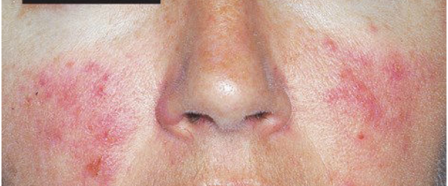
Pathology | A functional vascular anomaly with a tendency towards recurrent dilation and flushing of the face  - Disorder of the facial pilosebaceous units and increased capillary reactivity  - Inflammatory mediator release, extravasation of the inflammatory cells, and formation of inflammatory papules and pustules (acne subtype)  Stage 1= persistent erythema with telangiectasias  Stage 2= persistent erythema, telangiectasias, papules and pustules (acne rosacea)  Stage 3= persistent deep erythema, dense telangiectasia, papules, pustules, nodules, solid edema in rare cases  Stage 4- involves the entire face the papules and pustules  *Progression does not always occur
Epidemiology | Affects 6% of the population in Canada; 10% of fair-skinned people  - Peak incidence from age 40-50 in female mostly  - BUT rhinophyma is more common in males
Risk Factors | Tendency to flush frequently; exposure to heat, cold or sunlight; consumption of hot/spicy foods and alcoholic beverages; topical medications/astringents/toners
Screening
Clinical Presentation  (Subjective Symptoms & Objective Signs) | HALLMARK: reddening or flushing of the face, increased skin temperature of the face, and flushing in response to heat stimuli in the mouth, with telangiectasia visible  Other signs and symptoms:  - Ocular rosacea  - Periorbital erythema; telangiectasia paranasal and on cheeks; rhinophyma; blepharoconjunctivitis with reddened eyelid margins; conjunctivitis; keratitis causing pain, photophobia, and foreign-body sensation, stye, chalazion, keratitis  - May have several recurrences; disease may spontaneously disappear after several years or last a lifetime
Key Questions  Subjective | Location and onset (sudden or gradual); have symptoms continued to develop; asses whether skin is itchy or painful; assess for discharge; drug history; antibiotics; topical medication use or new skincare products; toxin exposure; sexual contacts; contact with others with skin disorders; provoking factors; effect of hot foods and alcohols  Rule out lupus: joint pain, abdo pain, fatigue, weight gain, hair loss, blood in pee, mouth and nose ulcers, fever?????
Physical Exam  Objective | VITALS: temperature, pulse, BP  INSPECT: skin, and eyes  - focusing on face and scalp; nose and paranasal structures; eyes/lids/conjunctiva/cornea (ocular manifestation can lead to corneal ulcers)  Assess skin for the rest of body
Red Flags | Eye involvement (rosacea keratitis; corneal ulcer risk)
Differential Diagnosis | Cutaneous sarcoidosis, lupus erythematosus, perioral dermatitis, seborrheic dermatitis
Diagnostics:  Labs & Imaging | Diagnostic tests and/or Imaging  Dermoscope  ● Consider skin biopsy to rule out lupus, sarcoidosis, or other causes if history warrants further testing  -From class…LUPUS: CRP, lupus antibodies, ANA for lupus?, Rheumatoid factor
Treatment/ Management | Counselling/Education  - Avoid sunlight exposure directly; wear protective clothing & SPF 30+  - Wash face with mild cleanser BID  Complementary Therapies (non-pharmacological)  - Laser & light therapies treat erythema  - Eliminate/reduce caffeine and alcohol
Referrals | To dermatologist if no improvement, maintenance is not reached  To ophthalmologist immediately if there is eye involvement
Follow-up | In 2 weeks to evaluate therapy; monthly for evaluation until maintenance is reached; relapses are common
References | Cash & Glass p. 69-70; Fitzpatrick’s

SCABIES
Definition | A contagious skin infestation by the Sarcoptes scabiei mite.  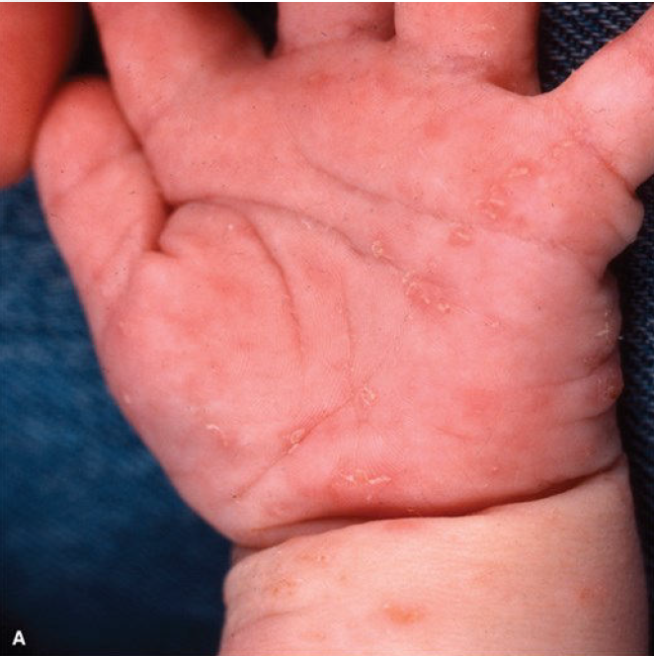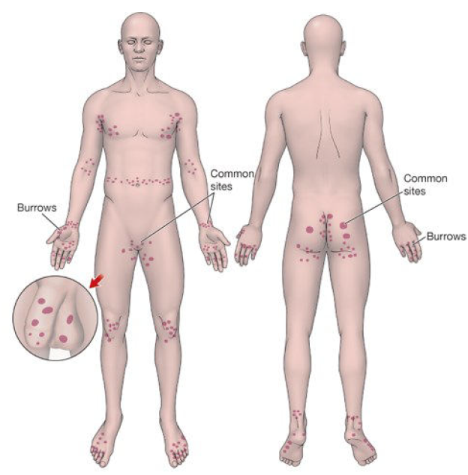
Pathology | Transmission→ close contact with an infected individual  - E.g., sexual contact, contact with mite-infested clothing or sheets  - Fertilized female mites burrow into the skin of the host, and deposit the eggs and fecal pellets  - Larvae hatch, mature, and repeat this cycle  A hypersensitivity reactions results in intense pruritus for both immediate and delayed reactions
Epidemiology | Occurs mostly in individuals with close contact to other individuals  - E.g., schoolchildren, nursing home residents  - High instance in Canada in those living in overcrowded situations, and Indigenous communities
Risk Factors | Close contact with many individuals; institutionalization; poverty; sexual promiscuity
Screening
Clinical Presentation  (Subjective Symptoms & Objective Signs) | HALLMARK: intense, widespread itching that is worse at night; eruption typically does not occur on the face unless in infants/children. Usually on wrists, between finger webbing  Common findings:  - Intense itching, skin excoriation, generalized itching, and rash  - Nodules can persist for months in covered, slightly eroded areas like the buttocks, groin, scrotum, penis, and axilla  Other signs and symptoms:  - Mites burrow at finger webs and wrists, sides of the hands and feet, and axilla buttocks, penis, and scrotum  - Discrete vesicles and papules are distributed in a linear fashion  - Risk of secondary infections from scratching  Elderly= fewer lesions, more significant itching; risk of cellulitis
Key Questions  Subjective | Information regarding housing conditions, close contact, sexual contact with infected individuals  OPQRST of itching symptoms
Physical Exam  Objective | VITALS: temperature  INSPECT:  - Examine all body surfaces while client is unclothed  - Use a magnifying lens to identify burrows in finger webs, wrists, penis  - Adult pubic area for lesions
Red Flags | ●
Differential Diagnosis | Atopic dermatitis; insect bites; pityriasis rosea; eczema; seborrheic dermatitis; syphilis; pediculosis; allergic/irritant contact dermatitis
Diagnostics:  Labs & Imaging | Diagnostic tests and/or Imaging  - 3 findings are diagnostic→ microscopic scabies mites, eggs, and fecal pellets (scybala)  - Ink the suspected burrow area with blue or black pen, and wipe with an alcohol swab→ burrow absorbs the ink and the surface ink is wiped clean  - Black dot on the burrow= mite, ova, or feces (can be transferred by a 25-gauge needle to immersion oil for microscopic identification
Treatment/ Management | Counseling/Education  - Treatment should extend to close household and sexual contacts over the last month regardless of symptom presence  - Pruritus may continue up to 1 week after treatment due to local irritation, prersence of dead mites/products  Complementary Therapies (non-pharmacological)  - Comfort measures for pruritus  - Launder all bed linens and clothing in hot water or store in sealed plastic bag for 5-7 days
Referrals | To additional providers if treatment is unsuccessful after 2 weeks
Follow-up | In 2 weeks to assess response to treatment
Common Complications | In the elderly; greater risk of cellulitis from severe excoriations and intense infections due to age-related immunity decline
References | Cash & Glass, Fitzpatrick’s

TINEA CORPORIS/RINGWORM
Definition | A fungal infection of the keratin skin tissue commonly seen on the face, trunk, and extremities
Pathology | Common pathogens= epidermophyton, microsporum, trichophyton  - Infection can come from other humans, puppies/kittens, or soil
Epidemiology | Common in both adults and children, affecting 10-20% of the population
Risk Factors | Exposure to infected persons or facilities; poor nutrition; poor health; poor hygiene; warm climates; immunosuppression
Screening
Clinical Presentation  (Subjective Symptoms & Objective Signs) | HALLMARK: a scaly, itchy patch that is circular in shape. Outer is elevated vs inwards and outer is darker in colour than inward. Can have vesicles/pustules  Other signs and symptoms:  - Capitis= redness/scaling of the scalp with hair loss (*children; rare in adults)  - Corporis= circular, erythematous, well-demarcated lesions ont he skin with hypopigmentation in the centre that is usually pruritic  - Cruris= scaling lesions on the groin (but not scrotum) or thigh (common in obese males)  - Pedis= on feet, between toes, in arch (extreme itching) (*adolescents, adults)  - Unguium= thickened or yellowed nails often with other fungal infections or alone (common in adolescents and adults, rare in children)
Key Questions  Subjective | OPQRST; rash and itching  - Other areas of skin involvement; pruritic; exposure to those with similar symptoms; history of lesions; predisposing factors; what remedies have been tried  - Any contact with animals (especially pets like cats and dogs)?  - Recent contact with contaminated objects (e.g., gym mats, towels)?  - History of excessive sweating or use of shared public showers?  - Any history of immunosuppression (e.g., diabetes, steroid use)?
Physical Exam  Objective | Temperature; inspection of skin for lesions  Location and Distribution: Common areas include feet, groin, scalp, or body.  Shape and Borders: Tinea often presents as round or annular plaques with central clearing and well-defined, raised, scaly borders.  Scaling and Erythema: Look for scaling at the edge of the lesion and redness.  Involvement of Hair or Nails: In tinea capitis, there may be hair loss or broken hairs; in tinea unguium (onychomycosis), the nails may appear thickened or discolored.  Other Signs: In tinea pedis, check for interdigital scaling or maceration between the toes.
Red Flags | ●
Differential Diagnosis | Dermatitis; alopecia areata; psoriasis; contact dermatitis; atoppic eczema
Diagnostics:  Labs & Imaging | Non needed  Laboratory tests  - Wood’s Lamp: A UV light exam can help identify certain fungal infections that fluoresce.  - Potassium Hydroxide (KOH) Prep : Skin scrapings are placed on a slide and examined under a microscope to look for fungus.  - Fungal Culture: In some cases, a skin scraping or hair sample can be sent for culture to identify the exact organism (though this may take time).
Treatment/ Management | Counseling/Education  - Need to treat sexual and household contacts  - Takes 4-8 weeks to resolve  Complementary Therapies (non-pharmacological)  - Camphor/menthol/eucalyptus treatment to toenails for 4-6 mos
Follow-up | At 2-4 weeks to evaluate progress  - Depending on treatment, may need to follow up LFTs at 6 weeks
References | Cash & Glass p. 96-97

TINEA VERSICOLOUR
Definition | A fungal infection of the skin that may be chronic in nature, mostly seen on the upper trunk but can spread to the extremities  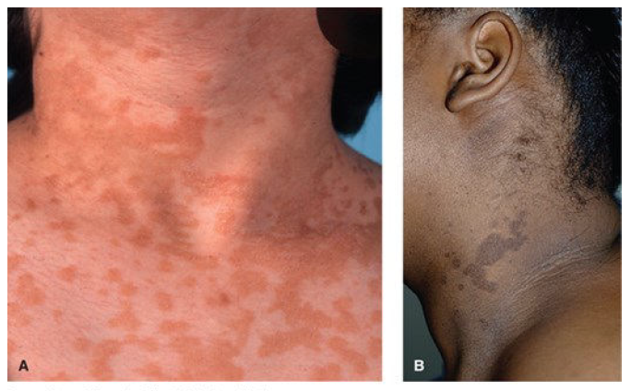
Pathology | Caused by overgrowth of Pityrosporum orbiculare (Cash & Glass); Malassezia furfur & m. globosa (Fitzpatrick’s)  - Part of normal skin flora
Epidemiology | Most frequent in adolescents and young adults
Risk Factors | Immunosuppressive therapy, pregnancy, warm temperatures, corticosteroid tx  - Sweating, oily skin, application of lipid-containing products  Tinea Corporis:  -poor nutrition  -poor health  -poor hygiene  -warm climates  -immunosuppression  -systemic corticosteroids  Tinea Versicolor  -mostly seen in adolescents and young adults  -immunosuppressive therapy  -pregnancy  -warm temperatures  -corticosteroids
Screening
Clinical Presentation  (Subjective Symptoms & Objective Signs) | HALLMARK: a scaly rash on the upper trunk with occasional, mild itching  Common findings:  - Round or oval maculae that can become confluent, ranging from 1-30cm  - Skin becomes discoloured  Other signs and symptoms:  - Annular maculae with mild scaling  - colour= pink, white or brown
Key Questions  Subjective | OPQRST: when and where did the rash begin, how has it changes, are there associated symptoms, what has been used to treat, any history of similar rashes, any current medications, any comorbid conditions  Location: Where are the patches located? TRUNK*** (Common areas: upper chest, back, shoulders, and arms.)  Symptoms: Do you experience itching? Is there any pain or discomfort? (Tinea versicolor is often asymptomatic but can be mildly itchy.)  Risk Factors: Do you have a history of excessive sweating or wear tight clothing? Have you used any lotions or creams recently? (These can sometimes worsen or trigger outbreaks.)
Physical Exam  Objective | INSPECT: for skin lesions and other areas besides the upper trunk  Location and Distribution: Inspect common sites (chest, back, upper arms, neck) for patches.  Can become more clear with mild scratching
Special Tests | - Potassium hydroxide wet preparation  - Wood’s lamp  - Use it to examine the skin for fine scales (would appear pale yellow-green if fungus is present)
Red Flags | ●
Differential Diagnosis | Tinea corporis; pityriasis alba; pityriasis rosea; seborrheic dermatitis; vitiligo
Diagnostics:  Labs & Imaging | Laboratory tests  ● Culture lesions by scraping from the edge
Treatment/ Management | Counselling/Education  - Recurrence is possible  - Skin pigmentation will return after infection clears; may take months  - Topical is BEST, only go with systemic treatment if resistance, recurring, not responding
Follow-up | None required if condition resolves
References | Cash & Glass p. 97-98; Fitzpatrick’s

WARTS
Definition | An elevation of the epidermal layer of the skin caused by the papillomavirus (aka a skin tumor)  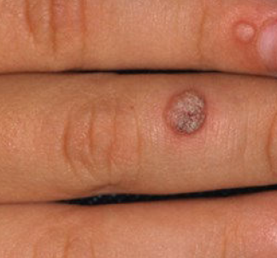
Pathology | Limited to the epidermal layer; virus is within the nucleus of the cells  - Transmitted by touch, and often seen on the hands and feet  - Most warts resolve without treatment in 12-24 months
Epidemiology | Occur in individuals of all ages; more common in childhood and early adulthood  - By adulthood, 90% of individuals have + wart virus antibodies  - More common in females than males
Risk Factors | Skin trauma, immunosuppression (HIV disease), exposure to public showers, pools, locker rooms, etc.
Screening
Clinical Presentation  (Subjective Symptoms & Objective Signs) | HALLMARK: a bump on the skin or area of the body that is usually painless  Common findings:  - Pain if on the bottom of the foot  Other signs and symptoms:  Common wart= verruca vulgaris  - Flesh-coloured, irregular lesion with a rough surface and some black dots in the centre (thrombosed capillaries)  Filiform wart= verruca filiformis  - Thin, thread-like and projecting papule on the face, lips, nose, or eyelids  Flat wart= verruca plana  - Flat-topped, flesh-coloured papule 1-3mm in diameter with a smooth surface  - Clusters or in a line on the face or extremities  Plantar wart= verruca plantaris  - Firm papule 2-3cm in diameter with indentation into the skin with a verrucous surface  - Painful to ambulate when weight is placed on ball oro heel of foot  - 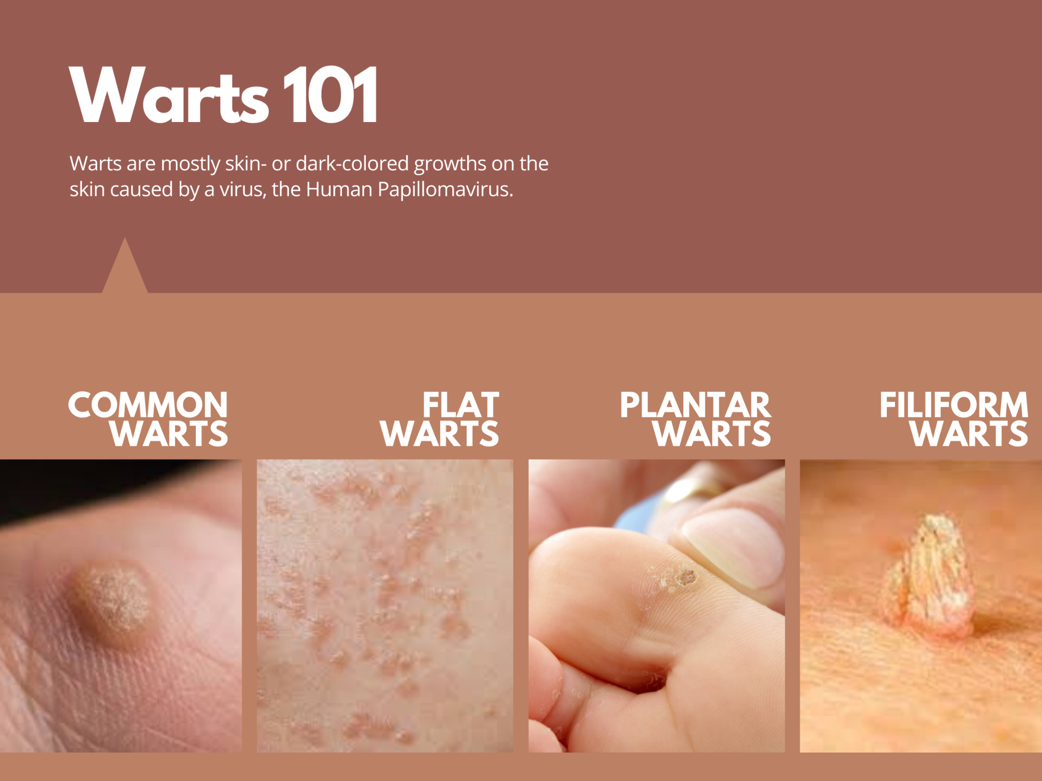  - Annular warts: at sites of prior therapy  - Butcher’s wart: large cauliflower like lesions on hands  - Filiform warts: have relatively small bases, extending out with elongated cap.  - Plantar wart: early small, shiny, sharply marginated papule,plaque with rough hyperkeratotic surface, studded with brown­black dots  - Genital warts: moist, pale pink, verrucous projections, bleed with trauma
Key Questions  Subjective | Onset, location, and duration of wart/tumour  - History of previous warts, past treatment and results, length of time using over-the-counter medications and how aggressive treatment was
Physical Exam  Objective | INSPECT: assess skin surface for lesions (note location, appearance, size, and surface texture)  - Examine entire body for other lesions
Red Flags | ●
Differential Diagnosis | Type of wart (as listed above); seborrheic keratosis; callus; molluscum contagiosum, skin tag, herpes vesicle
Diagnostics | Not indicated
Treatment/ Management | Counseling/Education  - For children, conservative management is recommended  Complementary Therapies (non-pharmacological)  - Soak site, file with nail file, cover with duct tape after treatment every night for up to 12 weeks or until resolved  - Cryotherapy, Salicylic Acid
Referrals | To dermatologist if diagnosis is unclear
Follow-up | Every 4-6 weeks until resolved
References | Cash & Glass; Fitzpatrick’s

Notable Emergent Dermatologic Conditions
Staphylococcal toxic shock syndrome  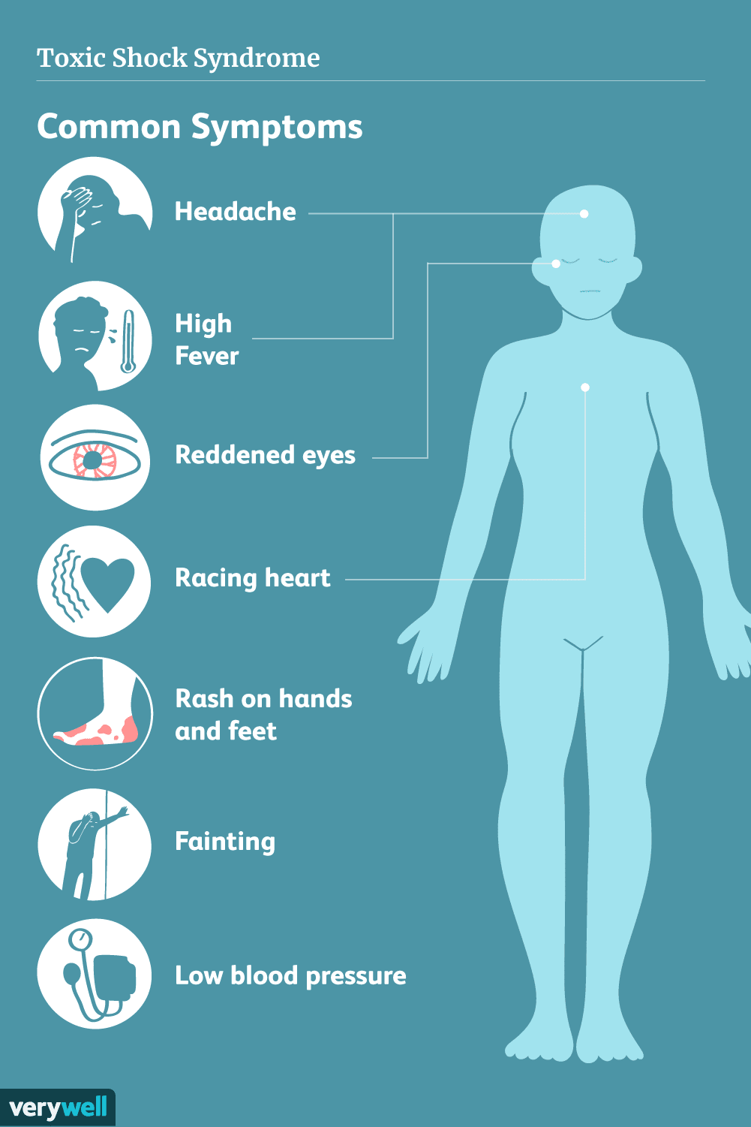 | Rapid onset erythema with desquamation, fever, hypotension and system failure.  The CDC defines criteria for TSS, including fever, rash, desquamation, hypotension, and involvement of at least three organ systems.  Pathogen: STAPH AUREUS or Strep Pyrogens  Risk: tampon use, surgical wound infections  Cause…  - Exotoxins cause T-cell cytokine secretion after 2-3 days of prodrome  Presentation…  - Patients present with fever, chills, nausea, and abdominal pain  - Rash occurs on the trunk and spreads to the palms and soles  Management…  - Supportive treatment for hypotension  - Remove inciting factors; teat with beta-lactamase resistant antibiotics
Angioedema  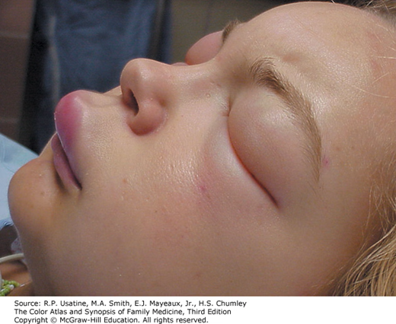 | Well-circumscribed areas of edema caused by increased vascular permeability of the skin, GI and resp tracts  Presentation…  - Most often occurs in the face, extremities, and genitalia  - May be a generalised anaphylactic reaction; 50% of cases are associated with urticaria  Cause…  - Can be induced by medications, allergies, or physical agents  - ACE inhibitors, penicillins, NSAIDs, contrast media  Management…  - Supportive, while ensuring airway patency  - Cool, moist compresses and antihistamines to control burning
Exfoliative erythroderma  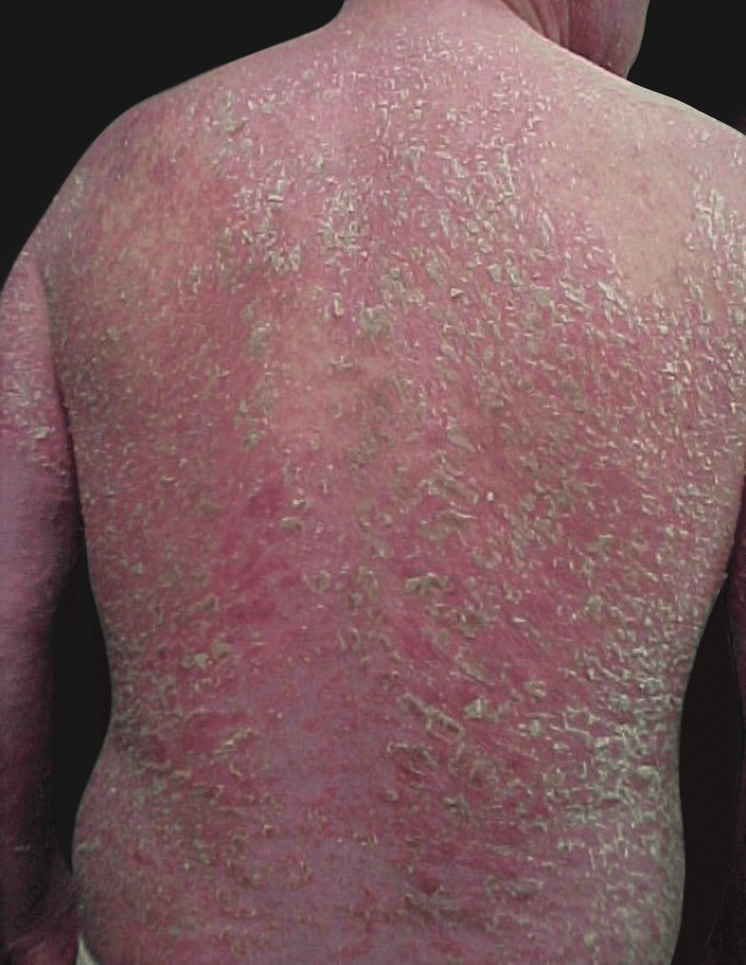 | A scaly, erythematous skin eruption involving 90% or more of the skin surface. Mortality rate in one study was 18%  Cause…  - Idiopathic  - Eczema, psoriasis, drug reactions (Antibiotics (penicillin, sulfonamides) Anticonvulsants, Allopurinol), lymphoma/leukemia, paraneoplastic syndrome, dermatomyositis (53%)  Presentation…  - Pruritus, malaise and fever from vasodilation, swollen LN  - Hypothermia or hyperthermia  - Fluid and protein loss through the skin leads to hypotension, lytes imbalance, CHF, and enteropathy  Management…  - Determine cause, stop medication if applicable  - Biopsy the skin if needed  - Supportive therapy
Necrotizing fasciitis  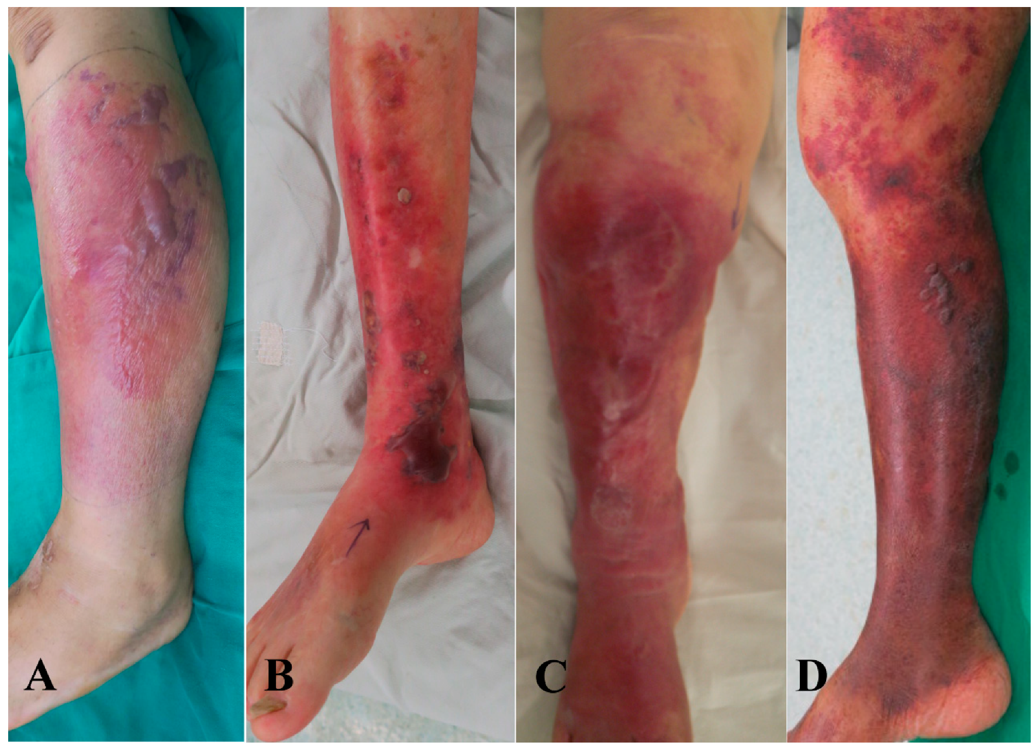 | Rapidly spreading infection of the deep fascia causing necrosis of the subcutaneous tissues  Pathogen: GROUP A STREP (in type 2 cases); mixed gram negative aerobic bacilli and enterococci (in type 1 cases)  Cause…  - Minor cuts, burns, trauma, or surgical procedures introduce microbes under the skin  Risk factors= diabetes, PVD, immunosuppression  Presentation…  - Flu like S/S  - Diffuse swelling= first symptom  - Bullae develop, becoming burgundy in colour  - Sever pain  - Suspect in the case of septic signs or severe local pain, edema, hyperesthesia, muscle weakness, and foul exudate, multi organ failure  Management…  - Early recognition, aggressive management of sepsis, surgical debridement of tissue  - Give antibiotics whether or not causative pathogen is known
Meningococcemia  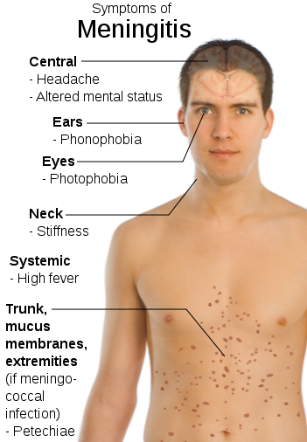 | Abrupt onset of maculopapular or petechial rash and flu-like symptoms  Pathogen: NEISSERIA MENINGITIDIS (leading causative), can lead to septicemia and meningitis  Presentation…  - Rash with fever, chills, malaise, rash, stiff neck, and disorientation  - Rash: Petechial or purpuric lesions that do not blanch when pressed.  - Disease can progress over several hours and progress to purpura, DIC, shock, and death  - Tests:  - Blood cultures, CBC, lactate level  - CT or MRI may be used if meningitis is suspected, but imaging is not typically needed for diagnosis of meningococcemia.
Stevens-Johnson Syndrome/Toxic epidermal necrolysis (overall TEN is more severe)  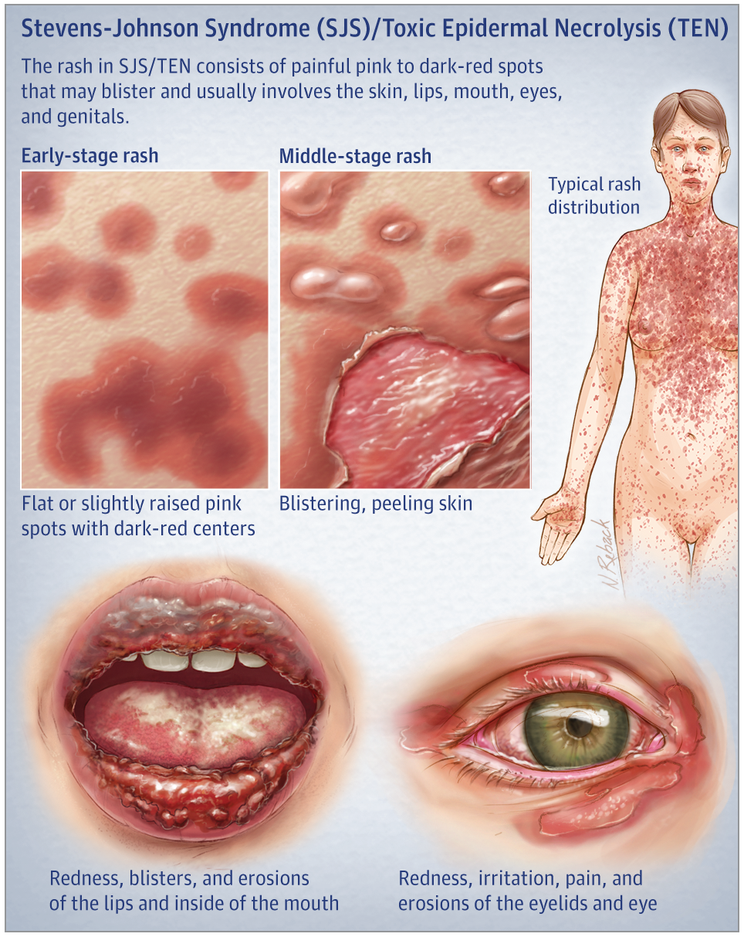 | Drug-induced or idiopathic reaction patterns  - Skin tenderness, erythema, epidermal necrosis, desquamation  Cause…  - An impaired capacity to detoxify drug metabolites  - Also genetic susceptibility  Common drugs→ sulfonamides, anticonvulsants, allopurinol, NSAIDs  - Drug administration occurs 1-3 weeks before rash  Presentation…  Flu like symptoms and then skin peeling  - Fever, stinging eyes, painful swallowing, dusky macules that progress to blisters affecting 2+ mucous membranes  - Ophthalmic involvement= risk of blindness  - Epidermal detachment is common (more with TEN)  - Dangerous due to skin barrier breakdown; predisposes patients to septicemia and fluid loss  Management…  - D/C MED ASAP!!! Supportive measures like burn unit care, IV fluids, skin care/wound care, IVIG, steroids, pain meds
Rocky Mountain spotted fever  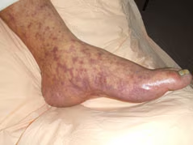 | Introduced to humans through tick bites carrying Rickettsia ricketti parasites  - In Canada, the dog tick and wood tick  Triad= fever, headache, and rash after a tick bite  RASH: appears within 2 weeks on the wrists and ankles, rapidly spreading to the palms, soles, trunk, and face  - Purpuric macules and papules  Complications…  - Myocarditis, cardiogenic shock, peripheral edema from hepatic failure, altered mental status, seizures/coma, meningismus, DIC  Management…  - Symptomatic support and antibiotic therapy  - Doxycycline; continue for 3 days after fever subsides  Remove tick at time of presentation if embedded in the skin

AHAD Week 4: Derm p.2

Traumatic Wounds (Minor lacerations or tears of the skin, animal bites, human bites)
Def’n | Breaks in the external surface of the body  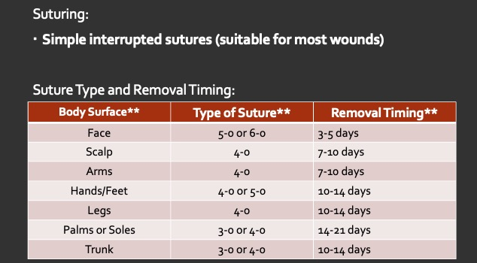  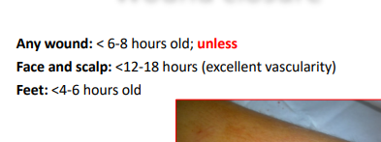  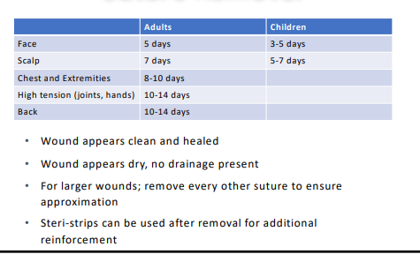-Primary closure  For wound edges that can be approximated  oTiming is key!  §How long since injury à in general, 6-8 hours is considered max time before closure; 12-18 hours for face and scalp  §Farther away from torso, greater chance of infection  -Delayed primary closure  oNot common  oWound bed is prepared by packing with wet, normal saline gauze, re-assessed at day 3-4.  oShould only be used if severely contaminated  oShould be referred or consulted out  -Closure by secondary intention  oPressure sores, diabetic ulcers  oClean and dress the wound, can’t close  oWound heals from the bottom up  Animal bites
Pathology/Cause | Most common pathogens of wound infxn in general: S. Aureus and Beta-lactam streptococcus  Kinds of wounds:  - Laceration: A deeper tear or cut in the skin caused by blunt trauma, resulting in irregular edges.  - Abrasion: A superficial scrape or rub of the skin, often from friction, removing the outer layer.  - Contusion: A bruise resulting from blunt force trauma that causes bleeding under the skin without breaking the surface.  - Avulsion: A serious injury where a portion of skin or tissue is forcibly removed or torn away from the body.  Bites (cat, dog, wild animal, human) probable organisms:  -P. Multiocida, S. Aureus, Viridans Strep, Bacteroides, Fusobacter, C. canimorsus, Anaerobic streptococci, Eikenella corrodens (humans)
Risk Factors/Epidemiology | -High-risk behaviours  -Poor wound healing conditions: diabetes, anticoag, corticosteroid therapy, immunodeficiency, advanced age, undernourishment
Clinical Presentation | -Infection: deep wounds or dirty wounds increase risk of infx  Soft-tissue damage: wounds with tissue necrosis increase risk of infx  -Sharp objects: often make smooth cuts, which can penetrate deep structures  - Crush injuries: damage underlying structures and #s  - Human bites may appear infected
Hx/Key Questions | - OPQRST  - Location? Farther from torso=greater risk (aka hands/legs)  - how much time elapsed until tx (if 6h of elapsed, bacterial multiplication is likely. Can only close wounds by primary closure is 6-8 hours. Face/scalp is 12-18hours)  - tetanus up to date? Rabies?  - complete drug hx (any steroids or anti-coags)  - allergies to iodine or sulfa drugs?  - any medical hx that may delay wound healing?  - How did it occur?  - Blood loss?  - Movement issues?  - Hx of keloid formation? Hx. of delayed wound healing (DM?)
Physical Exam | STERILE TECHNIQUE MAY BE NEEDED IF DEEP AND PENETRATING INTERNAL ORGANS/STRUCTURES  -Vital signs (temp is important to screen for infection)  -PULSE especially in arm  -Inspect: measure wound for length, width, depth; assess underlying bony structures; inspect for foreign objects  -Palpate: assess CSM; palpate tissue distal to wound; lymph nodes around injured area  MSK  -ROM and deep tendon reflex function in affected joints/muscle groups
Diagnostics/Labs | -Wound culture if suspicious for infx and slow healing wounds  -X-ray for deep or crushing wounds
Red flags | Significant drainage, ascending lymphangitis, Wounds that req. open-wound management, wounds with ++tissue damage, wounds >6 h old, dirty/contaminated wounds, large area of superficial skin denudation, puncture wounds  SIGNS OF RABIES; neurologic symptoms, foaming at mouth, headache, nausea  SIGNS OF TETANUS; lockjaw, headache, seizures, muscle cramps
Differential Diagnoses | Minor wound; non accidental self-inflicted injury (always consider that the wound may be a self-inflicted injury); domestic violence wound, cellulitis, rabies, tetanus
Treatment/Management | Treatment:  Bites: thoroughly clean and irrigate (NS or dilute povidone-iodine sol’n) and debride  Wounds that don’t require sutures:  - Cleanse with NS to remove dirt/foreign bodies; irrigate if necessary (soap and tap water is safe for healthy patients)  - Steri-strips for easily approximated wounds + dry/sterile dressing  For wounds where inflammation is present:  - Do not use wound closure strips  - Soak and wash for 15-20 min 3-4x/day + cover with clean/dry dressing  Wounds that require stitches:  - Irrigate with sterile saline, anesthetize with 1-2% lidocaine (don’t use epinephrine at fingertips/nose/ears) and then suture and cover with clean dry dressing; change dressing after 24 h  - Tetanus prophylaxis  - On face/scalp use 5-6 (small) and elsewhere use 3-4 stitches size  - Adults: remove sutures after 5 days if face and 7-10 days if body  - Peds: remove sutures after 3-5 days if face and 5-7 days if body  DO NOT SUTURE:  -wounds at risk for infection (bites, puncures, edema, s/s of infx, presenting too late post wound, closed-fist injury)  Counseling/Education:  Non-pharm therapies:  Note: wounds with untidy edges may heal more slowly and with disfigurement
Referrals | Refer to MD for facial/genital wounds, subcutaneous tissue penetration, functional disturbance of tendons/ligaments/vessels/nerves, grossly contaminated wounds, wounds req hospitalization or aggressive abx therapy, wounding involving nerve/tendon/bone, and wound with full thickness skin loss
Follow-up | F/U in 24-48 h for reassessment and dressing change
CHATGPT | 1. Tetanus Prophylaxis:  When to Consider Tetanus Prophylaxis:  - Dirty or Contaminated Wounds: Dog bites are considered tetanus-prone as they can be contaminated by saliva and bacteria.  - If the Patient’s Tetanus Vaccination Status is Uncertain or:  - No tetanus booster in the last 5 years (for high-risk wounds).  - No tetanus booster in the last 10 years (for low-risk wounds).  Vaccination Recommendations:  - Tetanus Toxoid Booster (Tdap or Td): If the patient’s last tetanus shot was more than 5 years ago for a high-risk wound or 10 years for a low-risk wound.  - Tetanus Immune Globulin (TIG): If the patient has never been vaccinated or has an incomplete vaccination history.  High-Risk Wounds Include:  - Deep puncture wounds.  - Wounds with devitalized tissue.  - Crush injuries or wounds with extensive contamination.  2. Rabies Prophylaxis:  When to Consider Rabies Prophylaxis:  - Bites from Unknown or Unvaccinated Animals: If the dog’s rabies vaccination status is unknown, consider rabies prophylaxis.  - Bites from Wild Animals: If the bite is from a stray, wild, or unprovoked domestic animal.  - High-Risk Regions: Consider the rabies risk based on local or regional epidemiology (e.g., areas where rabies is endemic).  - Unprovoked Attacks: If a normally docile dog behaves aggressively or bites without provocation, this could be a sign of rabies.  Vaccination Recommendations:  - Rabies Post-Exposure Prophylaxis (PEP): Consists of a series of rabies vaccines and rabies immune globulin (RIG) if not previously vaccinated.  - Rabies Immune Globulin (RIG): For previously unvaccinated individuals, RIG should be administered along with the first dose of rabies vaccine.  Important Considerations:  - If the Dog is Available for Observation: Healthy, vaccinated dogs can be observed for 10 days. If no signs of rabies develop, PEP may not be needed.  - If the Animal is Not Available for Testing or Observation: Rabies prophylaxis should be initiated immediately.  Summary:  - Tetanus Prophylaxis: Needed for all dog bites if the patient’s tetanus status is unknown or outdated.  - Rabies Prophylaxis: Consider based on the dog’s vaccination status, availability for observation, and regional rabies risk.  Assessing these two risks is a critical part of dog bite management to prevent potential complications.  When managing animal bites, such as dog bites, it is important to evaluate the need for tetanus and rabies prophylaxis based on the nature of the wound and the patient’s immunization status. Here's when to consider each:  1. Tetanus Prophylaxis:  Tetanus is a serious bacterial infection caused by Clostridium tetani. Animal bites can introduce this bacterium into the wound, especially if the wound is deep, dirty, or puncture-like.  - Assess the Patient’s Tetanus Immunization Status:  - Up-to-Date Immunization (within 10 years): If the patient has received a complete tetanus vaccine series and a booster within the last 10 years, no further tetanus prophylaxis is typically needed for a clean and minor wound.  - Inadequate or Unknown Immunization History: If the patient’s tetanus status is incomplete or unknown, or if it has been more than 10 years since the last booster:  - Administer Tdap (Tetanus, Diphtheria, Pertussis) Booster.  - Type of Wound:  - High-Risk Wounds (contaminated, deep, puncture, or crush injuries):  - If the last tetanus booster was given more than 5 years ago, consider giving a tetanus booster.  - If the patient is not fully immunized or has had fewer than 3 doses of tetanus vaccine, administer Tetanus Immune Globulin (TIG) along with the booster.  2. Rabies Prophylaxis:  Rabies is a viral infection transmitted through the saliva of an infected animal. For bites from a potentially rabid animal, consider rabies prophylaxis based on the following factors:  - Animal Type and Behavior:  - High-Risk Animals: Bats, raccoons, skunks, foxes, and stray dogs or cats.  - Low-Risk Animals: Rodents, rabbits, and other small mammals are less likely to carry rabies.  - Domestic Animals (e.g., dogs and cats): Evaluate the vaccination status and behavior of the animal. If the animal appears healthy and is available for observation, it can be monitored for 10 days. If the animal is healthy at the end of this period, rabies prophylaxis may not be needed.  - Nature of the Exposure:  - Bites on the Head, Neck, or Hands: Higher risk of rabies transmission due to proximity to nerves.  - Any Bite from a Suspected Rabid Animal: Start rabies post-exposure prophylaxis (PEP) immediately.  - Post-Exposure Prophylaxis (PEP) for Rabies:  - If Rabies Risk is High:  - Administer Rabies Immune Globulin (RIG) and begin the 4-dose rabies vaccine series (on days 0, 3, 7, and 14).  - If the animal’s rabies status can be determined (testing or observation), PEP can be adjusted accordingly.  General Approach:  - For every bite:  - Thoroughly clean and irrigate the wound.  - Assess risk factors (wound type, patient history, and animal behavior).  - Determine the need for tetanus and/or rabies prophylaxis.  - Tetanus Prophylaxis:  - Consider based on immunization history and type of wound.  - Rabies Prophylaxis:  - Consider if the animal is unvaccinated, acting strangely, or if the bite is unprovoked.  - If rabies status is unknown and the animal cannot be observed, start rabies PEP.  For any dog bite, a careful risk assessment for both tetanus and rabies is necessary, and consulting public health resources may be required for ambiguous cases.  I prefer this response

Chronic Wounds (Decubitus/Pressure Ulcer)
Def’n | Localized injury to skin or underlying tissue, usually over a bony prominence, as a result of unrelieved pressure, 95% on lower body Pathology Unrelieved pressure > capillary pressure, disrupts supply and deprives tissue of O2 and nutrients
Pathology/Cause | Pressure occludes microvascular vessels > tissue hypoxia > ischemia over time > pressure ulcer
Risk Factors/Epidemiology | -acute illness, nutrition, perfusion, comorbidities, condition of soft tissue, weight loss, inability to offload, medical devices may also create pressure injuries
Clinical Presentation  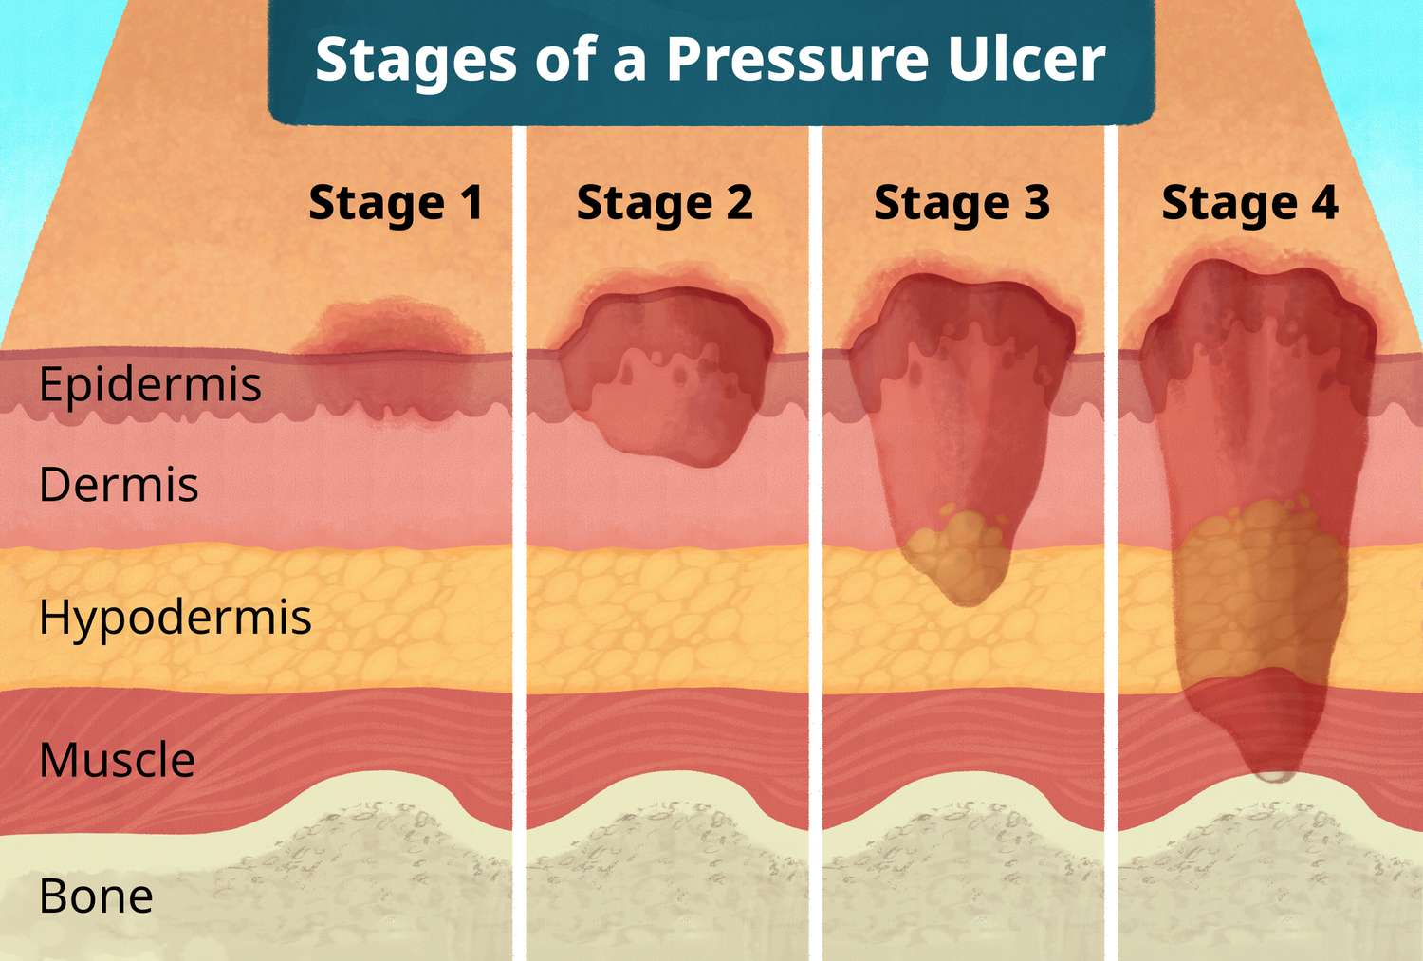 | Occurs on bony area begging with hyperemia (temporary redness that resolves within 1 hour of pressure relief); progresses to ischemia (tissue damage begins after 2-6 hours of continuous pressure); then tissue becomes necrotic (irreversible tissue death occurs after more than 6 hours of pressure); leading to the development of an ulcer (the visible necrotic skin is just the surface damage; deeper tissue may be affected)  -Pain, bleeding.  Diagnosis:  Stage 1: nonblanchable erythema of intact skin  Stage 2: partial-thickness skin loss with exposed dermis  - Wound bed visible, pink or red, moist, and may present as intact or ruptured blister; adipose and muscle not visible and no granulation tissue, slough or eschar are present  Stage 3: full thickness skin loss  - Adipose visible in the ulcer and granulation tissue often present; slough and/or eschar may be visible; undermining and tunneling may occur  Stage 4: full thickness skin and tissue loss  - Fascia, muscle, tendon, ligament, cartilage, and/or bone exposed  Unstageable: obscured full thickness skin and tissue loss  - Extent cannot be confirmed d/t obscurement by slough or escar > if removed, a stage 3 or 4 ulcer will be revealed  Deep tissue pressure injury (DTPI): persistent non-blanchable deep red, maroon, or purple discoloration  - Intact or nonintact skin with localized area of persistent nonblanchable discoloration or epidermal separation revealing a dark wound bed or blood filled blister
Hx/Key Questions | What do they think is the cause? Sudden or gradual onset? Itchy or painful? Drainage? Drug hx (steroids or anti-coags)? Numbness/tingling? Pain with ambulation? Sensation intact to feet? R/O domestic toxins or insect bites. Mobility? Nutrition status? Comorbidities?
Physical Exam | -VS  -Inspect: colour of skin (signs of ischemia), measure LxWxD, tunnelling or undermining, describe wound bed (necrotic, granulation, or epithelial tissue?), colour of tissue, drainage, odour  -Palpate: temp, sensation, cap refill, pulses
Diagnostics/Labs | CBC, wound culture and biopsy, xray, MRI, bone scan
Red flags | Osteomyelitis (pressure ulcers are a major cause)  Cellulitis, bacteremia, sepsis, lack of pulse, fever, chills, pain, consider malignancy in non-healing ulcers, swab if nonhealing
Differential Diagnoses | Abscess, trauma, vascular ulcer, venous ulcer, skin cancer, vascular ulcer (arterial or venous), diabetic foot ulcer, abscess, skin cancer, trauma, Venous ulcer, neuropathic ulcer Infections – osteomyelitis, necrotizing fasciitis, fungal, thermal burn, malignancy
Treatment/Management | Treatment:  - Preventable measures (repositioning)  - Good nutrition  - Tx of underlying medication issues  - Moisture reduction  - Wound bed preparation and tx ABX for infection
Referrals | Refer to wound-care:  - Extensive ulcer (visible bone, muscle, tendon)  - Vascular deficiency found  - Multiple comorbidities (esp diabetes)  - Unresponsive to tx after 2-4 wks  - Infx present
Follow-up | 1-2 weeks until healing well then 3-4 wks until complete closure

Chronic Wounds (Diabetic ulcers)
Def’n | Diabetic foot ulcer: usually on plantar surface of foot; most commonly d/t trauma or plantar pressure in a diabetic patient with neuropathy, pressure ischemia or venous HTN
Pathology/Cause | Repetitive stress to foot in pts with impaired protective sensation, movement, blood flow and wound healing, chronic ulcers usually have 3+ microorganisms
Risk Factors/Epidemiology | DM >15 years, dec mobility, HTN, dyslipidemia, hyperinsulinemia, PAD, neuropathy, hygiene, uncontrolled BS
Clinical Presentation | Diabetic Ulcer:  Pain, bleeding, drainage, hyperglycemia, on soles of feet
Hx/Key Questions | What do they think is the cause? Sudden or gradual onset? Itchy or painful? Drainage? Drug hx (steroids or anti-coags)? Numbness/tingling? Pain with ambulation? Sensation intact to feet? R/O domestic toxins or insect bites. Mobility? Nutrition status? Comorbidities? Previous ulcers? Cigarette use?
Physical Exam | -VS  -Inspect: colour of skin (signs of ischemia), measure LxWxD, colour of tissue, drainage, odour, inspect location (ulcers typically occur over pressure points, often at the metatarsal heads sole of foot), does it have a necrotic base, with dead or dying tissue present, wound margins, is the surrounding skin thin and dry, sometimes with a hyperkeratotic border (thickened skin), signs of ischemia, no claudication  -Palpate: temp, cap refill, diminished pulses, ABI may be elevated (>1-1.4), ulcer is often painless when palpated due to diabetic neuropathy, paresthesia present, CSMs  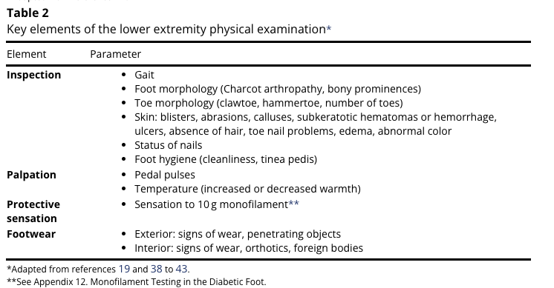
Diagnostics/Labs | Blood tests: CBC (to check for infection), HbA1c (for glycemic control), CRP (inflammatory marker).  Wound swab or tissue biopsy: If infection is suspected, to identify the organism and guide antibiotic therapy.  X-ray or MRI: To rule out osteomyelitis if the ulcer is deep or there are signs of underlying bone involvement.  Vascular studies: Doppler ultrasound or ABI for assessment of peripheral arterial disease…ONLY if intermittent claudication, cool extremities, diminished or absent pedal pulses, or delayed capillary refill,  non-healing or slow-healing ulcers, high risk of cardiovascular disease
Red flags | Pain, foul odour, signs of systemic infection, gangrene (risk of amputation)
Differential Diagnoses | Pressure ulcer, vascular ulcers, neuropathic ulcers necrotizing fasciitis, fungal infection, drug reaction
Treatment/Management | Treatment:  Diabetic foot ulcer:  - Establish arterial flow  - For S/S of infx, obtain tissue C&S and treat as per pharmacological recc. and apply dressings (same dressings as venous ulcers)  - Offload the site of ulcer  - Debride and granulate ulcer  - Control diabetes  Counseling/Education:  Non-pharm therapies:
Referrals | Refer to wound-care:  - Extensive ulcer (visible bone, muscle, tendon)  - Vascular deficiency found  - Multiple comorbidities (esp diabetes)  - Unresponsive to tx after 2-4 wks  - Infx present  - If life or Limb is threatened  - Wounds that have not reduced in size or are poorly healing at 4 weeks
Follow-up | 1-2 wks until healing well then 2-4 wks until complete closure

Chronic Wounds (venous & arterial ulcer) https://www.youtube.com/watch?app=desktop&v=QeViOIyNtA0&ab_channel=ZeroToFinals
Def’n | Vascular Ulcer:  - Arterial/ischemic ulcer: skin ulcers usually on foot over bone/pressure points; non-healing d/t inadequate arterial flow  - Venous ulcer: chronic skin and subcutaneous lesions found on lower extremity b/w ankle-knee due to blood pooling/inflammation
Pathology/Cause | Can have more than one cause; most common etiologies: venous insufficiency, arterial insufficiency, pressure of time
Risk Factors/Epidemiology | Male>female; diabetes, CHF, CAD, edema, obesity, older age, peripheral neuropathy
Clinical Presentation | Pain, bleeding, drainage, hyperglycemia.  Venus: less painful, more likely to bleed, irregular shape, pain relieved with elevation and worse with lowering leg. Look for signs of chronic venous insufficiency, such as varicose veins, hemosiderin staining (brownish skin discoloration), lipodermatosclerosis (hardened skin), and edema.  Arterial: painful, punched out circular shape, pain inc with elevation  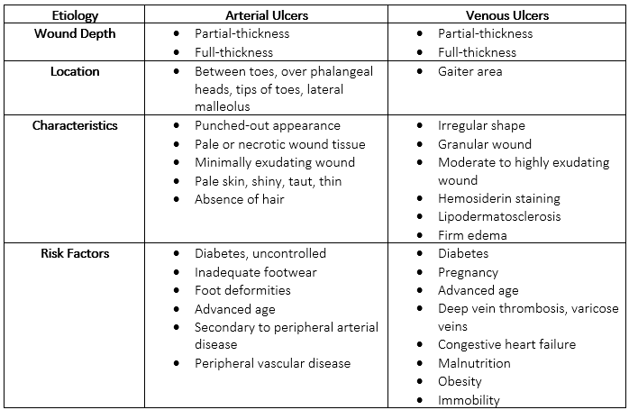  PAD Classification:  - Asymptomatic, where patients show no symptoms  - intermittent claudication, characterized by muscle pain during physical activity that resolves with rest  - Chronic limb ischemia, which involves pain at rest and potential tissue damage due to severely reduced blood flow  - Acute limb ischemia, a critical condition marked by sudden onset of pain, pallor, pulselessness, and potential limb loss if not promptly treated.  Main Signs and Symptoms of Peripheral Artery Disease (PAD)  - Pain at Rest: Severe pain in the feet or legs, especially when lying down, indicating critical ischemia.  - Decreased Pulses: Weak or absent pulses in the legs and feet due to reduced blood flow.  - Pain with Activity: Cramping or aching in the legs or buttocks during physical activity (intermittent claudication) that resolves with rest.  Main Signs and Symptoms of Peripheral Vascular Disease (PVD)  - Swelling: Edema in the legs or feet due to venous insufficiency.  - Varicose Veins: Enlarged, twisted veins visible under the skin.  - Skin Changes: Discoloration, thinning, or ulceration of the skin due to poor circulation.  - Leg Pain or Cramping: Pain may occur during prolonged standing or sitting, often relieved by movement.  - Numbness or Tingling: Sensations in the legs or feet indicating nerve involvement or poor blood flow.  - DVT s/s (6 Ps)
Hx/Key Questions | What do they think is the cause? Sudden or gradual onset? Itchy or painful? Drainage? Drug hx (steroids or anti-coags)? Numbness/tingling? Pain with ambulation? Sensation intact to feet? R/O domestic toxins or insect bites. Hx. MI/cerebral accident  -Assess iodine/sulfa allergies before starting tx
Physical Exam | -VS  -Inspect: color of skin (signs of ischemia), measure LxWxD, tunneling or undermining, describe wound bed (necrotic, granulation, or epithelial tissue?), color of tissue, drainage, odour  -6Ps (pain, pallor, paresthesia, paralysis, pulessness, piokiothermia  -Palpate: temp, sensation, cap refill, pulses, hair distribution, pulses (carotid, PMI)  -ABI  Auscultate: lungs and carotid bruits and heart, AAA, iliac, femoral, aortic  Eye exam to assess retina  -Homans sign (calf pain with dosriflexion)...indicated if DVT!! Can be PAD or PVD!  -Hand on calf, bend leg at 90% at the knee…dorsiflex ankle to see if any pain…if so DVT!  https://www.youtube.com/watch?v=4to5YGyFa9g  VENUS:  Venous Refill Test: Have the patient lie down and elevate the leg, then stand and observe how quickly the veins refill. Rapid refill indicates venous insufficiency.  Brodie Trendelenburg Test: Helps assess the competency of the venous valves.
Diagnostics/Labs | ABI: BP at right arm x2, then right leg and left leg.  Then highest systolic leg pressure at 2 pulse sites divided by highest systolic arm pressure between both arms.  Doppler  - Ultrasound: Duplex ultrasonography can assess blood flow and identify stenosis.  - Ankle brachial index→ to diagnose PAD but also to rule it out if CVI and need compression  - CT/MRI Angiography: Non-invasive imaging to visualize arterial disease.  - CBC (infection?), HBA1C, albumin if malnourished  arterial doppler, bone scan, CBC (infection?), HBA1C, MRI, Wound culture, biopsy if think its cancer, venous doppler, x-ray, albumin if malnourished, Ddimer, ECG, ultrasound if DVT risk? ABI if PAD
Red flags | Arterial clot S/S: severe pain, pulseless, cool limb, new onset of purple/blue discoloration to feet > ER
Differential Diagnoses | Vascular ulcer (arterial or venous), diabetic foot ulcer, abscess, nec fasc, skin cancer, trauma
Treatment/Management | Treatment:  Arterial ulcers: Refer to vasc sx and wound care specialist asap!! NO debridement or compression!!  Venous ulcers:  - Establish arterial flow - if deficiency found > refer to vasc sx.  - Any S/S of infx? - treat per pharmacological recc. and apply dressings  -Moderate drainage- silver alginate dressing  -Scant drainage - silver gel dressing  - If arterial flow is sufficient and infx is ruled out, main tx of venous ulcers is compression therapy  - ABI: 0.8-1 > full/high compression  - ABI 0.6-0.8 > light/moderate compression but be cautious  - <0.6 NO COMPRESSION PAD RISK***  Arterial  - Revascularization: Procedures like angioplasty or bypass surgery may be indicated if significant arterial blockage is present.  - Wound Care: Proper cleaning, debridement, and dressing of the ulcer to promote healing and prevent infection.  - Lifestyle Modifications: Smoking cessation, exercise, and a healthy diet to improve overall vascular health.  - Medications: Antiplatelet agents, statins, and medications to improve blood flow may be prescribed.  - Management of Comorbidities: Control of diabetes, hypertension, and hyperlipidemia is essential for overall treatment success.  Venus:  - Compression Therapy: The primary treatment, involving the use of compression stockings or bandages to improve venous return and reduce edema.  - Wound Care: Regular cleaning, debridement, and appropriate dressings to promote healing and prevent infection.  - Leg Elevation: Elevating the legs when resting to reduce swelling and improve blood flow.  - Medications: Topical treatments for infection or inflammation, and medications that may improve venous tone and reduce symptoms.  - Lifestyle Modifications: Encouraging regular physical activity, weight management, and avoidance of prolonged standing or sitting.  - Surgical Options: In some cases, procedures to address underlying venous issues (e.g., vein stripping, sclerotherapy) may be considered.
Referrals | For venus: Referral to a Wound Care Specialist or Vascular Specialist: Consider referral if the ulcer is large, recurrent, or not responding to standard wound care and compression therapy after 4–6 weeks.  For Arterial: Immediate Referral to a Vascular Surgeon: Always refer patients with suspected arterial ulcers for vascular assessment. Arterial ulcers indicate underlying peripheral artery disease (PAD) and a high risk of complications, including tissue loss or amputation.  Refer to wound-care:  - S/S infx  - Extensive ulcer (visible bone, muscle, tendon)  - Vascular deficiency found  - Multiple comorbidities (esp diabetes)  - Unresponsive to tx after 2-4 wks  - Infx present  Refer to vascular sx:  - Vascular deficiency found  - Ischemic ulcers  - Vascular Surgeon or Specialist: If there are signs of arterial disease, persistent non-healing ulcers, or if surgical intervention might be beneficial.  - Wound Care Specialist: For complex cases or if additional expertise is needed.  - Dermatologist or Podiatrist: For specific ulcer management issues or additional interventions.
Follow-up | 1-2 wks until healing well then 2-4 wks until complete closure

ULCER DIFFERENTIATION
Characteristic | Venous (70% of vascular ulcers) | Arterial | Diabetic
Cause | Valvular incompetence /insufficiency  Venous HTN | 2º to small and/or large vessel disease | Peripheral neuropathy  Atherosclerosis
History | Dependent edema trauma  Rapid onset thrombophlebitis, varicosities | Arteriosclerosis, claudication  Usually >45 y/o  Slow progression | DM  Peripheral neuropathy  Trauma/Pressure
Common distribution | Medial Malleolus | Distal locations (lower limbs and feet)  Lateral malleolus | Pressure point distribution  (metatarsal heads)
Appearance | Yellow exudates  Granulation tissue  Varicose veins  Brown discolouration of surrounding skin  Edema and pooling of blood | Pale/white, necrotic base dry eschar covering  ++ increased pain | Necrotic base
Wound Margins | Irregular | Even | Irregular or “punched out” or deep
Depth | Superficial | Deeper | Superficial/deep
Surrounding skin | Venous stasis discolouration (brown) | Thin, scaly, dry skin; hairless, cool | Thin, dry skin hyperkeratotic border  Hypersensitive/ischemic
Pulses | Normal distal pulses | Decreased or no distal pulses | Decreased pulses likely (take caution with calcified vessels)
Vascular exam | ABI > 0.9  Doppler; abnormal venous system | ABI <0.9  Pallor on elevation, rubor on dependency  Delayed venous filling | ABI is inaccurately high due to PVD  Usually associated with arterial disease
Pain | Moderately painful  Increased with leg dependency  Decreased with elevation  No resting pain  Dull, aching | Extremely painful  Decreased with dependency  Increased with elevation and exercise  Resting pain (worse pain at night) | Pains d/t neuropathy  No claudication or rest pain  Associated with paresthesia, anesthesia
TX | Leg elevation, rest  Compression at 30 mmHg (NEED to establish blood flow first)  Moist wound dressings topical, systemic antibiotics if infected  skin grafts | Rest, no elevation, no compression  Moist wound dressing topical and/or systemic antibiotics if infected  Modify risk factors (smoking, diet, exercise,  Vascular surgical intervention (angioplasty or bypass)  Treat underlying conditions | Control DM  Careful wound care  Foot care  Orthotics, off loading  Early intervention for infections (topical or systemic antibiotics)  Vascular surgery intervention

Burns
Def’n | -skin damage
Pathology/Cause | -caused by sun, chemicals, shear, water, electric etc.
Risk Factors/Epidemiology | -age (children and elderly), workplace, cooking, sun exposure
Clinical Presentation    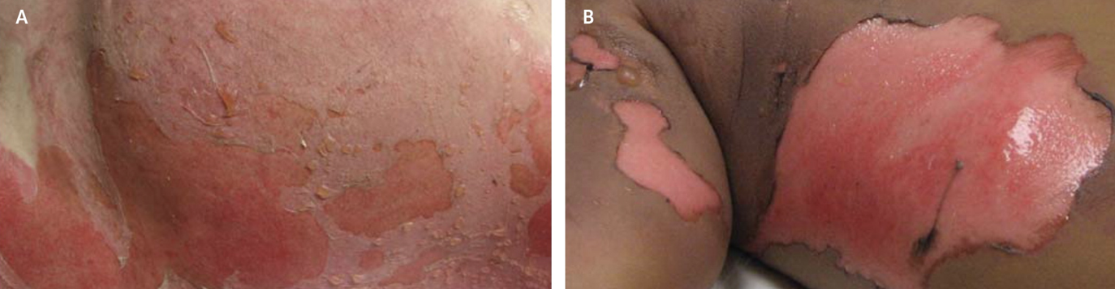  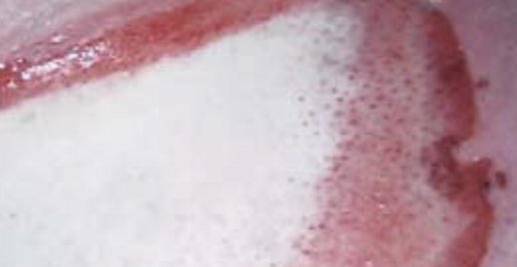 | Degrees:  Superficial (first-degree):  - localised to epidermal layer, painful, erythematous, dry and blanching (do not blister and heal in 3-6 days)  Partial-thickness (second-degree):  - epidermis destroyed and dermal layer injured; subdivided into superficial and deep  - Superficial: exudative, blanch with pressure, may blister, painful; heal within 3 weeks  - Deep: involve reticular dermis, drier, do not blanch; take more than 3 weeks to heal, loss of dermal layer and scarring; excision and grafting option  Full-thickness (third-degree):  - extend through entire dermis into fat and connective tissue and referral to burn center; white, waxy, dry, leathery, pain reduced (nerve endings destroyed); surgical intervention and skin grafting; weeks to months for healing  Zones:  Zone of Coagulation  - area of direct injury where tissue is most severely damaged.  - Tissue necrosis occurs due to irreversible damage. Cells in this zone have lost their structural integrity and function. This zone appears dry and leathery (in burns) and is typically the site of the most significant loss.  Zone of Ischemia (or Stasis)  - surrounds the zone of coagulation and is characterized by reduced blood flow.  - Tissue may be viable but at risk for further damage due to inadequate perfusion.Cells may be ischemic but not yet dead; they can potentially recover with proper treatment. This area may show signs of inflammation, such as redness or swelling, and is at risk for progression to necrosis if blood flow is not restored.  Zone of Hyperemia  - The outermost zone surrounding the zone of ischemia, characterized by increased blood flow.  - Tissue is generally viable and shows signs of inflammation and healing. This area appears red due to vasodilation and increased blood supply as a response to injury.  - While this zone is less severely affected, it may experience some mild damage and requires monitoring
Hx/Key Questions | Cause? Additional trauma/injuries? how the burn occurred (thermal, chemical, electrical, or radiation), the source (e.g., fire, hot liquid, chemicals), and the duration of exposure.
Physical Exam | Inspect skin and grade degree  Assess airway/breathing  VS (Hypotension, tachycardia, or tachypnea can indicate shock)  Estimate percentage of total body surface area- 10% or lower managed as outpatient; Palms method (palm of child or adult is 1%; can overestimate, least accurate); Rule of Nines (photo below) and Lund-Browder Classification (photo below, most accurate)  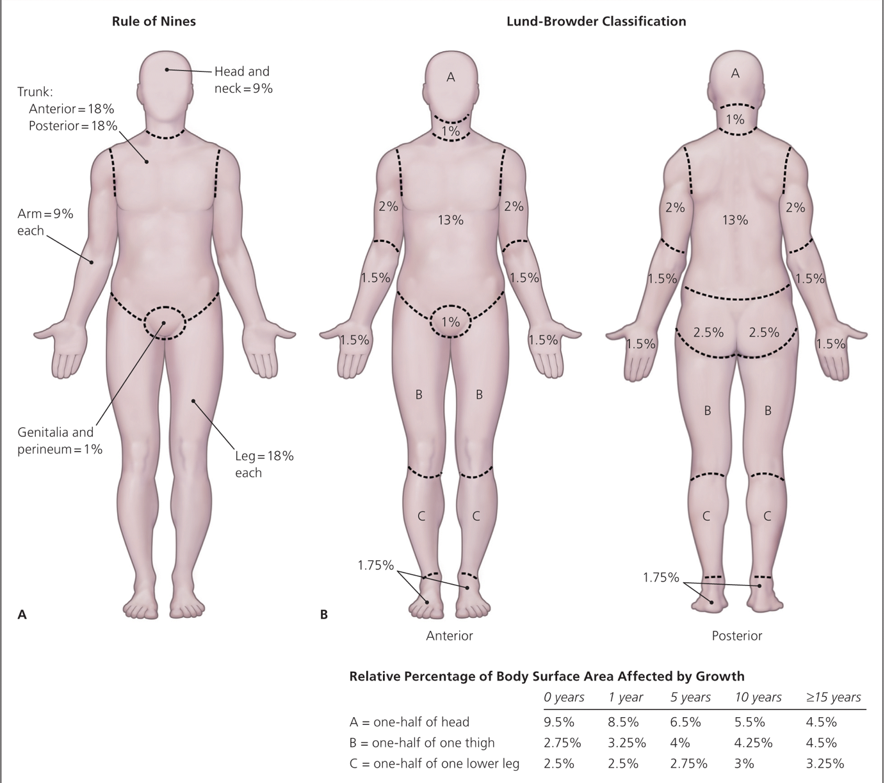  When to Transfer Based on the Rule of Nines:  - Adults:  - Burns covering more than 10% of total body surface area (TBSA) for partial-thickness burns (second-degree).  - Burns covering more than 5% TBSA for full-thickness burns (third-degree).  - Children:  - Burns covering more than 5% TBSA for partial-thickness burns.  - Burns covering more than 2% TBSA for full-thickness burns.  - Involvement of Critical Areas:  - Burns located on hands, face, feet, genitalia, or major joints (e.g., knees, elbows).  - Burns that may impair function  - Burns near or involving the airway or respiratory tract.  - Infection  - Sepsis or systemic infection signs, which are more likely with larger burn areas.  Screen for abuse*
Diagnostics/Labs | Laboratory Tests: Obtain a complete blood count (CBC), electrolytes, renal function tests, and blood glucose.  FLUIDS  Tetanus  Xray if inhaled smoke  Swab  In larger burns, consider coagulation studies and carboxyhemoglobin levels (especially for smoke inhalation injuries).  Imaging: Only if there is a concern for associated trauma or inhalation injury, consider chest X-rays or other relevant imaging.  Wound Swab: If there are signs of infection, take a swab from the burn wound for culture and sensitivity.
Red flags | -burns to face, hands, feet, major joints, genitalia or perineum
Differential Diagnoses | -vesicle/blister diseases
Treatment/Management | Treatment:  Opioids 30 mins before dressing changes; pregabalin  Tetanus  Counseling/Education:  Sun + kitchen safety  Non-pharm therapies:  Cold water, wet gauze reduces pain, aloe vera cream, NSAIDs,  Dressings:  - Superficial- do not require dressing  - Superficial partial thickness- moist, protected environment; debridement debated; topical antimicrobial agent (bacitracin, mupirocin) applied to simple dressing and changed every 12-24 hours OR advanced dressings (silver-impregnated foam like aquacel or mepilex Ag) that can be kept on up to 14 days  Concern for itching after healing has started  Pain Management: Administer analgesics such as acetaminophen, NSAIDs, or opioids based on the severity of the pain.  Wound Care:  - Cover the burn with a clean, non-adhesive, dry dressing or a sterile sheet if large.  - Avoid using ice, as this can cause further tissue damage.  Fluid Resuscitation:  - For burns ≥15% TBSA, start intravenous fluids using the Parkland Formula:  - 4 mL x % TBSA x body weight (kg) = total fluids for the first 24 hours.  - Administer half of this amount in the first 8 hours post-burn, and the remaining half over the next 16 hours.  Tetanus Prophylaxis: Administer tetanus toxoid if the patient’s immunization status is uncertain or if the last booster was more than five years ago.
Referrals | -referral to burn center >3% for adults and 2% for children  -burns to face, hands, feet, major joints, genitalia or perineum  -is thin skin (less than 5 years or older than 60yrs)  -electrical burns, chemical burns  -not healing after 2 weeks  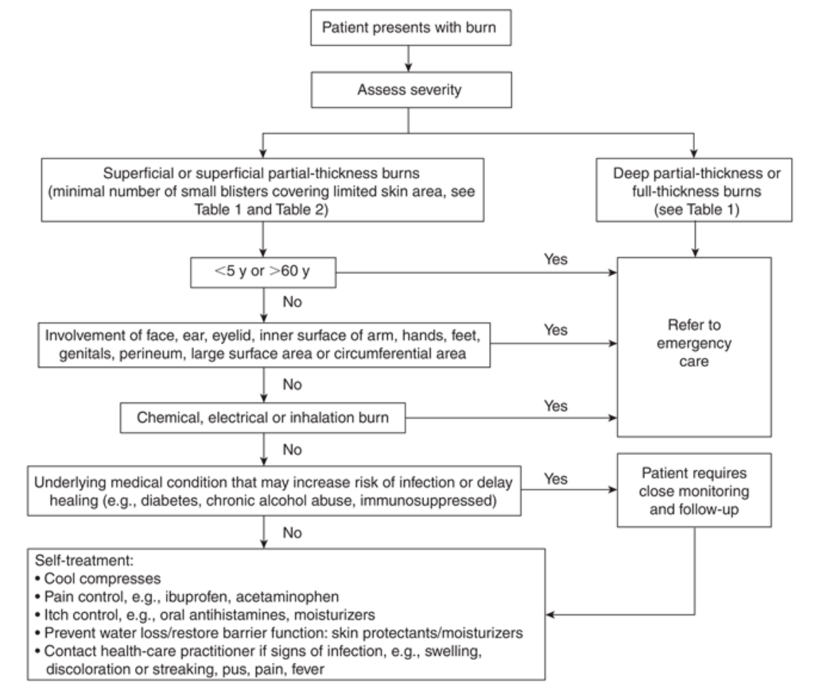
Follow-up | Reassess in 24-72 hours, superficial partial thickness can spontaneously evolve to deep  - Educate the patient on keeping the area clean, avoiding direct sunlight, and changing dressings as advised.  - Schedule follow-up visits to monitor healing, infection signs, and to manage pain as needed.  - Advise the patient on signs of infection (increased redness, warmth, pus, fever) and the importance of hydration and nutrition to support healing.

Chronic Venous Insufficiency (CVI) & Varicose Veins
https://www.youtube.com/watch?v=boxViet7FL0&t=30s
https://www.youtube.com/watch?v=fpiyGin5nGk
Short definition | Types of chronic venous diseases.  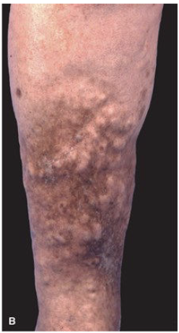
Pathology/cause | CVI  - Incompetent valves that allow reflux and venous hypertension  - Leads to obstruction of venous flow, tissue anoxia, inflammation & necrosis  - Subcutaneous fibrosing panniculitis & additional venous/lymph obstruction can occur  VV  - A form of CVI; incompetent valves and venous hypertension causes an influx of volume, pressure and leads to dilated, twisting, bulging vessels
Epidemiology | CVI= 40% of women (peaks in women >50), 25% of men  VV= most common circulatory condition of the lower extremities; affects 20% of adults  - More common in females
Risk Factors | CVI= age, female, prolonged standing or sitting, DVT history, tall stature, obesity, sedentary lifestyles  VV= genetics (90% chance if both parents have VV); age, pregnancy, prolonged standing, restrictive clothing, obesity, ligamentous laxity (flat feet, hernia), smoking
Screening
Clinical Presentation  (Subjective Symptoms & Objective Signs) | HALLMARK of CVI: extreme edema and worse at night, aching, heaviness, or cramping pain that worsens with standing, skin changes (hyperpigmentation around the ankles due to iron deposition from hemosiderin, eczema or dermatitis due to stasis, lipodermatosclerosis is hardening of the skin and subcutaneous tissue.)  Common findings:  - Dull, aching, cramping pain; itching sensation, heavy extremities, hyperpigmentation, thick/hardened skin, ulcerations
HALLMARK of VV: pain with a burning, aching, itching sensation; blue veins that protrude above the skin surface
Common findings:
- Leg fatigue, edema, symptoms that worsen towards the end of the day, leg heaviness
Hx/Key Questions | - When were the symptoms first noticed? Duration?  - Describe the pain, what makes it better or worse, rate it  - List all medications, substances not prescribed, illicit drugs  - Review history of invasive procedures and surgeries  - Symptom Timing: Ask if symptoms worsen with prolonged standing or sitting and improve with leg elevation.  - Hx DVT? Pregnant? Prolonged standing/sitting? Worse at night? Cardiac hx?  - Ask about walking distance before symptoms occur. Assess functional mobility and the need for assistan
Physical Exam | CVI…  - VITALS: BP, resting HR, respirations, temp, height, weight  - INSPECT: edema, hyperpigmentation, erythema, varicosities of extremities, colour, hair, ulcers  - PALPATE: tenderness, vein distention, temperature, edema, pulses  - AUSCULTATE: heart and lungs  - Brodie-Trendelenburg test https://www.youtube.com/watch?v=b5l3PcoZ65A https://www.youtube.com/watch?v=veeEgFHmz4M  - Homans sign  - Venous filling time  - ABI  - JVP***
Physical Exam | VV…  VITALS: BP, resting HR, respirations, temp, height, weight  INSPECT: superficial vein while client is standing; edema, hyperpigmentation, eczema  PALPATE: distended veins, tenderness  AUSCULTATE: heart and lungs  - TEST: cough impulse test, tap test of the great saphenous vein (assess if it is distended with blood),  JVP to r/u HF, and peripheral pulses CSM
Diagnostic/  Special Tests | CVI…  Laboratory Tests if wanting to r/u other issues  - Complete Blood Count  - ESR/CRP to rule out cellulitis if you think it’s this  - Lipids  - Glucose  - BNP  - - - - - - - - - - -  - PTT  - D-dimer test  - Lipid profile  - Blood glucose levels  - Iron  - BNP to r/u HF  Diagnostic Imaging  - Duplex Ultrasound for assessing venous function.****  - ABI to rule out PAD  - Trendelenburg test, perthes test, doppler ABI  - Venography (expensive, risk of phlebitis)  - Angiography: Imaging to visualize blood vessels and assess the extent of disease.  - CT or MRI Angiography: Non-invasive imaging techniques to visualize vascular anatomy
Diagnostic/  Special Tests | VV…  - Trendelenburg test, perthes test, duplex or doppler ultrasound
Red Flags | Send to emergency if there is bleeding with eroded skin, previous varicose bleed at risk of bleeding again, ulceration that is worse or painful despite treatment
Differential Diagnosis | For CVI: DVT, ulceration, infection, PAD, varicose veins with risk of hemorrhage  For VV: arthritis, peripheral neuritis, nerve root compression, telangiectasia, DVT, inflammatory liposclerosis
Treatment/ Management | Counseling/Education  - If clients are no-ambulatory, encourage rocking chair use  - Avoid prolonged sitting or standing, regularly exercise  - Encourage smoking cessation, weight loss, manage other comorbidities  - Lift legs, exercise, will go away after pregnancy  Complementary Therapies (non-pharmacological)  - Extremity elevation, compression stockings (FOR VV!!!), exercise, and wound care for CVI  - Compression Therapy:  - Use graduated compression stockings (usually 20-30 mmHg or higher) to improve venous return and reduce edema. Ensure ABI > 0.8 to confirm adequate arterial flow before applying compression.  - Apply bandages for ulcers as part of a multi-layer compression system.  - Skin and Wound Care:  - Clean and dress any venous ulcers with appropriate dressings (e.g., hydrocolloids, foam, alginate) to promote healing and prevent infection.  - Moisturize dry, scaly skin with emollients to prevent breakdown.  - Apply topical steroids if there's significant itching or dermatitis.  - Medications:  - Pain Management: Use analgesics such as acetaminophen or NSAIDs as needed.  - Antibiotics: Only if there are signs of wound infection (redness, warmth, purulent discharge, or fever).  - Diuretics: For patients with significant edema due to systemic causes (e.g., heart failure).  - Lifestyle Modifications:  - Advise the patient on elevating the legs multiple times a day to reduce swelling.  - Encourage regular physical activity, such as walking, to improve venous return.  - Recommend weight management, smoking cessation, and avoidance of prolonged standing or sitting.  - Patient Education:  - Educate the patient about the importance of wearing compression stockings daily.  - Teach proper skin care to prevent ulcer formation and to recognize signs of infection.  - Discuss the chronic nature of CVI and emphasize adherence to the treatment plan to prevent complications.
Advise clients when to RTC or call for help
Referrals | - Suspect limb ischemia→ hospitalization  - Chronic limb ischemia causing ulceration→ hospitalization for wound care & diagnostics  - Persistent PVD symptoms→ cardiologist  - Podiatrist for foot care and shoe assessment  - Pain management if needed
Follow-up | Persistent symptoms of PVD should always be followed up with by a cardiologist
Common Complications | CVI→ cellulitis, peripheral neuropathy, varicose veins, abscess, ulceration, stasis dermatitis, DVT  VV→ stasis dermatitis, stasis ulceration, petechial hemorrhage, chronic edema, superficial thrombophlebitis, hyperpigmentation, eczema
References | Cash & Glass, p. 205-207; photo from Fitzpatrick’s

Peripheral Arterial Disease
https://www.youtube.com/watch?v=3B6jt4nHHmg
Short definition/ description | REFER IF ABI<0.5!!!!!!  A circulatory disorder characterized by the buildup of plaque on the interior surface of arteries that hardens, narrowing the diameter of arteries and reducing circulating blood volume to organs and extremities.  - Includes Buerger’s disease, Raynaud’s disease, and Leriche syndrome
Pathology/cause | Affects all arteries except the cerebral and coronary arteries.  Can also be caused by arthritis, trauma, radiation damage, and fibromuscular dysplasia. Most often precipitated by atherosclerosis  Classifications…  - Asymptomatic→ risk factors and no symptoms  - Intermittent claudication→ discomfort with exertion, remits after activity ceases  - Chronic limb ischemia→ pain at rest and/or skin ulceration  - Acute limb ischemia→ pain at rest with a pulseless extremity
Epidemiology | More common in men, indigenous peoples, and African/Hispanic descent
Risk Factors | Smoking, diabetes, dyslipidemia, hypertension, obesity, age >60
Clinical Presentation  (Subjective Symptoms & Objective Signs) | HALLMARK: pain with activity that is characterized as cramping or aching  - Common to see coronary artery disease and cerebrovascular disease coexisting  Common findings: pain at rest (esp at night), calf weakness and fatigue, numbness/tingling, dizziness or syncope with upper extremity exertion, ulcerations  Other signs and symptoms: decreased pulses, blanching of the limb with elevation, ulcerations or infection on distal aspects, erectile dysfunction, pain at night  PAIN WORSE AT NIGHT OR WHEN LEGS ELEVATED
Hx/Key Questions | - What activity brought about or preceded the episode, when does the pain occur, was the person able to walk?  - Describe duration of pain, time of day, alleviating factors  - Previous episodes, medications, substances, herbal supplements including anything recently stopped  - Smoking history, MI/stroke history, erectile dysfunction/impotence  - In legs only or arms?  - Any erectile dysfunction
Physical Exam | VITALS: BP in both upper extremities (difference of 10mmHg systolic or greater indicates upper extremity PAD and cerebrovascular disease, 15mmHg systolic is lower extremity disease) and lower extremities, resting HR, RR, height, weight  INSPECT:  - Fundoscopic exam for retinal vascular changes or occlusion, macular edema and neovascularization  - Abdomen→ pulsating mass, AAA?  - Extremities→ edema, pallor, cyanosis, colour in dependent & elevated positions (ulceration and diffuse erythema of lower)  - Skin/hair/nails→ temperature discrepancies, trophic changes  - Homan’s sign= calf pain with forced dorsiflexion https://www.youtube.com/watch?v=qJ4FR20zDzk https://www.youtube.com/watch?v=4to5YGyFa9g  - Buerger test  PALPATE  - Asses 6Ps  - Pulses for symmetry (brachial, aorta, femoral, all lower limb)  - Cap refill, carotid bruits, lateral pulsation of the abdominal aorta  - Allen’s test= occlude radial and ulnar arteries with fist closed, have then open and close hands a few times then release one of the arteries, then repeat with other (observe for prompt cap refill)...must do both sides radial and ulnar (ex. Use for reynauds or vascular occlusion in hand)  AUSCULTATE: heart, lungs, carotids/abdomen/femoral for bruits
Red Flags | Acute limb ischemia requires immediate transport to emergency department  6Ps→ pain, pallor, paresthesia, paralysis, pulselessness, poikilothermia (inability to maintain constant core temp)
Differential Diagnosis | Venous stasis, venous obstruction/claudication, spinal stenosis, nerve root compression, hip arthritis, peripheral neuropathy, arteritis
Diagnostics:  Labs & Imaging | ABI and Duplex (maybe) and ECG (maybe)  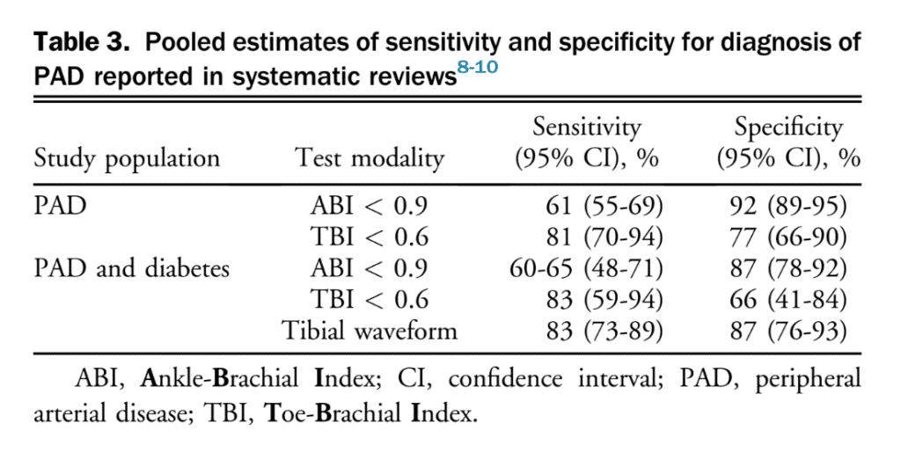  If other comorbidities can consider others but mainly ABI  Laboratory Tests  - Explain the importance of lab tests, such as:  - CBC  - Lipid Profile: To assess cardiovascular risk.  - Blood Glucose Levels: To identify diabetes.  - C-reactive Protein (CRP): To assess inflammation if you thing cellulitis.  - Basal metabolic panel (urea, creatinine, sodium, potassium) IF comorbidities  Diagnostic Tests  - ECG (12 lead)  - ABI: Non-invasive, comparing blood pressure in the ankle and arm.  - Doppler Ultrasound: To assess blood flow and identify blockages.  - IF THEY ARE ABNORMAL…  - Angiography: For visualization of blood vessels (more invasive).  - Exercise Stress Test: Treadmill testing, CTA, MRA, ateriography
Interpretation of Ankle Brachial index Results | >1.3=calicifation of arteries common in diabetics  1.00-1.3= normal  0.9-1= borderline PAD  0.8-0.9=some  0.5-0.8= moderate PAD  <0.5= severe PAD’  ***********  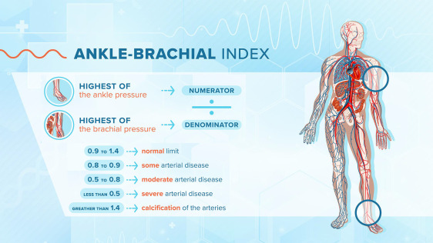  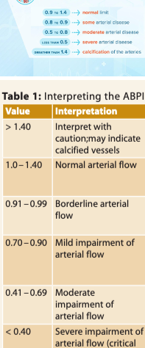
Treatment/ Management | Counseling/Education  - Smoking cessation, chronic disease management, foot care  Complementary Therapies (non-pharmacological)  - Dietary management based on comorbid conditions, walking programs
Medical management | If acute limb ischemia refer or ED STAT!  Prevent thromboembolism; ASA, clopidogrel, pentoxifylline  Reduce risk factors (reach goal BP, Hgb A1C, LDL levels, exercise)  Consider bypass, stenting, or angioplasty in patients with pain at rest, tissue loss, or significant limitations preventing exercise
Referrals | Routine Referral: vasc cardiology for mild-to-moderate claudication that hasn’t improved with lifestyle changes, medical management, or for ABI results confirming PAD without severe symptoms.  Acute limb ischemia, chronic limb ischemia progression too ulceration→ hospital  Persistent symptoms→ cardiologist  Angioplasty, stenting, bypass surgery→ vascular surgeon  For foot health and shoe assessment→ podiatrist  Pain management services as needed, dietician for modifications and risk factor improvement
Follow-up | Should be done by a cardiologist in the presence of persistent symptoms
Common Complications | Non-healing ulcerations of the lower extremities, infection, amputation
1° and 2° Prevention | Primary prevention  - Control chronic medical conditions (diabetes, dyslipidemia, HTN)
References | Cash & Glass, p. 222-225
PAD Guidelines | Initial Steps in PAD Assessment  - The assessment of a patient suspected of having PAD begins with a thorough medical history and physical exam.  - Differentiating PAD from Other Causes of Leg Pain:  - Neurogenic: Spinal stenosis, peripheral neuropathy, radiculopathy, spondylolisthesis.  - Musculoskeletal: Arthritis (hip or knee), Baker's cyst, chronic exertional compartment syndrome, stress fracture.  - Volume-related: Venous insufficiency, deep vein thrombosis.  - Vascular: PAD, chronic limb-threatening ischemia (CLTI), non-atherosclerotic arterial diseases like popliteal entrapment syndrome.  - Other: Restless legs syndrome, malignancy.  - The Edinburgh Claudication Questionnaire (ECQ) can be a valuable tool in the initial assessment, as it has high sensitivity and specificity for PAD and helps identify claudication symptoms.  Diagnosing PAD: The Role of ABI and TBI  - Ankle-Brachial Index (ABI):  - A simple, noninvasive, and inexpensive test central to PAD diagnosis.  - Involves measuring systolic blood pressure in the arm and ankle using a Doppler device while the patient is lying down.  - Calculated by dividing the higher ankle systolic pressure by the higher arm systolic pressure.  - An ABI below 0.9 is suggestive of PAD.  - Toe-Brachial Index (TBI):  - Another noninvasive test, particularly useful in patients with calcified arteries where ABI may be unreliable.  - Involves measuring systolic blood pressure in the great toe and the arm.  - Calculated by dividing the toe systolic pressure by the higher arm systolic pressure.  - A TBI value below 0.60 is commonly used as a diagnostic cutoff for PAD, though this can vary by study.  Challenges in PAD Diagnosis  - Medial Arterial Calcinosis:  - Common in patients with diabetes, chronic kidney disease, and advanced age; can lead to falsely normal or elevated ABI readings.  - Atypical Presentations:  - Many PAD patients do not present with classic claudication symptoms, complicating diagnosis.  - Symptoms may include discomfort in the back, buttocks, or legs, while some patients remain asymptomatic.  - Sex Differences:  - Further research is needed to understand sex differences in PAD diagnosis; current studies suggest women may have a higher prevalence of asymptomatic and more severe disease at diagnosis.  Recommendations for PAD Diagnosis  The Canadian Cardiovascular Society (CCS) 2022 Guidelines for Peripheral Arterial Disease provide the following recommendations:  - For Asymptomatic Adults Over Age 50 with PAD Risk Factors:  - Suggest using ABI to screen for PAD. (Weak Recommendation, Low-Quality Evidence)  - For Patients with Symptoms of PAD:  - Recommend using both ABI and TBI to confirm the diagnosis. (Strong Recommendation, Moderate-Quality Evidence)  - For Patients with Symptoms of PAD and Calcified Arteries:  - Suggest using TBI with tibial waveforms and/or transcutaneous oxygen pressure to confirm the diagnosis. (Weak Recommendation, Low-Quality Evidence)  Beyond Diagnosis: Screening Considerations and Risk Factor Management  - Screening Recommendations:  - The CCS guidelines recommend against broad population-based screening for PAD in asymptomatic patients. (Strong Recommendation, High-Quality Evidence)  - Routine PAD testing to infer global cardiovascular risk in asymptomatic patients with atherosclerosis in another vascular territory is not recommended. (Weak Recommendation, Moderate-Quality Evidence)  - Routine screening for asymptomatic carotid artery stenosis or CAD in patients with documented PAD is not recommended. (Weak Recommendation, Low-Quality Evidence)  - Management Focus:  - The primary focus for managing asymptomatic PAD should be aggressive control of cardiovascular risk factors, including:  - Smoking cessation  - Blood pressure control  - Lipid-lowering therapy  - Glucose control  - Coexisting Disease Consideration:  - Patients with PAD often have coexisting disease in other vascular beds, making them a high-risk group for future cardiovascular events. Aggressive risk factor management is crucial.

Deep Vein Thrombosis (DVT)
https://www.youtube.com/watch?v=POMdvRyxlFw&t=6s
Short definition/ description | A condition where thrombus forms in one or more veins
Pathology/cause | Venous changes related to Virchow’s Triad  - Hypercoagulability, venous stasis, and injury to the vessel wall  - 2 of 3 must be present for a DVT to form  - Thrombus spreads in the direction of blood flow, grows, occludes vessel and symptoms progress
Epidemiology | Affects 450 000 Canadians; ⅓ of the events are likely to be fatal
Risk Factors | Age > 60, hip or femur fracture, recent surgery to the heart or extremities, prolonged inactivity or immobility, pregnancy, medication use (HRT, OBCP, tamoxifen), smoking, obesity, cancer, inherited hypercoagulability conditions
Screening
Clinical Presentation  (Subjective Symptoms & Objective Signs) | HALLMARK: unilateral, sudden onset of edema, pain/tenderness starting in calf, can't feel pulse in leg, warmth/redness and other symptoms  Common findings: edema, pain, increased temperature, changes in color  ● May be asymptomatic
Hx/Key Questions | - When were symptoms first noticed, duration, describe pain & rate  - What makes symptoms better or worse  - List all medications, OTC, illicit drugs, herbal supplements  - History of invasive procedures/surgery  - Fam hx clotting disorders?????????????????
Physical Exam | VITALS: BP, resting HR, RR, height, weight  INSPECT: erythema, edema, Homan’s sign (see above)  - Moses’ or Bancroft’s sign→ Lay on belly and press on tibia. Pain in calf as it is compressed against tibia  - Lisker sign→ pain upon tibial percussion  PALPATE: pulses distal to area, note symmetry, cap refill, tenderness  - Do NOT perform deep palpation to the area  - Homens sign GOLD STANDARD! DVT  AUSCULTATE: heart and lungs  Measure leg is swoell to see if 3x the amount
Diagnostic/  Special Tests | ● WELLS SCORE** 3 points = likely DVT  https://www.mdcalc.com/calc/362/wells-criteria-dvt  - Doppler to find pulse, positive Ddimer means likely DVT, order ultrasound to confirm  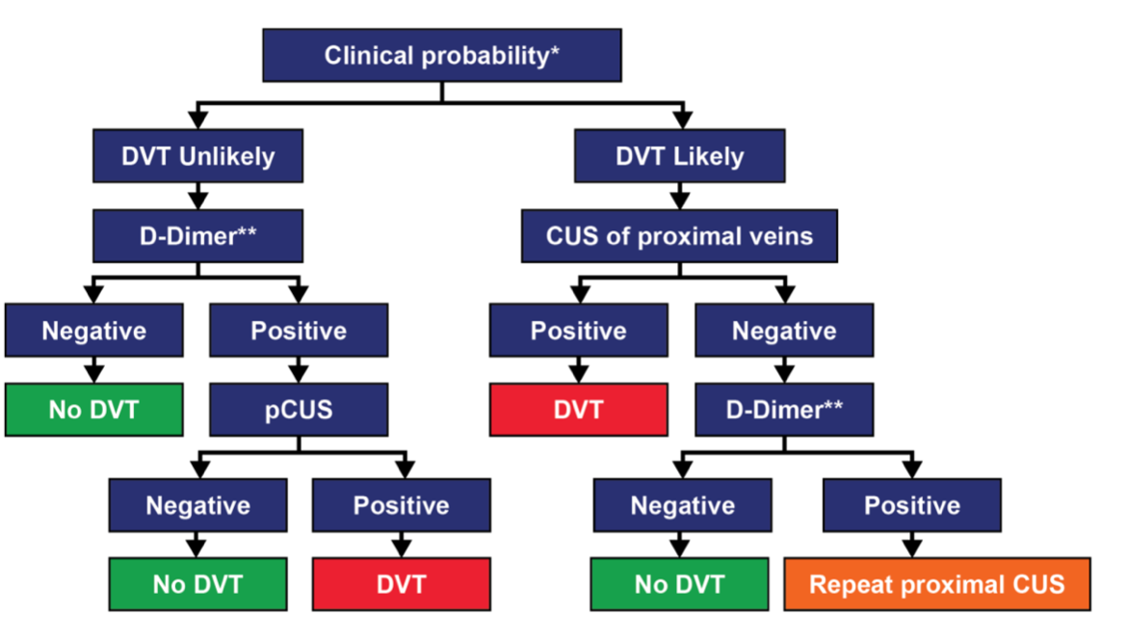  Wells Test determines pre-test probability for diagnosis  D-dimer to R/O  Doppler US: 95% specific and sensitive  Venography is gold standard, but very expensive and invasive  High risk for PE: V/Q scan or CTPA  Will require eGFR and pregnancy test for CTPA because of contrast  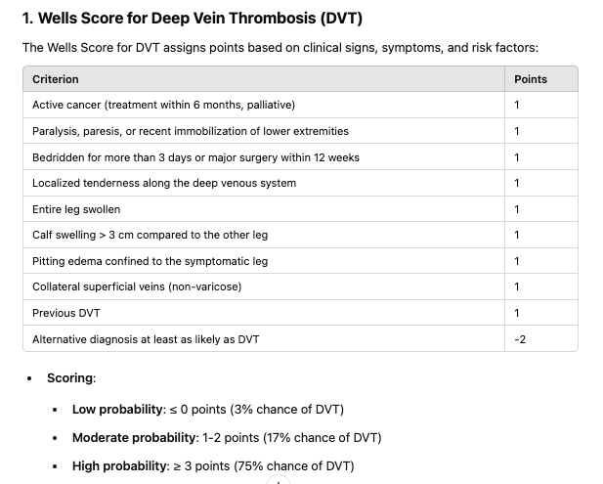  Low or Moderate Wells Score (≤ 2): DVT is considered unlikely. In this case, you would order a D-dimer test. If negative, DVT can be ruled out. If positive, ultrasound (U/S) should be performed to confirm or exclude DVT.  High Wells Score (≥ 2): DVT is considered likely. In this case, you would go directly to ultrasound (U/S) to confirm the diagnosis without ordering a D-dimer, as the likelihood of DVT is high, and a negative D-dimer wouldn't rule it out sufficiently.
Red Flags | SOB & chest pain for immediate transport to hospital…PE!!!  Cyanosis of the distal extremity→ hospitalization
Differential Diagnosis | Cellulitis, fracture, lymphoedema, CHF, vein compression from mass or enlarged lymph nodes, filariasis (parasitic disease), allergic reaction, compartment syndrome
Diagnostics:  Labs & Imaging | Laboratory tests  - D-dimer, CBCD, PT/PTT, INR, testing for idiopathic DVT (FactorV leiden, prothrombin, factors in coag cascade)  Diagnostic tests and/or Imaging  - Compression U/S done with Duplex ultrasound and push down further to see  - MRI if thrombus suspected in pelvic veins or vena cava  - Venography (expensive, risk of phlebitis)
Treatment/ Management | Counselling/Education  - ANTICOAG!!!!!!  - Compression Stockings: Consider prescribing graduated compression stockings to help reduce swelling and prevent post-thrombotic syndrome.  - Educate clients on warfarin about the role of vitamin k in foods  - Avoid prolonged sitting or standing, avoid crossing legs & immobility  - Exercise regularly, stop smoking, manage other chronic conditions  Complementary Therapies (non-pharmacological)  - Compression stockings (NEVER GIVE TO DIABETIC PT)
Medical management | Thrombolytics, anticoagulants, LMWH, factor 10a inhibitors, surgery to prevent PE or venous thrombectomy
Referrals | Acute limb ischemia, chronic limb ischemia progression too ulceration→ hospital  Persistent symptoms→ cardiologist  Angioplasty, stenting, bypass surgery→ vascular surgeon  For foot health and shoe assessment→ podiatrist  Pain management services as needed, dietician for modifications and risk factor improvement
Follow-up | Persistent DVT symptoms and anticoagulant regimens should be followed-up by cardiologist
Common Complications | Significant increase in the risk for pulmonary embolism (PE); arterial embolism, MI, CVI, postphlebitic syndrome, phlegmasia cerulea dolens (painful blue edema) due to extensive thrombus in lumb leading to venous gangrene
References | Cash & Glass, p. 206-208

Superficial Thrombophlebitis (ST) https://www.youtube.com/watch?v=BywjYRFhDME
Short definition/ description | Superficial thrombophlebitis is inflammation of the veins near your skin due to blood clots. These are typically in your legs or arms  Inflammation of the vessel wall accompanied by blood stasis in varicose veins, that may also have clot formation in a vein close to the surface  - Most common in the lower extremities, possible in the breast or penis  - Generally self-limiting but can persist for 3-4+ weeks
Pathology/cause | Caused by infection, abuse of IV drugs, chemical irritation from IV route overuse, trauma. Can be linked to carcinoma of the pancreas if many episodes are occuring in a patient
Epidemiology | 80% of thromboembolic events in pregnancy are venous  - PE deaths occur in 1.1 per 100 000 deliveries  Prevalence of ST in indwelling IV catheter is 4-8%  Common to see after vein radiofrequency or laser ablation
Risk Factors | Pregnancy up to 6 weeks postpartum due to reduced fibrinolytic state, previous thrombophlebitis, hemoglobinopathies, estrogen therapy, malignancy, lupus, sepsis, surgery, long bone trauma, recent IV catheter use, prolonged immobilization, obesity, varicose veins, age >60, stroke, MI, DVT family hx, HTN, smoking, infection
Screening | For women starting oral contraceptives, routine screening is NOT recommended
Clinical Presentation  (Subjective Symptoms & Objective Signs) | HALLMARK: warm, tender, inflamed vessel with palpable cord  Common findings: redness along the vein course, tenderness, pain  Other signs and symptoms: fever or afebrile, localized edema
Hx/Key Questions | - Symptom onset, duration, and intensity  - Fever and other related symptoms, medical history, recent physical activity, experience with this injury  - Similar symptoms in the past, hx of thrombophlebitis, prev treatment and therapies used as well as results  - Current medications including OTC, prescriptions, illicit drugs  - Specific to hormone therapy and contraceptives  - Occupation, sedentary habits, plane travel, invasive procedures
Physical Exam | VITALS: temp, pulse, respirations, BP  INSPECT: overall appearance, respiratory distress, erythema and edema of extremities, signs of deep vein thrombosis (DVT) or cellulitis.  AUSCULTATE: heart and lungs  PALPATE  - Warmth over affected vein; pulses of all extremities, tenderness, palpable cord, lymph nodes distal and proximal too site, Homan’s sign  - Palpation of veins: Check for cord-like structures indicating thrombosed veins.  - Homans, Moses’ or Bancroft’s sign→ Lay on belly and press on tibia. Pain in calf as it is compressed against tibia  - Lisker sign→ pain upon tibial percussion
Red Flags | DVT
Differential Diagnosis | Varicose veins, DVT, cellulitis, strained muscle, insect bites, erythema nodosum, cutaneous polyarteritis nodosa, kaposi’s sarcoma, hyperalgesic pseudothrombophlebitis
Diagnostics:  Labs & Imaging | MUST EXCLUDE DVT…order duplex U/S  Laboratory tests  - CBCD, hypercoagulability screening (only if recurrent)-D-dimer, PTT, blood cultures if infx likley??  Diagnostic tests and/or Imaging  - duplex ultrasound to identify presence, location, and extent of thrombosis
Treatment/ Management | - Apply a warm compress to the area.  - Elevate the limb when resting.  - Take NSAID  - Wear compression stockings (if the blood clot is in your leg).  Counseling/Education  - Stop smoking, avoid prolonged sitting or standing, don’t cross or massage legs  - Avoid restrictive clothing like high-knee socks  - Discontinue hormone replacement and oral birth control pills with estrogen  - Consider anticoagulant  Complementary Therapies (non-pharmacological)  - Compression stockings  - Bed rest specifically for superficial thrombophlebitis
Medical management | NSAIDs for pain, anticoagulation if ST is in lower extremities and patients are at high risk for thromboembolism, antibiotics if needed, surgery
Referrals | Hospitalization→ if heparin therapy needs to be initiated  Pregnancy→ co-manage with OB/GYN (routine anticoagulation is not recommended)  Consider referral to hematologist
Follow-up | Return in 7-10 days or earlier if needed to re-examine and evaluate progression  - Monitor clients on anticoagulation therapy for bone loss
Common Complications | May extend deep into the venous system  Suppurative thrombophlebitis progression; abscess formation, septicemia, septic emboli
References | Cash & Glass, p. 225-227

PRECANCEROUS & CANCEROUS SKIN LESIONS
Description | Cutaneous cells that may or may not be malignant. They can be primary or secondary lesions  - Non-melanoma skin cancers  - Squamous cell carcinoma (SCC)  - Basal cell carcinoma (BCC)  - Merkel cell carcinoma  - Cutaneous T-cell lymphoma  - Malignant melanoma  SCC Prediction Sites… BCC Prediction Sites…  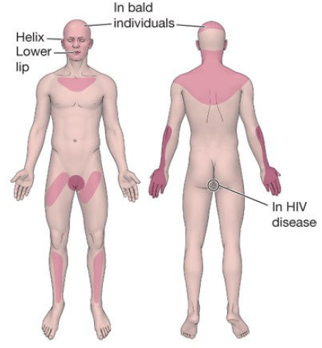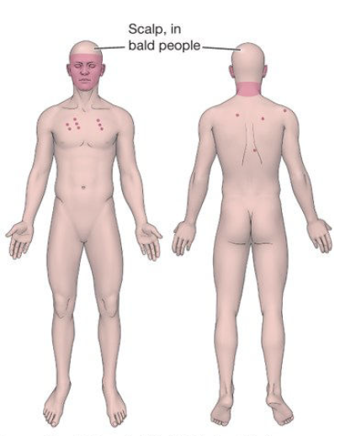  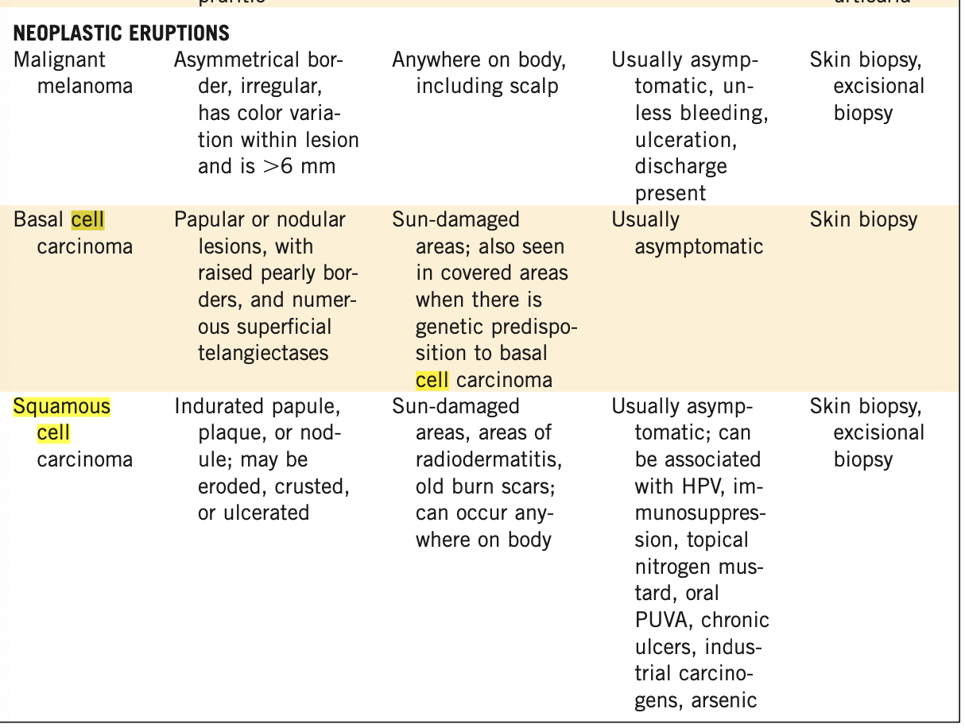
Pathology/cause | SCC: precursor= solar actinic keratosis  - Abnormal cells of the epidermis penetrate the basement membrane and move into the dermis, producing this cancer. Can begin as actinic keratosis with malignant changes  - Often identified in in-situ lesion & can be treated before invasion occurs  BCC:  - Abnormal basal layer cells expand and grow, supported by the surrounding stroma; slow-growing, rarely metastasizes  - Major contributor= UV rays  - Common to have minimally invasive, superficial BCC  Malignant melanoma:  - Abnormal cells proliferate from the melanocyte system, growing superficially and laterally into the epidermis and papillary dermis before growing into the reticular dermis and subcutaneous fat layers  - Malignancy occurs because damaged cells cannot protect themselves from long-term UV exposure  Keratoacanthoma: a variant of SCC  - Sun-exposed area lesions appearing as skin-coloured or red, smooth, dome-shaped papules that grow 1-2cm over a few weeks with crusted interiors (more common in males)  - A common, rapidly growing epithelial tumor with potential for metastasis, but often spontaneously regresses  - Associated with HPV strains 9/16/19/25/37; UVR, chemical carcinogens  - 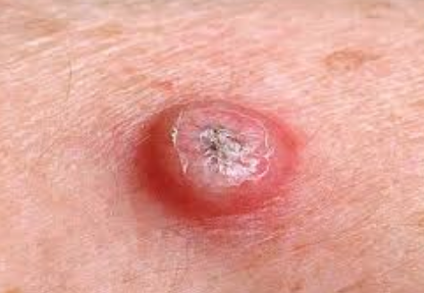  - 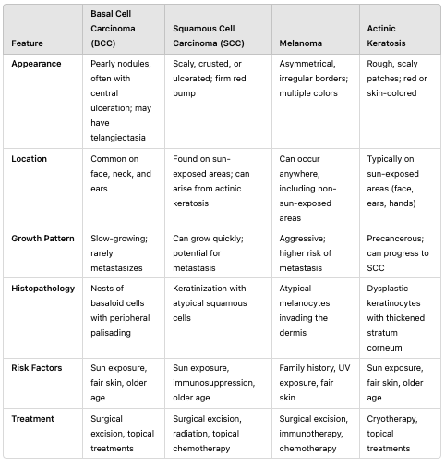
Epidemiology | Skin cancer= the most common cancer diagnosed in Canada each year  - Basal cell carcinoma makes up about 75-80% of all skin cancers in Canada; not common in black and brown individuals
Risk Factors | - UV radiation, tanning bed use before age 30, HPV infection  Age >50, median age 40 for malignant melanoma, UV exposure, fair complexion, smokers (damaged lips), burns or chronic inflammation on the skin, blistering sunburns before age 18
Screening | FULL BODY SCREENING EXAM ONLY IF OF HIGH RISK OTHERWISE NOT NEEDED  (fam hx, sun exposure, previous case, red/light body hair, >50 moles, severe sunburns in childhood, freckles, immunosurpression, hx cancer)
Clinical Presentation | HALLMARK: new lesions on the skin, ulcers that do not heal  Common findings:  SCC:  - Skin lesions in sun-exposed areas or skin damaged by burns/chronic inflammation; Lower lip lesions are common  - SCC in situ= Bowen’s disease  - A chronic, non-healing erythematic patch with sharp, irregular borders occurring on the skin or mucocutaneous tissue resembling eczema but unresponsive to steroids  - Irregular papules with scaly, bleeding, friable, sandpaper surface that grows rapidly  - Onset of pain is often a suggestion of progressing to invasive SCC  BCC:  - Tumors often on the face and neck; nodules >1cm (males>females)  - Shiny, pearly colour with telangiectasia and a centre that caves in  5 types of BCC  - Nodular- pearly, translucent papule, smooth with telangiectasia, firm, well-defined, may have erosions or stipples of melanin pigmentation  - Ulcerating- with a rolled border, translucent, pearly, smooth, telangiectasia, firm  - Pigmented- brown, blue or black; smooth surface that is hard, firm, and may be cystic/umbilicated  - Sclerosing- small patch of morphea or superficial scar, ill-defined, skin-coloured/whitish, with peppery pigmentation; finger-like strands extend into the surrounding tissue (requires wide margins for excision)  - Superficial- thin plaques, pink or red, threadlike border with telangiectasia (only type with scaling); often bleeds  - 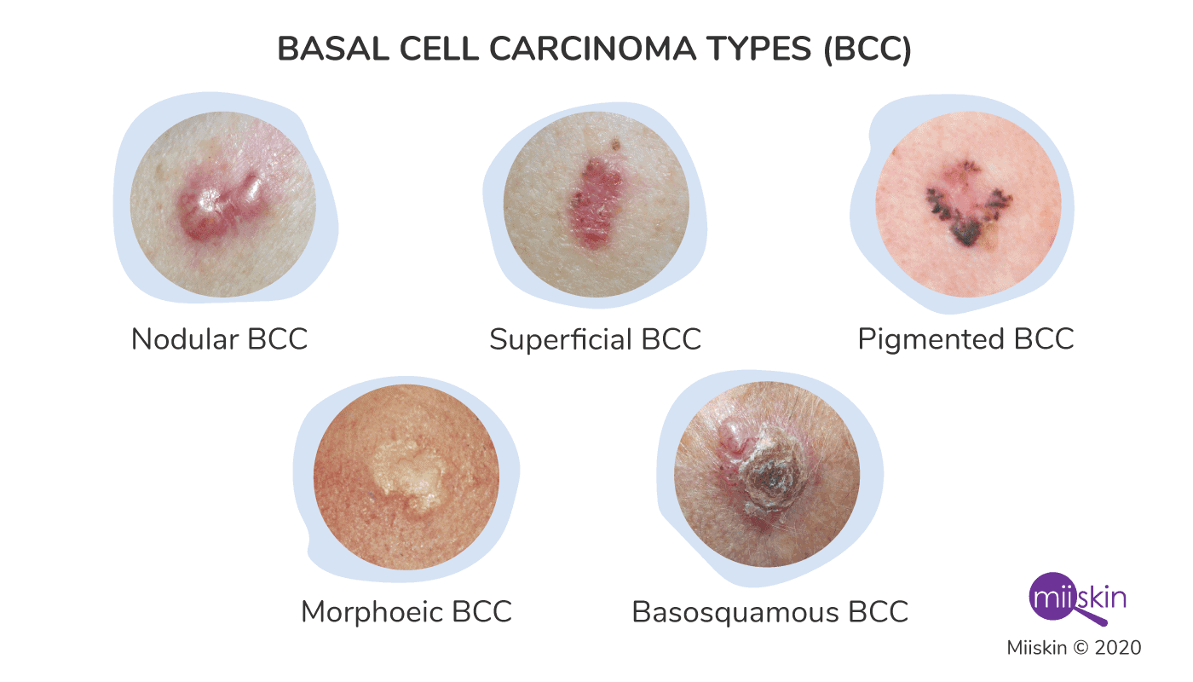  Mnemonic for malignant melanoma= ABCDE (most common is superficial spreading, then nodular)  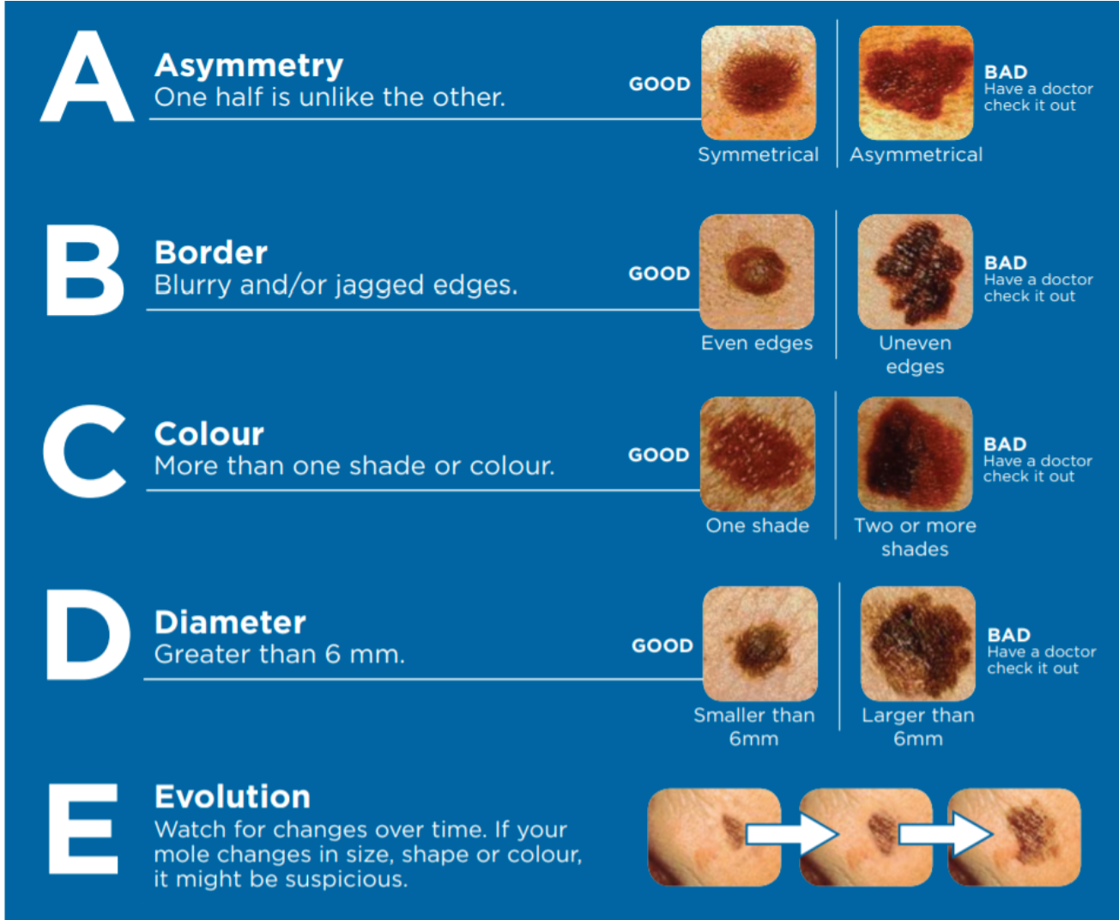
Hx/Key Questions | - When was the lesion first noticed  - Describe any changes in size, colour, or shape  - Are there any new lesions to the body  - Family history of malignant melanoma; personal history of skin exposure to the sun or UV rays  - Smoking history  - Progression with routine cancer screenings  - Trauma to the area  - Flakes? Pain? itchy?  - Family hx  CHAOS AND CLUES…If you see chaos and at least 1 clue=BIOPSY AND REFER ASAP FOR MELANOMA  Chaos: is anything abnormal, ABCDE  Clues:  - Eccentric structureless areas: a highway like area were  - Thick lines: reticular or branched (basket weave)  - Grey/Blue structures  - Peripheral black dots/clods  - Lines (radial and segmental)...usually indicates lentigo melanoma  - White lines (also lentigo)  - Polymorphous vessels  - Lines parallel on the ridges (acral) or lines parallel/charotic on the nails  EXCEPTIONS: You may have chaos and no clues…if changing lesion, bleeding, even if smaller than 6mm may be sus, lesion in head or neck with pigmented circled or/and or dermascopic grey, lesions on acral skin with linear/rigid pattern  acral=friction like hands/feet  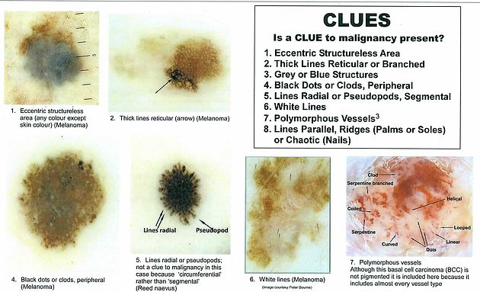
Physical Exam | INSPECT  - Perform full body exam of the skin for lesions  - Note surface, size, shape, border, colour, and diameter of lesions
Diagnostic/  Special Tests | Suspicious lesions should be biopsied…if you think its cancer refer urgency…if unsure and unlikely cancer then biopsy
Red Flags | High risk for development of lesions in the elderly
Differential Diagnosis | SCC, BCC, malignant melanoma, actinic keratosis, solar lentigo, seborrheic keratosis, common nevus, leukoplakia
Treatment/ Management | Counseling/Education  - Importance of early identification of lesions, monthly skin assessments  - Instruct pediatric patients’ parents to use SPF 30 or higher  Complementary Therapies (non-pharmacological)  - Biopsy any suspicious lesions  - Excise lesions with narrow margins, ensuring all margins are included  - BCC should be excised, especially in “danger” areas of the nasolabial area, eyes, ear canals and auricular sulcus, & scalp
Medical management | Monitor progress and change oof detected lesions  - No pharmacologic therapy is required
Referrals | If skin cancer is suspected, all clients should be referred to a dermatologist
Follow-up | In the presence of a diagnosis, examine every month for 3 months, twice per year for 5 years and then yearly
Common Complications | Malignant melanomas can metastasize to any system of the body
Rare types of skin cancer | MERKEL CELL CARCINOMA→ red nodule  - Derived from merkel cells, occurs exclusively in white skin and immunocompromised individuals  - A clear cell in the basal epidermal layer; high rate of recurrence after excision and spreads to lymph nodes in 50% of patients  - Cutaneous or subcutaneous papule, nodule, or tumor 0.5-5cm that is pink/red/violet/brown, dome-shaped, and solitary  - Rapid growth, requires excision
References | Cash & Glass, 90-91

ARTICLES/GUIDELINES READINGS

Cancer Care Ontario (JULIA)
VERY HIGH RISK OF SKIN CANCER (10x that of the general population)
- Individuals who have ANY of the following risk factors…
  - On immunosuppressive therapy after organ transplant
  - Personal history of skin cancer
  - 2+ first-degree relatives with melanoma
  - >100 nevi in total or 5+ atypical nevi
  - Received >250 treatments with psoralen UVA radiation for psoriasis
  - Radiation therapy for cancer received as a child
- Offer these individuals full body skin examinations by a dermatologist on a yearly basis
- Provide counselling for skin-exams and skin cancer prevention
- Closely monitor radiation sites
HIGH RISK OF SKIN CANCER (5x that of the general population)
- Individuals who have 2+ susceptibility factors
  - First degree relative with melanoma
  - 50-100 nevi
  - 1+ atypical nevi
  - Naturally red or blonde hair
  - A tendency to freckle
  - Skin that burns easily, and tans poorly or not at all
- Examine these individuals and counsel them about skin self-examination and skin cancer prevention; HCP trained in screening for skin cancer should see them one a year
- Other factors to consider that may influence skin cancer risk
  - Outdoor occupation, childhood at latitudes under 35 degrees, use of tanning beds during teens and twenties, radiation therapy as an adult
GENERAL POPULATION (not at increased risk for skin cancer)
- No evidence for or against skin cancer screening of the general population at average risk
- Routine total body skin examination and routine counseling on skin self-examination is not recommended for average or low risk individuals

Sun-protective Behaviours in populations at high risk for skin cancer (JULIA)
Most common skin cancers= BCC & SCC
Most common cause of skin cancer death= malignant melanoma
Most common skin cancer carcinogen= UV radiation exposure
Primary prevention measures…
- Decrease sun exposure; Decrease tanning bed use; Increase use for sun protection
Secondary prevention measures…
- Early detection screening programs

Organization-Specific Sun Protection Guidelines
Canadian Cancer Society | World Health Organization
Plan outdoor activities before 11am and after 3pm or when UV <3 | Limit time in the midday sun (10am-4pm)
Find shade or use an umbrella | Watch for the UV index
Cover up with loose-fitting, tightly woven and lightweight clothing, a hat, SPF 15+ broad-spectrum and SPF 30 for being outside most of the day | Use shade wisely
Wear sunglasses | Wear protective clothing- wide brim hat, sunglasses, tightly woven, loose-fitting clothing
Don’t use indoor tanning beds | Use sunscreen, broad-spectrum SPF 15+ and reapply every 2 hours or after working, swimming, playing, or exercising
Don’t use indoor tanning beds | Avoid sunlamps and tanning parlors

Importance of preventive behaviour…
- Increased sunburns in childhood, adolescence, and adulthood all increase melanoma risk
- UV avoidance in general is the most common practice of primary prevention
At-risk populations…
- Previous history of skin cancer
- Family history of melanoma
- Fair skin, freckling, sunburn tendency, high nevi count, atypical nevi, red/blonde hair
- Organ transplant history with immunosuppressive therapy

Cutaneous Malignant Melanoma: A Primary Care Perspective. (JULIA)
CMM= Cutaneous malignant melanoma; 3-5% of skin cancers, 75% of skin cancer deaths
- Incidence in highest in white individuals (20x more likely to develop melanoma than black individuals)
- Only 2% of melanomas occur in individuals <20 (0.3% in children <14)
- Most common cancer for women aged 25-29
Diagnosis…
- Can occur in a de novo or pre-existing nevus
- Some studies argue that the “E” in the ABCDE mnemonic is the most significant finding indicating melanoma
- Ugly duckling sign= the fact that a melanoma will look COMPLETELY different than surrounding nevi
- Dermoscopy is extremely important in detecting melanomas, increasing accuracy by 10-27%
- Biopsy any suspicious pigmented lesion
  - Elliptical excision is generally preferred for lesions with small margins in normal-appearing skin
  - Document dimensions of the lesion and the surgical margins
  - Saucerization/scoop shave biopsy and punch biopsy can also be used
  - Avoid scoop shaves in pigmented lesions because the depth of the CMM is important for staging and prognosis
Types of Melanomas…
- Melanoma in situ
- Superficial spreading melanoma
- Nodular melanoma
- Lentigo maligna/lentigo maligna melanoma
  - Treatment is challenging; up to 50% recurrence with excision margins of 0.5-1cm
  - Mohs micrographic surgery offers high cure rates with sparing of the surrounding tissue
    - Uses immunohistological staining of the tissue to identify melanocytes
    - Access is uncommon; not the standard of care
- Amelanotic melanoma
- Acral-lentiginous melanoma
- Subungual melanoma

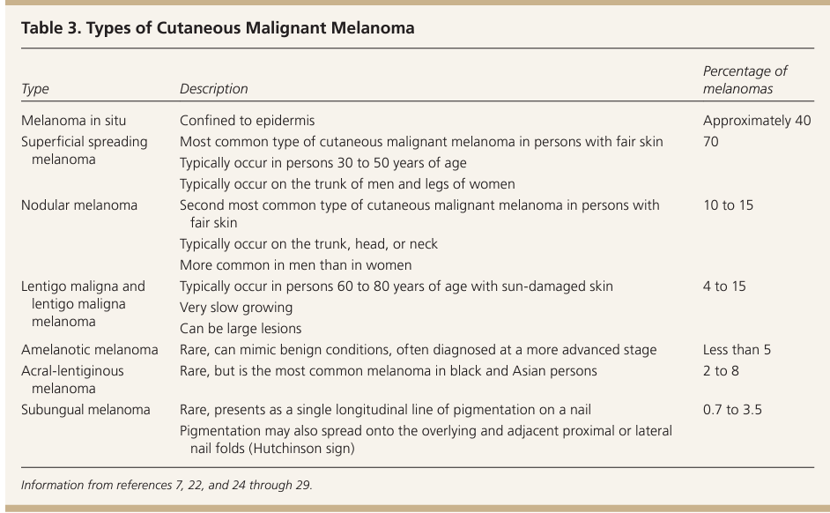

Surgical Treatment…
- Removal is the primary treatment for CMM
- Use the Brerslow depth of the lesion to determine definitive surgical margins to ensure complete removal of the lesion and residual cells
  - Previous studies show no difference in survival for 5cm vs 2mm margins
- Surgical treatment should occur no later than 3-4 weeks after biopsy report is received
- If Breslow's depth is 1mm or more
  - Refer for sentinel node biopsy→ wherever the tumor is likely to spread to first
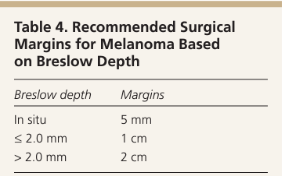
TNM staging is used to classify based on thickness, degree of nodal involvement, and metastatic spread
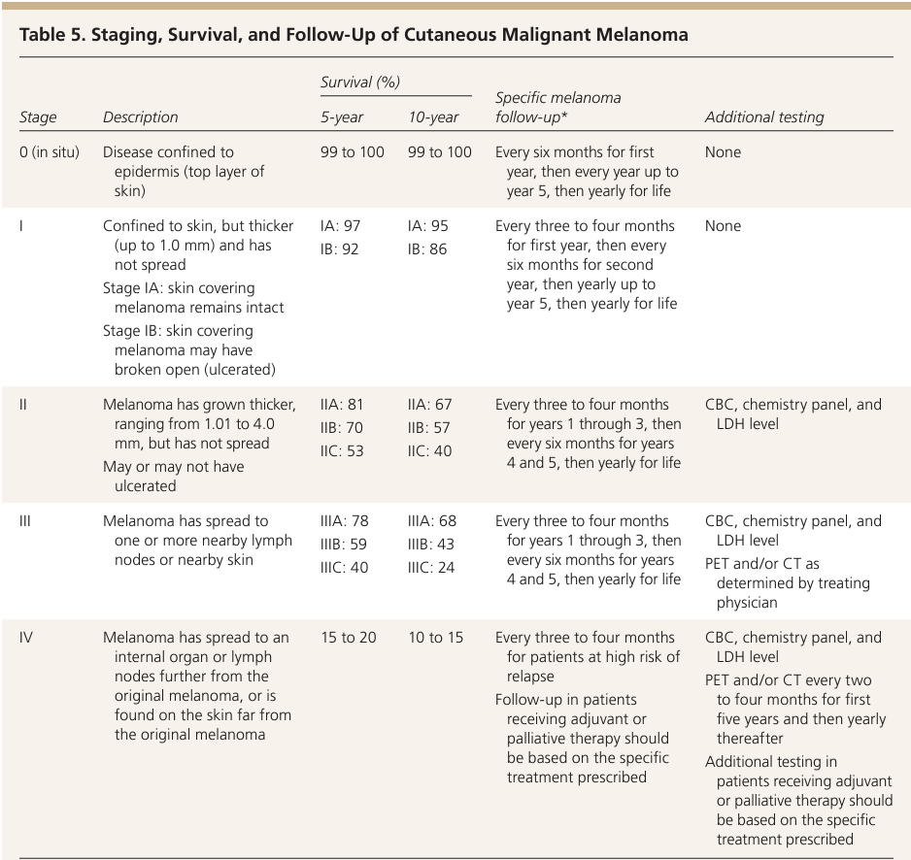

Prevention and Management of Pressure Injuries.

- There are three guiding principles within the best practice recommendation papers (BPRs) that support effective prevention and management of skin breakdown:
  - 1. the use of the Wound Prevention and Management Cycle regardless of the specifics to prevent and manage skin breakdown
  - 2. the constant, accurate and multidirectional flow of information within the team and across care settings
  - 3. the patient as the core of all decision making
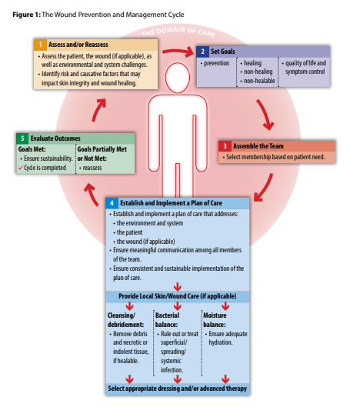
The quick reference guide below provides the recommendations associated with the five steps in the Wound Prevention and Management Cycle. 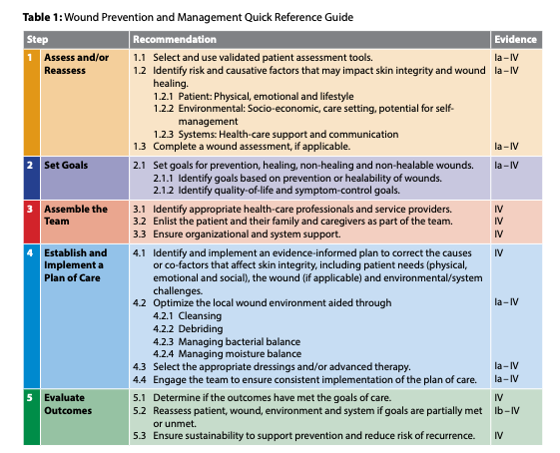
Step 1: Assess and/or Reassess
- Use Validated Assessment Tools:
  - Select a validated pressure injury risk assessment tool (Norton, Braden, Waterlow, SCIPUS) based on the care setting.
  - Develop care plans based on the tool’s subscale scores, identifying specific risk factors contributing to pressure injury development.
- Consider Intrinsic and Extrinsic Risk Factors:
  - Assess intrinsic factors like neurological deficits, advanced age, hydration status, peripheral vascular disease, and consciousness level.
- Special Populations:
  - Use specific assessment tools for particular populations. Ensure the same tool is used consistently for follow-up assessments.
- Nutritional and Pain Assessment:
  - Screen for nutritional deficiencies using validated tools (e.g., Mini-Nutritional Assessment). Malnutrition can significantly delay wound healing.
- Quality of Life (QoL) Assessment:
  - For non-healing or slow-to-heal pressure injuries, use a validated QoL tool to identify lifestyle or psychological factors interfering with patient participation in care.
- Wound Assessment Using the MEASURE Tool:
  - Apply the MEASURE mnemonic to guide wound assessment:
    - Measure (size of wound),
    - Exudate (type and amount),
    - Appearance (tissue types and color),
    - Suffering (pain level),
    - Undermining (or tunneling),
    - Re-evaluate (wound progress),
    - Edge (condition of wound edges).
Step 2: Set Goals
- Establish Goals Based on Wound Status:
  - Set goals for prevention, healing, non-healing, or non-healable wounds, tailored to the patient’s condition and potential for recovery.
  - For healable wounds, focus on reducing wound size, decreased pain, and alleviation of smell or discharge.
  - For non-healable or non-healing wounds, focus on symptom management, including controlling exudate and pain.
- Address Healability Factors:
  - Determine if intrinsic or extrinsic factors like poor blood supply, malnutrition, or co-morbidities affect healing potential.
  - In cases of inadequate blood supply, terminal illness, or other unmodifiable factors, recognize that wound closure may not be realistic, and classify the wound as non-healable.
- Prioritize Quality-of-Life and Symptom Control:
  - Set goals that enhance patient quality of life, especially for those with non-healable wounds.
  - For terminally ill patients, prioritize comfort, symptom control, and dignity over aggressive treatment.

Step 3: Assemble the Team
- Identify Health-Care Professionals:
  - Assemble a multidisciplinary team to address the complex factors contributing to pressure injuries. .
- Engage Patients and Their Families:
  - Involve the patient, their family, and caregivers as integral members of the team.
- Ensure Organizational Support:
  - Organizations should allocate sufficient financial and human resources to support pressure injury prevention and management programs. This includes access to necessary equipment like moisturizers, skin barriers, and therapeutic devices.
  - Conduct needs assessments to identify knowledge gaps and tailor education

Step 4: Establish and Implement a Plan of Care
- Evidence-Informed Plan:
  - Create a patient-centered treatment plan that addresses the physical, emotional, and social needs of the patient while correcting factors that affect skin integrity.
- Managing Pressure, Friction, and Shear:
  - Focus on minimizing pressure, friction, and shear forces, which are critical in preventing and managing pressure injuries.
- Access to Equipment:
  - Ensure that all care facilities have the necessary equipment to meet patient needs, such as repositioning sheets, pressure management cushions, and therapeutic devices. Care providers should be trained on the proper use and maintenance of this equipment.
- Patient Education:
  - Educate patients and caregivers about daily skin inspections, repositioning techniques, pressure management strategies, and the importance of nutrition and hydration in healing.

Step 5: Evaluate Outcomes
- Outcome Assessment:
  - Use validated tools to determine if the care plan's goals have been met. For preventive measures, the ultimate goal is to avoid pressure injuries; for existing wounds, signs of healing should be evident within two weeks.
- Reassessment if Goals Are Unmet:
  - If outcomes do not meet expectations, reassess the patient, wound, and environmental factors. Adjust the treatment plan as needed to address underlying causes and optimize care.

Best Practice Recommendations for the Prevention and Management of Skin Tears (JULIA)
Who is at risk for skin tears?
- The extremes of ages (neonates, older adults)
- Critically and chronically ill patients
The Wound Prevention and Management Cycle…
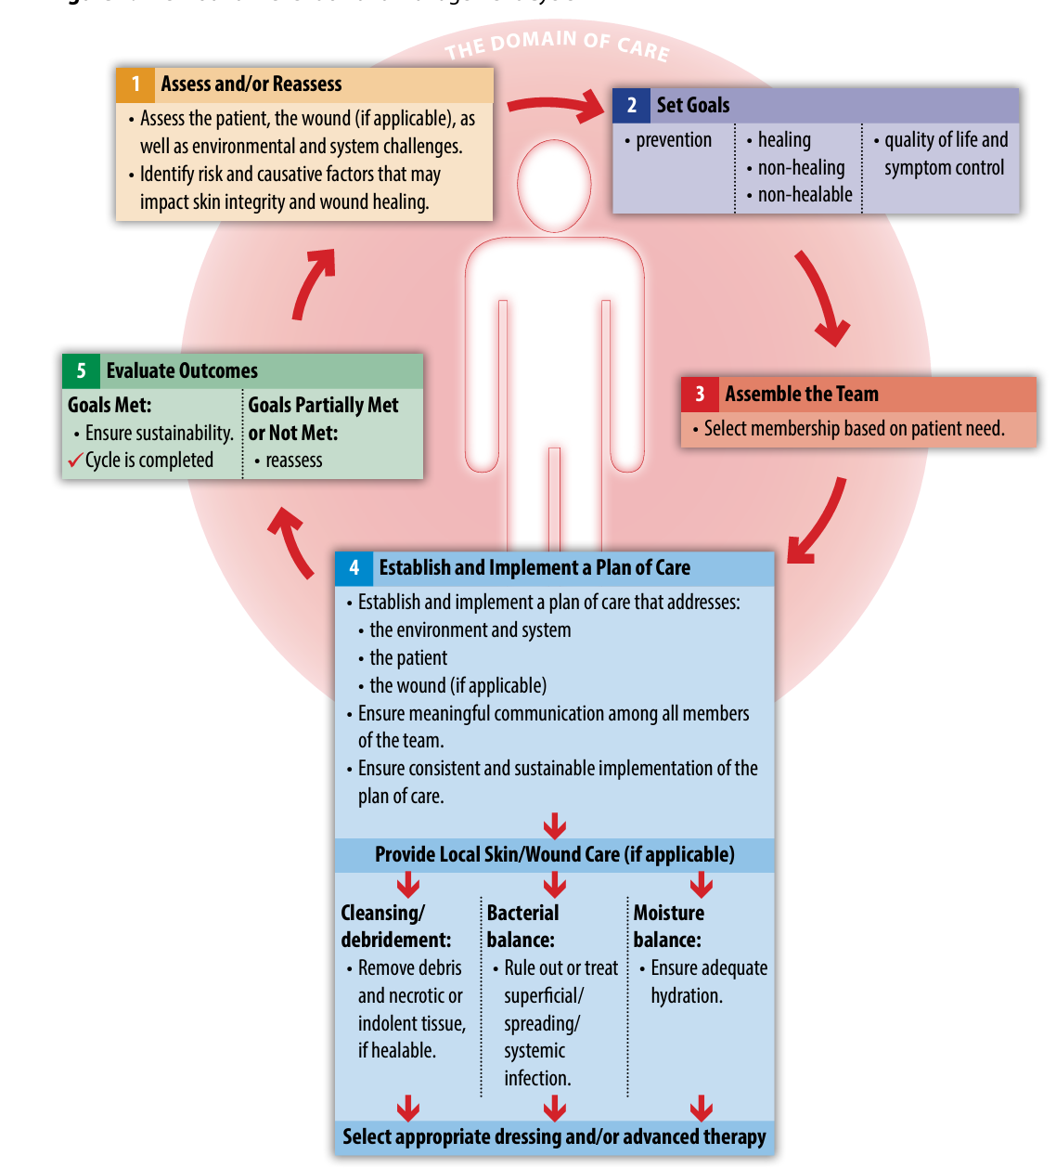

STEP 1: ASSESS
- Ensure validated patient tools are being used to assess
  - General health, mobility, and skin (if any are at risk, implement a tear reduction program)
- Identify causative factors that impact skin integrity and wound healing (physical, emotional, lifestyle)
  - Examples= cognitive impairment, nutrition concerns, polypharmacy, falls risk
  - Increased risk of skin tears from adhesive removal in preterm infants (minimal stratum corneum)
    - Lack of subcutaneous tissue; dermis lies directly over muscle
- CLASSIFICATION by type
  - 1= no skin loss; 2= partial skin loss; 3= total flap loss
STEP 2: SET GOALS
- Primary goal is prevention of future skin tears; goals should be based on healability of the wound
- Wounds may be healing, non-healing (e.g. In presence of uncontrolled edema), or non-healable (terminal disease, end of life status)
STEP 3: TEAM
- Include patient and caregivers, relevant HCPs, engage patient and families, as well as organizational and system support
STEP 4: ESTABLISH/IMPLEMENT PLAN OF CARE
- Incorporate prevention strategies such as creating safe patient environments, involving OT/PT, minimizing polypharmacy, optimizing nutrition, assisting with ADLs, recognizing risks for skin tears in each patient
- Optimize the local wound environment by controlling bleeding, cleansing, debriding
  - Manage bacterial balance, wound moisture, selecting appropriate dressings, assessing for tetanus risk
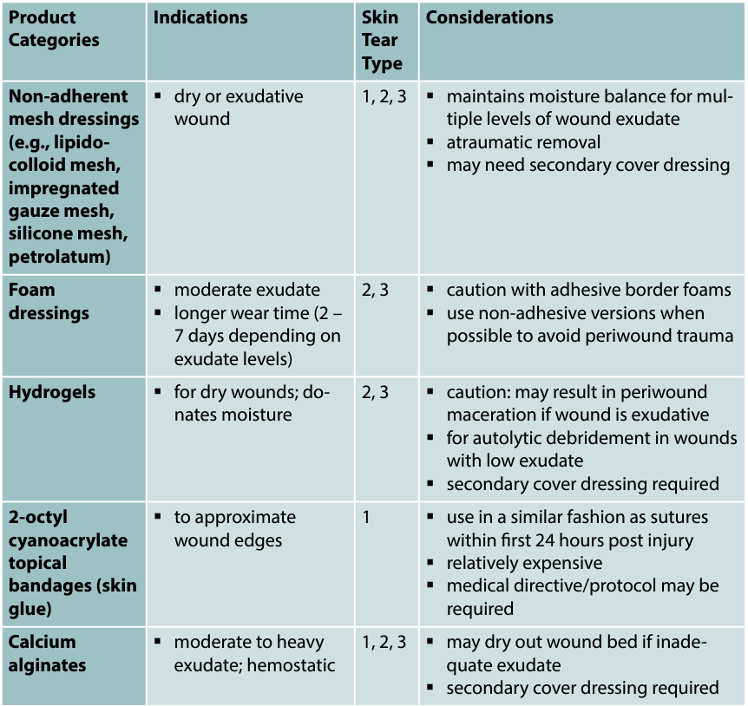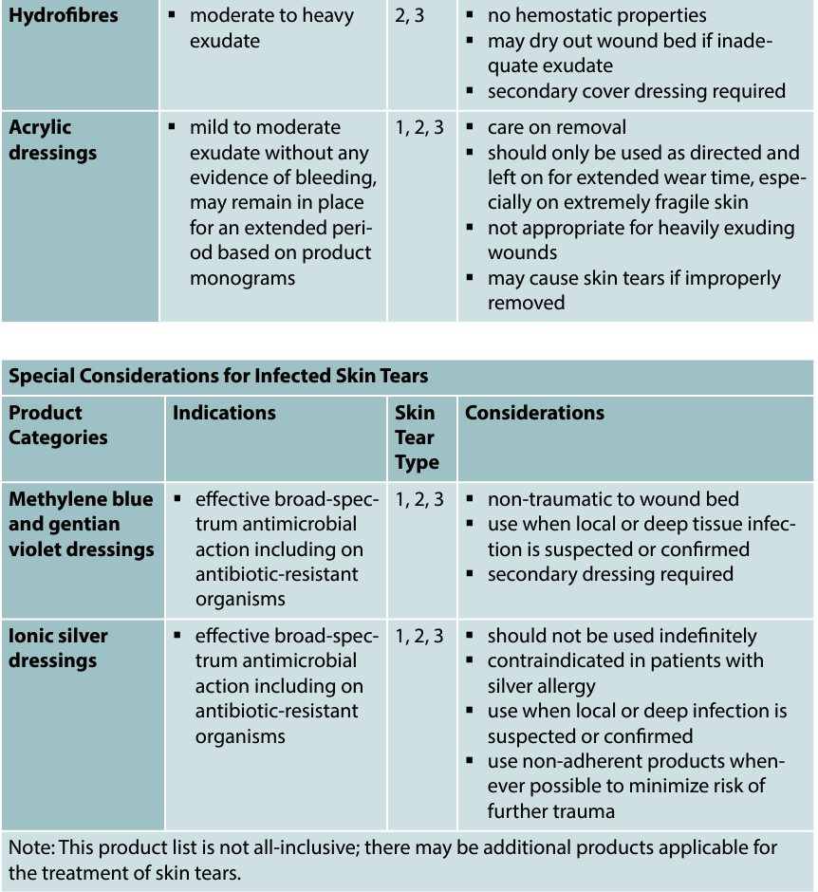
Products that should not be used for skin tears…
- Iodine based dressings (too drying)
- Film/hydrocolloid dressings (too adhesive)
- Sutures and staples are not recommended for use in fragile elderly patient skin
- Topical glue for pediatrics is faster and less painful than sutures/staples
*Important to control peripheral edema and rule out any chance of peripheral vascular disease

STEP 5: EVALUATE OUTCOMES
- Re-assess wound, environment, etc. and whether or not goals were met
- Support prevention and risk reduction, to avoid recurrence

Best Practice Recommendations for the Prevention and Management of Wounds- Wounds Canada

Step 1: Assess and Reassess
Assessment includes evaluating the patient's health history, current physical and emotional state, skin condition, and environmental factors such as socio-economic status and access to healthcare.
- Patient Participation: Encourage patients to actively participate in their assessment.
- Assessment Tools: Use validated assessment tools to predict risks for skin breakdown and monitor healing.
- Gather comprehensive information on:
    - Overall health (e.g., weight changes, comorbidities)
    - Medication history and allergies
    - Lifestyle factors (e.g., smoking, physical activity)
    - Physical function and mobility
    - Nutrition and hydration
    - Psychological and psychosocial factors (e.g., stress, support systems)
- Assess pain systematically, considering types (nociceptive and neuropathic) and factors affecting pain experience.
- Conduct a thorough skin assessment, looking for signs of dehydration, maceration, bruising, and pressure injuries.
- Assess socio-economic factors affecting care, such as income, employment, and access to resources.
- Evaluate healthcare systems, including access to services and communication.
- Use standardized assessment tools to enhance communication and care planning.
- Regular reassessment is crucial if initial care goals are not met.

Step 2: Set Goals
- Patient-Centered Goals: Goals should be aligned with the patient’s health and lifestyle to ensure they are achievable.
- Dynamic Nature of Goals: Goals may change over time based on the patient’s condition and available support.:
- Establish Goals Based on Wound Status:
  - For Intact Skin: Create preventative care goals to avoid skin breakdown.
  - For Healing Wounds: Set goals that promote healing
  - For Non-Healing Wounds: Develop goals that address the situation where healing is possible but not supported by patient choices or healthcare resources.
  - For Non-Healable Wounds: Focus on supportive care goals for patients unable to heal.
- Identify Quality-of-Life and Symptom-Control Goals:
  - Address goals that enhance daily functioning and emotional well-being, such as:
    - Stabilizing wounds
    - Reducing bacterial load
    - Minimizing dressing changes
    - Managing symptoms like pain and odor
    - Supporting a return to normal routines

***Steps 4-5 are the exact same as the BPG Prevention and Management of Pressure Injuries. I have listed some helpful diagrams below from the BPG on wound care/dressings.

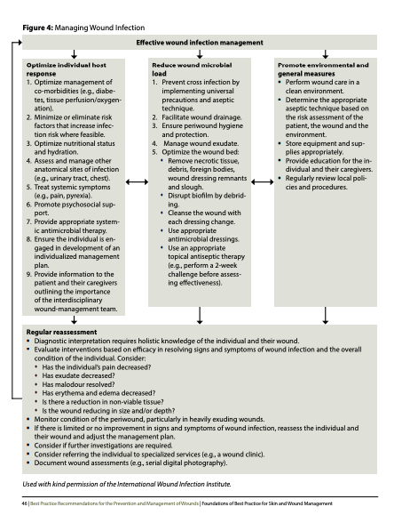
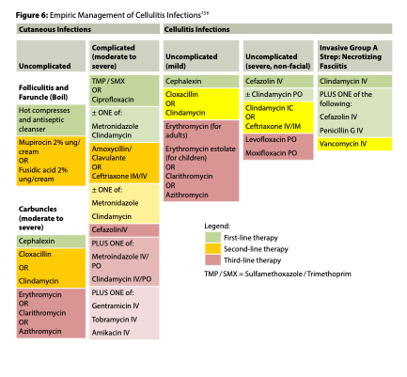
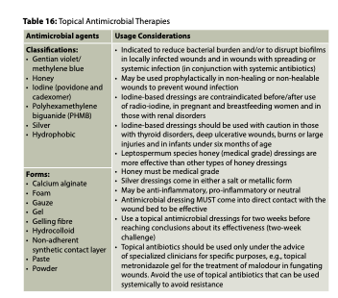
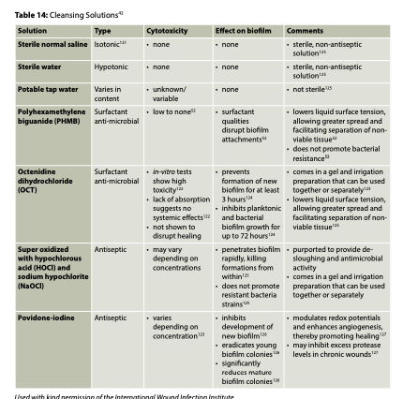
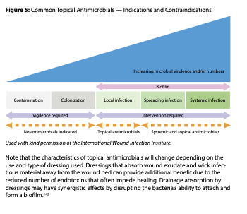
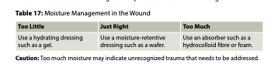

Lacerations - StatPearls (JULIA)
Lacerations= a pattern of injury where the skin and underlying tissue is cut or torn
4 Stages of wound healing…
- Hemostasis
  - Immediately; contraction of smooth muscles, platelet aggregation, clotting cascade
- Inflammation
  - Immediate to 30 days; neutrophils, macrophages, phagocytosis
- Proliferation
  - Day 7 to weeks; angiogenesis, fibroblasts, collagen laid down
- Maturation
  - Lasts up to 6-12 month; collagen is remodeled, scar flattens, erythema resolves
Patient History…
- Time of initial injury
- Location of laceration (extremity injuries have increased risk of infection)
- Measure the laceration (length, width, depth); as it gets larger, risk of infection increases
- Mechanism of injury (crush, sharp object, shear from a fall)
  - Higher risk of infection and scarring with crush injuries
- Age (poor healing at the extremes of age)
- PMHx→ diabetes, chronic renal failure, obesity, malnutrition, immunosuppression/chemotherapy
- Allergies→ latex, anesthetics, antibiotics
- Immunization status→ tetanus vaccine history
Category | Clean Wounds | Dirty/Complex Wounds
Adults with 3+ tetanus doses | Tdap or Td only if >10 years since last vaccination | Tdap or Td if >5 years since last vaccination
Adults with < 3 tetanus doses | Tdap or Td required | Tdap or Td required  Add immunoglobulin
Children < 7 | DTaP recommended  If pertussis is contraindicated, give DT vaccine
Children 7-9 | Td vaccine recommended
Children 10+ | Tdap is preferred if patient has never received it and has no contraindications  Use Td if age is a contraindication

Contraindications to Laceration Repair…
- Bite wounds
- Overt infections of nearby skin
- Lacerations >24h old
Preparing to care for any laceration→ LACERATE
- Look at the wound to assess repair options
- Anesthetize the wound
- Clean the wound (irrigate it to allow for complete visualization)
- Equipment setup
- Repair the wound
- Assess the results/anticipate complications
- Tetanus immunization
- Educate patients about wound care
Techniques for Reducing Discomfort…
- Buffer the solution at a rate of 9mL lidocaine, 1mL 8.4% sodium bicarbonate
- Warm the anesthetic, use small needles >27 gauge, infuse anesthetic slowly, inject through edges of clean wounds vs creating new punctures
- Use topical anesthetics like EMLA or tAC before infiltration
- Place ice within a sterile glove over the injection site for 2 min before injection to reduce pain

Simple interrupted sutures | Versatile; good choice for most wounds
Horizontal/vertical mattress sutures | Can evert wound edges  Increased risk for scar formation
Deep sutures | Reduces tension on superficial sutures to help reduce future scarring  Increased risk of infection; ensure wound is fully clean first

Suture Removal Timelines
*Slightly earlier in children if possible
Face | 3-5 days
Scalp and arms | 7-10 days
Trunk, legs, hands, feet | 10-14 days
Palms and soles | 14-21 days
Complications= missed foreign body/tendon injury/nerve injury, infection, wound dehiscence

Human Bites - Treatment and Management. (only section called approach considerations)

Essentials of treatment include inspection, debridement, irrigation and closure if indicated
Prevent severe complications by:
- Culture for aerobes and anaerobes if abscess, severe cellulitis, devitalized tissue, or sepsis is present
- Use saline solution for wound irrigation; 100-200ml of irrigation solution/inch of wound; 19-G blunt tip and 35mL syringe = 7psi pressure; iodine indicated if presumed rabies
- Debride necrotic tissue and remove any foreign bodies
- If fracture or bone penetration has occurred, radiography is indicated (MRI or CT may also be indicated)
- Initiate prophylactic antibiotics in selected cases (based on type and specific animal species involved)
- If methicillin-resistant Staphylococcus aureus (MRSA) is suspected, first-line antibiotics include trimethoprim-sulfamethoxazole, doxycycline, minocycline, and clindamycin ^{[27]}
- Hospitalization is indicated if fever, sepsis, spreading cellulitis, severe edema, crush injury, or loss of function is present
- Administer tetanus booster (if none given in past year) or initiate primary series in nonvaccinated individuals
- Assess the need for rabies vaccine and immunoglobulin
- Primary Closure: only after cleansed effectively; Mammalian bites (dog, cat, human) 6-8% infection rate if closed; face wounds low risk of infection when closed primarily due to increased vascularization therefore recommended
- Secondary Closure: wounds to hands, lower extremities with delay presentation (>8-12 hours) or immunocompromised left open or treated by delayed primary closure

Animal Bites in Emergency Medicine Treatment & Management. (only section called emergency department care)

Inspection:
- Carefully inspect bite wounds for deep injury and devitalized tissue.
- Proper inspection without anesthesia is difficult; anesthesia is recommended.
- Ensure the wound is visualized completely, possibly through a range of motion.

Debridement:
- Essential for infection prevention by removing devitalized tissue, particulate matter, and clots.
- Clean, surgical wound edges promote faster healing and reduce scarring.

Irrigation:
- Key method for preventing infection.
- Use a 19-gauge blunt needle and a 35-mL syringe to create enough pressure (7 psi) for cleaning.
- General recommendation: 100-200 mL of irrigation solution per inch of wound; more for heavily contaminated wounds.
- Irrigation solutions:
  - Preferred: Isotonic sodium chloride solution or tap water (effective, inexpensive).
  - Povidone-iodine solution (diluted 10-20:1) for rabies concerns (CDC recommendation).
- Shield devices should prevent the irrigation solution from returning to the wound.

Small Puncture Wounds:
- Small puncture wounds (e.g., from cat bites) are harder to irrigate and have a higher risk of infection.
- Consider opening the wound with a No. 15 scalpel (1-1.5 cm incision) to allow for better irrigation and healing by secondary intention.

Closure:
- Infection rate for mammalian bites is around 6-8% when wounds are closed primarily.
- Primary closure (sewing the wound shut) is generally safe for facial wounds due to better blood supply and low infection risk.
- Consider primary closure only for well-cleansed wounds.
- Wounds on hands, lower extremities, delayed presentations (>8-12 hours), or in immunocompromised patients should be left open or closed later (delayed primary closure).
- Avoid deep sutures, which can promote infection.

Hand Wounds:
- Immobilize with bulky dressing or splint to limit movement and encourage elevation.

Prophylaxis:
- Consider tetanus and rabies prophylaxis for all bite wounds.
- Antirabies treatment may be needed for bites from animals with uncertain rabies status (e.g., wild animals).

Wound Management:
- Culture: For aerobes and anaerobes if abscess, cellulitis, devitalized tissue, or sepsis is present.
- Irrigate: Use saline solution.
- Debride: Remove necrotic tissue and foreign bodies.
- Imaging: Perform radiography (or MRI/CT if needed) for fractures or bone penetration.
- Antibiotics: Consider prophylactic antibiotics for certain cases based on bite type and animal species.
  - If MRSA is suspected, use first-line antibiotics like trimethoprim-sulfamethoxazole, doxycycline, minocycline, or clindamycin.
- Hospitalization: Required for fever, sepsis, spreading cellulitis, severe edema, crush injury, or loss of function.
- Tetanus: Give a tetanus booster if none has been administered in the past year.
- Rabies: Assess the need for rabies vaccine and immunoglobulin

Outpatient Burn Care: Prevention and treatment. American Family Physician (JULIA)
Prevention
- Identify high-risk populations and common mechanisms of injury
- Vulnerable
  - Young children (¼ of burns occur in children under age 15)
    - Sunburns are the most common and preventable type of burn
    - Scalds occur most often in children <5 due t spilled hot liquids during cooking
    - Bathing-related scalds occur in sink baths
  - Older adults
    - Due to thinned skin, cognitive decline, decreased sensation, comorbidities
    - The least likely group to be targeted for burn prevention programs
- A 5 minute educational video to parents and older adults can increase home safety knowledge

Burn Prevention Strategies
Children | Older Adults
Avoid using tablecloths and placemats | Kitchen Safety  - Consider automatic devices for stove power control  - Easy access to fire extinguishers  - Turn pot handles inwards  - Wear tight clothing and avoid long sleeves
Use anti scald devices or thermometers
Do not hang dish towels on the oven door
Block access to high-risk areas like kitchens and bathrooms with gates or child locks | Bathroom Safety  - Check water temperature before washing  - Install anti-scald devices to stop hot water flow  - Install railings and easy-access tubs/showers; obtain assistance PRN  - Set water to 120 F/48.9 C or less
Do not heat formula in a bottle, never microwave bottles
Do not run water while a child is being bathed; do not bathe in sinks; supervise all baths
Keep all chairs away from the stove and counters | Home Safety  - Avoid space heaters and candles  - Ensure cords, appliances and outlets work  - Ensure heat pipes are covered  - Install smoke and CO detectors on every level of the home and in all bedrooms
Keep chemicals, matches, lighters locked up or out of reach
Set water to 120 F or lower, keep small children’s foods below 101 F
Test all foods and liquids that have been microwaved before giving to children
Use oven locks

Assessment
- Options for estimating TBSA (not including superficial burns)
  - Rule of 9s (faster)
  - Lund and Browder charts (more accurate in both children and adults)
  - Palm method (palm= 0.5% TBSA; including fingers= 1%)
    - Can overestimate in cases of large burns
Diagnosis
Superficial Burns
- Painful, erythematous, dry, blanching
- Do not blister; take 3-6 days to heal
Partial thickness Burns
- Superficial partial thickness
  - Exudative, blanch with pressure, may blister, painful
  - Heal within 3 weeks
- Deep partial thickness
  - Involves the reticular dermis, drier, does not blanch
  - Takes >3 weeks to heal
  - Loss of dermal layer and scarring occurs
- Full thickness burns
  - White, waxy, dry, leatherry
  - Pain sensation is reduced due to destroyed nerve endings

WEEK 5/6 CARDIOLOGY

Congestive Heart Failure (CHF)
https://www.youtube.com/watch?v=AScf1Z40lng&ab_channel=khanacademymedicine
https://www.youtube.com/watch?v=VoXbwlm8sY8&t=1479s
Def’n | A condition in which the heart is unable to pump enough blood to meet the metabolic needs of the body.
Pathology/Cause  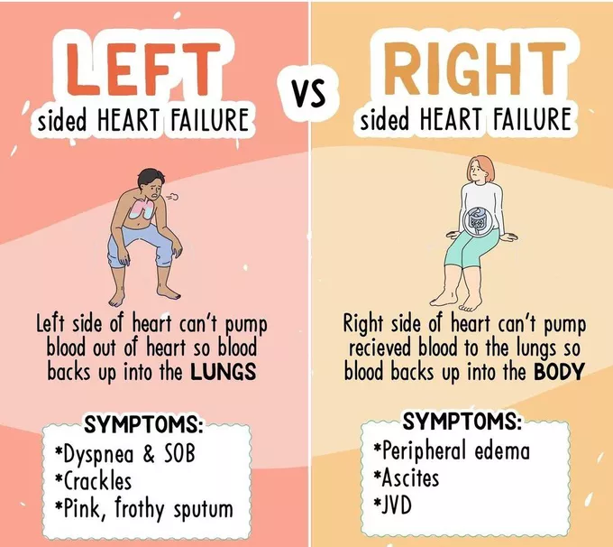 | Predisposed by injury (ex. ischemic heart disease, HTN and valvular heart disease).  As the heart’s ability to pump is reduced, several cardiac compensatory mechanisms occur:  - Cardiac dilation to increase cardiac output by the Frank-Starling mechanism.  - Ventricular hypertrophy develops to handle the greater preload, and hyperplasia develops to maintain cardiac output by increasing contractility.  - Initially, these cause improvement, but over time the heart decompensates, and functioning is compromised.  - Results in decreased cardiac output resulting in activation of the SNS and RAAS, leading to sodium and water retention, increases preload and afterload, tachycardia & perpetuates a cycle of increasing cardiac demand and decompensation.  Left Ventricular Systolic Dysfunction (LVSD/HFrEF): preserved filling, impaired emptying due to decreased contractility, chamber dilation, and hypertrophy.  Ventricular diastolic dysfunction (preserved EF/HFpEF): normal emptying but stiffening of the ventricles with resultant impaired diastolic relaxation, filling and elevated LVEDP at rest or during stress.  Right Heart Failure: inability of the right ventricle to provide adequate blood flow into the pulmonary circulation at a normal central venous pressure. Increased pulmonary resistance (afterload) causes the right ventricle to dilate, which decreases contractility. Blood begins to backup into the systemic venous circulation.  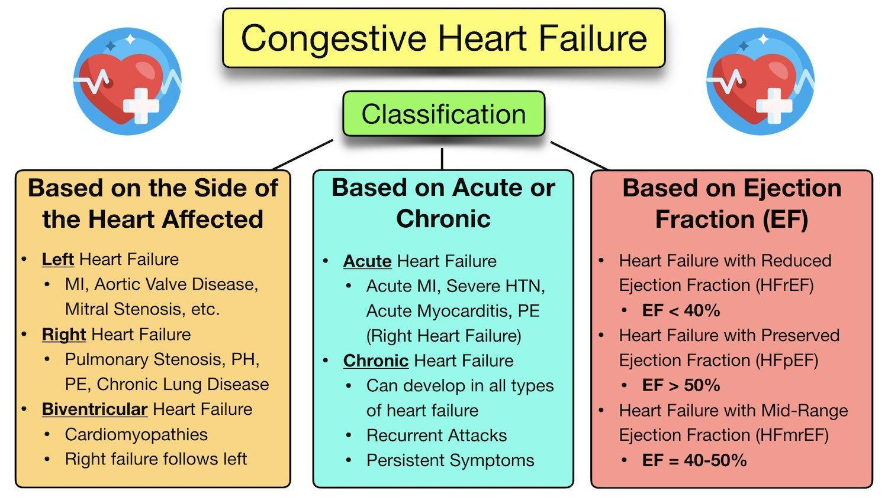
Risk Factors/Epidemiology | HFrEF incidence is higher in older women, chronic hypertension, obesity, cardiomyopathy, excessive alcohol use, end-stage chronic obstructive pulmonary disease, valvular disorders, anemia, renal failure, atrial fibrillation, coronary artery disease, or diabetes. Mortality rate is high as greater than 50% die within 5 years of diagnosis.  Other risks include age, dyslipidemia, hypertension, ischemic heart disease, obesity, smoking, atrial fibrillation, chemotherapy, chest radiation, family history of cardiomyopathy, substance abuse (alcohol, cocaine, amphetamines), valvular heart disease  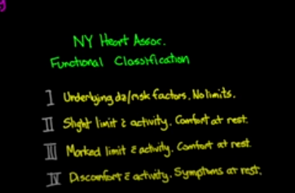
Clinical Presentation | Symptoms of CHF:  - FATIUGE***********  - Bendopnea (shortness of breath when leaning forward)  - Cough  - Dyspnea on exertion  - Hemoptysis  - Exercise intolerance  - Cough  - Edema/Weight gain  - Fatigue  - Paroxysmal nocturnal dyspnea (PND)  - Orthopnea  Signs of CHF  Specific  Elevated jugular venous pressure (JVP)  Hepatojugular reflux (HJR)  Laterally displaced apical impulse  Third heart sound (S3)  Less Specific  Cold extremities  Peripheral edema  Pulmonary rales  Tachycardia  Unintentional weight gain (/2-3 pounds (about 1-1.5 kg) in a single day or 5 pounds (about 2.3 kg) over a week)  )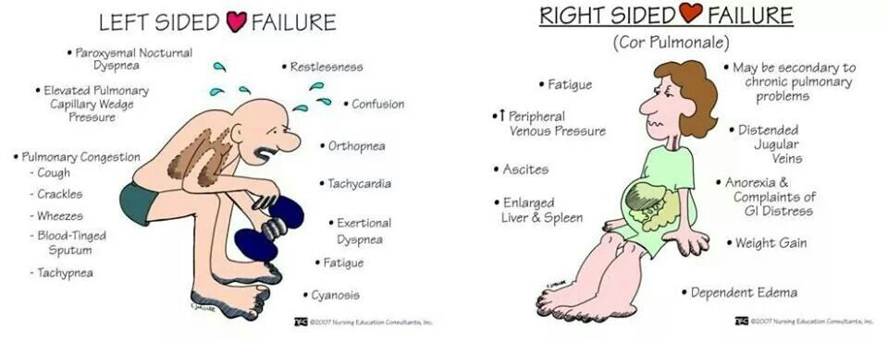  3lbs in 1 days, 1 lbs each over 3 day
Hx/Key Questions | Symptoms, functional limitations, history of cardiac disease, risk factors, exacerbating factors, comorbidities, medications  Ever treated for cancer to rule out lymphedema
Physical Exam | - Vital signs: HR, BP, Respirations, height & weight (BMI)  - Weight gain on subsequent visits  - Inspect skin (pallor, cyanosis, temperature), neck (jugular vein distension), extremities (edema, cyanosis, pallor and ulcers), JVD  - Auscultate heart (murmurs, tachycardia, S1, S3, S4 gallops), lungs (moderate to severe crackles/rales and other abnormal sounds), and neck/carotid arteries  - Palpate abdomen (hepatomegaly and HJR), extremities (peripheral pulses), Chest wall (displaced point of maximal impulse (PMI), lifts, heaves, thrills  - Inspect for ulcers on extremities  - Mental status (confusion, especially in older adults)  - JUGULAR VEIN PRESSURE  - ABDO ASSESSMENT TO RULE OUT DIFFERENTIALS IF DISTENDED  INSPECT:  - VS, H&W, BMI  - Skin (pallor, cyanosis, JVD, edema in extremities, pallor, ulcers  PALPATE  - Abdo for hepatomegaly, pulses at extremities, PMI, heaves/thrills  AUSCULTATE:  - Heart for murmurs, S1, S2, 2 heart valves, carotid arteries and bruits, lungs for crackles  Mental status too** for confusion
Red flags | - Abnormal vital signs (hypotension, tachycardia, bradycardia, and tachypnea)  - Respiratory distress  - Cyanosis  - Confusion
Differentials | - HFrEF vs HFpEF  - MI  - Renal disease or nephrotic syndrome  - Liver disease  - Asthma  - COPD (presence of weight gain and S3 gallop indicates progressing heart failure not COPD exacerbation, and weight gain is CHF!!)
Diagnostics/Labs  **All patients (CBC, creatinine, eGFR, electrolytes, urinalysis, glucose, ferritin, TSH, troponin, BNP) and Echo + ECG  ChestXRay if needed but not necessary (ie SOB)  Start with BW→then BNP→then echo→ then cardiac cathet, exercise testing  Physical Examination Vital signs Weight Volume status Heart Lung Abdomen Peripheral Vascular | 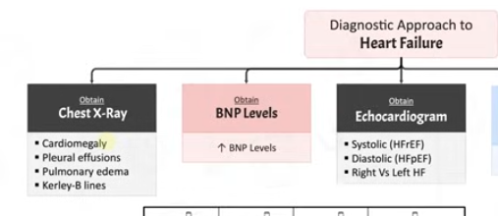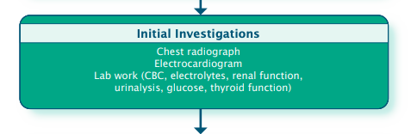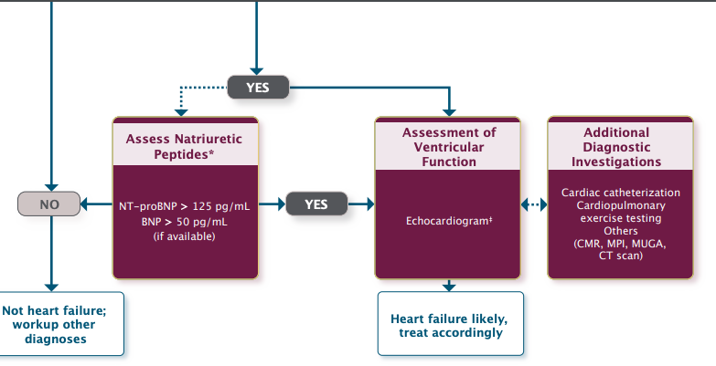Initial  - Chest x-ray  - ECG for patients with suspected arrhythmia, ischemia, or cardiac disease  - CBC, creatinine, ferritin (because SOB so r/u anemia), TSH, troponin, glucose  - Urinalysis (protein in kidney for differential??)  - LFT? To assess for liver congestion or dysfunction if HJR present  If heart failure is still suspected…  - BNP  - Echo with doppler, BNP/NTproBNP (GOLD STANDARD), coronary angiography, CT angiograph  If abnormal (see ranges below)...  - Echocardiography with doppler to evaluate LVEF  - Radionuclide ventriculography (may be used to measure LVEF and LV volumes)  - Coronary angiography and cardiac MRI/CT angiography (to detect specific etiology and select targeted treatment)  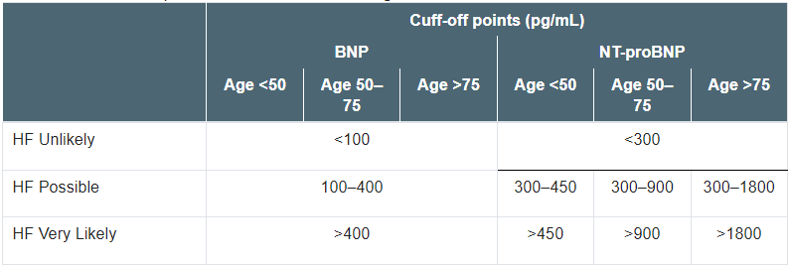  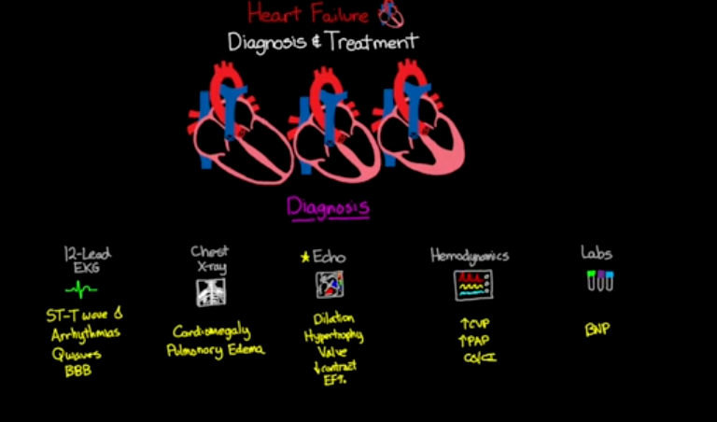  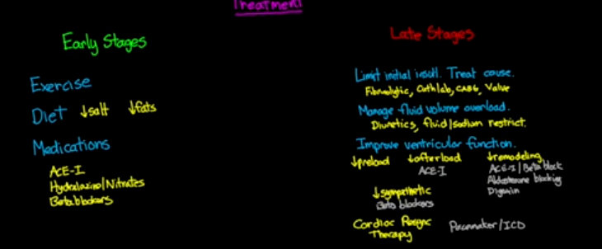
Treatment/Management | Daily monitoring of weight - encourage patients to report rapid weight gain (>2lbs in 2 days or 5lbs/week)???  Limit fluid intake to 1.5-2L/day if fluid retention or congestion is not easily controlled with diuretic or renal dysfunction/hyponatremia  No added salt diet - max 2-3g salt/day, if advancing HF or increase in fluid, <2g salt/day  Avoid high potassium foods if hyperkalemic  Exercise  Meds:  A ACEi/Arb  B Beta Blocker  A Aldosterone antag  L SGLT2
Referrals | ALWAYS REFER especially to Cardiology if BNP>2000  Education: exercise, flu shot, smoking dec, treat other comorbidies  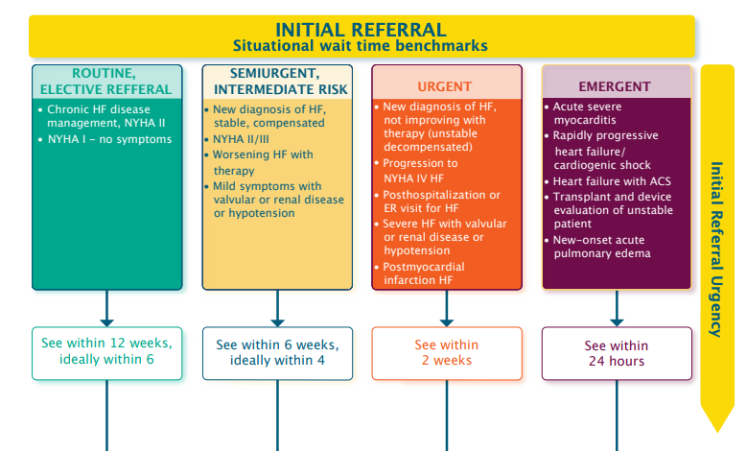
Follow-up | 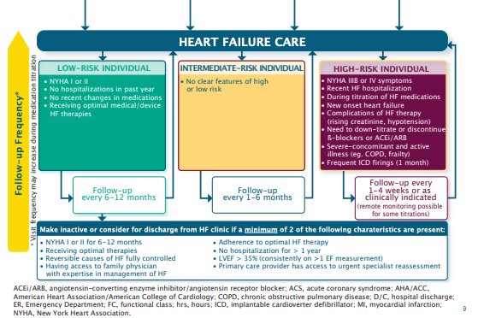  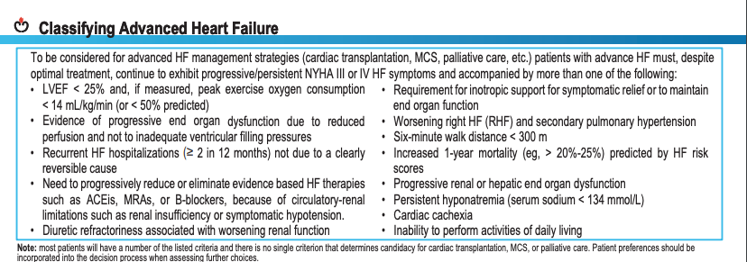

Dyslipidemia
Def’n | The abnormal elevation of plasma cholesterol or triglyceride levels. Largest modifiable risk factor to developing atherosclerosis, because endothelial damage/ inflammation (due to age, stress, genetics) allows uptake of LDL (bad cholesterol) into the intimal layer of the blood vessel.
Pathology/Cause | - Hyperlipidemia:  - Refers to high levels of fat (lipids) in the blood. These lipids can include LDL and triglycerides.  - It is an umbrella term that can involve elevated LDL-C or triglycerides, both of which are risk factors for cardiovascular disease.  - Hypercholesterolemia:  - A type of hyperlipidemia specifically involving high levels of LDL.  - This condition is characterized by elevated cholesterol levels, particularly LDL-C, which contributes to the buildup of plaque in arteries, increasing the risk of heart disease and stroke.  - Dyslipidemia:  - Refers to any abnormal lipid levels in the blood, which could include:  - High triglycerides,  - Low HDL-C (good cholesterol),  - High LDL-C (bad cholesterol).  - Dyslipidemia can encompass both elevated LDL-C and triglycerides, as well as low HDL-C, and is commonly associated with conditions like metabolic syndrome and diabetes.  In short:  - Hyperlipidemia covers high fat levels (LDL, triglycerides).  - Hypercholesterolemia is a subtype of hyperlipidemia focusing on high LDL cholesterol.  - Dyslipidemia refers to any abnormality in lipid levels, which can involve high triglycerides, high LDL-C, or low HDL-C.  We eat a mixed diet. But we consume fats, mostly in the form of triglycerides.  Lipoproteins: transport and deliver lipids in the body. Lipoproteins are made up of different % of triglycerides, cholesterol, phospholipids, and proteins.  Types of Lipoproteins:  - Chylomicron: carry triglycerides (TG)  - VLDL: Carry the hepato-synthesized form TG  - IDL (intermediated density lipoprotein)- after breakdown of TG from VLDL by lipoprotein lipase.  - LDL- removal of TG from IDL core by hepatic lipase (BAD cholesterol)  - HDL- transport cholesterol from the periphery back to the liver (GOOD)  Carbohydrates: are digested and replace glycogen in the liver (modulates blood sugar), any leftovers are stored as fats.  Proteins: are digested into (i) HDL (good cholesterol- takes cholesterol back to the liver) (ii) nitrogen, to make enzymes, used for muscle synthesis etc. and (iii) carbon which is turned into fat.  LIPIDS/ FAT  Fat (mostly TG) is transported by Chylomicrons from the GI tract to the rest of the body. Fat is transport through the lymph, and emptied into the blood. Lipoprotein lipase on the wall of blood vessels in muscle and adipose tissue cleaves the chylomicron into fatty acid and glycerol. This allows uptake for fuel (muscle) or storage (adipose).  - The remaining chylomicron remnants travel to the liver for disassembly  VLDL: transports lipids (mostly triglycerides) away from the liver and again LPL cleaves off the fatty acid for cells, leaving IDL in the blood.  IDL: are returned to the liver, or transformed into LDL in the blood  LDL: are taken up by cells (receptor mediated) where the cholesterol and other components can be used.  - VLDL can become IDL or LDL  - High fat diets overwhelm receptors leaving LDL cholesterol in the blood.  HDL: made of more protein than triglycerides, picks up the leftover cholesterol, returns it to the liver, or transports it to places with high cholesterol requirements (decreasing circulating cholesterol)  - Reverse cholesterol transport (high soluble fiber diet improves HDL)  - Eg. High soluble fiber diet, causes bile excretion. Which means the liver has to make more bile to replace it. It secretes more LDL receptors, removing more LDL from the blood.  Cholesterol (fat) allows cell membranes to be fluid, is a precursor for sex hormones, vitamin D, and bile acids (fat digestion). Too much fat (LDL cholesterol) in the blood infiltrates the intimal layer of the blood vessel.  High LDL or Low HDL= bad news
Risk Factors/Epidemiology | Primary Causes: Hyperlipidemia  Secondary Causes: hypothyroidism, CKD, DM, nephrotic syndrome, liver disease.  SCREEN: OVER 40 years (or post menopause)....South Asian or Indigenous individuals can be earlier  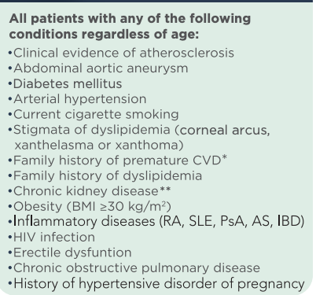  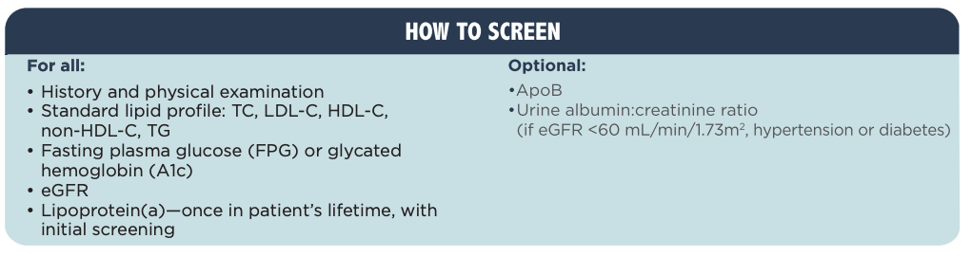
Clinical Presentation | Usually Asymptomatic  - Higher probability if obesity (BMI >25 or Waist-hip ratio >1m/ >0.85f)  - Erectile dysfunction (atherosclerosis in penis)  - Diagnosed with routine blood work by identifying risk factors OR  - In the late progression of atherosclerosis (peripheral artery and coronary artery disease)  - Pain, fatigue, discomfort in the limbs with exertion  Complications:  - Angina or Myocardial Infarction which can progress to Heart Failure (breakoff of plaque, increased thrombus formation, or narrowing of vessels)  - Aneurysm (aortic, thoracic or abdominal aorta, iliac, cerebral circulation)  - Stroke
Hx/Key Questions | OPQRST for MI/ Angina/ Aneurysm.  - Age (Over 40)  - Gender (Higher risk in men)  - Family history of CAD or hyperlipidemia (genetic)  - Diet/ cholesterol (High in saturated fats/ trans-fats, red meat, refined sugar, and alcohol. Low in nuts, fruits, fish, fiber, poultry, and vegetables)  High LDL or Low HDL= BAD NEWS  - Physical Exercise (less than 150min of moderate aerobic exercise/ week- sedentary people)  - Personal history of high cholesterol (or pharmacological treatment/ current medications)  - Smoking status (High risk 30 pack-year)- HUGE**  - Diabetic (High risk in type 2 with poor control)  - History of obesity  High Risk Group: first nation, south Asian, smokers, DM, HTN, Family history of premature CAD or Hyperlipidemia, erectile dysfunction, CKD, Inflammatory diseases, HIV, COPD, Clinical evidence of atherosclerosis (AAA), obesity (BMI >30)
Physical Exam | - Cardiac, Vascular, and Risk Assessment  - Vitals: BP, HR.  - Blood workup  Xanthomas – fatty deposits on skin (dyslipidemia)  - Pulses present and equal  - Bruits (carotid, abdominal, aortic, femoral, iliac)  - Coronary or peripheral arterial disease (see related charts)
Diagnostics/Labs | Screening for dyslipidemia (See Lipid Profile)  - Lipid profile Q1-3 years for all men over 40 or post-menopausal. Or for any patient with the following risk regardless of age.  High LDL or Low HDL= BAD NEWS  ABI- Screen for peripheral arterial disease (<0.9)  Screen for Aneurysm (ABD U/S)  - X 1 MEN between the ages of 65-80  Calculate Framingham Risk Score for Cardiovascular disease (10-year % risk)  - Age, gender, HDL-C, TC, SBP, Smoker, DM  - Recalculate 5yr for patients age 40-75 or PRN  HgA1C, kidney function- things that aren’t dyslipidemia related but are associated with associated conditions  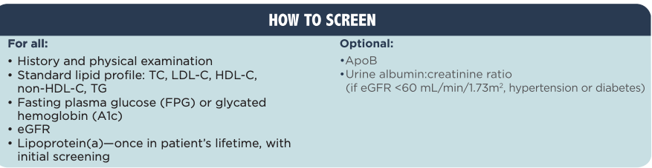  ALSO ADD Coronary Artery Calcium screening IF…  - asymptomatic adults ≥ 40 years and at intermediate risk (FRS 10%-20%)  - NOT suggested if a) high risk individuals b) patients receving statin treatment: or c) most asymptomatic, low-risk adults  - Also consider if low-risk middle-aged individuals ≥40 years with a family history of premature ASCVD (men ≤55 years; women ≤65 years) in addition to identifying known genetic causes of ASCVD such as elevated Lp(a) or FH
Red flags | Ruptured Aneurysm, MI, Unstable Angina, Stroke
Differential Diagnoses
Treatment/Management | Lifestyle changes (diet, exercise) or statin  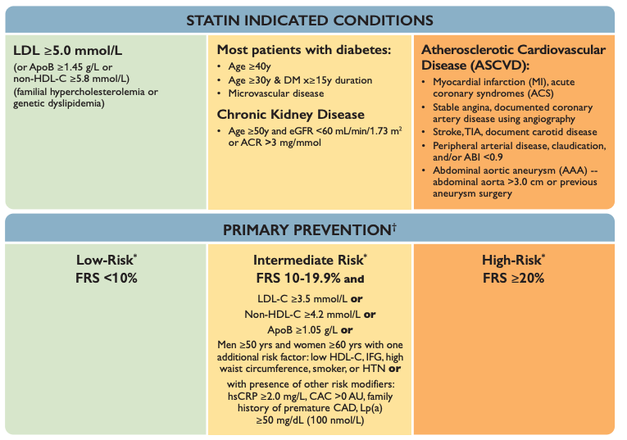  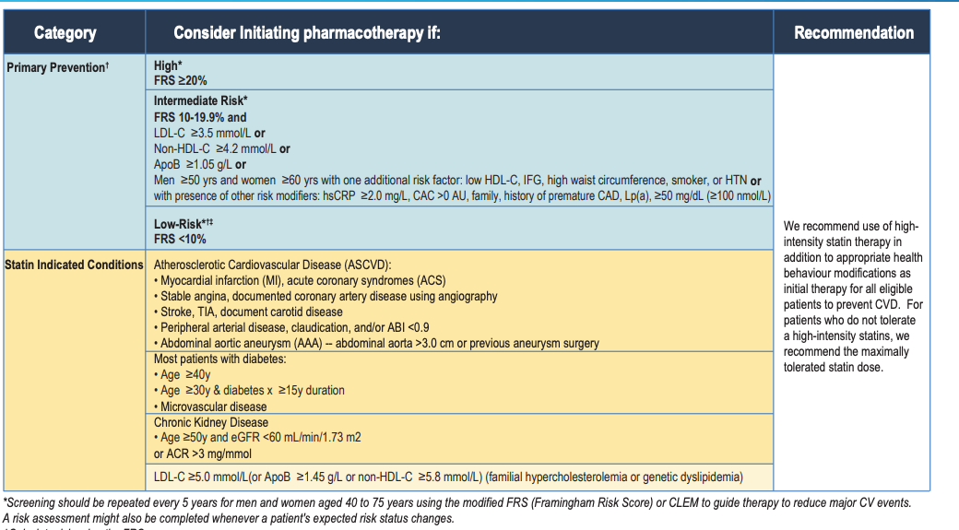
Referrals | Manageable in clinic unless RED FLAGS- ER  Bruits or Angina- Refer for workup to appropriate cardiovascular specialist.  Lifestyle Modifications- smoking cessation, dietician, physiotherapy, diabetes educator, occupational therapy, social worker.  Unexplained atherosclerosis  Severe dyslipidemias  Genetic lipoprotein disorders  Patients refractory to pharmacological treatment
Follow-up | - AST/ALT checked within first 3 months of statin started  - CK checked if myalgias develop  - Routine testing of ALT or CK is not required thereafter

Hypertension
Def’n | Diagnosis: Generally HTN = SBP>130 or 135 and DBP>80 or 85 depending on the method of measurement (at home vs in office). If taken in office, the average of 2 readings from 2 separate visits are used to diagnose HTN. 24-hour ambulatory BP monitoring at home is the gold standard for diagnosis in order to eliminate white coat syndrome.  If 180/110 then visit 2 should be scheduled within 1 month  -visit for a history and physical examination, diagnostic tests to search for target organ damage and associated cardiovascular risk factors should be arranged within 2 visits.  HTN Canada Guideline for diagnosis:  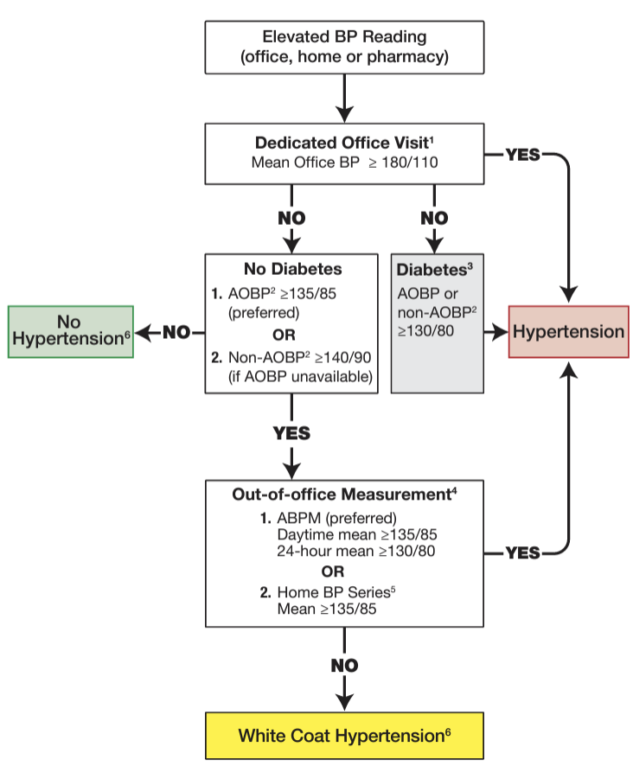  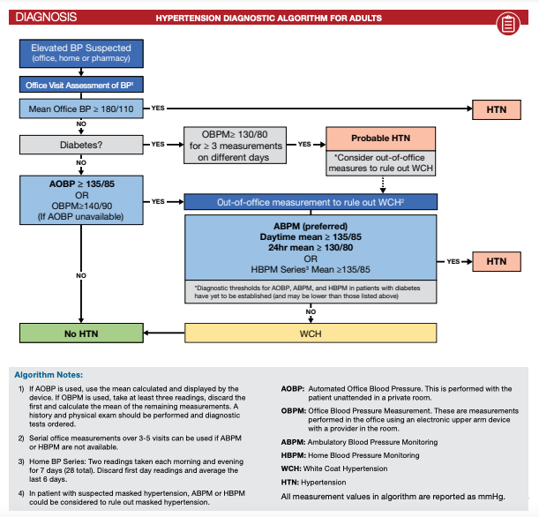  AOBP = automated office BP with me not in room  Non-AOBP = BP with me in room  ABPM = ambulatory BP monitoring; the mean BP within 24h period or mean BP during the daytime is used for diagnosis  Home BP = patient self-measurement  OBPM- measure at least 3 times, discard first measurement and use the average of the remaining measurements  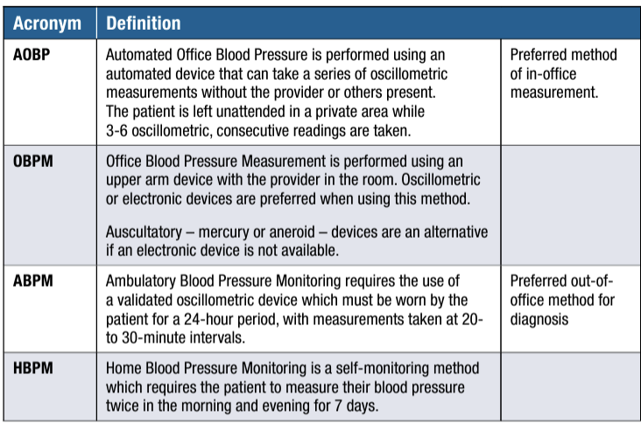  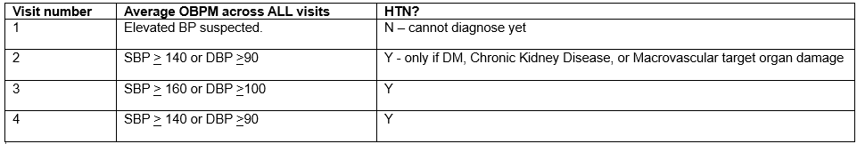  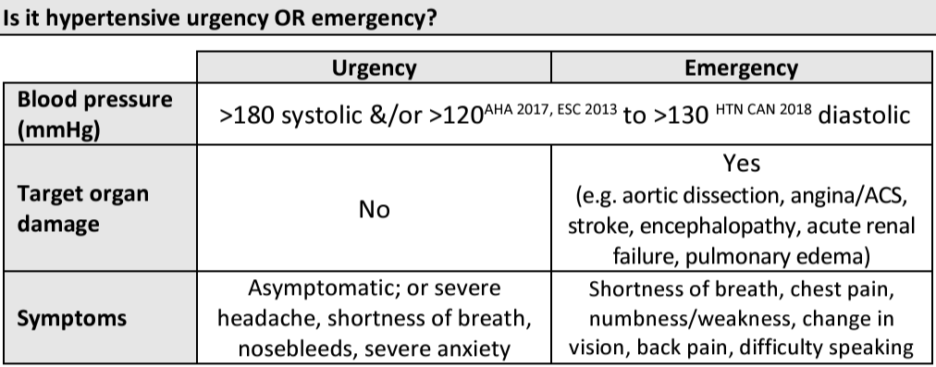  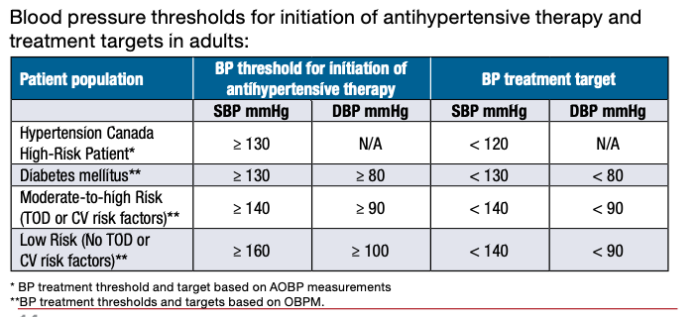  Resistant HTN defined as:  - BP not at target despite 3-drug regimen which includes a diuretic  - BP that IS controlled while taking >4 BP meds  Isolated systolic HTN: when SBP >130 with normal DBP - normally affects elderly and increases risk of stroke/MI  Isolated diastolic HTN: when DBP>80 with a normal SBP - more common in younger people  Malignant HTN: marked HTN with retinal hemorrhages, exudates or papilloedema  Note: Nocturnal BP is typically 15% lower than daytime values. Failure of BP to fall by at least 10% during sleep is called “nondipping” and is a stronger predictor of adverse cardiovascular outcomes than daytime BP
Diagnosis | If 180/110 then visit 2 should be scheduled within 1 month If the visit for a history and physical examination, diagnostic tests to search for target organ damage and associated cardiovascular risk factors should be arranged within 2 visits.  - If out-of-office measurements, like ambulatory or home BP monitoring, are not available. Here’s a breakdown of the protocol for diagnosing hypertension across multiple visits:  - Visit-Based Criteria for Diagnosing Hypertension with OBPM  - Visit 1: check BP.  - Visit 2: If averaged BP (over the first and second visits) shows >140/90, a diagnosis of hypertension can be made for patients who have specific high-risk conditions (Macrovascular Target Organ Damage such as the heart or arteries due to high blood pressure (like left ventricular hypertrophy or previous stroke), DM, CKD.  - If these conditions are met, hypertension may be diagnosed at this point. Otherwise, the evaluation continues to the next visit.  - Visit 3: At this point, the mean OBPM is calculated over three visits. If the average BP (cumulative mean of all three visits) reaches >160/100 hypertension can be diagnosed without further visits.  - If these levels are not reached, continue to the next visit.  - Visit 4 or 5: By the fourth or fifth visit, the mean OBPM (calculated over all visits up to that point) is reviewed. If the average BP reaches >140/90 hypertension is confirmed.
Pathology/Cause | Primary/Essential HTN (most common): HTN with no identifiable cause (idiopathic)  Secondary HTN: HTN d/t an identifiable cause (e.g. renal, vascular, med induced)
Risk Factors/Epidemiology | Family hx, obesity, ETOH, stress, sedentary, African American, Male, age>30, excessive salt intake, meds, drug use
Clinical Presentation | Common findings: usually asymptomatic  Other S/S: HA, retinopathy, organ specific complaints d/t advanced disease
Hx/Key Questions | -Assess risk factors (lifestyle, family hx, meds, drug use etc.)  -Ask about S/S suggestive of secondary etiology (e.g. anxiety/weight changes could be related to thyroid abnormality which then induces HTN)
Physical Exam | -VS, height, weight, waist circumference, BMI  -Inspect: fundoscopic exam (look for papilleodema, AV nicking), JVD distension, pedal edema  -Auscultate: heart (noting PMI), lungs (bronchospasm, rales), carotid arteries (bruits)  -Palpate: thyroid (enlargement), abdo (masses), extremities (periph pulses, edema), deep tendon reflexes
Diagnostics/Labs | -Urinalysis, Hematocrit, LFTs, chemistry profile, lipid profile, urinalysis (protienuria), eGFR, ECG  -If needed, based on hx/physical exam/lab tests, obtain the following: renal arteriogram, plasma renin, catecholamines, CXR, aortogram, sleep study etc.  -Monitor K levels if on: ACE inhibitors,ARBs, or spironolactone
Red flags | Assess presence of target organ damage (TOD) in pts with HTN (i.e. CVA, MI, Renal failure, HF, peripheral arterial disease). Presence of any of these would put pt into moderate-to-high risk categories for therapy.  200/130 is emergency**  Rx files says SBP 180 and DBP 110 is hypertensive “urgency” and if there are signs of TOD, then it’s an emergency
Differential Diagnoses | Primary HTN, secondary HTN, drug-induced HTN, “white coat” syndrome
Treatment/Management | Treatment: Lifestyle modifications (#1), pharmacotherapy (if lifestyle mods are not working)  Counseling/Education:  - Lifestyle: Weight loss (-10 lbs can reduce BP), diet, substances  - Stress importance of ongoing monitoring and treatment  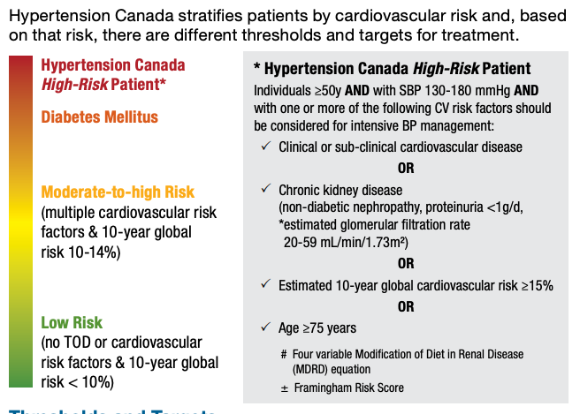  Thresholds and targets based on patient population/risk:  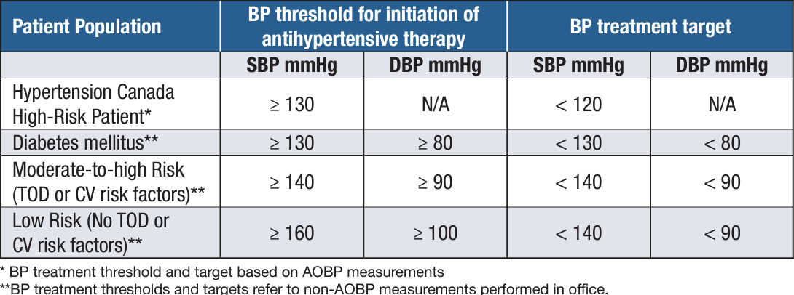  1. Patients Not Diagnosed with Hypertension  If there’s no hypertension diagnosis and no target organ damage, check BP once a year.  2. Hypertensive Patients Changing Lifestyle  Follow-up every 3 to 6 months if they're actively working on lifestyle changes (like diet and exercise). Every 1 to 2 months if their BP is high and they need closer monitoring.  3. Patients on BP Medication  Check BP every 1 to 2 months until the target BP is reached and stable across two visits. After reaching target BP, switch to 3 to 6-month follow-ups. More frequent visits are needed for patients with severe hypertension, symptoms, or drug side effects.
Referrals | -Consult OB if pregnant before prescribing meds (many harm fetus)  -Cardiologist if having acute HTN emergency (DBP >130)
Follow-up | -2-4 wks if drug therapy initiated; once stable, Q3-6 months - review drug therapy compliance, effectiveness, and adverse rxns at each visit  -Annual blood work (uric acid, creatinine, potassium)  Patients on antihypertensive drug treatment should be seen every 1-2 months, depending on the level of BP, until readings on 2 consecutive visits are below their target. When the target BP has been reached, patients should be seen at 3- to 6-month intervals  - During the maintenance phase of hypertension management, tests (including electrolytes, creatinine, fasting lipids, and pregnancy) should be repeated  - Pregnancy testing should be considered prior to initiation of health behaviour changes or drug therapy.  - Diabetes develops in 1-3% per year of those with drug-treated hypertension. The risk is higher in those with one or more of the following: treated with a diuretic or β-Blockers, impaired fasting glucose or impaired glucose tolerance, obesity (especially abdominal), dyslipidemia, sedentary lifestyle and poor dietary habits.  - Screen adults with hypertension with annual fasting plasma glucose

Acute Rheumatic Fever (ARF)
https://www.youtube.com/watch?v=bfrcIM3C1gA
Def’n | -Autoimmune inflammatory process that occurs as a sequelae of a Group A beta-haemolytic streptococcal (GABHS) tonsillopharyngitis.  -Individual who has had an attack of ARF is at ++risk of developing recurrences after subsequent GABHS pharyngitis and needs continuous antimicrobial prophylaxis to prevent recurrences (secondary prevention)
Pathology/Cause | -Caused by a preceding infx with GABHS and streptococcus pyogenes  -Characterized by nonsuppurative inflammatory lesions of the joints, heart, subcut tissue, and CNS
Risk Factors/Epidemiology | Risk factors: Group A pharyngitis (untreated or inadequately treated); Crowded living conditions; occupational exposure (teachers, HCPs), tropical countries
Clinical Presentation  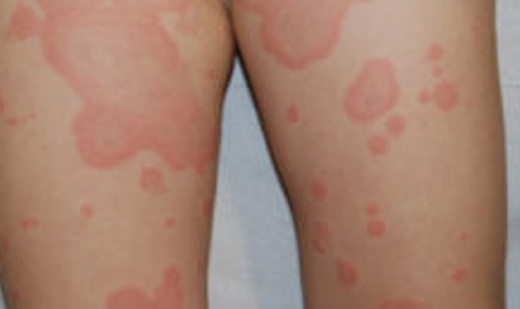 | Common findings: Sore throat (sudden onset), painful swallowing, joint pain (joints warm, swollen, inflamed; polyarthritis), fever  Other S/S:  -Chorea: a CNS dis order- purposeless involuntary rapid movements assoc with muscle weakness, involuntary facial grimaces, emotional liability)  -Erythema marginatum: non-pruritic pink rash with pale centres and round or wavy margins (see picture, looks like ringworm or lyme)  -Other: Subcutaneous nodules, enlarged lymph nodes, HA, carditis, fatigue, appetite loss, pericarditis, aortic regurgitation, and fever
Hx/Key Questions | -Any recent hx (1-3 months) of sore throat?  -Drug hx- did client finish previous course of antibx?  -Use of ASA? Can mask signs of inflammation and prolong the course of disease  -Hx of heart problems, CP, or SOB?  Joint Pain (Arthritis): Ask about joint pain, swelling, and redness, especially if it’s migratory (shifting from one joint to another).  Muscle movements involuntarily?  Rash?
Physical Exam | -VS (temp)  -Inspect: joints for swelling warmth, observe for signs of chorea, conduct dermal exam (look for signs of erythema marginatum), ENT exam (evaluate tonsillopharyngeal erythema +/- exudates; observe for beefy red swollen uvula)  -Auscultate: heart (murmurs, pericardial friction rub, effusion), lungs  -Palpate: neck lymph nodes, extremities (check pulses), abdomen  -Neuromuscular exam for chorea: have pt grip hand- they’ll be unable to maintain a grip; also check for spooning sign in nails and pronator sign
Diagnostics/Labs | -No single lab test can confirm dx of ARF  -Throat culture confirms GABHS infx OR ASO shows strep antibodies  -Bloodwork: elevated ESR and CRP and CBC  -ECG: look for heart block  -CXR: look for cardiomegaly and CHF  -Tests to R/O diff dx incl rheumatoid factor, ANA, Lyme serology, blood cultures, and gonorrhea test  Diagnosis requires 2 major criteria OR 1 major criteria + 2 minor criteria in a client with evidence of a preceding GABHS infx:  - Major criteria: carditis, polyarthritis, CNS involvement, erythema marginatum, subcutaneous nodules  - Minor criteria: arthralgia, fever, elevated ESR or CRP, prolonged PR interval  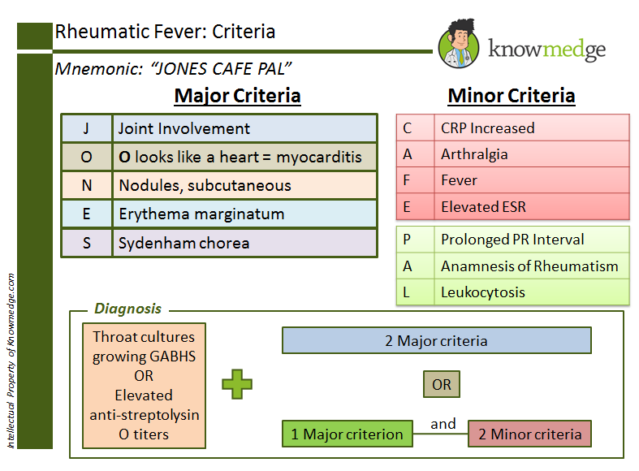
Red flags | -Cardiac involvement is most serious complication (e.g. CHF, stroke, endocarditis). ARF accounts for largest number of aortic regurgitation cases  - Rheumatic heart disease is most serious complication and occurs after repeated bouts of illness
Differential Diagnoses | Rheum arthritis, septic arthritis, sickle cells anemia, infective endocarditis, leukemia, gout, Huntington’s chorea, Kawasaki disease, Lupus, Lyme disease, Scarlet fever
Treatment/Management | Treatment: Penicillin long term and bed rest  Counseling/Education: reinforce need to complete full course of antibx for strep infections; adequate tx for strep pharyngitis or skin infx is the best prevention against rheumatic fever; chorea is usually managed conservatively  Non-pharm therapies: Bed rest is a very important part of ARF therapy, especially with carditis; bed rest needed throughout acute illness and should continue until ESR has returned to normal for 2 weeks
Referrals | -Consult and co-manage pt with ENT specialist if indicated for pts with intact tonsils and recurrent symptomatic strep infx for consideration of tonsillectomy  -Cardiologist to manage heart blocks and CHF  -Neurologist or psychiatrist may be required to confirm dx of chorea and assist in its management
Follow-up | -Clients with carditis should be followed Q6 months and by a cardiologist with an echocardiography every 1-2 years  -Test of cure is a negative throat cx  -Pharyngitis patients with a hx of ARF and those who are symptomatic and have a household member with documented GABHS infx should rec’v immediate tx without need for prior testing  -Continuous streptococcus prophylaxis in clients with prior ARF is major means of preventing cardiac sequelae

Arterial Aneurysm
https://youtube.com/watch?v=jJUJN7EjOKk
Def’n | An arterial aneurysm is a localized, abnormal dilation or bulging of a blood vessel, typically an artery.
Pathology/Cause | Aneurysms can result from weakening of the vessel wall due to atherosclerosis, trauma, infection, or genetic factors.
Risk Factors/Epidemiology | Arterial aneurysms can affect individuals of any age, but prevalence increases with age. Men are more commonly affected. Smoking, hypertension, atherosclerosis, family history, trauma, connective tissue disorders (e.g., Marfan syndrome).
Clinical Presentation | HALMARK AAA: Flank or back pain, pulsating mass and bruit  May be asymptomatic until rupture  Pulsatile mass  Pain (localised or radiating)  Neurological deficits if compressing adjacent structures.  Asymptomatic: Many aneurysms, especially small ones, are asymptomatic and found incidentally.  Pain: Ask about any back, abdominal, chest, or flank pain that could indicate an expanding or ruptured aneurysm.  Pulsatile Mass: Inquire if the patient has noticed a pulsating mass, particularly in the abdomen.  Neurological Symptoms: For aneurysms like thoracic aortic or intracranial aneurysms, ask about dizziness, syncope, or vision changes.  Compression Symptoms: Ask if they experience difficulty swallowing, hoarseness, or shortness of breath, which could indicate pressure on nearby structures.  Rupture Symptoms: Sudden, severe pain with possible hypotension, shock, or syncope may indicate rupture. This is a medical emergency.
Hx/Key Questions | Risk Factors including Family History  Determine the onset, location, and characteristics of pain or discomfort.  Inquire about changes in size or symptoms over time.  - History of atherosclerosis, hypertension, coronary artery disease, hyperlipidemia, connective tissue disorders (e.g., Marfan syndrome, Ehlers-Danlos syndrome), or a previous aneurysm.
Physical Exam | Palpation for a pulsatile mass. NEVER PALPATE OVER ANEURYSM TO AVOID RUPTURE  Assess for neurological deficits if near nerves.  Evaluate signs of rupture (hypotension, shock).  Asses left flank pain (abdomen, chest, lower back, groin)  Hypotension (if ruptures)  - General Inspection:  - Look for any visible pulsating masses, particularly in the abdomen.  - Observe the general appearance and assess for signs of distress or shock if rupture is suspected.  - Vital Signs:  - Measure blood pressure in both arms to assess for discrepancies, especially in thoracic aortic aneurysms.  - Record heart rate and respiratory rate. In cases of suspected rupture, hypotension may be present.  - Abdominal Examination:  - Palpation: Gently palpate for a pulsatile mass in the abdomen (typically around the umbilicus), which could indicate an AAA.  - Auscultation: Listen for bruits over the abdominal aorta, which may suggest turbulent blood flow.  - Peripheral Vascular Examination:  - Check pulses in the upper and lower extremities (radial, brachial, femoral, popliteal, posterior tibial, dorsalis pedis) for asymmetry or diminished pulses.  - Assess for signs of peripheral artery disease (e.g., delayed capillary refill, cold extremities, skin changes).  - Cardiovascular and Respiratory Examination:  - Auscultate the heart and lungs to detect any signs of heart failure or pulmonary complications that may be associated with larger aneurysms.  - For thoracic aneurysms, listen for bruits or abnormal heart sounds.
Diagnostics/Labs | - Ultrasound  - CT Angiography/MRI for localization/size and assessment of vessel wall  - CBC, aPTT, INR  Abdominal Ultrasound: The initial screening tool for AAA due to its sensitivity, non-invasiveness, and low cost.  CT Angiography (CTA): Provides detailed information on the size and extent of the aneurysm, especially useful for pre-surgical planning.  MRI: An alternative to CTA in cases where contrast dye is contraindicated, although it’s less commonly used.  - Ultrasound:  - Abdominal US for Aortic Aneurysm: Abdominal ultrasound is often the first-line diagnostic tool for AAA screening and measurement.  - CT Angiography (CTA):  - Often used for more precise visualization and measurement of aneurysms, especially for planning surgical intervention.  - It is ideal for thoracic or abdominal aneurysms if the patient is stable.  - MRI Angiography (MRA):  - Another non-invasive imaging technique, useful for patients with renal impairment or when detailed vascular imaging is needed.  - Echocardiogram??  - Transesophageal Echocardiogram (TEE): Useful for assessing thoracic aortic aneurysms and aneurysms involving the ascending aorta not for AAA.  - Laboratory Tests:  - CBC: To assess for anemia or leukocytosis in the event of rupture.  - Renal Function Tests: Important prior to contrast imaging studies.  - Lipid Panel: To evaluate cardiovascular risk factors.  - A1C/BG if diabetic
Red flags | Sudden, severe pain could indicate rupture and requires immediate attention.  Rapidly expanding aneurysm.  S/S hypovolemic shock
Differential Diagnoses | Thoracic aneurysm  Pancreatitis  Bowel obstruction  Pseudoaneurysm  Abdo tumor  Hematoma  Arteriovenous Malformation  DVT  Cellulitis  Lipoma  PE
Treatment/Management | - Smoking Cessation  - Blood pressure control!!******  - Statins******  - Discuss the importance of regular follow-up and monitoring.  - Close monitoring of aneurysm size and symptoms.  - Surgical intervention or endovascular repair for larger or symptomatic aneurysms.  - Lifestyle modifications and risk factor control.********  Primary prevention: Control risk factors (e.g., blood pressure, smoking).  Secondary prevention: Regular screening for HTN if at risk.
Referrals | Vascular surgeon or interventional radiologist
Follow-up

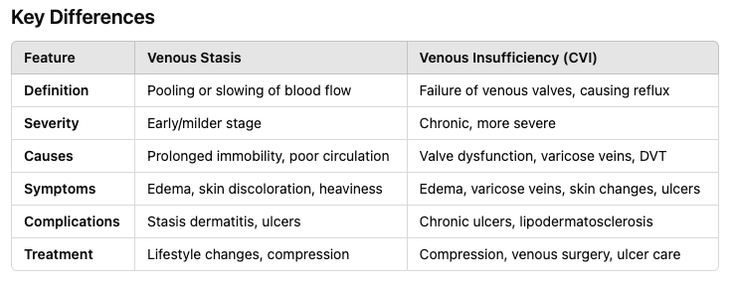

REYNAUD’S PHENOMENON (RP)
https://www.youtube.com/watch?v=uCfzd1W99lk&ab_channel=NinjaNerdNursing
https://www.youtube.com/watch?v=HQPwpV--7NI&ab_channel=DoctorO%27Donovan
Description | An idiopathic disease where an exaggerated vascular response occurs in extreme heat, cold, or stress. Manifested by bilateral blanching of the skin  - Well-demarcated, finger discomfort, followed by cyanosis and erythema after rewarming  - Attacks typically start with a single finger and spread symmetrically, sparing the thumb  *Can be primary or secondary, and spontaneous remission may occur with primary RP
Pathology | Primary RP…(symmetrical)  - Occurs alone without other disease processes due to digital vascular microspasm from increased alpha-2 adrenergic receptors and high sympathetic vascular tone  - Usually occurs in young teen girls  Secondary RP… (poorer morbidity, asymmetrical)  - Can be secondary to autoimmune, atherosclerotic, hematologic, metabolic/endocrine, neoplastic, infections, environmental exposures/neurologic changes, and medications  - May see unilateral symptoms affecting 1-2 fingers  - Usually occurs after 40, lupus, scleroderma, RA
Epidemiology | Occurs in 5-20% of females and 4-14% of males in the population
Risk Factors | Primary RP…  - Female, onset after meenarch (15-30yrs, smoking, emotional stress)  Secondary RP…  - Onset after age 40 (most commonly associated with underlying disease), male gender  - Common in children with RA, systemic lupus erythematosus & scleroderma  Other= family history, frostbite, vascular trauma to the distal ulnar artery, vibration-induced/occupational exposure (e.g., jackhammers, pneumatic drills, weed eaters), medicactions  MEDICATIONS THAT INDUCE RP…  - Amphetamines, beta-blockers, bleomycin, cisplatin, clonidine, cocaine, cyclosporine, ergot, interferon alpha, nicotine, vinblastine, vinyl chloride
Clinical Presentation  (Subjective Symptoms & Objective Signs) | HALLMARK: cold hands*** and feet, cutaneous colour change and cool skin temperature  Common findings: age of onset 15-30 years  - Areas= toes, ears, nose, face, knees, nipples  - Paleness of the fingertips after exposure to cold temperatures, followed by redness, discomfort after warming  - White attack= sharp demarcated colour of pallor (15-20 min)  - Blue attack= cyanosis (15-20 min)  Criteria for diagnosis of PRIMARY RP  - Symmetric episodes  - No evidence of PVD  - No tissue gangrene, digital pitting, or tissue injury  - Negative nailfold capillary examination  - Negative antinuclear antibody test (ANA)  - Normal ESR  SECONDARY RP  - Age of onset >40  - Painful, severe attacks with ulceration and ischemia  - Ischemia S&S proximal to the fingers or toes  - Asymmetric attacks  - Abnormal labs, suggesting vascular or autoimmune disorders  Other signs and symptoms:  - Paresthesias, numbness, clumsiness of the aching hand/fingers, loss of pulp in finger pads in severe cases
Hx/Key Questions | - Age of onset, OPQRST  - Location and symptoms of blanching, erythema, and pain  - Frequency of attacks  - Presence of other skin alterations;  - Mottling of the arms/leg? Livedo reticularis= lilac or violet mottling or reticular pattern occurring during a cold response  - Precipitate occurrences (air conditioning, grocery freezer sections, cold weather/water, emotional stress, sudden startling)  - Concurrent symptoms such as headaches  - History of underlying disorders (hypothyroidism, autoimmune and connective tissue disorders)  - Current or past occupations, involving vibratory tools  - Medications, stimulants, herbals, OTC
Physical Exam | VITALS→ pulse, respirations, BP  INSPECT  - Dermal exam: malar/petechia rash, telangiectasias, digital pallor, erythema, ulcerations/signs of ischemia  - Swelling/redness of joints  - Microscope/ophthalmoscope: fingernail capillaries  - Normal= fine red capillaries lined in the same direction  - Abnormal= dilated, tortuous, irregular spacing, avoid evaluating the index finger  AUSCULTATE→ heart and lungs  PALPATE→ joints for tenderness and peripheral pulses bilaterally to r/u arthritis  NEURO Vascular EXAM→ assess sensory function  - Sensory discrimination  - Location of sensation  - Vibratroyr sensation  - Graphesthesia→ draw a # ono the hand and have them identify it  Allens test*****This test can help assess the blood flow in the hands and determine any occlusions in the radial or ulnar arteries.
Red Flags | Significant pain, ischemia
Differential Diagnosis | Scleroderma, systemic lupus erythematosus, occupational trauma, medication-induced, peripheral vascular disease, neurovascular process (diabetes, atherosclerosis, thromboangitis obliterans)
Diagnostics:  Labs & Imaging | *No gold standard diagnostic test for RP (history alone is accepted)  - History of at least two colour changes, pallor, and cyanosis after cold exposure is adequate (ask client to photograph symptoms and bring the photo in for evaluation)  Laboratory tests  - ANA, ESR, CRP, thyroid profile, CBC, RF, others as guided by history and physical  - CBC, chemistry profile (renal/liver function), urinalysis, Rheumatoid factor, complement C3 and C4, ANA  Diagnostic tests and/or Imaging  - Nailfold capillaroscopy  - Cold water test no longer recommended
Treatment/ Management | Counseling/Education  - Monitor ulcerations for secondary infections  - Smoking cessation, keep the body warm, wear mittens to protect hands, and hat to prevent heat loss  - Stop repetitive vibratory activity that induces symptoms or decrease time spent  - Avoid cold/stressors  - Calcium Channel Blockers: First-line treatment, such as nifedipine, can help dilate blood vessels and reduce the frequency of episodes.  Complementary Therapies (non-pharmacological)  - Biofeedback and relaxation techniques are frequently used  - Consult therapist to control stress
Medical management | - Consider antibiotics if secondary infections are present (may require debridement)  - Avoid decongestants, ephedra-containing herbals, and migraine medications such as serotonin agonists (Sumatriptan, caffeine+ergotamine)  Surgical therapies: only for clients resistant to therapy initially  - Sympathectomy involving local block with lidocaine or bupivacaine to temporarily relieve pain (without epinephrine)  - Chemical and cervical sympathectomy for severe cases with digital ischemia  - Vascular reconstruction  Pharmacologic Therapy: may be required only during winter months  - Long-acting CCBs (nifedipine, amlodipine)  - Low-dose ASA antiplatelet therapy in secondary cases with history of ischemic ulcers or thrombotic events  - Vasodilators (sildenafil) and endothelin receptor agonists (bosentan) for refractory cases with digital ulcers and infarcts but NOT FDA approved
Referrals | Involve a specialist if there are signs of ischemia or refractory symptoms  Rheumatologist→ moderate or high suspicion of secondary RP  Refer as needed for surgical therapies
Follow-up | In 1 month or as needed by client symptoms
Prevention | Primary prevention: Avoid triggers!
References | Cash & Glass, p. 619-622

PULMONARY EMBOLISM
Description | The sudden blockage of a major blood vessel (Artery) in the lung, usually by a blood clot  - Most cases involve small clots that may not be deadly, but can damage the lung
Pathology | Occlusion of all or part of a pulmonary artery; a piece of a DVT breaks off and enters pulmonary circulation, impairing gas exchange and increasing pulmonary vascular resistance  - Hemodynamically unstable PE  - Causes hypotension, death from obstructive shock and RV failure  - Hemodynamically stable PE  - Patients may be mildly symptomatic or asymptomatic  - Stabilize with fluid therapy
Epidemiology | Combined, DVT and PE is the third most common cardiovascular disorder, affecting 5% of the population  - PE incidence increases with age significantly  - Cause of death in up to 10% of hospitalized patients
Risk Factors | - DVT of the legs, arm or pelvis; infectious material, fat, air bubbles, tumors, amniotic fluid  - RARE for superficial thrombi to cause PE  - Virchow’s triad: hypercoagulability, venous stasis, and endothelial injury  Two types  - Genetic  - Thrombophilia  - Acquired  - Immobilization (bed rest >3 days), recent ortho surgery, malignancy, indwelling venous catheter, obesity, pregnancy, cigarette smoking, oral contraceptive pill use, MI  - Other  - Fractures of the lower limb, HF or A. fib requiring hospitalization in past 3 mos, hip/knee replacement, CVC, chemotherapy, CHF/resp failure, HRT, postpartum, infection  - Cancer= high risk for thrombus and PE  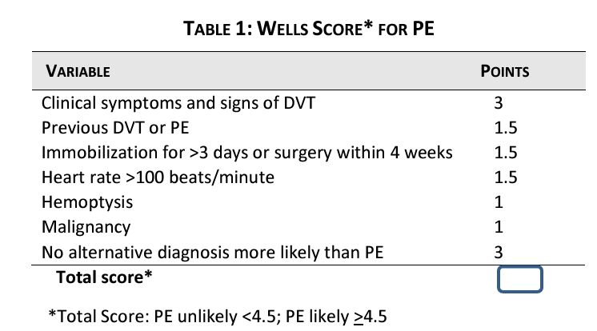  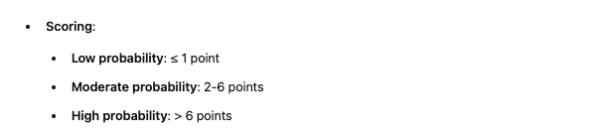  A pulmonary embolism can be safely excluded in patients with a low (<2) or moderate (2 to 6) pre-test probability and a negative D-dimer. No imaging required.  Low or Moderate Wells Score (≤ 4): PE is considered unlikely. In this case, you would typically order a D-dimer test. If the D-dimer is negative, PE can be ruled out. If positive, further imaging (like CT pulmonary angiography) is required.  High Wells Score (> 4): PE is considered likely. In this case, you would skip the D-dimer and go directly to imaging, such as a CT pulmonary angiogram (or U/S if considering deep vein thrombosis). A D-dimer wouldn't reduce the high suspicion of PE in these cases.
Screening | Suspect PE in anyone with hypotension and jugular venous distention (JVD) when acute MI, pericardial tamponade, and tension pneumo has been ruled out
Clinical Presentation  (Subjective Symptoms & Objective Signs) | HALLMARK: dyspnea/SOB that has a sudden onset, pleuritic sharp chest pain that is worse when you cough or take a deep breath, and produces hemoptysis  Common findings:  - Hemoptysis, sinus tachycardia and palpitations, chest pain and SOB  - Previous thrombophlebitis/DVT  - Hypoxia, hypotension  - Anxiety, sweating, syncope, tachypnea  Other signs and symptoms:  - Fatigue, cough, dyspnea, syncope, palpitations, profound fatigue, URTI symptoms  - Look for signs of DVT (calf swelling, tenderness, palpable cord, pedal edema)  - Patient may demonstrate “Levine’s sign”= placing the fist on the centre of the chest to demonstrate pain (i can’t believe this has a name, dumb)
Hx/Key Questions | NEED TO RULE OUT MI, PANIC ATTACK, PNEUMONIA, ETC.  - How long has the chest pain been present  - Have you ever been treated for chest pain? What treatment, tests, medications?  - OPQRST  - Characteristics of the pain  - Radiation to both arms/jaw= acute MI  - Between the scapula radiation= thoracic aortic dissection  - Discuss risk factors for cardiac diseases, review family history  - Medications (illicit substances, herbals, OTC, rx)  - New physical labor, trauma, recent infections  Can use things like the ‘Revised Geneva Clinical Prediction Rule’ or the ‘Wells Criteria’ to score patients
Physical Exam | General Observations:  - Check the patient's respiratory rate, heart rate, blood pressure, and oxygen saturation.  - Observe the patient’s general appearance for signs of respiratory distress (e.g., tachypnea, cyanosis).  Cardiovascular Examination:  - Inspection: Look for jugular venous distention, which can indicate right heart strain. JVD and hypoT=PE !!  - Auscultation: Listen to the heart for any abnormal sounds (e.g., split S2) and lungs for decreased breath sounds, crackles, or wheezing.  Respiratory Examination:  - Inspection: Observe chest movement symmetry and any signs of accessory muscle use.  - Auscultation: Listen for decreased breath sounds, crackles, or pleural rubs.  - Percussion: Assess for any areas of dullness.  Extremities:  - Examine the legs for signs of DVT, such as:  - Swelling or asymmetry  - Redness or warmth  - Tenderness along the calf or popliteal area  - Homans sign
Red Flags | Acute right ventricular failure→ JVD, parasternal lift, third heart sound, cyanosis, shock (tachycardia on presentation that develops to sudden bradycardia or new broad-complex tachycardia with right bundle branch block)
Differential Diagnosis | Panic attack, pneumonia, MI, cardiac tamponade, heart failure, stable angina, malignancy, pneumothorax, vasovagal syncope, pericarditis, pneumonitis
Diagnostics:  Labs & Imaging | If Wells <4.5 then do ddimer. If negative then no PE, if positive then order CTPA/VQ perfusion scan  If wells >4.5 then go right to CTA. If CTA contraindicated (pregnant, renal issues, allergy to contrast) then do a VQ perfusion scan so long as CXR is normal..VQ is prefered for young people  Initial Labs and Imaging:  - D-dimer: Useful in ruling out PE in low-risk patients, but non-specific.  - ABG: Check for hypoxemia, hypocapnia, and increased A-a gradient.  - BNP? Troponin? CK?  - ECG: Look for signs of right heart strain (e.g., S1Q3T3 pattern), tachycardia, or other abnormalities.  - Chest X-ray: May show non-specific signs, but helpful to rule out other causes of symptoms.  - Complete all DVT tests as well (compression ultrasound, venography)  - Renal if getting CT with contrast  Definitive Imaging:  - CT Pulmonary Angiography (CTPA): Gold standard for diagnosing PE.  - V/Q Scan: Useful if CTPA is contraindicated, such as in patients with renal impairment or iodine allergies.  Laboratory tests  - D-dimer test (if there is a low likelihood of VTE, rule out without having to do imaging if the d-dimer test is negative)  - D-dimer has a highly negative predictive factor  - If D-dimer is normal, acute PE/DVT is highly unlikely  - Low positive predictive value  - Positive D-dimer does NOT always confirm PE  - ABG (hyperventilation→hypocapnia, resp alkalosis), BNP (elevated), troponin (prognostic, not diagnostic)  Diagnostic tests and/or Imaging  - Chest x-ray: web-shaped density= PE  - ECG to rule out MI, echo to assess right ventricle function  - May show signs of right ventricular strain (S1Q3T3, right bundle branch block, T-inversion in leads V1-V4)  - Contrast pulmonary angiography, ventilation-perfusion lung scan, CT, pulmonary angiography, MR pulmonary angiography  - Complete all DVT tests as well (ultrasound, venography)
Treatment/ Management | - Oxygen Therapy: If hypoxemia is present, administer supplemental oxygen.  - Anticoagulation: Start anticoagulation with agents like low-molecular-weight heparin, unfractionated heparin, or direct oral anticoagulants unless contraindicated.  - Thrombolysis: Consider in cases of massive PE with hemodynamic instability (e.g., hypotension, shock).  Supportive Care:  - Pain Management: Administer analgesics for pleuritic chest pain if needed.  - IV Fluids: If hypotensive, administer IV fluids carefully to avoid fluid overload.
Medical management | Oxygen for hypoxia, IV fluids for hypotension, vasopressor agents for shock or organ hypoperfusion  THROMBOLYTICS or EMBOLECTOMY  ANTICOAGULANT THERAPY; ongoing, may be lifelong depending on risk
Advise clients when to RTC or call for help | Acute pain that follows signs of heart attack, stroke  Coughing up blood, significant SOB
Referrals | ● Send this patient IMMEDIATELY to the hospital if assessing in a primary care setting.
Follow-up | ● Should be followed by cardiologist/vascular specialist/respirologist
Common Complications | Recurrent thromboembolism, chronic thromboembolic pulmonary hypertension, right heart failure, cardiogenic shock, increased risk of stroke  - If left untreated, mortality rate up to 30%
1° and 2° Prevention | Primary prevention
References | eCPS, Cash & Glass ‘chest pain’; https://stanfordhealthcare.org/medical-conditions/blood-heart-circulation/pulmonary-embolism/treatments.html  StatPearls: PE https://www.ncbi.nlm.nih.gov/books/NBK560551/

Peripheral Arterial Disease
Short definition/ description | A circulatory disorder characterized by the buildup of plaque on the interior surface of arteries that hardens, narrowing the diameter of arteries and reducing circulating blood volume to organs and extremities.  - Includes Buerger’s disease, Raynaud’s disease, and Leriche syndrome
Pathology/cause | Affects all arteries except the cerebral and coronary arteries.  Can also be caused by arthritis, trauma, radiation damage, and fibromuscular dysplasia. Most often precipitated by atherosclerosis  Classifications…  - Asymptomatic→ risk factors and no symptoms  - Intermittent claudication→ discomfort with exertion, remits after activity ceases  - Chronic limb ischemia→ pain at rest and/or skin ulceration  - Acute limb ischemia→ pain at rest with a pulseless extremity
Screening | No current recommendations exist for intervention on asymptomatic disease (no benefit)  - Studies show no benefit of interventions for reducing major CV adverse events in asymptomatic PAD patients  - Recommendations against broad, population-based screening for PAD in patients without signs or symptoms of claudication, atherosclerosis in another territory as well as screening for CaD or stenosis in patients with PAD
Epidemiology | More common in men, indigenous peoples, and African/Hispanic descent  - Prevalent among individuals aged 50+
Risk Factors | Smoking, diabetes, dyslipidemia, hypertension, obesity, age >60  - Diabetes, CKD, advanced age→ medial arterial calcinosis  - Causes poorly compressible vessels; can falsely normalize/elevate ABI findings
Clinical Presentation  (Subjective Symptoms & Objective Signs) | HALLMARK: pain with activity that is characterized as cramping or aching  - Common to see coronary artery disease and cerebrovascular disease coexisting  - Only 5-10% present with classical symptom of intermittent claudication  Common findings: pain at rest (e.g. at night), calf weakness and fatigue, numbness/tingling, dizziness or syncope with upper extremity exertion, ulcerations  - Claudication= muscle pain in the calf muscle that is cramping  - Pain only when the muscle is exercised that resolves in 10 min of resting  Other signs and symptoms: decreased pulses, blanching of the limb with elevation, ulcerations or infection on distal aspects, erectile dysfunction, pain at night  - Non-specific back, buttock, leg discomfort
Hx/Key Questions | - What activity brought about or preceded the episode, when does the pain occur, was the person able to walk?  - Describe duration of pain, time of day, alleviating factors  - Previous episodes, medications, substances, herbal supplements including anything recently stopped  - Smoking history, MI/stroke history, erectile dysfunction/impotence  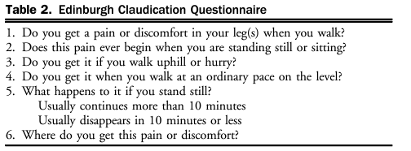
Physical Exam | VITALS: BP in both upper extremities (difference of 10mmHg or greater indicates upper extremity PAD and cerebrovascular disease, 15mmHg is lower extremity disease) and lower extremities, resting HR, RR, height, weight  INSPECT:  - Fundoscopic exam for retinal vascular changes or occlusion, macular edema and neovascularization  - Abdomen→ pulsating mass  - Extremities→ edema, pallor, cyanosis, colour in dependent & elevated positions (ulceration and diffuse erythema of lower)  - Skin/hair/nails→ temperature discrepancies, trophic changes  - Homan’s sign= calf pain with forced dorsiflexion  PALPATE  - Pulses for symmetry (brachial, aorta, femoral, all lower limb)  - Cap refill, carotid bruits, lateral pulsation of the abdominal aorta  - Allen’s test= occlude radial and ulnar arteries with fist closed, have then open and close hands a few times then release one of the arteries, then repeat with other (observe for prompt cap refill)...must do both sides radial and ulnar (ex. Use for reynauds or vascular occlusion in hand)  - Beurger test  AUSCULTATE: heart, lungs, carotids/abdomen/femoral for bruits
Red Flags | Acute limb ischemia requires immediate transport to emergency department  6Ps→ pain, pallor, paresthesia, paralysis, pulselessness, poikilothermia (inability to maintain constant core temp)
Differential Diagnosis | Venous stasis, venous obstruction/claudication, spinal stenosis, nerve root compression, hip arthritis, peripheral neuropathy, arteritis  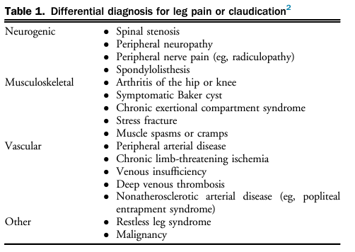
Diagnostics:  Labs & Imaging | Laboratory tests  - Basal metabolic panel (urea, creatinine, sodium, potassium)  - CRP, homocysteine, d-dimer  Diagnostic tests and/or Imaging  - ABI and abdominal ultrasound with doppler, ECG (12 lead)  - Treadmill testing, CTA, MRA, ateriography  The ABI= the most widely used test  - Inexpensive, non-invasive; PAD is ABI <0.9  - Use of the ABI based on recommendations  - Asymptomatic adults >50 with risk factors for PAD  - Confirm a diagnosis of PAD based on symptoms with ABI/TBI  - Use TBI in the presence of PAD symptoms and calcified arteries to confirm a diagnosis of PAD  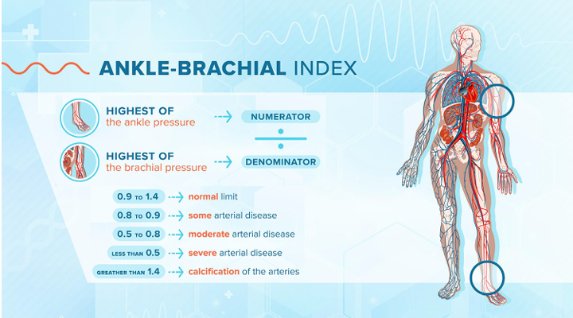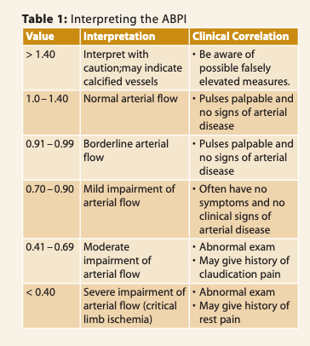
Interpretation of Ankle Brachial index Results | 1.00-1.29= normal  0.91-0.99= borderline PAD  0.41-0.90= mild/moderate PAD  0.00-0.40= severe PAD
Treatment/ Management | Counseling/Education  - Smoking cessation, chronic disease management, foot care  - Smoking is most strongly associated with development and progression of PAD  - Consider behavioral counselling, pharm therapy, nicotine replacement therapy (gum, patches, vapes), bupropion and varenicline  - Tight glycemic control for patients with PAD and diabetes can prevent limb adverse events and the need for re-vascularization  Complementary Therapies (non-pharmacological)  - Dietary management based on comorbid conditions, walking programs  - First-line therapy= supervised walking programs to improve pain-free walking distance and time  - Home-based, structured programs if supervised not available  - Walking is preferred, then cycling or leg exercises if unable  - Resistance training is not a substitute for walking therapy
Medical management | Prevent thromboembolism; clopidogrel, ASA, pentoxifylline  Reduce risk factors (reach goal BP, Hgb A1C, LDL levels)  Consider bypass, stenting, or angioplasty in patients with pain at rest, tissue loss, or significant limitations preventing exercise  - Monitor BNP prior to peripheral arterial surgery  - Surgery is appropriate for patients in which claudication affects ADLs, vocational and recreational activities after a trial of exercise programs and medical therapy has failed  - Endovascular therapy no recommended for femoral arteries involvement (common or profunda femoris/femoral/tibial bypass) or asymptomatic patients  For management of diabetes in PAD patients, SGLT-2 inhibitors reduce mortality, and adverse cardiac and limb events.  Use aggressive lipid-lowering strategies to reduce overall mortality  - Implement that maximum tolerated statin dose  - Add ezetimibe or PCSK-9 inhibitors if on max dose of statins and LDL remains >/=1.8/non-HDL >/=2.4 or apoB >/=0.7  - Icosapent ethyl if triglyceride level is 1.5-5.6 despite statin therapy  Target BPs of <140/90 in patients without compelling indication for pharm agents  - Increased adverse events in SBP <110 for PAD patients  - First choice meds for HTN= ACE/ARB  Routine antithrombotic therapy is contraindicated for isolated asymptomatic lower extremity PAD (may be indicated if other conditions exist)  Symptomatic lower-extremity PAD  - Rivaroxaban 2.5 mg BID plus aspirin 80-100 mg daily in symptomatic patients with high risk for ischemic events  - Clopidogrel > aspirin in high risk bleeding patients (do not need full dose)
Referrals | Acute limb ischemia, chronic limb ischemia progression too ulceration→ hospital & vascular specialists (may require amputation)  Persistent symptoms→ cardiologist  Angioplasty, stenting, bypass surgery→ vascular surgeon  For foot health and shoe assessment→ podiatrist  Pain management services as needed, dietician for modifications and risk factor improvement
Follow-up | Should be done by a cardiologist in the presence of persistent symptoms
Common Complications | Non-healing ulcerations of the lower extremities, infection, amputation
1° and 2° Prevention | Primary prevention  - Control chronic medical conditions (diabetes, dyslipidemia, HTN)
References | Cash & Glass, p. 222-225

PAD/Arterial Ulcers Refer if… | PVD/Venus Ulcers Refer if…
- PAD manifesting persistent symptoms should always be followed by a cardiologist visit.  - Advanced PAD Symptoms: Rest pain, non-healing ulcers, or critical limb ischemia.  - Ulcers unresponsive to initial wound care or showing signs of infection.  - Severe PAD indicated by ABI or Doppler ultrasound.  - Reduced ABPI:  - ABPI < 0.8 for routine vascular referral  - ABPI < 0.5 for urgent vascular referral  - Symptoms persisting despite lifestyle changes, exercise, or medication.  - Chronic/Acute limb ischema  - Comorbidities like diabetes or kidney disease increasing PAD complications.  - Claudication limiting daily life, unresponsive to treatment after several months.  - Worsening claudication or new symptoms of advanced PAD.  - Newly Diagnosed Arterial Ulcers: Prompt referral as soon as identified.  - Referral to a podiatrist to trim toenails and assess client for properly fitting shoes.  - Refer to pain management if pain is uncontrolled  - Referral to a dietitian to improve status of risk factors. | - Underlying medical problems requiring targeted treatment  - Ulcers of non-venous origin (e.g., rheumatoid, diabetic, arterial, or mixed etiology)  - Suspected malignancy  - Reduced ABPI:  - ABPI < 0.8 for routine vascular referral  - ABPI < 0.5 for urgent vascular referral  - Increased ABPI (> 1.2, indicating possible vessel calcification)  - Rapid ulcer deterioration  - Newly diagnosed diabetes mellitus  - Ulcers unresponsive to adequate treatment over three months  - Recurring or deteriorating ulceration  - Ischemic foot or foot infection  - Pain management  - Non-healing or atypical leg ulcers requiring biopsy

SYNCOPE
https://www.youtube.com/watch?v=kFLnZPhFEy8
Description | A common cardiovascular presentation; a symptom that occurs in many settings with many underlying causes  Brief sudden loss of consciousness/muscle tone due to tissue ischemia, recovery is spontaneous  TRANSIENT LOSS OF CONSCIOUSNESS THEN RETURN TO BASELINE FAST  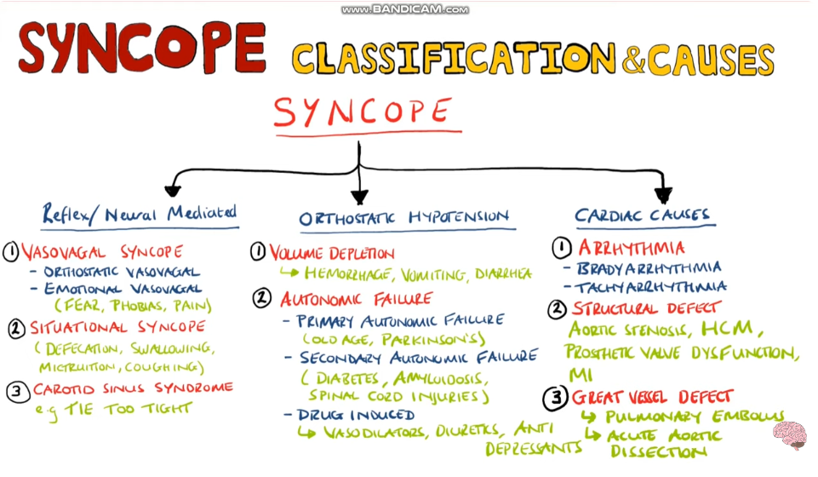  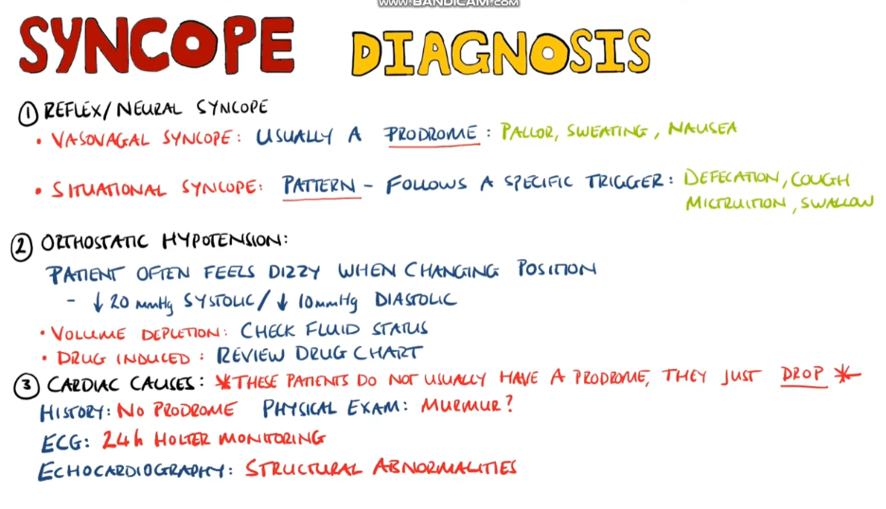  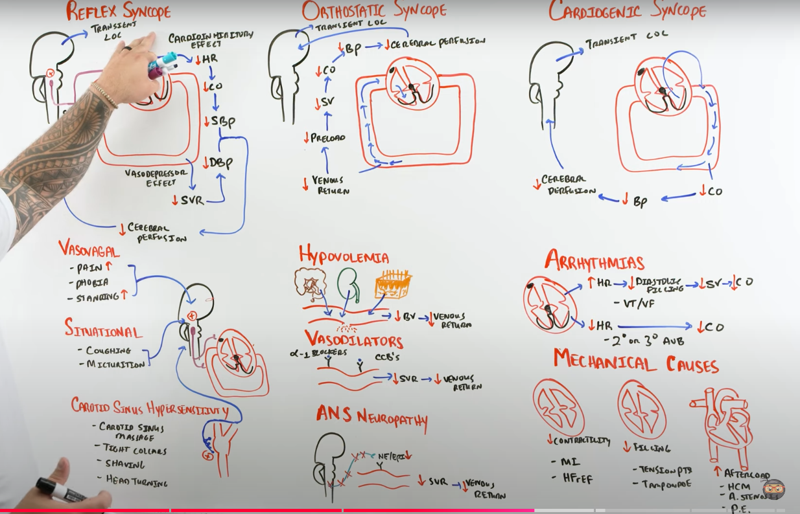  REFLEX: PRODROME  ORTHOSTATIC: POSITIONAL  CARDIOGENIC: SUDDEN
Pathology | Cause ranges from benign to life-threatening  - Non-cardiac/reflex syncope  - Vasovagal, situational, carotid sinus syndrome  - Orthostatic intolerance  - Dehydration, medications, neurogenic, postural orthostatic tachycardia, initial orthostatic hypotension  - Cardiac syncope  - Arrhythmic, structural, cardiopulmonary
Epidemiology | Lifetime occurrence is underreported in the literature (est. 32-35%)  - Higher rates of prevalence/incidence in women, increases with age
Risk Factors | Poor prognosis predictors…  - Older age; heart disease; abnormal ECG; abnormal lab values (hgb, hct, troponin, natriuretic peptides); presumed etiology, abnormal vital signs
Clinical Presentation  (Subjective Symptoms & Objective Signs) | ● HALLMARK:  ● Common findings:  ○  ● Other signs and symptoms:  ○
Hx/Key Questions | Low-risk features…  - Prodrome of typical reflex syncope  - Triggers or specific situations typical of reflex syncope  - Positional syncope  - Absence of cardiovascular disease  High-risk features…  - Cardiac disease symptoms; syncope with exertion or supine without prodrome; history of CVD; trauma; family hx of sudden cardiac death <50; abnormal vitals; abnormal cardiac exam; any brady/tachy arrhythmia or conduction disease; elevated cardiac biomarkers or other abnormal relevant blood tests  Risk Stratification Score for Syncope  It is used to estimate the risk of serious adverse events following a syncope episode. The risk ranges from very low ( –3-0 so d/c with no f/u ) to medium (1-3 so d/c with comunity f/u) to very high (>4-11 so admit to hospital)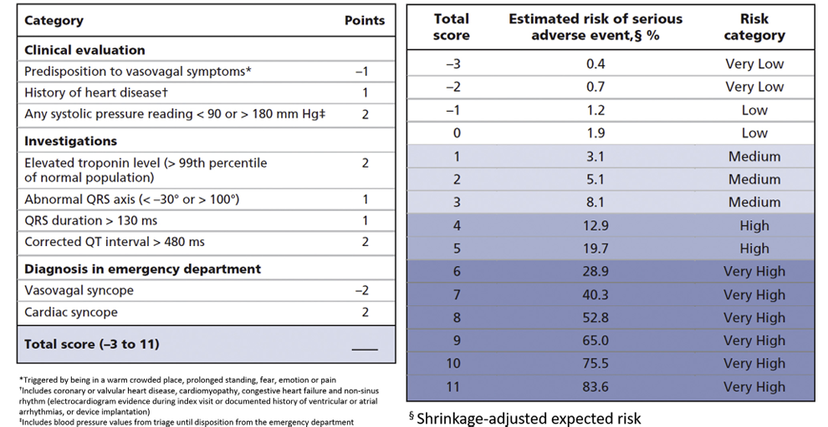
Physical Exam | Geral appearance: Observe the patient's general condition. Are they pale, diaphoretic, or anxious? These signs can suggest dehydration, vasovagal syncope, or cardiac causes.  Orthostatic vitals→ BP and HR changes in lying and standing positions, on immediate standing, and after 3 min of upright posture  Cardiac exam: Check for any signs of cyanosis or peripheral edema (could suggest heart failure). Look for jugular venous distension (indicating possible elevated central venous pressure).  MSK of neck but be careful  Neuro exam: Mental Status, Cranial Nerves, Motor Strength, Gait and Coordination  Abdominal Examination: Palpate for abdominal masses or tendernessfor AAA and auscultate for abdominal bruits
Diagnostics:  Labs & Imaging | Laboratory tests: tailor based on ddx  Diagnostic tests and/or Imaging  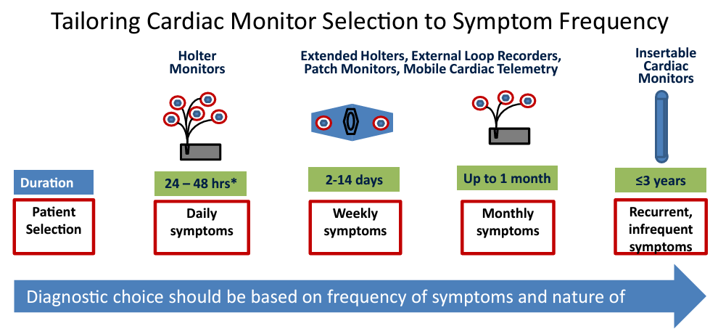  - First line is ECG and Otho vitals  - Then consider Holter for 2 weeks  - Regular stress testing in patients who present with syncope before/during/after exertion  - Consider a tilt-table test…you lay on table bed and strapped in, then moved around different planes to see if they pass our. ONLY if othero or relfex syncope!! Not cardiac!!  - 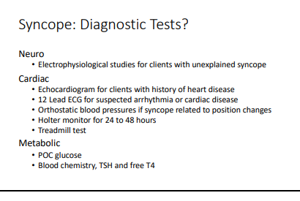  - 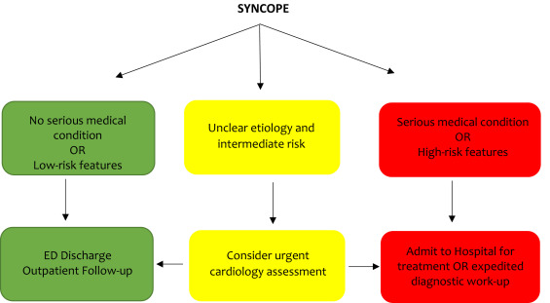  - Atypical presentations, older patients with few clues in health history, determining convulsive syncope vs epilepsy, and non-hemodynamic collapses  - Neurologic testing for routine syncope is not recommended  - Cardiac monitoring: 15 days identified 92% of arrhythmic outcomes  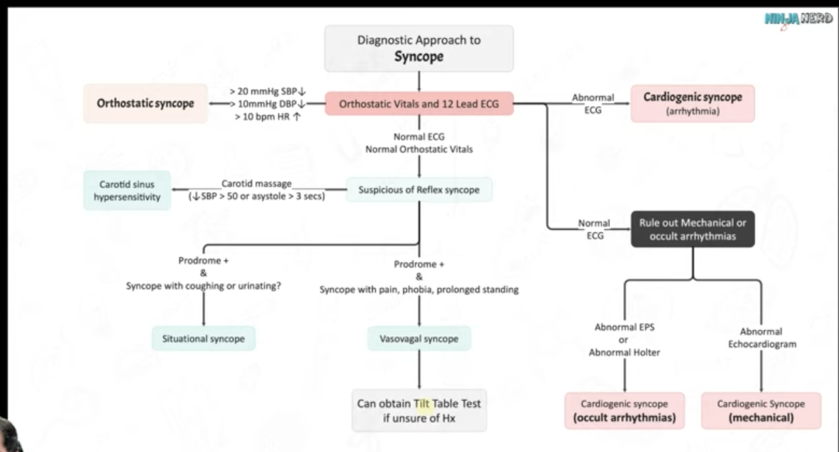  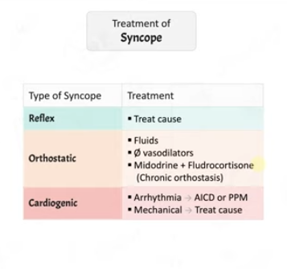
More diagnostics from Aric | Any kid with syncope r/u seizure by referring to neuro for EEG  Cardiac:  - Echo if hx heart disease  - 12 lead ECG for suspected arrhythmia or cardiac disease  - Ortho BP if related to position changes  - Holter for 2 weeks is suggested  - Treadmill test is activity induced  Metabolic  - POC glucose  - Chemistry, TSH, free T4, CBC*** main ones  - BNP if HF related?  - Can do B12, A1C, ferritin but NOT FOR PRIORITY
Management | Vasovagal Syncope…(usually benign)  NON-PHARM  - Education and reassurance  - Avoidance of triggers (coughing, micturition, defecation, laughing, dehydration, crowded environments) and education on recognizing early prodrome to prevent episodes  - Increase water and salt intake (limited evidence)  - Lie down quickly with onset of presyncope  - In patients with a clear prodrome, try leg-crossing, abdo contractions, and squatting  PHARM  - No single therapy has been proven to be most effective  - Treatment on the basis of a low BP phenotype of SBP </=110  - For recurrent, refractory vasovagal syncope  - Fludrocortisone or midodrine as first-lie options  - Beta blockers for patients over 42 years as second-line therapy  - Cardiac pacing may be used in patients >40 with highly symptomatic recurrent VVS and…  - Documented symptomatic asystole >3s or asymptomatic >6s OR  - Tilt-induced asystole >3s or HR <40 for >10s  Orthostatic Hypotension…(frequent in older adults)  - Most commonly caused by a neurogenic etiology and drug-induced  - For postural decrease of 20/10 or more, consider OH as a cause of syncope  NONPHARM  - Education, lifestyle, adequate salt and water intake  - Stop or adjust levels of vasoactive agents like ACE/ARB, thiazides, diuretics, CCBs, B-blockers  - Compression garments and head-up tilt sleeping in persistent symptoms despite counter-pressure maneuvers  PHARM  - Midodrine & fludrocortisone as first lie (droxidopa not available in Canada)  STRESS TEST IF DIZZINESS ON EXERTION
Referrals | If there is serious medical conditions present or high-risk features, consider admission to hospital/send patient to ED with an urgent cardiology referral
DDx | Vertigo, diabetes, hypothyroid, anaemia, arrhythmia, ortho hypotension, med side effect?? Vasovagal episode, stenosis, pump failure, anxiety, MDD, unexplained, subclavian steal syndrome (do bilateral BP)
Common Complications | Adversely affects independence: DRIVING  - Some methods exist to calculate fitness to drive, but there is a lack of data (also how do you quantify “type of vehicle”??)  - In VVS, risk of syncope while driving is <1%/year  - No driving restrictions for patients with single VVS event unless they had the event while driving or had no prodrome  - May be reasonable to restrict driving for 1 month in patients with an unexplained episode of syncope or frequent VVS with limited prodrome

Syncope Guideline
https://onlinecjc.ca/article/S0828-282X(19)31549-1/fulltext
How to manage syncope
- Initial Evaluation:
- Detailed hx, physical exam (including ortho VS), 12-lead ECG
- Goal is to identify whether the syncope is cardiac or non-cardiac:
  - Non-cardiac syncope includes: reflex syncope (e.g. vasovagal), orthostatic intolerance (e.g. dehydration, medication, orthostatic hypotension)
  - Cardiac syncope (e.g. arrhythmic, structural, cardiopulmonary)
- Risk Stratification:
- Identify low-risk (benign) vs high risk (serious) syncope to guide tx and need for hospitalization
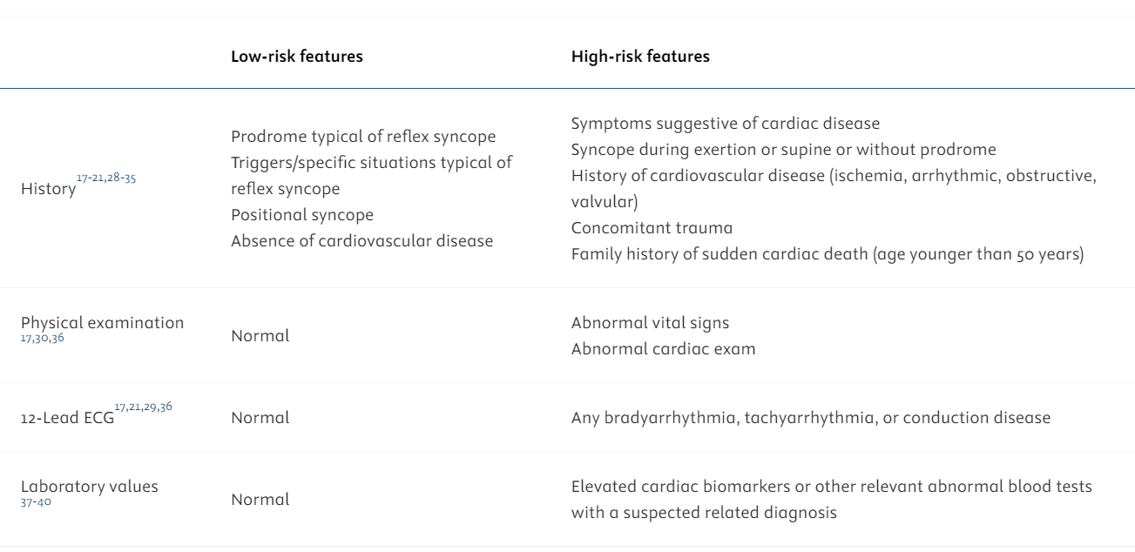
Canadian Syncope Risk Score
Used to determine 30 day risk of an adverse event
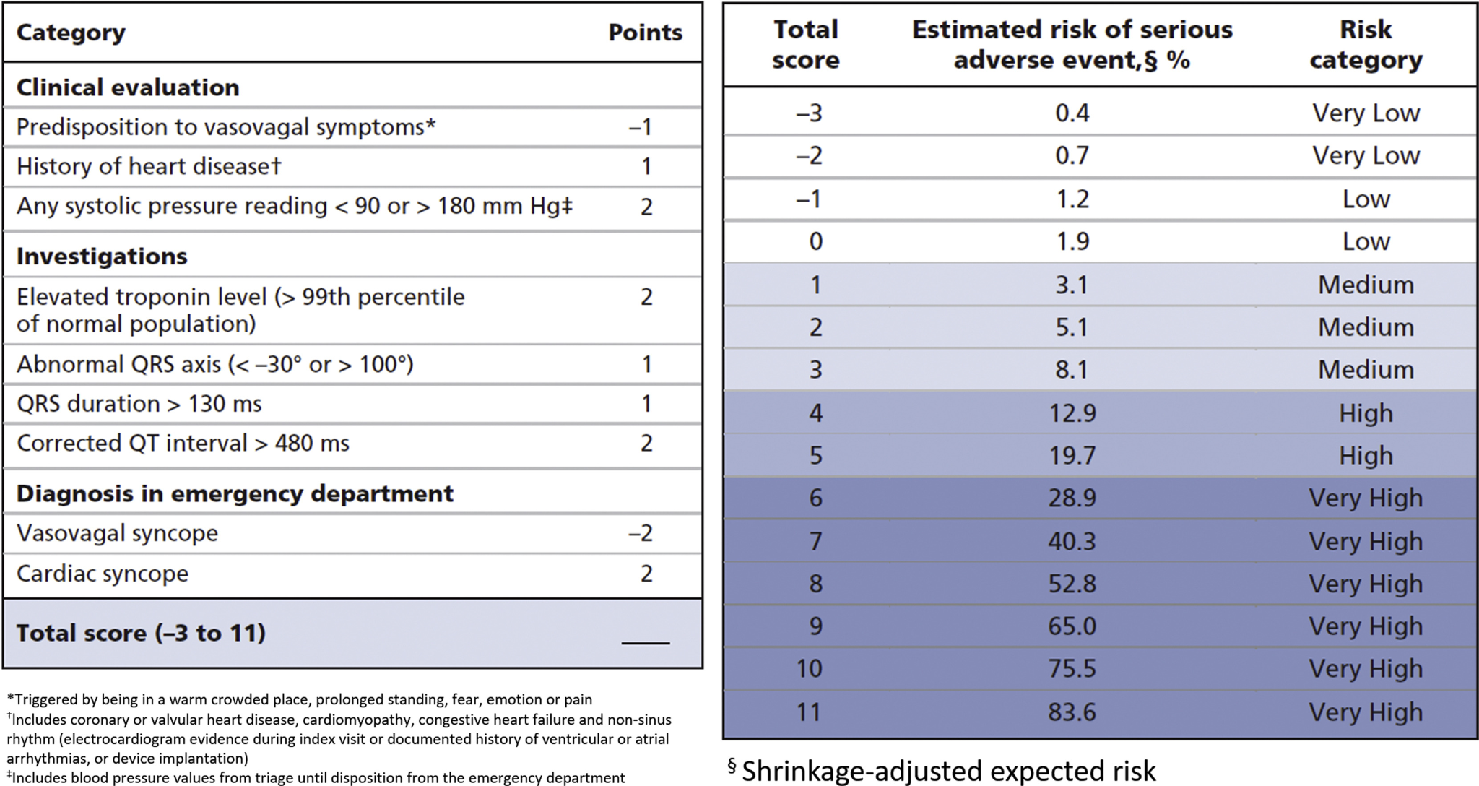

- Diagnostic workup
- Avoid broad investigations. Cardiac imaging (e.g. echo, stress test) should be on basis of clinical suspicion of ischemic, structural, or valvular heart disease
- Stress test: regular stress testing only for patients who present with syncope associated with exertion (syncope occurs before, during, or after exertion)
- Bloodwork has limited value; only do it in patients where you suspect MI, PE, or HF
- Brain imaging only for patients whom intracranial disease is highly suspected
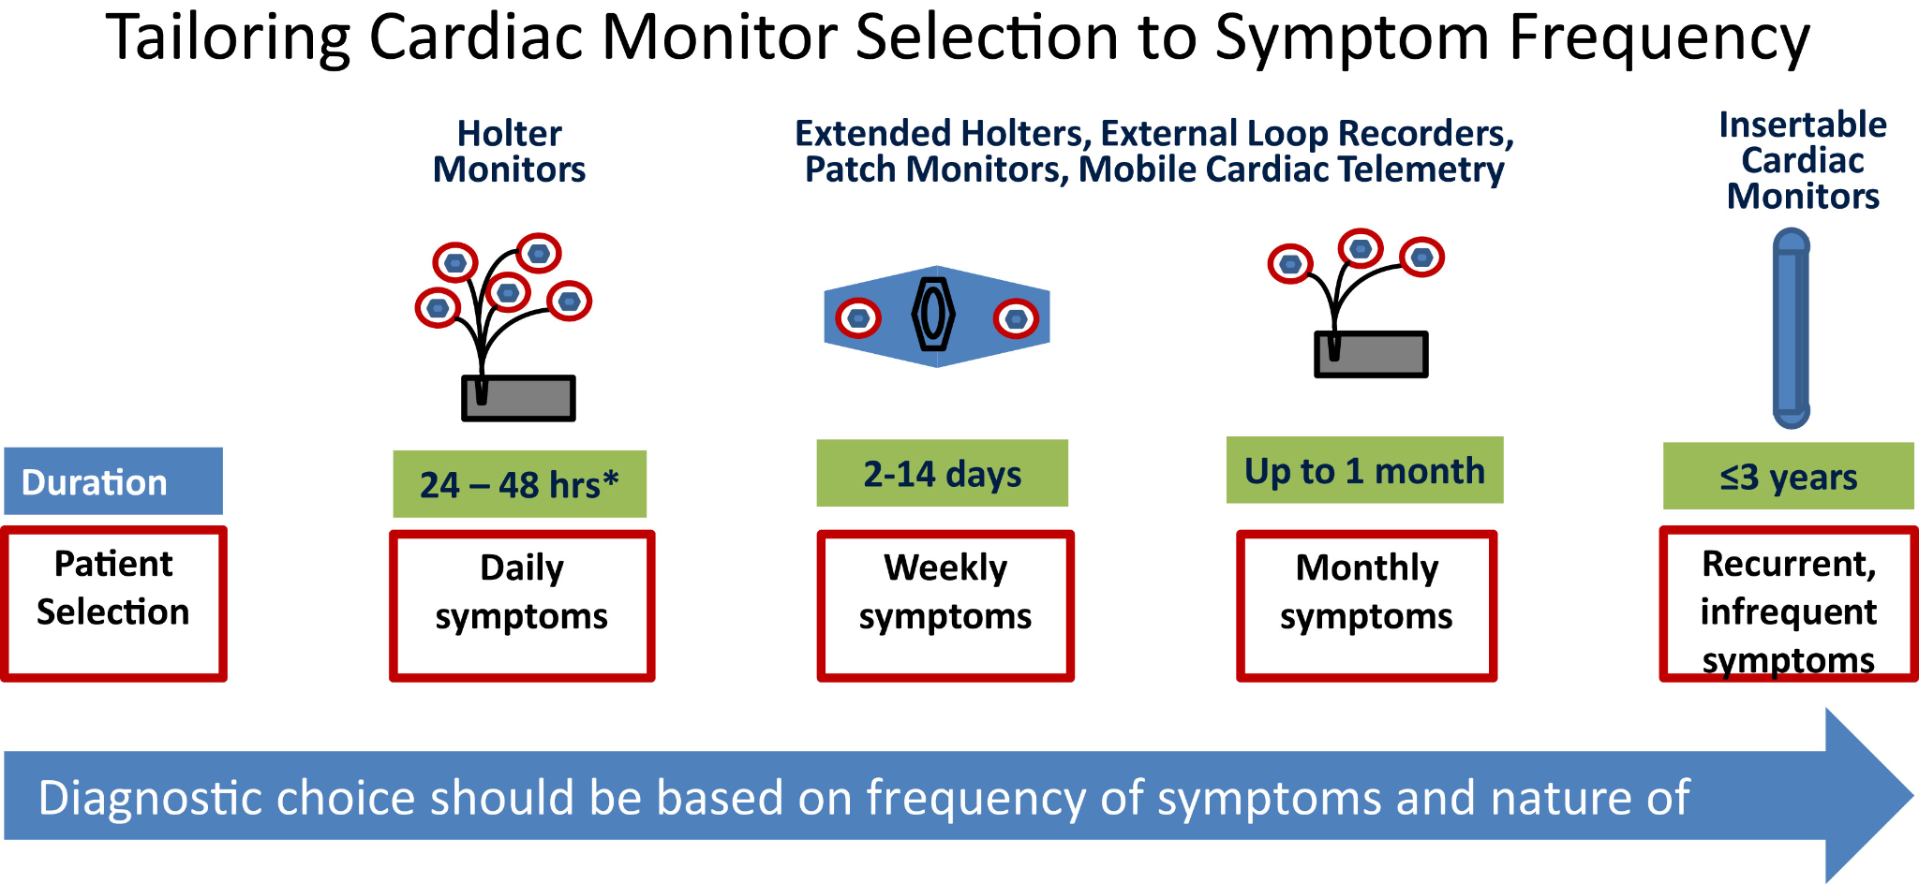

- Management of non-cardiac syncope
- Vasovagal
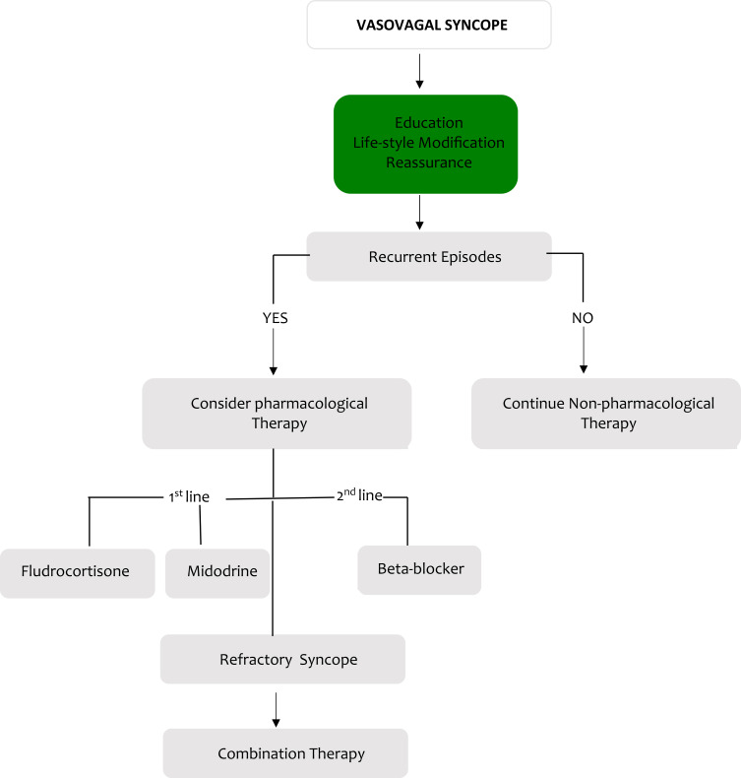
- Orthostatic hypotension
- Frequent cause in older patients
- Often neurogenic or drug-induced
- Tx: education, lifestyle measures, and adequate salt and water intake are 1st line therapy
  - Stop or adjust vasoactive agents like ACE inhibitors, ARBs, thiazides, or other diuretics etc.

Note on driving and syncope:
- No driving restrictions for pts with a single vasovagal syncope event unless high risk features are present (e.g. syncope while driving, lack of prodrome)
- Driving restriction of 1 month is reasonable for pts with unexplained syncope or frequent vasovagal syncope or limited prodrome

Heart Failure Reference Guide
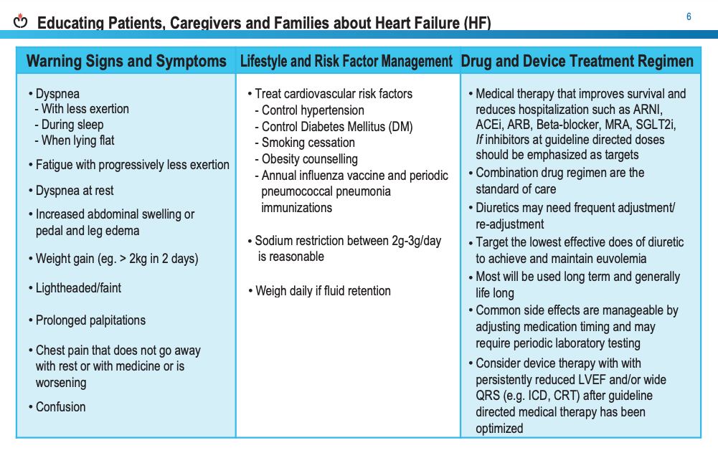
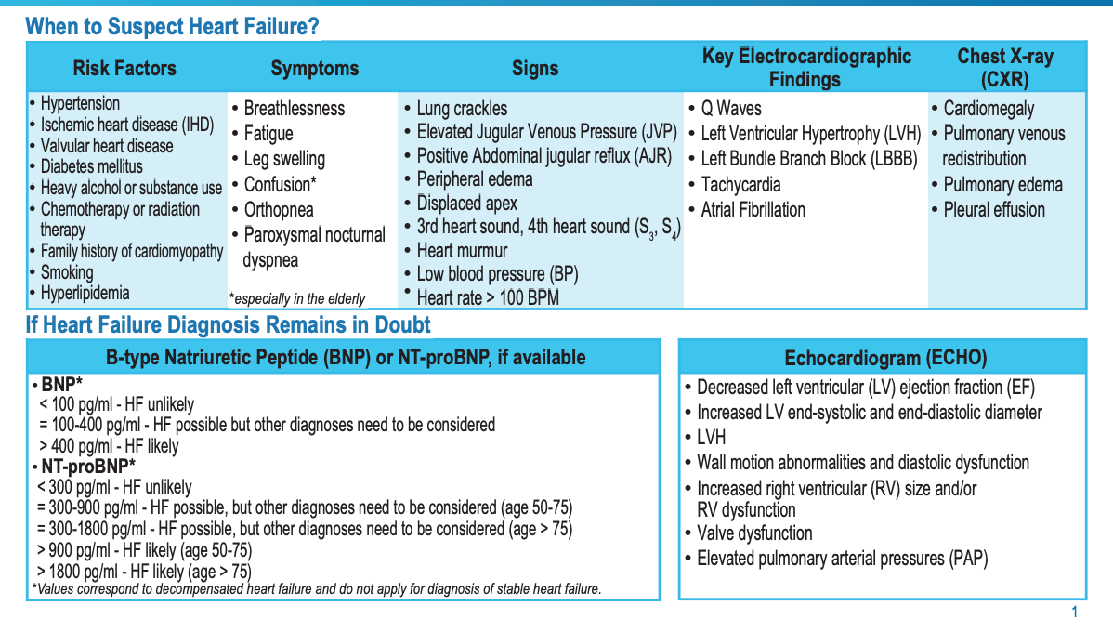
What is BNP?
B-type Natriuretic Peptide (BNP) and N-terminal pro-B-type Natriuretic Peptide (NT-proBNP) are biomarkers used to diagnose and assess the severity of heart failure. They are proteins produced by the heart in response to excessive stretching of heart muscle cells, particularly in the ventricles, due to increased pressure or volume.
Steps to diagnose HF:

1. Suspected Heart Failure
When a patient presents with symptoms or risk factors that might suggest heart failure, the clinician starts by gathering key information through:
- Clinical History:
  - Symptoms: The patient may report shortness of breath, fatigue, or swelling (edema).
  - Functional limitation: How limited the patient is in their daily activities.
  - Prior or established cardiac disease: Any history of conditions like coronary artery disease or past heart issues.
  - Risk factors: Includes hypertension, diabetes, or obesity.
  - Exacerbating factors: What worsens symptoms (e.g., fluid overload, infections)?
  - Comorbidities: Other conditions the patient has, such as kidney disease or lung disease.
  - Drugs: Medications the patient is on, including any that may impact heart function (e.g., chemotherapy agents, NSAIDs).
- Physical Examination:
  - Vital signs: Blood pressure, heart rate, etc.
  - Weight: Rapid weight gain could indicate fluid retention.
  - Volume status: Whether there are signs of fluid overload (e.g., swollen legs, jugular venous distention).
  - Heart, lung, abdominal, and peripheral vascular examination: Assess for abnormal heart sounds, crackles in the lungs, or signs of liver congestion.

2. Initial Investigations
If heart failure is suspected based on clinical history and physical exam, the following initial investigations are done to gather more information:
- Chest radiograph (X-ray): To look for signs of heart enlargement or fluid in the lungs.
- Echocardiogram: An ultrasound of the heart to evaluate its structure and function.
- Lab work:
  - CBC (complete blood count): To check for anemia or infection.
  - Electrolytes: To assess the body's salt balance.
  - Renal function: To assess kidney function.
  - Liver function: To evaluate if liver congestion is present.
  - Urinalysis: To check for kidney disease or infection.
  - Glucose: To screen for diabetes.
  - Thyroid function: To rule out thyroid problems that could affect the heart.

3. Assessing Natriuretic Peptides
- NT-proBNP:
  - If NT-proBNP ≥ 125 pg/mL, this supports the diagnosis of heart failure.
- BNP:
  - If BNP ≥ 50 pg/mL, this is also indicative of heart failure.

4. Assessment of Ventricular Function
- The next step is an echocardiogram, this helps classify heart failure as:
  - HFrEF (Heart Failure with Reduced Ejection Fraction) or
  - HFpEF (Heart Failure with Preserved Ejection Fraction).
NYHA and Heart Failure
The New York Heart Association (NYHA) Classification is a system used to categorize the severity of heart failure based on a patient’s symptoms and impact on physical activity
- NYHA Class I: No symptoms with ordinary activity, no limitation in physical activity.
- NYHA Class II: Slight limitation with ordinary physical activity, but comfortable at rest.
- Class III: Significant symptoms, marked limitation with less-than-ordinary activity.
- Class IV: Severe symptoms even at rest, unable to perform any physical activity without discomfort.

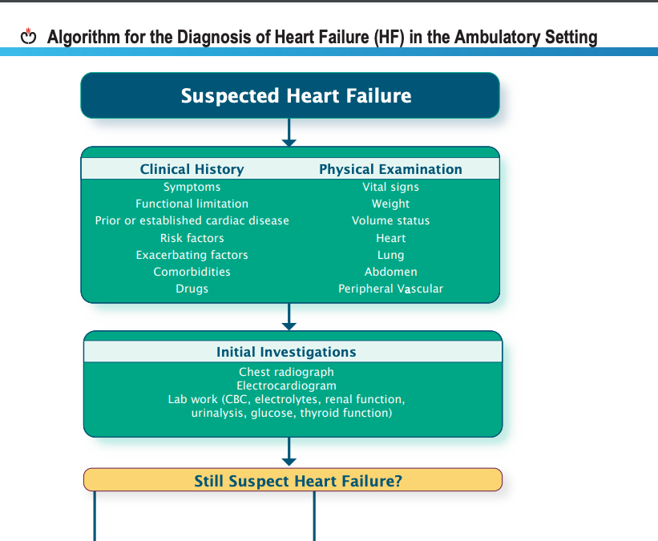
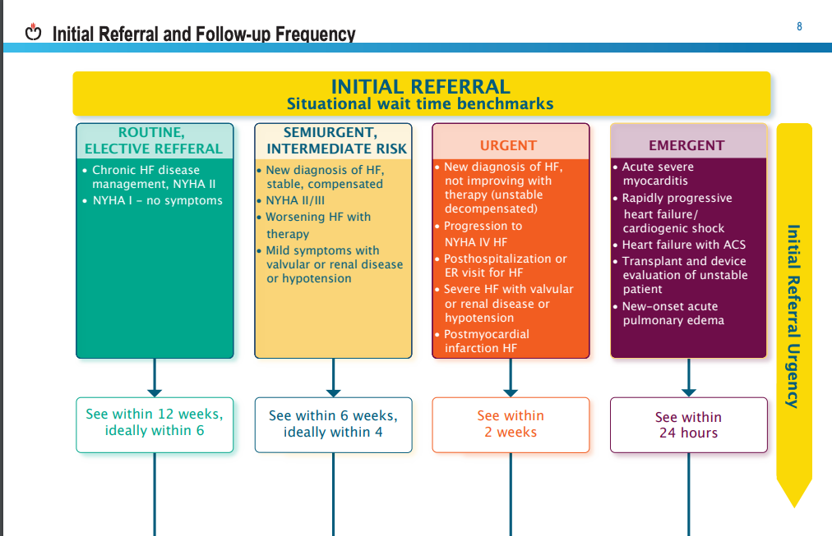

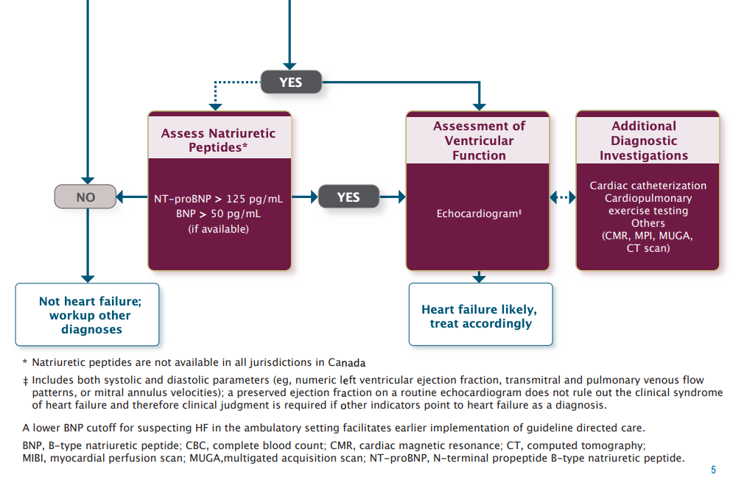
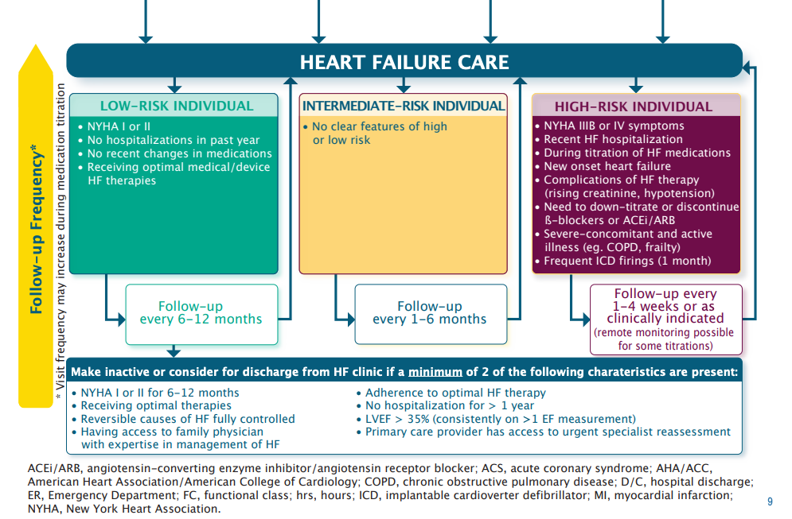

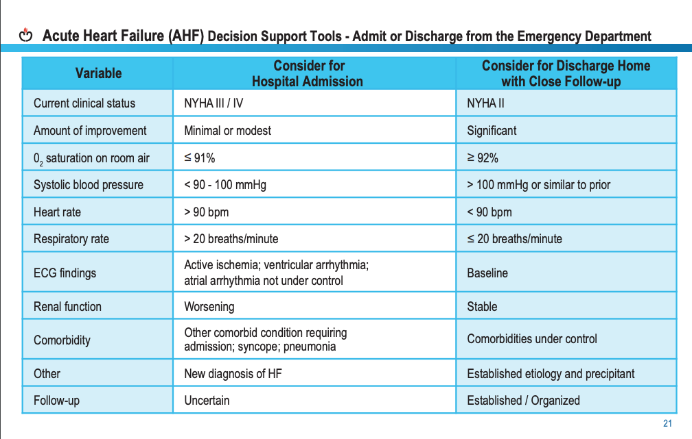

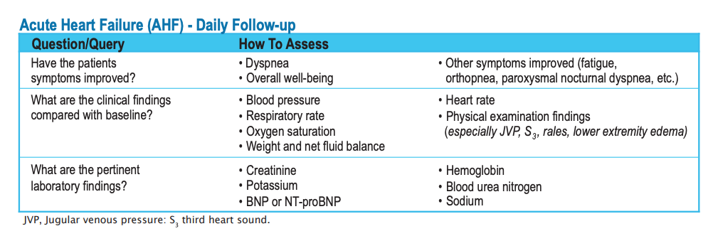

Hypertension Guidelines

STEP 1: Check BP

Automated Office Blood Pressure (AOBP)
- Diagnosis Threshold:
  - Mean SBP > 135 mmHg
  - Mean DBP > 85 mmHg
- Technique:
  - Verify cuff position and measurement validity with the first reading.
  - Leave the patient alone after the first measurement; the device will automatically take subsequent readings.

Non-Automated Office Blood Pressure (Non-AOBP)
- Diagnosis Threshold:
  - Mean SBP ≥ 140 mmHg
  - Mean DBP ≥ 90 mmHg
- Diabetes Diagnosis Threshold:
  - Mean SBP ≥ 130 mmHg
  - Mean DBP ≥ 80 mmHg
- Technique:
  - Record BP to the nearest 2 mmHg, noting the arm used and the patient's position (supine, sitting, standing).
  - Record heart rate.
  - Discard the first reading; average the latter two.

Home Blood Pressure Monitoring
- Indications for use:
  - Diabetes mellitus
  - Chronic kidney disease
  - Suspected non-adherence
  - White coat effect
  - Masked hypertension (controlled in-office but not at home)
- Home BP Threshold for Diagnosis:
  - SBP > 135 mmHg
  - DBP > 85 mmHg
- Technique:
  - Take 2 measures in the morning and evening for seven days; discard the first day's values.

Ambulatory Blood Pressure Monitoring (ABPM) GOLD STANDARD FOR AT HOME
- This is an at home device that takes several readings over a period of time and calculates an average.
- Indications:
  - Suspected white coat effect in treated patients not reaching BP targets.
  - Symptoms suggestive of hypotension.
  - Fluctuating office BP readings.
- ABPM Threshold for Diagnosis:
  - Mean 24-hour SBP > 130 mmHg
  - Mean DBP > 80 mmHg
  - OR Mean daytime SBP > 135 mmHg
  - Mean daytime DBP > 85 mmHg
- Considerations:
  - Monitor nocturnal BP changes; a decrease of <10% increases cardiovascular event risk.
Serial office measurements over 3-5 visits can be used if ABPM or home measurement is not available. Annual BP measurement is recommended to detect progression to hypertension.

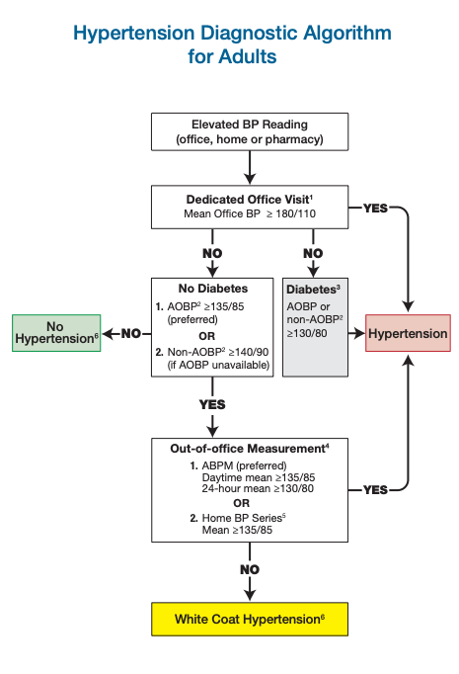

STEP 2: CONFIRM HTN WITH DIAGNOSTIC TESTS
If the patient’s blood pressure is suggestive of hypertension conduct the following labs/tests:
- Urinalysis
- Blood chemistry (potassium, sodium and creatinine)
- Fasting blood glucose and/or glycated hemoglobin (A1c)
- Serum total cholesterol, low-density lipoprotein (LDL), high-density lipoprotein (HDL), non-HDL cholesterol, and triglycerides; lipids may be drawn fasting or non-fasting
- Standard 12-lead ECG
- FYI: routine testing of microalbuminuria in patients with hypertension by without diabetes or renal disease is not supported by current evidence

STEP 3: ASSESS ORGAN DAMAGE
Once diagnosed next you need to assess Target Organ Damage. Presence of any of the following would put a patient into the moderate-to-high or high-risk categories for therapy.

Cardiovascular Disease
- Coronary Artery Disease (CAD)
  - Acute Coronary Syndromes
  - Angina Pectoris
  - Myocardial Infarction
- Heart Failure
  - Left Ventricular Dysfunction
  - Left Ventricular Hypertrophy

Cerebrovascular Disease
- Aneurysmal Subarachnoid Hemorrhage
- Dementia
- Intracerebral Hemorrhage
- Ischemic Stroke or Transient Ischemic Attack (TIA)
- Vascular Dementia
- Mixed Vascular Dementia and Alzheimer’s Type Dementia

Hypertensive Retinopathy

Peripheral Arterial Disease (PAD)
- Intermittent Claudication

Renal Disease
- Albuminuria
- Chronic Kidney Disease (GFR < 60 ml/min/1.73 m²)

Global Cardiovascular Risk Assessment
- Global cardiovascular risk should be assessed using multifactorial risk assessment models for more accurate prediction of global cardiovascular risk and antihypertensive therapy.
- Risk calculators for assessment:
  - CCS Risk Calculators
  - My Health Checkup
  - SCORE Canada

STEP 4: DETERMINE RISK AND TARGETS
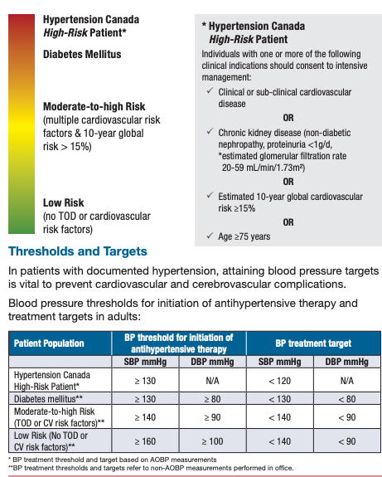

STEP 5: CONSIDER NON-PHARM INTERVENTIONS

Being More Physically Active
  - Accumulate 30-60 minutes of moderate-intensity dynamic exercise (walking, cycling, swimming) 4-7 days/week.
  - Higher intensities are not more effective for BP lowering but may offer other cardiovascular benefits.
  - Resistance training (free weights, fixed weights, hand grip exercises) is safe for non-hypertensive and stage-1 hypertensive individuals.

Weight Reduction
  - Healthy BMI: 18.5 – 24.9 kg/m².
  - Waist circumference: <102 cm for men, <88 cm for women.

Moderation in Alcohol Intake
  - Limit to 0-2 standard drinks/day:
    - Men: <14 drinks/week.
    - Women: <9 drinks/week.

Eating Healthier
  - Adopt a DASH-like diet: high in fruits, vegetables, dietary fiber, non-animal protein (e.g., soy), and low-fat dairy; low in saturated fat and cholesterol.
  - Consider increasing dietary potassium for hypertensive patients.

Relaxation Therapies
  - Use individualized cognitive behavior interventions with relaxation techniques for better effectiveness.

Smoking Cessation
  - Encourage quitting and provide pharmacotherapy options.
  - Promote abstinence and a smoke-free environment.

STEP 6: CONSIDER PHARM INTERVENTIONS

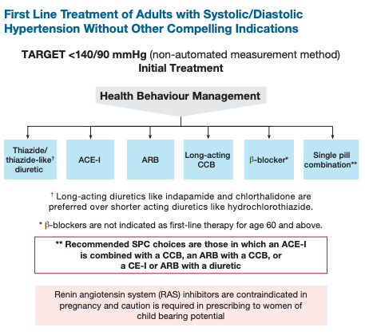

Combination Therapy for Optimal Blood Pressure Targets
- Multiple Medications:
  - Often necessary to achieve target BP levels, especially in patients with Type 2 diabetes.
  - Consider single pill combination therapy to replace multiple antihypertensive agents.
- Combination Restrictions:
  - Avoid using ACE inhibitors and ARBs together.
  - In high-risk patients, prefer combining an ACE inhibitor with a long-acting dihydropyridine calcium channel blocker (CCB) over a thiazide or thiazide-like diuretic.
- β-Blocker Use:
  - Adding β-blockers to ACE inhibitors or ARBs has not shown significant BP improvement.

Suspected Resistant Hypertension
- Considerations:
  - Evaluate for white coat hypertension and non-adherence to medication.
  - Consider adding diuretic therapy if not already prescribed or contraindicated.
- Monitoring Requirements:
  - Monitor creatinine and potassium levels when combining potassium-sparing diuretics with ACE inhibitors and/or ARBs.
- Referral:
  - Consider referring to a hypertension specialist if BP remains uncontrolled after treatment with three antihypertensive medications.

STEP 7: FOLLOW UP
- NON-PHARM:
  - Schedule patient follow-up every 3-6 months to monitor active modifications.
  - For patients with BP not at target, visits every 1-2 months are recommended.
- PHARM:
  - Patients on antihypertensive drugs should be seen every 1-2 months based on BP levels until readings on two consecutive visits are below target.
  - Once target BP is reached, follow-up should be every 3-6 months.
- Individualized Follow-Up:
  - Follow-up frequency should reflect the individual’s clinical situation.
  - Shorter intervals may be necessary for symptomatic patients, those with severe hypertension, intolerance to antihypertensive drugs, or target organ damage.
OTHER CONSIDERATIONS BELOW FROM BPG:
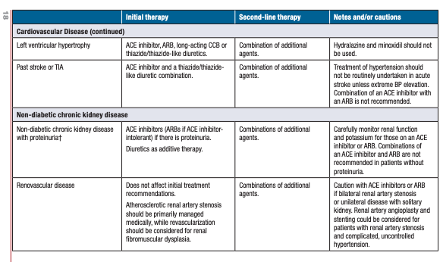
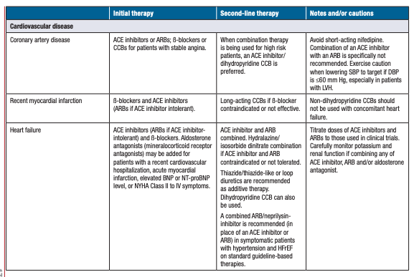
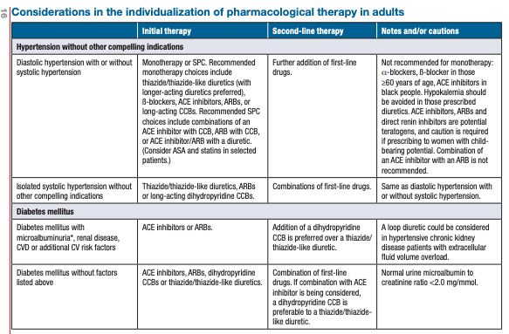
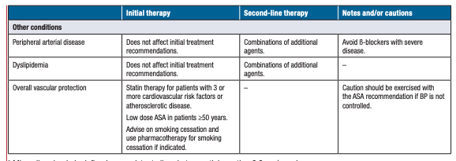

Dyslipidemia Guideline

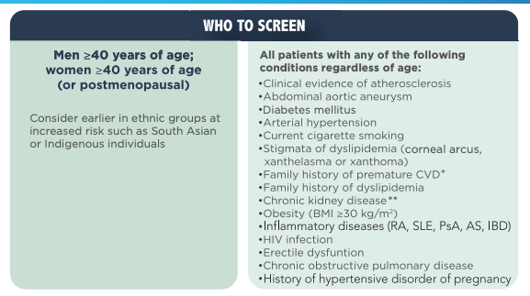
How to Screen
- History and Physical Examination
- Standard Lipid Profile:
  - Total Cholesterol (TC)
  - Low-Density Lipoprotein Cholesterol (LDL-C)
  - High-Density Lipoprotein Cholesterol (HDL-C)
  - Non-HDL Cholesterol (Non-HDL-C)
  - Triglycerides (TG)
- Fasting Plasma Glucose (FPG) or Glycated Hemoglobin (A1c)
- Estimated Glomerular Filtration Rate (eGFR)
- Lipoprotein(a): Measure once in the patient’s lifetime, with initial screening.
  - If Lp(a) ≥50 mg/dL (or ≥100 nmol/L), we recommend earlier and more intensive health behaviour modification. This is only tested once in lifetime as it is genetically influenced and value rarely changes with age.
Optional Tests:
- Apolipoprotein B (ApoB)
- Albumin-to-Creatinine Ratio (ACR): If eGFR < 60, or if the patient has hypertension or diabetes.
Lab Values:
FASTING:
- Low-Density Lipoprotein Cholesterol (LDL-C):
  - Optimal: < 2.0 mmol/L
  - Non-fasting: DO NOT LOOK AT! Look at non-HDL!
- High-Density Lipoprotein Cholesterol (HDL-C)
  - Optimal: ≥ 1.2 mmol/L
- Triglycerides (TG)
  - Normal Range: < 1.7 mmol/L
  - Non-fasting: DO NOT LOOK AT! Look at non-HDL!
    - BPG recommends that for any patient with triglycerides >1.5 mmol/L, non-HDL-C or ApoB be used instead of LDL-C as the preferred lipid parameter for screening.
NON FASTING:
- Non-HDL Cholesterol (Non-HDL-C)
  - Optimal: <2.6 if above 20% on FRS
  - < 5.2 mmol/L if between 10-19% on FRS
  - Only look at when non-fasting!
- Total Cholesterol (TC): < 5.7 mmol/L
  - Looks at LDL and TG, can be non fasting!

Fragmin risk score?:
<10%: lifestyle
11-19%: lifestyle and statin
>20%: statin!!!!! and lifestyle

If don't want statin: look at 3Fs…fitness, fibre, fatty acid
Secondary Testing to Consider
- Coronary Artery Calcium (CAC) screening can be done using computed tomography imaging for asymptomatic adults ≥ 40 years and at intermediate risk (Fragmin Risk Score 10%-20%)
- CAC screening SHOULD NOT be undertaken for
  - a) high risk individuals
  - b) patients receiving statin treatment
  - c) most asymptomatic, low-risk adults
- CAC screening might be considered if low-risk middle-aged (≥40 years) with a family hc of premature ASCVD with a genetic causes
Risk assessment:
In order to evaluate risk for dyslipidemia you can calculate risk using the Framingham Risk Score (FRS)✝ for r men and women age 40 to 75. Repeat screening every 5 years for FRS <5% or every year for FRS ≥5%
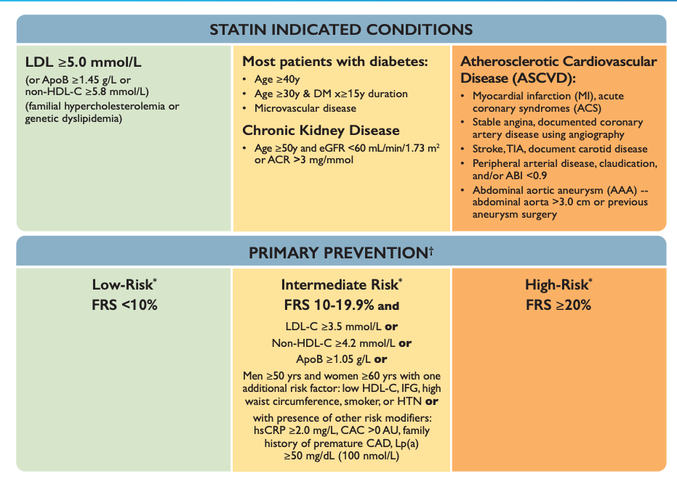
Note statins are NOT ONLY used for dyslipidemia. Other conditions may necessitate the use of statins as listed to the right, in addition too:
- Adults ≥50 years with chronic kidney disease not treated with dialysis or a kidney transplant
- DO NOT initiate in adults with dialysis-dependent CKD unless already receiving it at the time of dialysis initiation
- In adults with kidney transplantation
Consider therapy if:
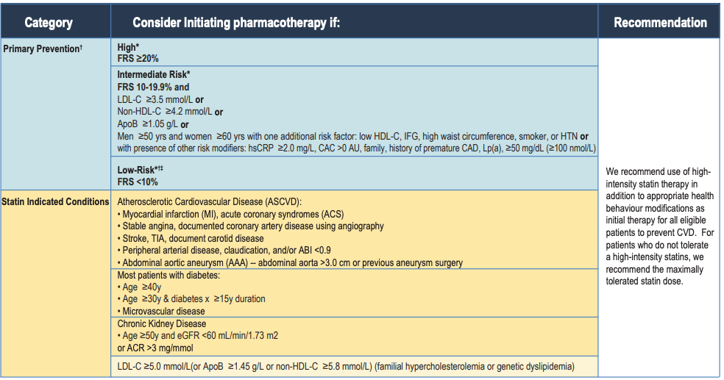

Non-Statin Therapy
Intensification of lipid-lowering therapy with a PCSK9 inhibitor (evolocumab or alirocumab) can be done (with or without the additional use of ezetimibe) for secondary CV prevention patients who’s LDL-C remains ≥1.8 mmol/L (or non-HDL-C ≥2.4 mmol/L or ApoB ≥0.7 g/L) while receiving the maximally tolerated statin dose.
If ezetimibe is used initially and LDL-C remains ≥1.8 mmol/L (or nonHDL-C ≥2.4 mmol/L or ApoB ≥0.7 g/L) PCSK9 inhibitor therapy is recommended
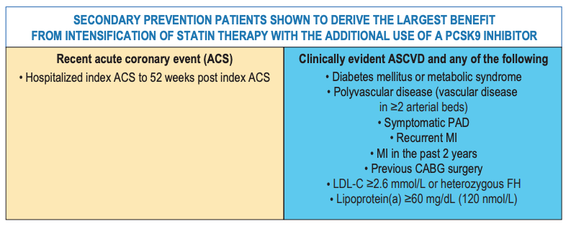
Bile acid sequestrants can be considered for LDL-C lowering in high risk patients whose levels remain above target despite statin treatment +/- ezetimibe therapy
Non-Pharm Approaches/Health Teaching
- At least 150 minutes of moderate-to-vigorous intensity aerobic physical activity per week, in bouts of 10 minutes or more to reduce CVD risk
- Adults who smoke should receive clinician advice to stop smoking to reduce CVD risk
- Combining low-risk lifestyle behaviors that include achieving and maintaining a healthy body weight, healthy diet, regular physical activity, moderate alcohol consumption, and moderate sleep duration to achieve maximal CVD risk reduction
Putting it all together
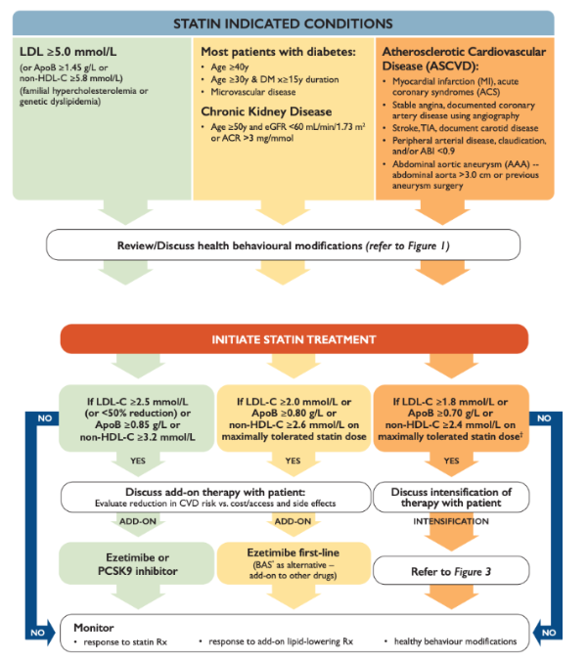
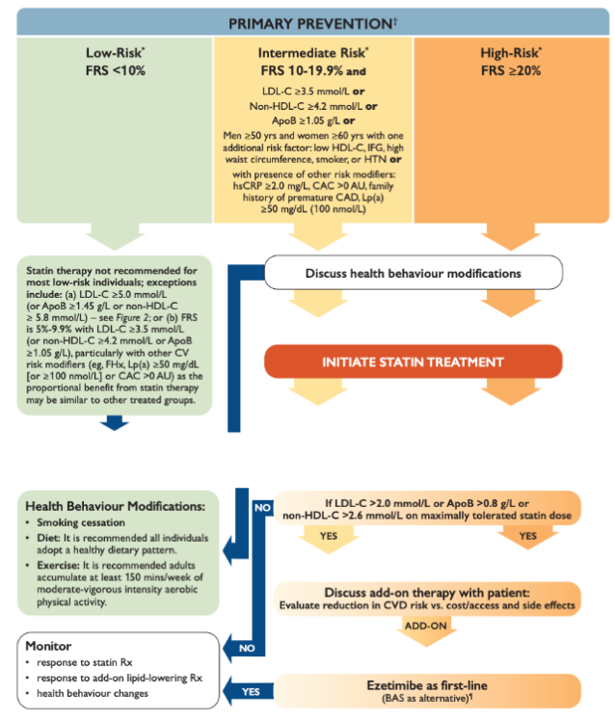
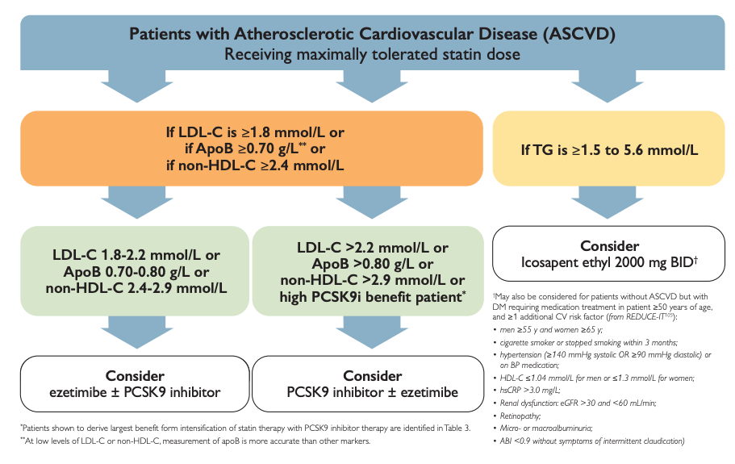

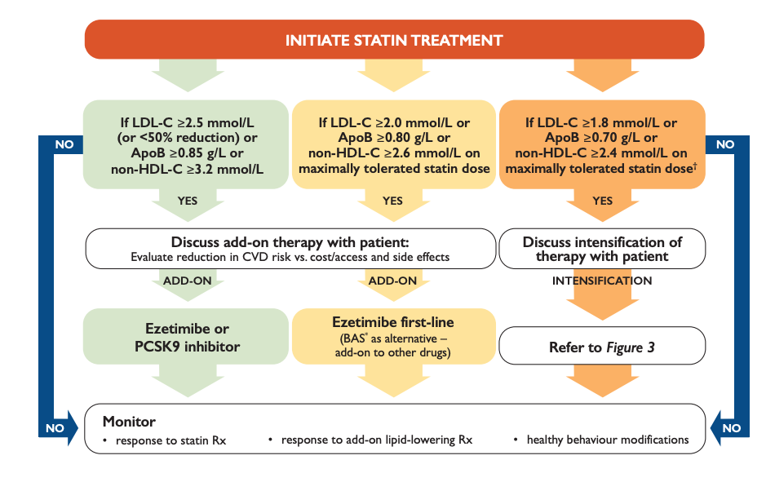

Guideline for the prevention and management of cardiovascular disease in primary care: 2018 update
C-CHANGE= Canadian Cardiovascular Harmonized National Guideline Endeavor
- Brings together 9 guideline groups to provide a composite set of recommendations for guiding treatment plans (77 recommendations)
What guidelines are incorporated?
- Canadian action network for the advancement, dissemination, and adoption of practice-informed tobacco treatment
- Canadian Cardiovascular society for heart failure management
- Canadian cardiovascular society for dyslipidemia management
- Canadian association of cardiovascular prevention and rehabilitation
- Canadian society for exercise physiology
- Diabetes canada
- Hypertension canada
- Canadian association of bariatric physicians and surgeons/obesity Canada
- Heart and stroke Foundation
Highlighted Change Recommendations:
- Cardiovascular risk assessment every 5 years in men and women 40-75
  - Use FRM or CLEM
- Calculate cardiovascular age to improve livelihood of reaching targets and treating poorly controlled hypertension
  - Share the risk assessment with patients to support shared decision-making
HYPERTENSION
- Measurement with automated devices or home measurements is preferred over auscultation for diagnosing HTN, using upper arm devices and electronic/oscillometric measurement
  - With AOBP, ambulatory and home-monitoring
    - 135+/85+ is high
  - For non-AOBP monitoring
    - 140+/90+ is high, and 130-139/85-89 is high-normal
  - Wrist devices can be used for estimation in patients with large arm circumference
- Single-pill combinations are recommended as initial therapy for patients with BP elevated less than 20/10 above target (improved adherence)
- Assess global cardiovascular risk
  - Use of risk assessment models can be more accurate, engage individuals in conversation about behaviour changes, and use antihypertensive therapy more efficiently
- Routine hypertension lab tests…
  - Urinalysis
  - Blood potassium, sodium, creatinine
  - Fasting BG or A1c
  - Lipids: total cholesterol, LDL-C, HDL-C, non-HDL-C, triglycerides (fasting or nonfasting)
  - Standard 12-lead ECG
DYSLIPIDEMIA
- Screen plasma lipids in men 40+ and women 40+ OR postmenopausal
- Update tobacco use status of all patients on a regular basis and advise to quit smoking
- Inform patients of their global risk to improve effectiveness of risk factor modifications
- Canada follows a “treat to target” model
- Recommendations= statins in high-risk groups
  - Atherosclerosis, abdominal aortic aneurysm, diabetes, kidney disease, LDL cholesterol 5+ & framingham risk score 20+%
  - Those with a risk score <10% do not require pharmacotherapy
- Intnermediate risk for consideration of therapy
  - LDL 3.5+
  - Non-HDL 4.3+
  - Apolipoprotein B-100 1.2+
  - Me >50 & women >60 with one additional CVD risk factor
DIABETES
- Screen for diabetes using FPG or A1C every 3 years in individuals over age 40 or at high risk
- IF FPg 6.1-6.9 or A1C 6-6.4, test 2h pG with 75g OGTT to identify impaired glucose tolerance and diabetes in patients
  - Reliance on A1C alone can miss impaired fasting glucose or impaired glucose tolerance
  - Use OGTT in patients with unexplained microvascular complications
- Management has been expanded to include…
  - SLGT2 inhibitors (sodium-glucose cotransporter 2)
  - GLP-1 receptor agonists (glucagon-like peptide-1)
- The above 2 meds have shown reductions in cardiovascular outcomes, blood glucose lowering, and weight loss
  - Recommended in patients with uncontrolled diabetes and cardiovascular disease
- In diabetics, an antihypertensive should be added to existing therapy
  - For patients >55 with one additional cardiovascular risk factor or microvascular complications, include and ACE or ARB if there is diabetes
  - Replaces the recommendation for the use of an RAA system blocker in ALL diabetic patients over age 55
- DIAGNOSIS
  - FGP 7+
  - A1C 6.5+
  - 2hPG inn 75g OGTT 11.1+
  - Random PG 11.1+
ATRIAL FIBRILLATION
- Use of direct oral anticoagulants is recommended for non-valvular atrial fibrillation over warfarin
  - Better outcomes in studies; no long-term data
HEALTH BEHAVIOURS
- Sodium intake maximum 2000 mg/day to reduce BP and prevent HTN
  - High sodium intake >6g/day is associated with worse cardiovascular outcomes
- Moderate energy intake to maintain health body weight
  - DASH, mediterranean, vegetarian and portfolio diets
  - High in nuts, legumes, olive oil, fruits/veeg, fibre
  - Low glycemic load
- Offer self-management education to diabetics
- Provide a dietary plan and lifestyle interventions for overweight/obese individuals
- Smoking cessation
  - Advice and pharmacotherapy increases cessation rates compared to advice alone
HEART FAILURE
- Daily morning weights for patients with heart failure and fluid retention/congestion not easily controlled with diuretics OR if there is significant renal dysfunction
- Assess patients with known or suspected HF for multimorbidity, frailty, cognitive impairment, dementia/depression
- Measure BNP/NT-proBNP to confirm or rule out HF diagnosis where the cause of dyspnea is in doubt
- PRovide LVEF evaluation before starting cancer treatments known to cause impairments in LV function
STROKE
- At risk and previous stroke patients should be assessed for vascular risk factors, lifestyle management issues, and use of oral contraceptives or HRT
  - Counsel on lifestyle modifications, refer to specialist

TREATMENT TARGETS
Diabetes | - A1C 7 or less (under 6.5 in CKD & retinopathy)  - May consider higher goals if at risk for hypoglycemia  - BP < 130/80  - Healthy weight goals, regular physical activity, stop smoking
Dyslipidemia | - LDL <2 or a 50% reduction with treatment where LDL >5  - ApoB <0.8, non-HDL-C <2.6
Hypertension | - 30-60 min of moderate intensity dynamic exercise 4-7 days per week to reduce risk of developing hypertension  - For high-risk patients age 50+, and SBP 130+, consider targeting SBP 120 or less  Start antihypertensive therapy when…  - DBP 100+ or SBP 160+ when patients do not have macrovascular target organ damage or other CV risk factors  - Strongly consider at DBP 90+ and SBP 140+ when macrovascular target organ damage or other CV risk factors are present  For diabetes…  - Target BP of <130/80 (same as treatment thresholds)
Obesity | Consult physician/provider before starting vigorous exercise training programs

PHARMACOLOGIC THERAPY FOR RISK REDUCTION
CAD/Ischemic Heart Disease | Low-dose ASA 81mg
Diabetes | When to initiate statin therapy in T1/T2DM  - Clinical CVD  - Age 40+  - Age <40 with one of the following  - Diabetes >15 yrs and age >30  - Microvascular complications  If T2DM adults have clinical CVD and glycemic targets not achieved with existing antihyperglycemic medication…  - Add an antihyperglycemic agent with a demonstrated CV outcome benefit  - E.g., Empagliflozin (SGLT2), liraglutide, canagliflozin (SGLT2)  - Can also use SGLT2 to prevent HF admissions  When to add an ACE/ARB in T1/T2DM…  - With clinical CVD  - Age 55+ with CV risk factor or end-organ damage  - Microvascular complications
Dyslipidemia | High-risk conditions requiring statin management…  - Clinical atherosclerosis  - Abdominal aortic aneurysm  - Diabetes mellitus  - CKD & age 50+  - LDL 5+  - Framington Risk Score (FRS) 20+%  - Intermediate risk (FRS 10-20%) with LDL 3.5+ or apoB 1.2+ or non-HDL 4.3+  - Men 50+ and women 60+ with 1+ CV risk factors  *If not at LDL goal, combination therapy with second agent chosen based on the size of the gap from goal LDL levels
Heart Failure | Treat patients with HFrEF with TRIPLE therapy  - ACE or ARB  - Beta blocker  - MRA (mineralocorticoid receptor antagonists)  - Aka aldosterone antagonists  - E.g. spironolactone  Loop diuretics→ for congestion and peripheral edema symptoms  HF, non Atrial Fibrillation patients: stroke prophylaxis…  - Use NOACs as first choice (non-vitamin K antagonist oral anticoagulants)  In HFrEF where patients remain symptomatic despite treatment with appropriate doses of guideline-directed medication therapy (GDMT)...  - Use Angiotensin receptor/neprilysin inhibitor (ARNI) drugs
Hypertension | Initial therapy= monotherapy or a single-pill combination  Recommended monotherapy…  - Thiazide or thiazide-like diuretic (longer-acting preferred)  - Beta-blocker in patients under 60  - Not recommended for first-line therapy in uncomplicated hypertension for patients 60+  - ACE in non-black patients  - ARB or  - Long-acting CCB  Combination single-pill→ ARB + CCB; ACE + CCB; ACE/ARB + diuretic  Patients with stable angina but no prior HF/MI/coronary artery bypass  - Beta blocker or CCB as initial therapy
Stroke | Options include…  - ASA 80-325 mg  - Combined ASA 25 mg  - Extended-release dipyridamole 200 mg  - Clopidogrel 75 mg  TIA or ischemic stroke and non-valvular AF  - Oral anticoagulation  - For treatment in Atrial fibrillation, NOACs are preferred

Canadian Cardiovascular Society Clinical Practice Update on the Assessment and Management of Syncope Links (JULIA)

SYNCOPE
Description | A common cardiovascular presentation; a symptom that occurs in many settings with many underlying causes
Pathology | Cause ranges from benign to life-threatening  - Non-cardiac syncope  - Vasovagal, situational, carotid sinus syndrome  - Orthostatic intolerance  - Dehydration, medications, neurogenic, postural orthostatic tachycardia, initial orthostatic hypotension  - Cardiac syncope  - Arrhythmic, structural, cardiopulmonary
Epidemiology | Lifetime occurrence is underreported in the literature (est. 32-35%)  - Higher rates of prevalence/incidence in women, increases with age
Risk Factors | Poor prognosis predictors…  - Older age; heart disease; abnormal ECG; abnormal lab values (hgb, hct, troponin, natriuretic peptides); presumed etiology, abnormal vital signs
Clinical Presentation  (Subjective Symptoms & Objective Signs) | ● HALLMARK:  ● Common findings:  ● Other signs and symptoms:  ○
Hx/Key Questions | Low-risk features…  - Prodrome of typical reflex syncope  - Triggers or specific situations typical of reflex syncope  - Positional syncope  - Absence of cardiovascular disease  High-risk features…  - Cardiac disease symptoms; syncope with exertion or supine without prodrome; history of CVD; trauma; family hx of sudden cardiac death <50; abnormal vitals; abnormal cardiac exam; any brady/tachy arrhythmia or conduction disease; elevated cardiac biomarkers or other abnormal relevant blood tests
Physical Exam | Orthostatic vitals→ BP and HR changes in lying and standing positions, on immediate standing, and after 3 min of upright posture
Diagnostics:  Labs & Imaging | Laboratory tests: tailor based on ddx  Diagnostic tests and/or Imaging  - 12-lead ECG to determine potential underlying cause***  - Regular stress testing in patients who present with syncope before/during/after exertion  - Consider a tilt-table test…  - Atypical presentations, older patients with few clues in health history, determining convulsive syncope vs epilepsy, and non-hemodynamic collapses  - Neurologic testing for routine syncope is not recommended by Choosing Wisely  - Cardiac monitoring: 15 days identified 92% of arrhythmic outcomes
Management | Vasovagal Syncope…(usually benign)  NON-PHARM  - Education and reassurance  - Avoidance of triggers (coughing, micturition, defecation, laughing, dehydration, crowded environments) and education on recognizing early prodrome to prevent episodes  - Increase water and salt intake (limited evidence)  - Lie down quickly with onset of presyncope  - In patients with a clear prodrome, try leg-crossing, abdo contractions, and squatting  PHARM  - No single therapy has been proven to be most effective  - Treatment on the basis of a low BP phenotype of SBP </=110  - For recurrent, refractory vasovagal syncope  - Fludrocortisone or midodrine as first-lie options  - Beta blockers for patients over 42 years as second-line therapy  - Cardiac pacing may be used in patients >40 with highly symptomatic recurrent VVS and…  - Documented symptomatic asystole >3s or asymptomatic >6s OR  - Tilt-induced asystole >3s or HR <40 for >10s  Orthostatic Hypotension…(frequent in older adults)  - Most commonly caused by a neurogenic etiology and drug-induced  - For postural decrease of 20/10 or more, consider OH as a cause of syncope  NONPHARM  - Education, lifestyle, adequate salt and water intake  - Stop or adjust levels of vasoactive agents like ACE/ARB, thiazides, diuretics, CCBs, B-blockers  - Compression garments and head-up tilt sleeping in persistent symptoms despite counter-pressure maneuvers  PHARM  - Midodrine & fludrocortisone as first lie (droxidopa not available in Canada)
Referrals | If there is serious medical conditions present or high-risk features, consider admission to hospital/send patient to ED wiht an urgent cardiology referral
Common Complications | Adversely affects independence: DRIVING  - Some methods exist to calculate fitness to drive, but there is a lack of data (also how do you quantify “type of vehicle”??)  - In VVS, risk of syncope while driving is <1%/year  - No driving restrictions for patients with single VVS event unless they had the event while driving or had no prodrome  - May be reasonable to restrict driving for 1 month in patients with an unexplained episode of syncope or frequent VVS with limited prodrome

Thrombosis Canada:

Diagnosis of DVT
Pre-Test Probability (Clinical Suspicion)
Most widely used is the Wels Score (see above)
Venous Compression Ultrasound (CUS)
Proximal leg CUS is the compressibility of the femoral and popliteal veins
- Suggestive of DVT→ failure to demonstrate full compressibility of a proximal vein i a patient without prior DVT
- Distal thrombosis may extent proximally in 20% of cases
  - Repeat an initial negative in 5-7 days in patients with a high likelihood of DVT
- Whole-leg CUS may be performed in high suspicion of DVT
  - Would not require serial diagnostics if negative; associated with overdiagnosis of isolated distal calf DVT
D-Dimer
A sensitive, non-specific marker for thrombosis (elevated in DVT but also other conditions such as inflammation, malignancy, pregnancy, surgery, hospitalization, trauma, and advanced age)
- Useful for ruling out DVT when negative, but no diagnostic value if positive
- Most D-dimer assays used in Canada have 90+% sensitivity
Diagnostic Strategy:
- History and physical exam focused on the components of the Wells Score, and S&S of PE
- If unlikely pre-test probability→ D-dimer test
- If likely pre-test probability→ proximal CUS as first-line testing
  - If CUS negative, D-dimer testing and determine need for CUS repeat/repeat in 5-7 days to exclude diagnosis of distal DVT that has extended proximally
- If whole-leg CUS is done and DVT is isolated
  - Anticoagulation can be offered if there are severe symptoms or high risk of proximal extension
  - May choose to follow with serial cUS over 1-2 weeks, after which time, thrombus extension is unlikely
- Risk factors for proximal extension of distal dvT
  - Positive D-dimer
  - Calf DVT that is extensive or close to the proximal veins
  - Asence of a reversible provoking risk factor
  - Cancer
  - Previous history of VTE
  - Lower extremity immobilization (plaster casting, neuromuscular disease)
  - In-patient status
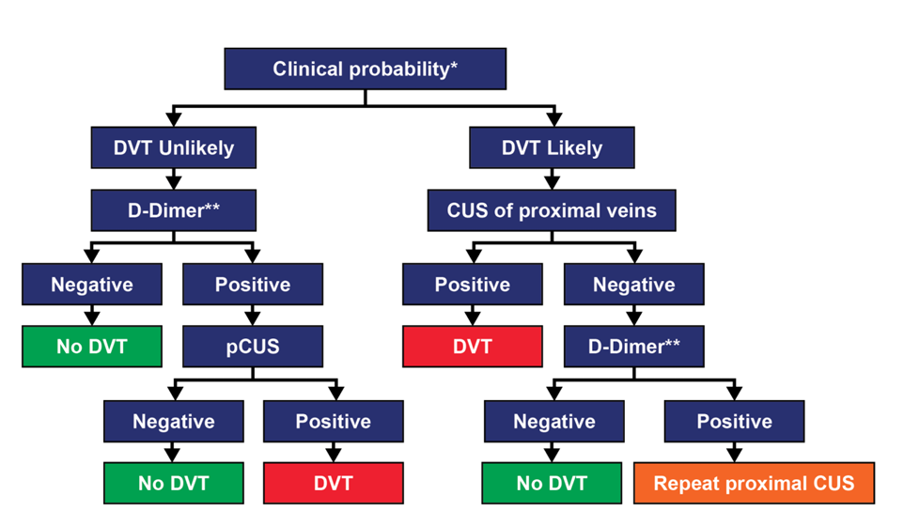

Special Considerations
Timing of Testing
Do testing as quickly as possible; provide rapid anticoagulation if patients have a high pretest probability and the delay will be >4 hours (e.g., LMW heparin or DOAC)
Suspected Recurrent DVT
Residual compression abnormalities are often present after DVT, making CUS problematic in recurrent cases.
- Compare current CUS to previous findings
- Can only definitively diagnose recurrent DVT with evidence of new thrombosis
  - Non-compressibility in previously normal venous segments
  - Increases of 4mm= in compression diameter from prior studies
Upper Extremity DVT (UEDVT)
Uncommon; most individuals have risk factors like CVC, recent pacemaker or malignancy
- Often spontaneous cases are related to sudden physical effort & narrowing of the thoracic outlet
  - E.g., Paget-Schroetter syndrome, thoracic outlet syndrome
- Manifestations→ Acute and chronic arm pain, swelling, discolouration, dilated collateral veins over the arm/neck/upper chest
- Can use the Constans Decision Score with D-dimer to safely exclude diagnosis of UEDVT
  - Typical use is CUS with colour Doppler flow studies
- If likelihood is low, start with D-dimer or duplex ultrasound alone
- If likelihood is high, duplex ultrasound, D-dimer as needed with repeat ultrasound, contrast venography, CT, or MRI if ultrasound is negative but suspicion remains high
Pediatrics
Incidence is more associated with use of central venous catheters, primary diseases (cancer & congenital heart disease)
Clinical decision rules and D-dimer testing is NOT validated in children
- Initiate diagnosis with CUS (may not be accurate for upper extremities)
- Consider MRI or CT if the clinical suspicion for DVT is high and CUS is negative

Pulmonary embolism : diagnosis (JULIA)
Diagnosing PE:
- In patients with hypotension (SBP 90 or less), pretest probability can be assessed using a validated tool
- If there is low pretest probability, further testing is not necessary if all criteria in the PERC are present (PE rule-out criteria)

Pulmonary Embolism Rule-Out Criteria
Clinical Characteristic | Meets Criteria | Does Not Meet Criteria
Age < 50 | Score 0 for each | Score 1 for each
Initial HR <100 | Score 0 for each | Score 1 for each
Initial SpO2 94+% in room air | Score 0 for each | Score 1 for each
No unilateral leg swelling | Score 0 for each | Score 1 for each
No hemoptysis | Score 0 for each | Score 1 for each
No surgery or trauma in past 4 weeks | Score 0 for each | Score 1 for each
No history of VTE | Score 0 for each | Score 1 for each
No estrogen use | Score 0 for each | Score 1 for each
- Can rule out the diagnosis of PE with an unlikely pretest probability PLUS a negative D-dimer test
- Must follow-up positive D-dimer tests to confirm or refute PE as a diagnosis
- In patients over 50
  - D-dimer is negative if it is < age x 10
- In patients under 50
  - D-dimer is negative if <500
- With high-sensitivity D-dimer assays, Wells Score 4 or less PLUS D-dimer under 1000 can be indicative of low likelihood of PE
- No reason to order D-dimer with pE likely pretest probabilities
  - When Wells Score is 4.5+, go directly to imaging to establish diagnosis
- Multidetector CT Pulmonary Angiogram (CTPA)= available in Canada, sufficiently sensitive and specific to exclude PE diagnosis when it is negative and to confirm it when it is positive
  - Limitations= radiation exposure, contrast nephropathy, small filling defects detected may be of uncertain clinical significance
- V/Q lung scanning= high sensitivity and specificity in patients with a normal chest x-ray and no significant lung disease
  - Consider in patients with renal insufficiency, contrast allergies, young patients with normal chest x-rays, and pregnant women
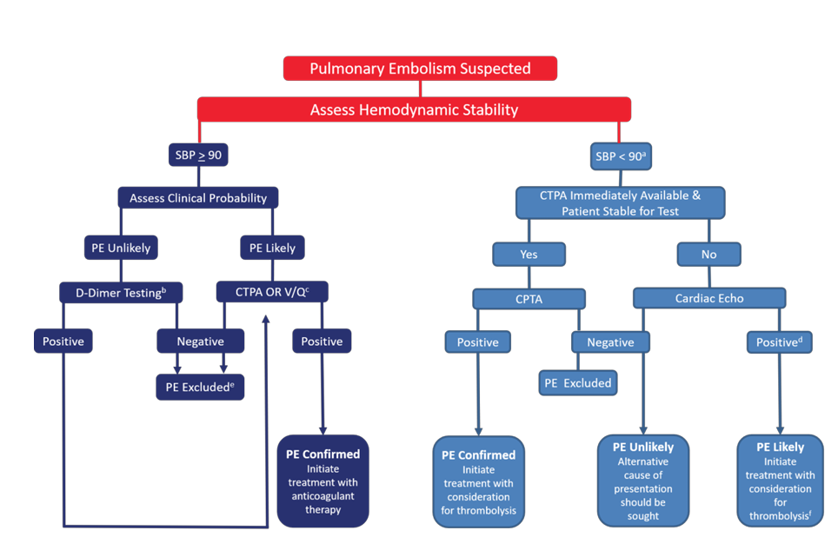
Patients with hypotension too unstable for CTPA…
- Urgent echo to look for right heart overload or embolus in right ventricle or main pulmonary arteries
  - If present, should initiate treatment for PE if there is no alternative diagnosis
- RV dysfunction alone does NOT prove a diagnosis of PE; seek confirmatory evidence
  - CTPA, V/q study, lower extremity compression ultrasound
  - If a hypotensive patient does not have echo features of RV dysfunction, it is unlikely that the hemodynamic instability is caused by a PE (still will not conclusively rule out a small PE)
The YEARS Algorithm:
- A simplified diagnostic strategy where 3 clinical items of the Wells Score and differential D-dimer cutoff values are used to reduce CTPA in patients
- Clinical signs of DVT
- Hemoptysis
- PE most likely diagnosis
- YEARS is safely able to rule out PE with a low 3-month VTE risk
  - Higher failure observed in patients with no YEARS items and D-dimer <1000 but above their age cut-off for D-dimer levels
- Not fully ready to be used as a recommended tool for non-pregnant patients

Pulmonary embolism : diagnosis (JULIA)
Diagnosing PE:
- In patients with hypotension (SBP 90 or less), pretest probability can be assessed using a validated tool
- If there is low pretest probability, further testing is not necessary if all criteria in the PERC are present (PE rule-out criteria)

Pulmonary Embolism Rule-Out Criteria
Clinical Characteristic | Meets Criteria | Does Not Meet Criteria
Age < 50 | Score 0 for each | Score 1 for each
Initial HR <100 | Score 0 for each | Score 1 for each
Initial SpO2 94+% in room air | Score 0 for each | Score 1 for each
No unilateral leg swelling | Score 0 for each | Score 1 for each
No hemoptysis | Score 0 for each | Score 1 for each
No surgery or trauma in past 4 weeks | Score 0 for each | Score 1 for each
No history of VTE | Score 0 for each | Score 1 for each
No estrogen use | Score 0 for each | Score 1 for each
- Can rule out the diagnosis of PE with an unlikely pretest probability PLUS a negative D-dimer test
- Must follow-up positive D-dimer tests to confirm or refute PE as a diagnosis
- In patients over 50
  - D-dimer is negative if it is < age x 10
- In patients under 50
  - D-dimer is negative if <500
- With high-sensitivity D-dimer assays, Wells Score 4 or less PLUS D-dimer under 1000 can be indicative of low likelihood of PE
- No reason to order D-dimer with pE likely pretest probabilities
  - When Wells Score is 4.5+, go directly to imaging to establish diagnosis
- Multidetector CT Pulmonary Angiogram (CTPA)= available in Canada, sufficiently sensitive and specific to exclude PE diagnosis when it is negative and to confirm it when it is positive
  - Limitations= radiation exposure, contrast nephropathy, small filling defects detected may be of uncertain clinical significance
- V/Q lung scanning= high sensitivity and specificity in patients with a normal chest x-ray and no significant lung disease
  - Consider in patients with renal insufficiency, contrast allergies, young patients with normal chest x-rays, and pregnant women
Patients with hypotension too unstable for CTPA…
- Urgent echo to look for right heart overload or embolus in right ventricle or main pulmonary arteries
  - If present, should initiate treatment for PE if there is no alternative diagnosis
- RV dysfunction alone does NOT prove a diagnosis of PE; seek confirmatory evidence
  - CTPA, V/q study, lower extremity compression ultrasound
  - If a hypotensive patient does not have echo features of RV dysfunction, it is unlikely that the hemodynamic instability is caused by a PE (still will not conclusively rule out a small PE)
The YEARS Algorithm:
- A simplified diagnostic strategy where 3 clinical items of the Wells Score and differential D-dimer cutoff values are used to reduce CTPA in patients
- Clinical signs of DVT
- Hemoptysis
- PE most likely diagnosis
- YEARS is safely able to rule out PE with a low 3-month VTE risk
  - Higher failure observed in patients with no YEARS items and D-dimer <1000 but above their age cut-off for D-dimer levels
- Not fully ready to be used as a recommended tool for non-pregnant patients

Cardiology Week 2

FOR ALL Cardiac assessment:

General appearance:
- Colour, resp rate, level of anxiety, diaphoresis ?
Common concerning S/S
- Chest pain, palpitations, SOB, orthopnea, paroxysmal nocturnal dyspnea
Inspect:
- Pulsations/heaves
Palpation
- Heaves, thrills, apical pulse, one carotid at a time
- Pulses: femoral, popliteal, dorsalis pedis, posterior tibial (compare sides)
Auscultations
- Cardiac valves (aortic, pulmonic, tricuspid, mitral) …S1/S2/S3/S4, split?
- Bruits at carotid
Physical
- BP (ortho BP…lay for 5, sit for 3, stand for 3, Bilateral BP to rule out narrowing in one area like a aneurysm or atherosclerosis)
- JVP (1-3…or 6-8 cm minus 5)...its from base or RIGHT ATRIUM

Vertigo vs syncope S/E?
Bilateral BP if PVD, PAD< stenosis in arms***

Reading ECG:
- Identify P waves…present and upright ?
- Measure PR interval (start at P waves to R) (PR is 0.12-0.2…3 small-1 large box
- Identify QRS waves…present and upright?
- Measure QRS (0.06-0.12 (1.5-3 small blocks)
- Identify rhythm with a cue-card…ALWAYS DO 3 beats!!!
- HR: look at 6 seconds and count QRS then x 10 to gate rate

Normal interventions ECG:
Big box: 0.2 seconds
Small box: 0.04 seconds
- PR-interval: <0.2 seconds (3 small-1 large box)
- QRS interval: <0.12 seconds (1.5-2.5 small boxes)
- QT interval:
  - Men→ <430 milliseconds
  - Women→ <460 milliseconds

Sinus tachy/brady: only difference is rate, PR and QRS is normal
Atrial tachy: >160-250 bpm or no pwave/abnormally shaped (palpitations feeling, leads to decreased perfusion of brain and can lead to ischemia). Impulse comes from outside SA node
AFlutter: 250-350 bpm (atrial only) from impulse out of SA node in the atria so ventricle cant respond to every impulse (saw tooth ECG). QRS is normal, can't measure PR
Afib: no real P-wave, wavy p wave area and more than 350 atrial rate. If HR > 100 its uncontrolled! QRS is normal. If no pwave should think afib first!!
AV block: delay of conduction from SA to ventricles
- 1st degree: SA-AV is normal but Av-ventricles are delayed, prolonged PR interval..but regular rate and QRS…no treatment or S/S!
- 2nd degree (Mobitz 1/wienchback): AV node fighting but not all impulses transmitted to ventricles. Rhythm is irregular and PR lengthened longer and longer until QRS not conducted (dropped) then repeated itself, narrow QRS
- 2nd dgeree type 2 (Mobitz 2): disturbance in bundle of hiss, atrial rate is regular but ventricle rate is slow…for every 2-3 pwaves you get 1 QRS. p wave is normal but no QRS for every pwave since not getting through to ventricles. Wide QRS and atrial rate is regular, ventricular is irregular
- 3rd degree block: atria is getting blocked completely to ventricles so ventricles have to take over (2 independent pacemakers basically). P wave is normal but no consistent PR. R-R and P-P is equal, QRS is wide. Atrial rate > ventricle
PVC: no pwave or PR, ventricle depolarize abnormally so QRS is wide and bizzare.If PVC occurs very close to T wave its called R-T phenomena and can lead to vtach
Vtach: fast impulses (150-200bpm) aks more than 3 PVCs, wide QRS and no PR
Vfib: disorganised chaotic rhythm, ventricles quiver, no true QRS…follows untreated Vtach

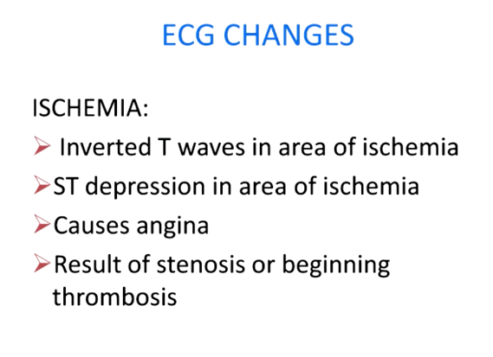
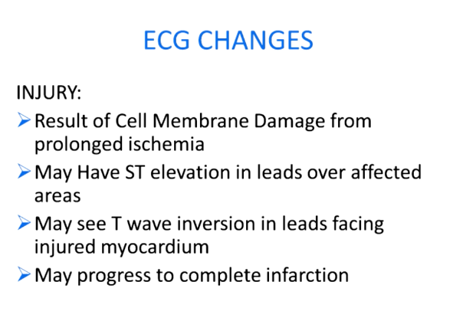
ST depression and inverted T wave is ischemia
ST elevation (possibly inverted t wave) is MI
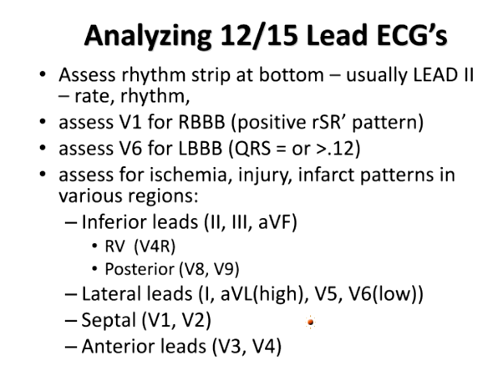
BIG LIE
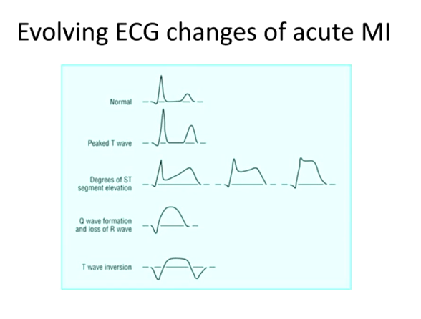
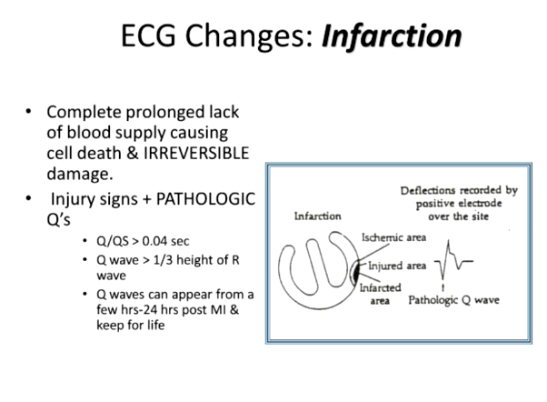
Pahological Q waves stay even post MI on ECG to show damage. It is a negative defection and ⅓ the height of the r wave

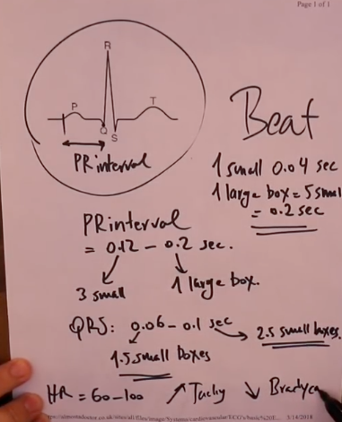https://www.youtube.com/watch?v=Ied6nB3bS6I

NSR
https://youtu.be/JhqVivwes_g?si=DHW4Cdso29mPYKT8
Definition | NSR is the normal regular rhythm of the heart, initiated by the sinoatrial (SA) node. It results in a heart rate of 60–100 beats per minute in adults, with evenly spaced P waves followed by QRS complexes and T waves in a 1:1 ratio on ECG.
Pathology/Cause | NSR is driven by the sinoatrial node (the heart's natural pacemaker), located in the right atrium. It generates regular electrical impulses that travel through the atria, the AV node, and ventricles, leading to normal cardiac contraction.
Risk Factors/Epidemiology | NSR is the normal heart rhythm seen in healthy individuals. It is maintained in most people without underlying cardiac conditions. However, age-related changes, electrolyte imbalances, or heart disease can disrupt it, leading to arrhythmias.
Clinical Presentation | NSR is typically asymptomatic and presents as a regular, steady heartbeat with no palpitations, chest pain, or shortness of breath. It is characterized by a normal pulse rate (60-100 bpm) without any irregularities.
History/Key Questions | - Is the patient asymptomatic?  - Are there any underlying medical conditions or medications affecting heart rate?  - Have they experienced any palpitations, dizziness, or shortness of breath recently?
Physical Exam | - Vital signs: Heart rate between 60-100 bpm, regular rhythm.  - Cardiovascular exam: Normal, regular heart sounds (S1 and S2), with no extra beats or murmurs.  - Peripheral pulses: Strong and equal bilaterally.
Diagnostics/Labs | - ECG: Shows regular P waves before each QRS complex with a rate between 60-100 bpm. Normal PR interval (120-200 ms) and QRS duration (<120 ms).  - No further labs are required for normal sinus rhythm unless there are concerns.
Red Flags | There are no red flags in patients with NSR. However, if the patient develops symptoms such as chest pain, dizziness, or palpitations, investigate for possible arrhythmias or underlying cardiac issues.
Differential Diagnoses | NSR is a normal finding, but it must be distinguished from:  - Sinus tachycardia: Heart rate >100 bpm.  - Sinus bradycardia: Heart rate <60 bpm.  - Premature atrial or ventricular contractions (PACs, PVCs).
Treatment/Management | No specific treatment is required for NSR. Encourage patients to maintain a healthy lifestyle to support normal cardiac function, including regular exercise, a heart-healthy diet, and controlling risk factors such as hypertension and diabetes.
Referrals | No referrals are necessary for patients with NSR.
Follow-up | Routine follow-up to monitor for any changes in heart rhythm or the development of cardiac conditions, especially if the patient has risk factors for arrhythmias (e.g., hypertension, diabetes, coronary artery disease).

AFib
https://www.youtube.com/watch?v=2JjDC_MEh-g
https://www.youtube.com/watch?v=6FLE6HWiImM
Definition | Afib is a supraventricular arrhythmia characterized by rapid, uncoordinated atrial electrical activity leading to an irregular and often rapid heart rate. This results in ineffective atrial contraction and compromised cardiac output.
Pathology/Cause | AFib occurs when normal electrical impulses originating from the sinoatrial (SA) node are replaced by disorganized electrical signals in the atria, causing quivering or "fibrillation" instead of effective contraction. Common causes include structural heart changes (atrial enlargement, fibrosis), increased atrial pressure, inflammation, ischemia, and autonomic nervous system imbalance.  S/S: Palpitations, irregular heartbeat, dizziness, fatigue, chest pain, shortness of breath.  Episodes of syncope or fainting, which may suggest an arrhythmia.  Duration and frequency of symptoms (paroxysmal, persistent, or permanent AF).
Risk Factors/Epidemiology | - -Age (more common in individuals over 65)  - -FHX of afib  - -Male  - - Hypertension  - • HF with reduced ejection fraction  - - Coronary artery disease  - - Heart failure  - - Valvular disease (especially mitral stenosis or regurgitation)  - - Diabetes mellitus  - -Thyroid  - - Sleep apnea***  - - Hyperthyroidism  - -obese  - - Alcohol consumption  - - Post-cardiac surgery  - 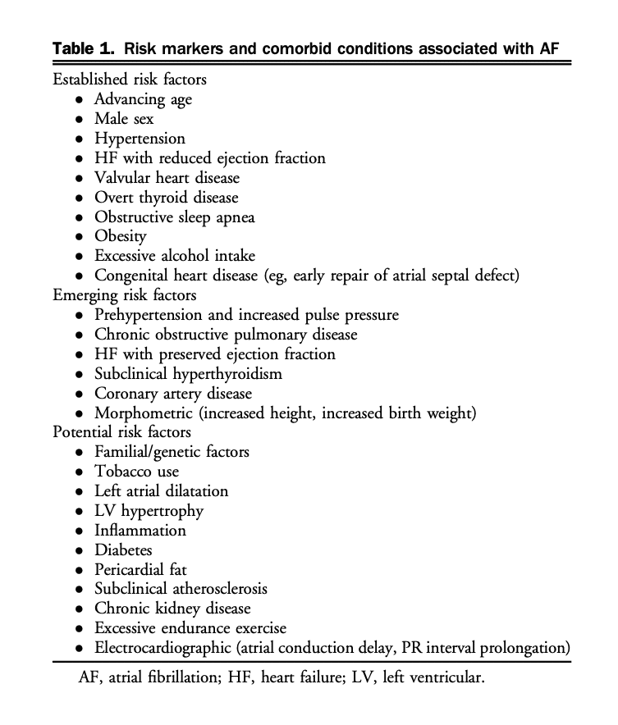
Clinical Presentation  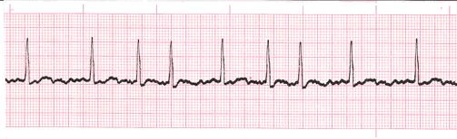  Different to aflutter because they quiver, no pwave (replaced by “f wave”), irregular rhythm, HR>160bpm | Usually asymptomatic however can see…  - Palpitations  - Fatigue, reduced exercise capacity  - Dizziness, lightheadedness  - Dyspnea (shortness of breath)  - Chest discomfort or pain  - Syncope (rare)  -Some may present with complications such as stroke or heart failure.  - Establish severity (including impact on quality of life)  - Identify etiology  - Identify risk factors whose treatment could reduce recurrent AF or improve overall prognosis (i.e. hypertension, sleep apnea, left ventricular dysfunction, etc)  - Take social history to identify potential triggers (i.e. alcohol, intensive aerobic training, etc)  - Determine thromboembolic risk (CHADS)  - Determine bleeding risk (Hasbled)  - Review prior pharmacological therapy for AF, both for efficacy and adverse effects
History/Key Questions | - Onset and duration of palpitations: sudden or gradual?  - Frequency of episodes: intermittent or continuous?  - Triggers: exercise, alcohol, stress?  - Associated symptoms: chest pain, fatigue, shortness of breath, dizziness?  - History of hypertension, heart disease, thyroid disorders?  - Family history of AFib or other arrhythmias?  - Smoking, alcohol, drug use?
Physical Exam  During the physical exam, assess for:  -Irregular fast pulse (indicative of AF). -Signs of heart failure -Thyroid gland enlargement -Blood pressure | - Vital signs→ look for irregular pulse, tachycardia, and blood pressure instability.  -Height and weight  - Cardiovascular exam→ look for irregular rhythm on auscultation, potential signs of heart failure (peripheral edema, jugular venous distention, carotid and peripheral pulses to detect evidence of structural heart disease).  - Respiratory exam→ Crackles indicating pulmonary congestion.  - Neurological exam→ assess for signs of stroke since high risk of clots with afib  -Palpate thyroid gland
Diagnostics/Labs  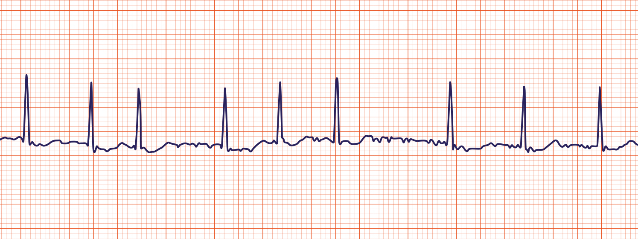 | - GOLD STANARD: 12-Lead Electrocardiogram (ECG):  A 12-lead ECG is the cornerstone for diagnosing AF. Key features to look for:  - Absence of distinct P waves.  - Irregular RR intervals (irregularly irregular rhythm).  - Presence of fibrillatory waves (chaotic atrial electrical activity). The ECG is necessary to confirm the presence of AF and should be obtained in all patients with suspected AF.  - Ambulatory ECG Monitoring (if paroxysmal AF is suspected)  - Echocardiogram:  Once AF is confirmed, an NP should order a transthoracic echocardiogram:  - Left atrial size is enlarged  - Left ventricular function (to assess for heart failure or left ventricular hypertrophy).  - Valvular disease (mitral regurgitation, aortic stenosis) that might predispose to AF.  - Blood Tests:  Labs are essential for identifying underlying causes or contributing factors:  - LABORATORY INVESTIGATIONS FROM GUIDELINE: CBC, coagulation profile, renal function, thyroid and liver function, fasting lipid profile, fasting glucose  - Thyroid function tests (hyperthyroidism can trigger AF).  - Renal function and electrolytes (important for assessing cardiovascular and renal status).  - Complete blood count (CBC) to check for anemia or infection.  - Liver function tests to evaluate hepatic status, especially if considering anticoagulation therapy.  - Risk Stratification:  Once AF is diagnosed, use tools like the CHADS2 or Hasbled.  - Additional Testing:  Depending on the clinical scenario, further investigations may include:  - Chest X-ray (if there is suspicion of heart failure or lung disease).  - Sleep study (for patients with a high suspicion of obstructive sleep apnea, which is a risk factor for AF).  - Stress test  - GOLD STANDARD IS ECG, echo, labs: Shows absent P waves, irregular RR intervals, narrow QRS complexes.  - Holter monitor 48hrs if you think they're having paroxysmal episodes.  - Echocardiogram to see structural heart disease or atrial enlargement.  LABS (same as HTN):  -TSH, electrolytes (imbalances that could affect heart), renal function, blood glucose (to rule out hypoglycemia as a cause of S/S), CBC (rule out anaemia as a differential)  LABORATORY INVESTIGATIONS FROM GUIDELINE: CBC, coagulation profile, renal function, thyroid and liver function, fasting lipid profile, fasting glucose  Additional: stress test, sleep study, ambulatory BP, CXR, holter, genetic testing
Red Flags | - Hemodynamic instability→Hypotension, syncope, acute heart failure.  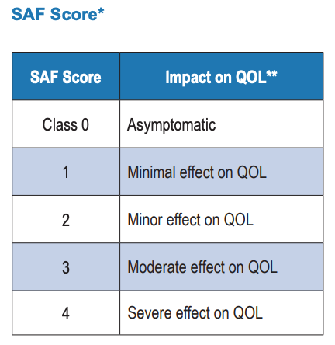  - Signs of stroke→ FAST, confusion  - Chest pain→myocardial infarction.  - Pulmonary embolism→sudden dyspnea, chest pain, tachypnea.
Differential Diagnoses | -Atrial flutter, SVT, VT, Hyperthyroidism, anemia, electrolyte imbalances (Abnormal potassium or magnesium levels)
Treatment/Management | Once atrial fibrillation (AF) is diagnosed, the next steps focus on assessing the patient’s risk for stroke, managing symptoms, and addressing underlying causes. According to the Canadian Cardiovascular Society (CCS) guidelines, here’s what to do next:  The primary goal after diagnosing AF is to prevent complications, especially stroke. The CCS recommends using the CHA2DS2-VASc score to evaluate stroke risk.  Anticoagulation options include:  - Direct oral anticoagulants (DOACs): These are preferred over warfarin for most patients due to ease of use and fewer monitoring requirements.  - Warfarin: May be considered for patients with mechanical heart valves or severe mitral stenosis.  Rate Control: The goal of rate control is to slow the heart rate and alleviate symptoms, especially in patients with persistent AF. Medications include:  - Beta-blockers (e.g., metoprolol).  - Non-dihydropyridine calcium channel blockers (e.g., diltiazem or verapamil).  - Digoxin (less commonly used, but may be added if needed).  - Target heart rate: <110 bpm at rest is generally acceptable, but for symptomatic patients, aim for a more strict rate control of 60-80 bpm.  - Rhythm Control: Rhythm control involves restoring and maintaining normal sinus rhythm, typically for patients with more severe symptoms or those who fail rate control. Options include:  - Antiarrhythmic drugs: Flecainide, sotalol, or amiodarone (based on the patient’s underlying conditions).  - Cardioversion: Electrical or pharmacological cardioversion may be considered, especially in newly diagnosed or symptomatic patients.  - Catheter ablation: This is recommended if medications fail to maintain sinus rhythm or if the patient prefers a non-pharmacological option.  Management of Underlying Causes and Comorbidities:  - Hypertension: Control blood pressure to target levels (often <130/80 mmHg for AF patients).  - Heart failure: Optimize treatment according to heart failure guidelines.  - Sleep apnea: Consider a sleep study and initiate CPAP therapy for obstructive sleep apnea.  - Thyroid dysfunction: Treat hyperthyroidism or other thyroid disorders.  - Obesity: Encourage weight loss and lifestyle changes if applicable.  Lifestyle Modification and Risk Factor Reduction:  - Smoking cessation: Smoking increases the risk of AF recurrence. Support cessation efforts.  - Alcohol: Advise reducing or eliminating alcohol, especially in patients with alcohol-related AF triggers ("holiday heart syndrome").  - Physical activity: Encourage regular physical activity, but avoid excessive endurance exercise, which can be a trigger for AF.  - Weight management: Weight loss programs for overweight or obese patients can reduce AF recurrence.  Summary of Key Steps After AF Diagnosis:  - Assess stroke risk using the CHA2DS2-VASc score and start appropriate anticoagulation.  - Decide between rate control (using beta-blockers or calcium channel blockers) and rhythm control (using antiarrhythmic drugs, cardioversion, or ablation) based on symptoms.  - Manage underlying conditions (hypertension, heart failure, thyroid issues) and modify lifestyle risk factors.  - Educate the patient and ensure regular follow-up to monitor progress and adjust treatment.  This structured approach aligns with CCS guidelines and helps NPs provide comprehensive, patient-centered care for AF.  Surgery:  Ablation therapy or MAZE procedure if unresponsive to medications.  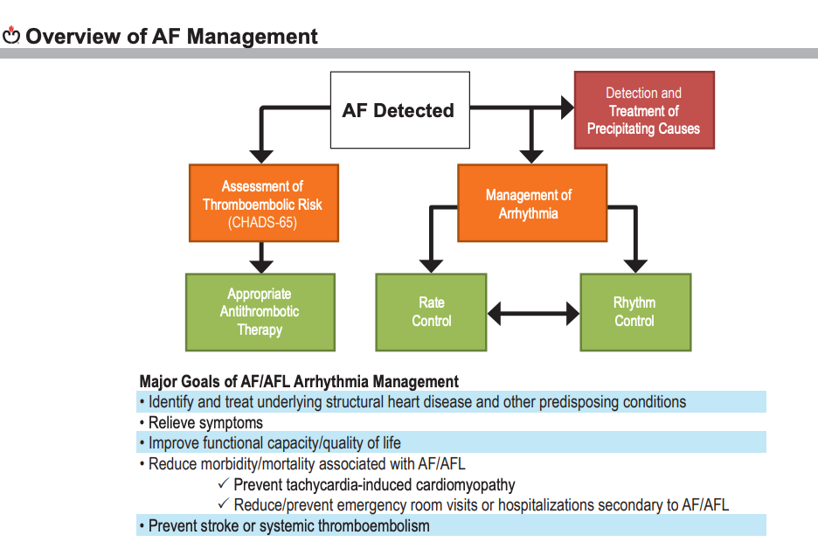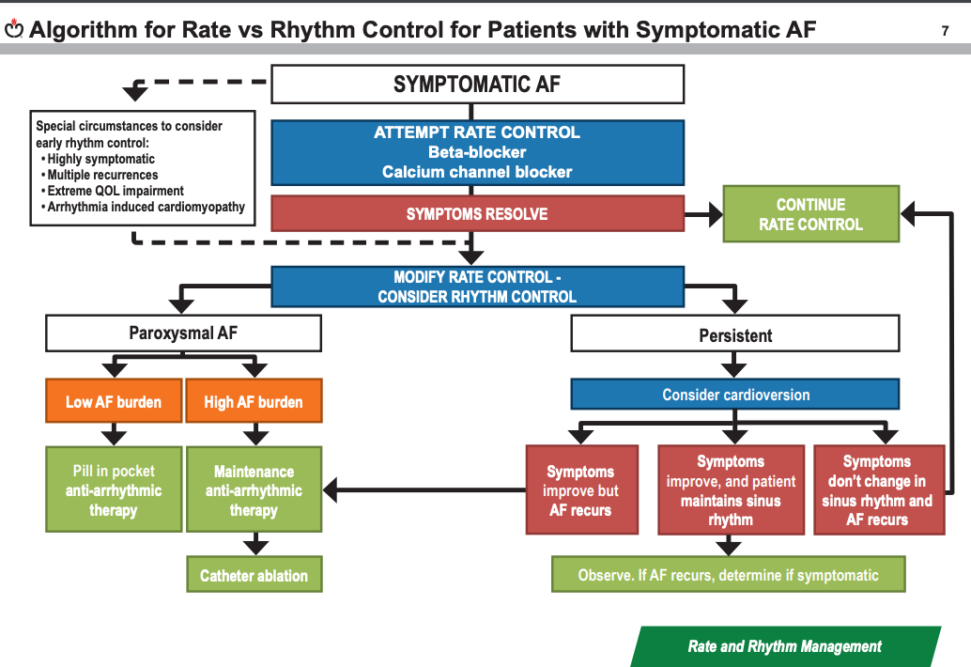  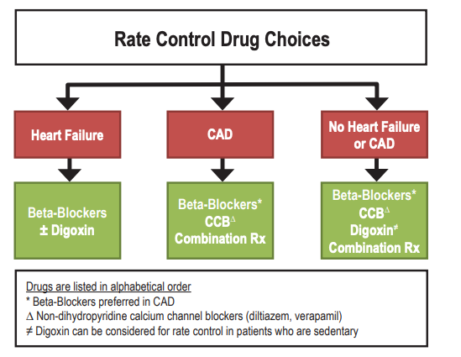  We suggest that digoxin can be considered as a therapeutic option to achieve rate-control in patients with AF and symptoms caused by rapid ventricular rates whose response to beta-blockers and/or calcium channel blockers is inadequate, or in whom such ratecontrolling drugs are contraindicated or not tolerated  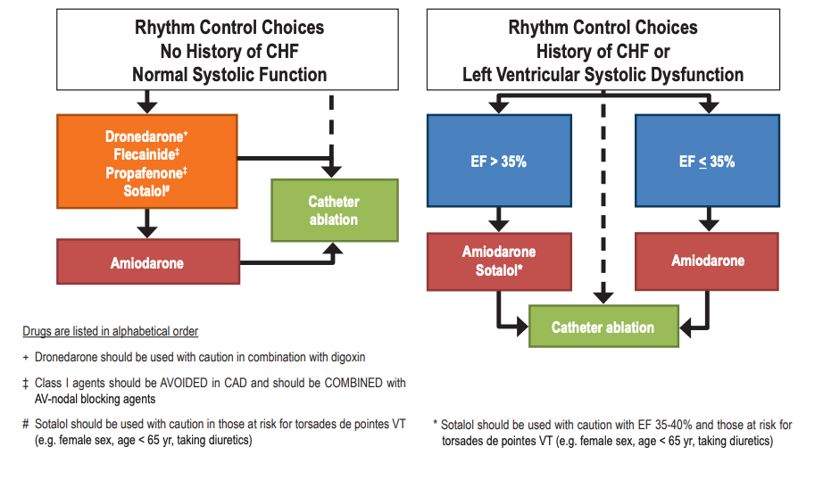  - Catheter Ablation after Medication: If someone with AF continues to have symptoms even after trying antiarrhythmic drugs, catheter ablation is recommended.  - Atrial Flutter Ablation as First Option: For people with typical atrial flutter, catheter ablation is recommended as the first treatment or as a good alternative to medications.  - First-Line Ablation for Paroxysmal AF: In selected patients who have paroxysmal AF (episodes of AF that start and stop on their own), catheter ablation is suggested as a first option to relieve symptoms.  - Anticoagulation During Ablation: Catheter ablation can be done safely while patients continue taking blood thinners to reduce stroke risk.  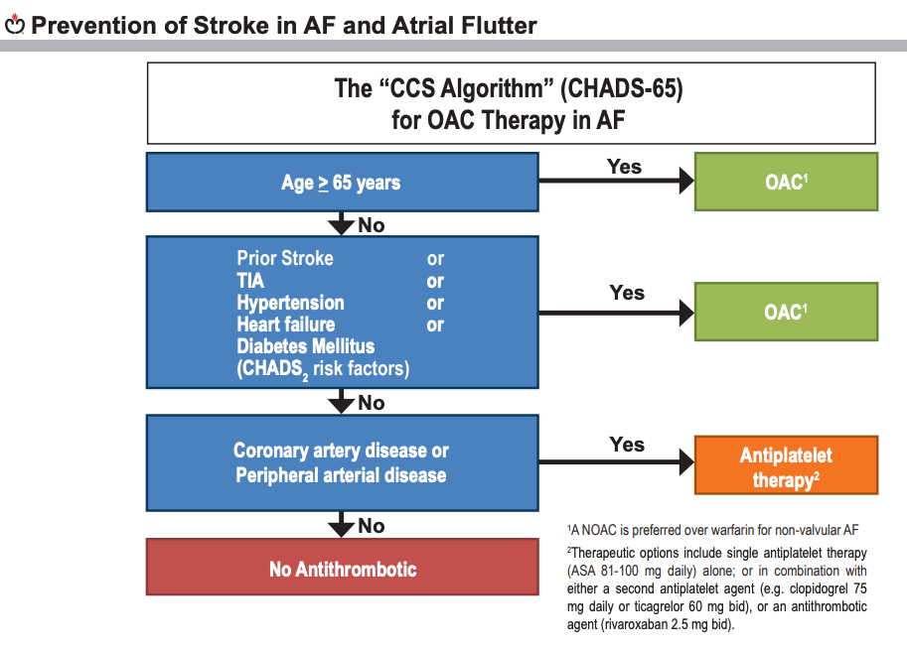  For patients under 65 with non-valvular AF or AFL and no stroke risk factors, blood thinners aren't needed, and treatment should focus on managing heart or artery disease with aspirin alone or combined with clopidogrel, ticagrelor, or low-dose rivaroxaban.  We recommend that when OAC-therapy is indicated for patients with non-valvular AF, most patients should receive dabigatran, rivaroxaban, apixaban or edoxaban in preference to warfarin  Give idarucizumab IV to reverse the anticoagulant effect of dabigatran in emergencies, such as when a patient has uncontrollable or life-threatening bleeding, or needs urgent surgery where normal blood clotting is required.  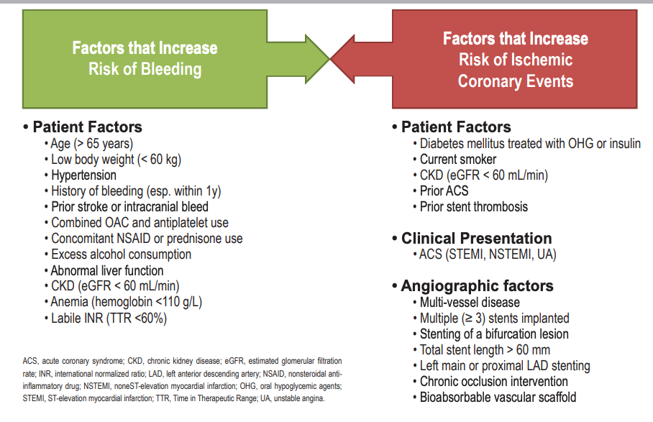  For patients with AF aged ≥ 65 years or with a CHADS2 score ≥ 1 and coronary or arterial vascular disease (peripheral vascular disease or aortic plaque), we recommend long-term therapy with OAC alone
Referrals | Cardiology→ management of rate or rhythm disturbances, especially if ablation is considered.  Neurology→If S/S of stroke or TIA.
Follow-up | -Regular follow-up of ECG to assess rate control or rhythm.  - INR monitoring if on warfarin & renal function monitoring for DOACs.  - Holter monitor if paroxysmal AFib or symptoms persist.  - Regular check-ups to assess for complications such as heart failure or thromboembolic events.  Summary of AF Monitoring Steps:  - Regularly monitor anticoagulation therapy effectiveness and safety.  - Assess symptom control, adjusting rate or rhythm management as needed.  - Use ECG or Holter monitoring to evaluate heart rate and rhythm.  - Reassess comorbidities and adjust treatment for underlying causes like hypertension or sleep apnea.  - Repeat echocardiograms as necessary based on clinical status.  - Review stroke and bleeding risks annually and modify therapy as appropriate.  - Ensure patient education and engagement with treatment and lifestyle changes.  - Consider referral to specialists for advanced interventions if needed.
CHA2DS2-VASc and HAS-BLED
CHA2DS2-VASc is used for assessing stroke risk and guiding anticoagulation therapy, while HAS-BLED is used to evaluate bleeding risk in patients receiving anticoagulation.
CHADS:
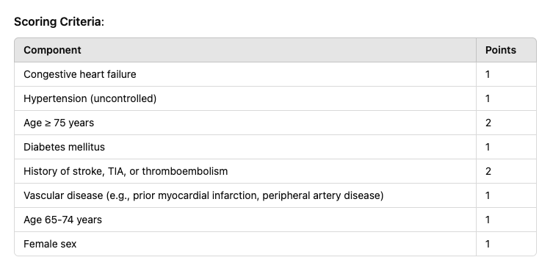
Total Score Interpretation:
- Score 0: Low risk of stroke; anticoagulation is generally not recommended.
- Score 1: Moderate risk; consider anticoagulation based on individual patient factors.
- Score 2 or greater: High risk; anticoagulation is recommended to reduce stroke risk.
HASBLED
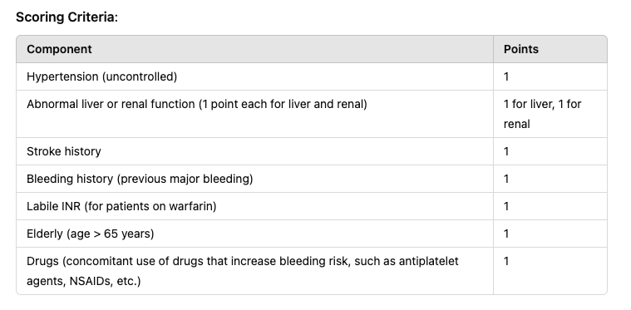
Total Score Interpretation:
- Score 0-1: Low risk of bleeding; anticoagulation can be used with caution.
- Score 2: Moderate risk; discuss risks and benefits of anticoagulation with the patient.
- Score ≥3: High risk of bleeding; careful consideration should be given to the use of anticoagulation.

AFlutter
Definition | Atrial flutter is a type of supraventricular tachycardia characterised by rapid, regular atrial contractions (typically around 250-350 beats per minute) with a "saw-tooth" pattern on ECG, known as flutter waves. The ventricular rate is usually regular but may vary depending on AV node conduction, often resulting in a 2:1 conduction ratio (e.g., atrial rate of 300 bpm, ventricular rate of 150 bpm).
Pathology/Cause | Atrial flutter occurs due to a reentrant circuit within the atria, often involving the right atrium. The reentrant loop causes rapid, repetitive electrical impulses in the atria, leading to ineffective atrial contraction and compromised filling of the ventricles. The condition is frequently associated with atrial fibrosis, inflammation, ischemia, or increased atrial pressure.
Risk Factors/Epidemiology | - Age (over 60 years old)  - Hypertension, coronary artery disease  - Heart failure or valvular disease, particularly mitral stenosis  - Post-cardiac surgery  - Chronic lung disease  - Obesity, diabetes mellitus  - Hyperthyroidism  - Alcohol abuse  - Hx of atrial fibrillation (often co-exists with atrial flutter).
Clinical Presentation  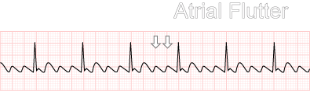  No P-wave, R-R can be regular or irregular, saw tooth, called F waves, usually a 4:1 | - Palpitations (rapid heart rate sensation)  - Fatigue  - SOB  - Lightheadedness, dizziness  - Chest discomfort  - Symptoms may be less pronounced than in atrial fibrillation due to the regularity of the ventricular response. But if untreated, atrial flutter can lead to heart failure or thromboembolic events.
History/Key Questions | - Duration of palpitations… sudden onset or gradual?  - Associated symptom like fatigue, dyspnea, dizziness, chest pain?  - Any known history of heart disease or arrhythmias?  - Any recent surgery, infection, or history of lung disease?  - Alcohol consumption, thyroid disease, or other risk factors?
Physical Exam | - Vital signs→regular but often rapid pulse (if 2:1 conduction), possible tachycardia.  - Cardiac exam  - Respiratory exam→ Crackles if there is pulmonary congestion.  - Neurological exam-> for signs of thromboembolic events like stroke
Diagnostics/Labs | - ECG→reveals the characteristic "saw-tooth" flutter waves, especially in leads II, III, and aVF  - Holter monitor if pparoxysmal episodes.  - Echocardiogram→To assess for structural heart disease, atrial enlargement, or valvular abnormalities.  - Labs→TSH to rule out thyroid disease, CBC, electrolytes, renal and liver tests, and trops/BNP if heart failure is suspected.  - Lipid and PTT/INR if risk of clots
Red Flags | - Can also cause clots!!! S/S of embolism  Hemodynamic instability (hypotension, syncope, or signs of acute heart failure)  - Signs of stroke  - Severe chest pain  - Pulmonary embolism
Differential Diagnoses | - Afib, SVT, VT, hyperthyroidism
Treatment/Management | - Rate control with Beta-blockers, calcium channel blockers  - Rhythm control with electrical or pharmacological cardioversion  - Anticoagulation  - Catheter ablation.  - Lifestyle changes→Alcohol reduction, treat sleep apnea, hypertension.
Referrals | - Cardiology  -Neurology if s any signs of thromboembolic events (stroke or TIA).
Follow-up

Atrial premature contractions
https://www.youtube.com/watch?v=riPFwUYEYso https://www.youtube.com/watch?v=gQDCgKb-7fQ&t=31s
https://www.youtube.com/watch?v=xvLqVRnYriE
Definition | Atrial premature contractions (APCs), also known as premature atrial complexes, are early electrical impulses originating from atrial tissue outside the sinoatrial (SA) node. These ectopic beats occur prematurely before the next normal sinus beat, interrupting the regular rhythm of the heart.  Can have 1 PAC, Bigeminy (2 normal beats then PAC), trigeminy (3 morenal beats then PAC), multiform PACs (don’t look the same/some are inverted), or couplet PACs (multiple PACs back to back)
Pathology/Cause | APCs are caused by abnormal automaticity or triggered activity in atrial tissue outside of the SA node. Common causes include increased adrenergic tone, electrolyte imbalances, ischemia, or structural heart disease, but they can also occur in healthy individuals without underlying pathology.
Risk Factors/Epidemiology | - Age (more common in older adults)  - Stimulants→Caffeine, alcohol, tobacco  - Stress and anxiety  - Electrolyte imbalances→Hypokalemia, hypomagnesemia.  - Heart disease-> Coronary artery disease, heart failure, or valvular disease.  - Hyperthyroidism.  -anemia  - Medication (digoxin toxicity)  - COPD, asthma
Clinical Presentation  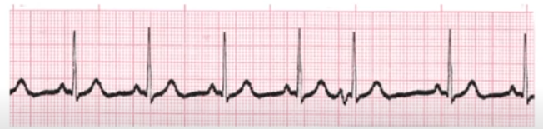  ***Its atrial so effects p-wave. P wave is intervted or odd.  There is a compensatory pause again after a APC.  Difficult to measure PR interval when there is an APC  Technically underlying rhythm is NSR with a PAC. Narrow QRS and regular rhythm with a compensatory pause | Many patients are asymptomatic, but some may report:  - Palpitations or sensation of a skipped or extra heartbeat  - Fatigue  - Shortness of breath (rare)  - Dizziness or lightheadedness  ***Symptoms are usually mild and self-limiting***  R-R is irregular  P waves have different shapes and can occur in different locations  Narrow QRS  Compensatroy pause
History/Key Questions | - How often do the palpitations occur?  - Do the palpitations happen with activity or at rest?  - Are there any triggers, such as caffeine, stress, or alcohol?  - Any known history of heart disease, hypertension, or thyroid issues?  - Associated symptoms like dizziness or chest discomfort?
Physical Exam | - Usually asymptomatic  -Vital signs are normal, but irregular pulses may be felt.  - Cardiovascular exam→Irregular pulse when APCs are present  - Peripheral pulses you may feel an early or extra beat then a compensatory pause afterwards
Diagnostics/Labs | - ECG→Will see premature P waves with a different morphology from the sinus P wave, followed by a normal QRS complex. There is often a compensatory pause after the APC.  - Holter monitor: May be needed if you have intermittent APCs.  - Labs:  -Electrolytes to check for imbalances  -TSH  -CBC (r/u anemia).  -Glucose  -renal  -trops
Red Flags | - Same as VPCs!  - Frequent APCs (more than 20% of all beats) or APCs associated with symptoms such as chest pain, syncope, or significant dizziness, as these may indicate underlying heart disease.  - Progression to atrial fibrillation or other arrhythmias in some patients
Differential Diagnoses | Afib, aflutter, VPCs
Treatment/Management | Usually no treatment needed if asymptomatic  -Can treat the underlying cause with lifestyle changes (avoid triggers like caffeine, alcohol, stress).  - Electrolyte correction→If hypokalemia or hypomagnesemia is present.  - Beta-blockers or calcium channel blockers if APCs are frequent or symptomatic.
Referrals | - Cardiology if APCs are frequent or associated with significant symptoms (syncope, chest pain), or if there is concern for underlying heart disease
Follow-up | - Regular follow-up to monitor symptoms and ensure no progression to more serious arrhythmias.  - Consider repeated ECG or Holter monitoring if symptoms worsen or become more frequent.

Ventricular premature contractions
https://www.youtube.com/watch?v=U9KvHbMgLPo
Definition | Ventricular premature contractions (VPCs), also known as premature ventricular complexes (PVCs), are early depolarizations that originate from the ventricles. These contractions occur prematurely, before the next expected normal sinus beat (they override the SA node), and are typically followed by a compensatory pause, leading to an irregular heartbeat.  Can have 1 PVC, Bigeminy (2 normal beats then PVC), trigeminy (3 morenal beats then PVC), multiform PVCs (don’t look the same/some are inverted), or couplet PVCs (multiple PVCs back to back)
Pathology/Cause | VPCs occur due to abnormal electrical activity within the ventricles, either from enhanced automaticity or triggered activity. Common causes include myocardial ischemia, electrolyte imbalances (e.g., hypokalemia or hypomagnesemia), structural heart disease, or increased sympathetic tone. They can also occur in healthy individuals.
Risk Factors/Epidemiology  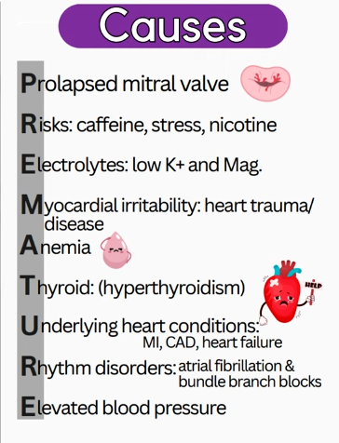 | - Age (more common in older adults)  - Heart disease (hx. MI, HF, cardiomyopathy)  - Stimulants→ cocaine, meth, caffeine, alcohol, tobacco.  - Electrolyte imbalance→Hypokalemia, hypomagnesemia.  - Stress, anxiety, and excessive exercise.  - Hyperthyroidism  -Anemia  -severe cases of digoxin toxicity
Clinical Presentation  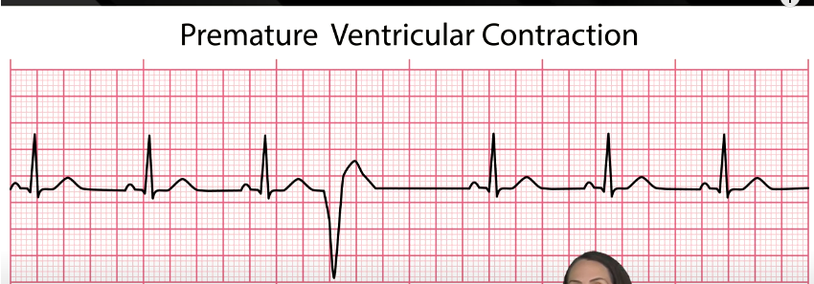  Flat line after PVC is a “compensatory pause” where the heart is resetting. In a PVC there is no p-wave at the PVC!  Wide QRS and irregular rhythm with a compensatory pause  ***Its ventricular so effects QRS | Similar to afib/PAC:  - Palpitations or sensation of skipped or extra beats  - Dizziness, lightheadedness  - Fatigue  - Chest discomfort (rare)  - Shortness of breath (if frequent or associated with underlying heart disease)  - Some may be completely asymptomatic  QRS are wide+inverted, no Pwave at PVC, consentory pause
History/Key Questions | - How often do the palpitations occur?  - Are the palpitations associated with physical activity or stress?  - Are there any known heart conditions, such as myocardial infarction or heart failure?  - Any use of stimulants (caffeine, alcohol, tobacco)?  - Any recent electrolyte disturbances or dehydration?
Physical Exam | - Vital signs→May be normal, but an irregular pulse can be felt when VPCs occur.  - Cardiovascular exam→ look for an irregular rhythm with occasional extra beats and a compensatory “pause” between PVCs.  - Peripheral pulse (feel skip or extra beats)
Diagnostics/Labs | - ECG (VPCs appear as wide QRS complexes that occur prematurely, without a preceding P wave. They are followed by a compensatory pause. Can be inverted)  - Holter monitor for intermittent or frequent VPCs.  - Labs→CBC (anemia), Electrolytes (low potassium, magnesium), renal function, TSH, and cardiac biomarkers if concerned about ischemia.  - Electrolytes (Na, K, Mg, Ca): Electrolyte disturbances, especially low potassium and magnesium, can increase the likelihood of PVCs.  - Thyroid function tests (TFTs): Hyperthyroidism may contribute to ventricular arrhythmias, including PVCs.  - Renal function tests (creatinine, BUN): To evaluate kidney function, especially if medications affecting electrolyte balance are being considered.  - Complete blood count (CBC): To detect anemia or infection, both of which may exacerbate PVCs.  - Cardiac enzymes (troponin): If there's concern for myocardial ischemia or infarction, especially if PVCs occur with chest pain.  - Fasting glucose or HbA1c: To check for diabetes, a risk factor for cardiovascular complications.
Red Flags | - Frequent VPCs (more than 20% of all beats), which may lead to reduced cardiac output or progression to ventricular tachycardia.  - Hemodynamic instability: Hypotension, syncope, or signs of heart failure.  - Chest pain or shortness of breath: May indicate underlying ischemia or heart disease.  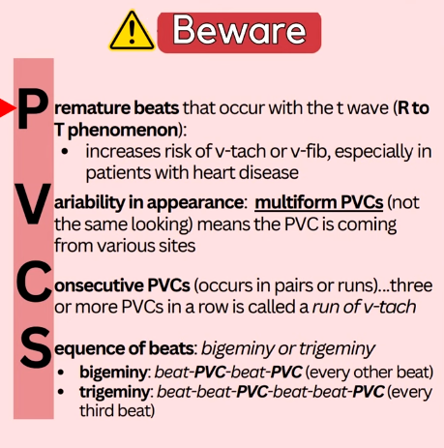
Differential Diagnoses | - Atrial premature contractions, Vtach, afib
Treatment/Management | Asymptomatic:  - Lifestyle changes (avoid triggers like caffeine, alcohol, and stress)  Symptomatic:  - Electrolyte correction  - Beta-blockers or CCB (metoprolol, nifedipine).  - Antiarrhythmics (flecainide for refractory or severe cases)  - Catheter ablation can eliminate the source if frequent VPCs, meds not working ad causing symptoms or leading to ventricular dysfunction
Referrals | - Cardiology→frequent VPCs, especially if associated with symptoms, structural heart disease, or progression to ventricular tachycardia.  - Electrophysiologist→if getting catheter ablation/medical therapy is ineffective or poorly tolerated.
Follow-up | - Monitor symptoms and VPC burden with repeat ECG or Holter monitor.  - Routine follow-up to assess for progression to more severe arrhythmias or underlying heart disease.  - Adjust treatment based on symptom severity and frequency of VPCs.

VTach
Definition | Ventricular tachycardia (VT) is a rapid heart rhythm that originates from the ventricles, defined as three or more consecutive ventricular beats at a rate greater than 100 beats per minute (bpm). It can be sustained (lasting more than 30 seconds) or non-sustained (self-terminating within 30 seconds).
Pathology/Cause | VT is caused by abnormal electrical circuits in the ventricles, often due to scarring from myocardial infarction, cardiomyopathy, or other structural heart diseases. It can also result from electrolyte imbalances (e.g., hypokalemia, hypomagnesemia) or drug toxicity (e.g., digitalis, antiarrhythmics).
Risk Factors/Epidemiology | - Heart disease (MI, HF, cardiomyopathy, ischemic heart disease)  - Electrolyte imbalances→Hypokalemia, hypomagnesemia  - Congenital conditions→Long QT syndrome, Brugada syndrome  - Drug toxicity–?Antiarrhythmics, digoxin  - Male sex  - Older age
Clinical Presentation  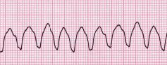  Doesnt last long before VFIB!! No P wave, QRS is bizarre and wide, rate is >100bpm, most become unconscious and into VF  Not all need defib, some need synchronised cardioeversion. Looks like a tomb stone. | - Palpitations  - Chest pain  - Shortness of breath  - Dizziness or lightheadedness  - Syncope  - Hemodynamic instability→Hypotension, altered mental status  - In severe cases, VT can degenerate into ventricular fibrillation, leading to cardiac arrest  -severe cases of digoxin toxicity
History/Key Questions | - How fast is the heart racing?  - Duration of symptoms (sustained vs non-sustained)?  - Any history of myocardial infarction or heart failure?  - Recent electrolyte imbalances, dehydration, or drug toxicity?  - History of syncope, dizziness, or chest pain?  - Any family history of sudden cardiac death?
Physical Exam | - Vital signs→Tachycardia (usually >100 bpm), hypotension, possible respiratory distress  - Cardiovascular exam→Rapid, regular rhythm without corresponding atrial activity. Heart sounds may be difficult to differentiate.  - Peripheral pulses→Weak or absent during VT  - Other systems→May show signs of hemodynamic decline (altered mental status, pallor, cool extremities).
Diagnostics/Labs | - ECG→Wide QRS complexes (>120 ms) with a regular rhythm and no visible P waves.  - Holter monitor for non-sustained VT episodes.  Labs  Electrolytes, cardiac markers (troponin), renal & liver function, and drug levels (if on digoxin), TSH, CBC, toxicology, ABG (if s/s hypoxia or acidosis)
Red Flags | - Sustained VT lasting more than 30 seconds leads to VFib  - Syncope or hemodynamic instability (hypotension, altered mental status)  - Chest pain or signs of MI  - Underlying heart disease with poor left ventricular function
Differential Diagnoses | - SVT, Afib, Vfib
Treatment/Management | - Antiarrhythmic meds(amiodarone, procainamide, sotalol).  - if hemodynamically unstable: Immediate synchronized cardioversion.  - Correct underlying causes (electrolyte imbalance, ischemia, or drugs) -Implantable cardioverter-defibrillator  - Ablation if not controlled with meds.
Referrals | - Cardiology for possible ICD placement of catheter ablation in cases of recurrent or life-threatening VT.  - ICU if sustained VT with hemodynamic instability or risk of cardiac arrest.
Follow-up | - Close monitoring with regular ECGs and Holter monitoring for recurrent episodes.  - Evaluate for ICD efficacy if placed.  - Adjust antiarrhythmic medications and manage any underlying cardiac conditions.  - Monitor electrolyte levels, especially in patients on diuretics or antiarrhythmics.

Ventricular Tach vs. VFib
Def’n | - Ventricular tachycardia (VT) is usually defined as ≥3 consecutive ventricular complexes at a rate >100 bpm on an ECG recording. VT can be a clinically unimportant, asymptomatic event or a life-threatening arrhythmia.  - Ventricular fibrillation (VF) is a subcategory of V-Tach and is defined as a rapid, disorganized rhythm without recognizable QRS complexes on the ECG. VF is almost always fatal unless the pt is electrically defibrillated.
Risk Factors/Epidemiology | Same as above chart.
Clinical Presentation | VTach (Repetitive QRS >0.12 seconds, and no P/T waves):  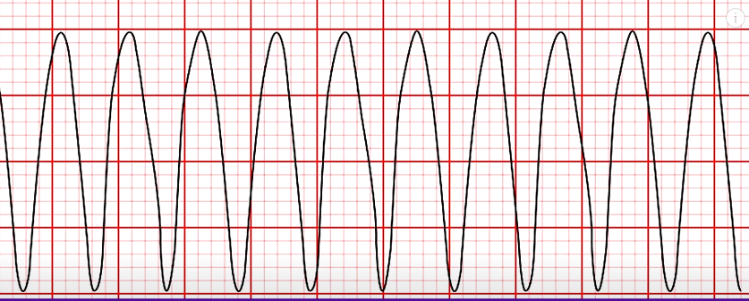  Vfib: diarganizes chaos, unable to identifty any clear P, PR,QRS, T waves  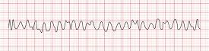
Diagnostics/Labs | - Electrolyte abnormalities  - Echo  - Holter or loop monitor, Stress test, ECG  - If on digoxin draw values as may be due to toxicity
Red flags | - Vtach: Rapid regular rhythm of more than three sequential premature ventricular complexes (100–250 bmp); can be sustained (<30 seconds) or nonsustained; if sustained, can be life-threatening and progress to ventricular fibrillation; patients can be stable or unstable and pulseless; most common cause is MI; symptoms include palpitations, angina, syncope, sudden cardiac death. Can lead to Torsades de points!!!!  - Vfib: fatal if untreated; most common cause is ischemic heart disease; patient will be unconscious (no pulse or blood pressure)
Differential Diagnoses | Drug induced QT prolongation
Treatment/Management | If unstable: CRASH CART!  If asymptomatic or stable:  - Antiarrhythmic (amiodarone), if ineffective then cardioversion  If symptomatic:  - Cardioversion and follow up with antiarrhythmic (amiodarone)  Also consider:  - Lifestyle modifications  - Control stress, illegal drugs, limit alcohol, limit caffeine, control BP and cholesterol.  - Beta-blockers- useful for patients with exercise, stress or ischemia induced VT. Metoprolol, atenolol and bisoprolol are frequently used. Unless has hx PVD, DM, COPD and asthma- contraindicated for beta-blockers  - Implanted cardioverter defibrillator  - Catheter ablation
Referrals | Consult Cardiology if unable to manage in primary care, send to ED is symptomatic
Follow-up | Follow up if no resolution of symptoms following medication therapy.

Palpitations
Short definition/ description | A feeling of unpleasant awareness of the forceful, rapid, or irregular heartbeat in the chest. A “flip-flopping”, or a “rapid flutter”. A common presenting symptom that is usually benign but may indicate a life-threatening arrhythmia
Pathology/cause | Several causes…  - Increased stroke volume or contractility  - Sudden change in heart rate or rhythm  - Unusual cardiac movement in the thorax  - Hyperkinetic states (constant pounding caused by hyperthyroidism, or late-stage pregnancy)  - Valvular heart disease that produces large stroke volumes  - Catecholamine release during anxiety or panic attacks
Epidemiology | Occurs in 1-8% of patients in primary care
Risk Factors | Cardiac defects, severe anemia, hyperthyroidism, pregnancy, fever, anxiety, stimulants like caffeine and drugs, emotions, exertion, diabetes mellitus and insulin reactions
Clinical Presentation  (Subjective Symptoms & Objective Signs) | HALLMARK: a turning over or flopping sensation in the chest (not usually occurring a t the time of examination). May be intermittent or sustained, regular or irregular  Other signs and symptoms:  - Fluttering in the chest, SOB, pounding in the chest or neck, sweating, light-headednness, anxiety or fear  - Often felt at rest when other stimuli are minimal
Hx/Key Questions | Rule out a life-threatening arrhythmia  - History of CAD, is there syncope associated, is there chest pain, difficulty breathing, family history of sudden cardiac death, heart surgery  Have the client describe the symptoms, when they occur, how long they last, and if they start/stop abruptly  - Skipped beats give the sensation of the heart stopping and starting with a pounding, flipping, or jumping sensation when sitting quietly or lying in bed, lasting for brief periods (PACs or PVCs)  - Rapid fluttering (sinus tachycardia)  - Neck pounding (dissociation of atria and ventricles)  - Produces cannon A waves into the neck because the atria and ventricles are contracting at the same time  - Palpitations that start during sleep or increased vagal tone  - Vagal-mediated aa. Fib or long QT syndromes  - Worse at night= benign ectopy or A. fib  - Palpitations that start and stop abruptly  - SVT or ventricular tachycardia  - These can usually be stopped with the valsalva vagal maneuver  - Rapid palpitations during catecholamine excess  - SVT, sinus tachycardia, a. fib  - Palpitations with exertion  - Hypertrophic cardiomyopathy or CAD  - Palpitations at rest exacerbated by exercise  - Anemia  - Persistent palpitations  - Systemic condition  Is it related to a psychological condition, a systemic condition (anemia, pregnancy, infection, fever, dehydration, menopause), is it related to drug or substance use?  May be brought on by cold medications in children  - Skipped Beats:  - PACs (Premature Atrial Contractions)  - PVCs (Premature Ventricular Contractions)  - Rapid Fluttering:  - Sinus Tachycardia  - Neck Pounding:  - Cannon A Waves (atria and ventricles contracting together)  - Palpitations During Sleep:  - Vagal-mediated A-fib or Long QT Syndrome  - Worse at Night: Could indicate benign ectopy or A-fib.  - Abrupt Start/Stop Palpitations:  - Feeling: Sudden episodes of rapid heart rate.  - SVT (Supraventricular Tachycardia)  - Ventricular Tachycardia  - Management: Often resolved with Valsalva maneuver.  - Rapid Palpitations with Stress:  - SVT  - Sinus Tachycardia  - A-fib  - Palpitations with Exertion:  - Hypertrophic Cardiomyopathy  - Coronary Artery Disease (CAD)  - Palpitations at Rest Exacerbated by Exercise:  - Anemia  - Persistent Palpitations:  - Indicates a systemic condition.
Physical Exam | VITALS: pulse for 1 full minutes, respiration and BP  - Pulse deficit= lower pulse at the wrist than at the apex of the heart  - Suggests atrial fibrillation or vtach  INSPECT: appearance, skin for pallor/diaphoresis, neck for thyromegaly or JV distention/pressure, legs for edema  - Cannon A waves in the JVP assessment= the frog sign  - Shows afib  PALPATE: skin for temp/dryness, lower extremities for edema and calf tenderness, neck for thyroid enlargement  AUSCULTATE: heart for rhythm abnormalities (while sitting, standing, and left lateral decubitus position), as well as after walking briskly down the hallway  Assess mental status: lightheaded, anxious, fearful
Red Flags | Palpitations leading to syncope, angina-like chest pain, orr dyspnea
Differential Diagnosis | Palpitations are secondary to an underlying cause; need to uncover what that is  - Any condition that causes sinus tachycardia can result in symptoms of palpitations (anxiety, pain, fever, caffeine, hypovolemia PE, hyperventilation)  (E.g., anxiety, medication-induced, cardiac or pulmonary origin)  Cardiac Causes:  - Structural abnormalities (mitral valve prolapse, valvular disease, cardiomyopathy, congenital heart lesions)  Non-Cardiac Causes:  - Psychological conditions (anxiety)  - Systemic conditions (thyroid disorders, anemia, hyperdynamic cardiovascular states)  - Medications, drugs, stimulants
Diagnostics:  Labs & Imaging | Highly recommended for clients who have arrhythmias  Laboratory tests  - ECG  - CBC: Hemoglobin to rule out anemia, infection  - TSH to rule out hyperthyroid, free T4  - Toxicology  - echo  - Catecholamines and metanephrines in 24-hour urine measurements to rule out pheochromocytoma  Diagnostic tests and/or Imaging  - ECG during an episode if possible  - Ambulatory monitoring if symptoms continue (24h Holter monitor or client-activated transtelephonic monitoring)  - Treadmill test if palpitations are provoked by exercise  - Echo to rule out structural abnormalities
Treatment/ Management | Counseling/Education  - Caution to avoid triggers like stress, exercise, foods, and medications  - Teach the vagal maneuver to halt palpitations
Medical management | Correct the underlying problem; d/c non-essential medications that could be causing the arrhythmia
Referrals | Arrhythmia management needs to be supervised by a cardiologist
Common Complications | ● Syncope
1° and 2° Prevention | Primary prevention: avoidance of triggers where possible

ECG Interpretation: Arrhythmias

Info for this section gathered from various sources including: https://www.magonlinelibrary.com/doi/pdf/10.12968/pnur.2019.30.6.270 and textbooks

S/S: Arrhythmias can cause palpitations, dizziness, LOC, dyspnea, and CP; Can also be asymptomatic

Rhythm | ECG Findings | Treatment
Normal sinus rhythm | Regular p-waves which are positive in leads I and II, HR 60-100 bpm, QRS following every p-wave  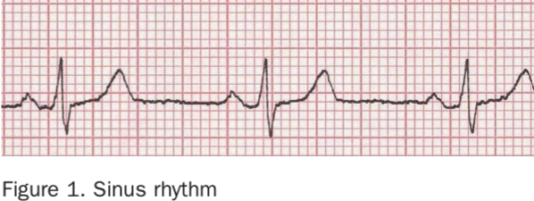
Atrial Fibrillation | Irregular ventricular rate; no p-waves; rapid irregular atrial deflections of varying shape and size  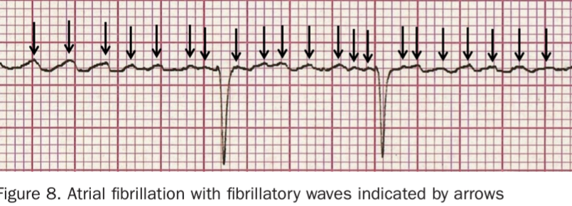 | Most common sustained arrhythmia; high risk of stroke > anticoagulation &  BB/CCB
Atrial Flutter | Atria contract very rapidly but not all atrial impulses conduct to ventricles resulting in ventricular rate that’s less than atrial rate and may be regular or irregular  “Sawtooth” baseline  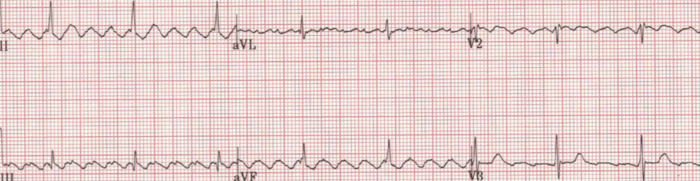 | Like afib, requires anticoagulation
Atrial premature contractions (APC) | Premature p-wave of a different shape from normal -pwave of sinus node origin  Early p-wave followed by a normal QRS > the there’s a short pause before the next sinus beat appears  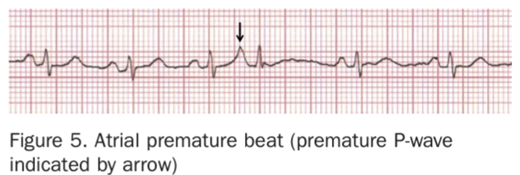 | APCs generally benign and rarely warrant treatment
Ventricular premature contractions (PVC) | Premature beat originating from ventricles so they are not preceded by a premature p-wave. QRS is wide and bizarre > followed by a pause  -When checking pulse, the pulse will be diminished or absent during the PVC  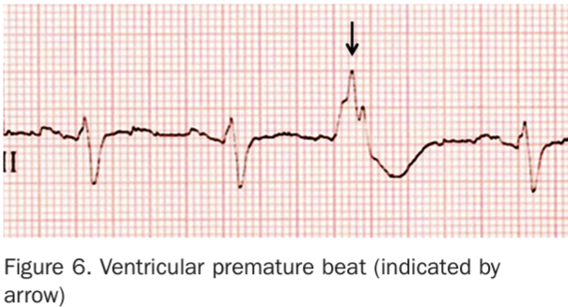 | Very common; can occur in healthy people but more common in people with heart disease
Ventricular Tachycardia (VTach) | Regular rhythm, fast 120-250, arises in ventricles and has broad and bizarre QRS complexes; no p-waves  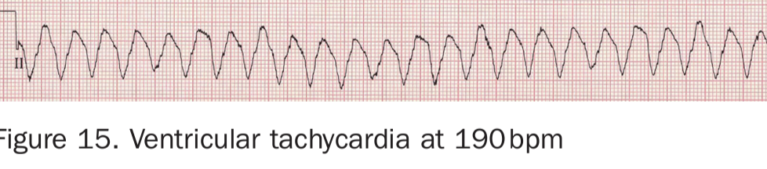 | Life-threatening; ER; Occurs most commonly in people with significant structural heart disease
The next 2 conditions weren’t listed as conditions to know on CRDB but they were in the article so I included them:
Supraventricular Tachycardia (SVT) | Fast, regular QRS complexes usually with normal shape, and no clear p-waves  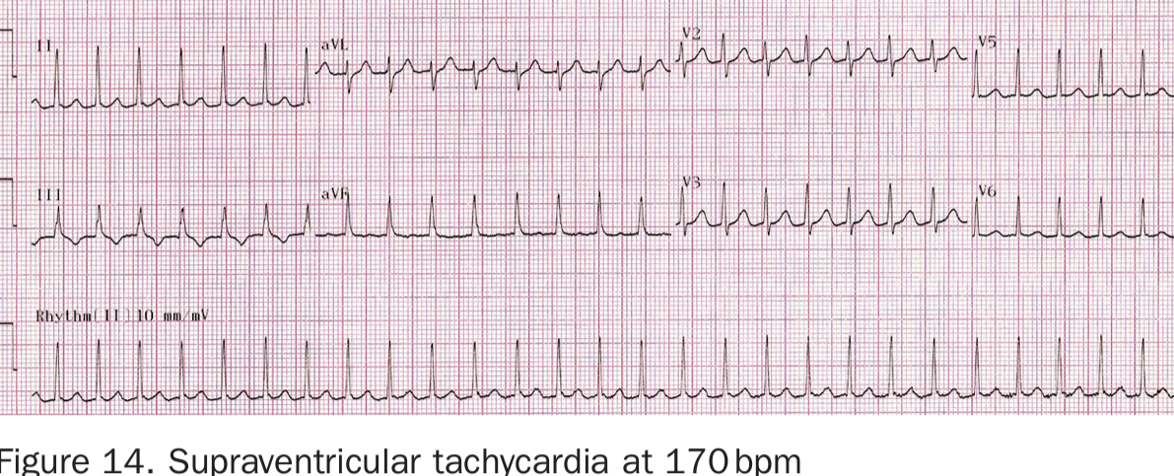 | Often resolves spontaneously but if persists, go to ER; can try valsalva maneuver or carotid sinus massage
AV blocks | 1st degree: prolonged PR interval  2nd degree:  - Mobitz I (Wenckebach): PR intervals progressively increase until QRS drops off, resulting in a pause of the P-wave; then this sequence typically repeats; “going, going, going, drop, now you’ve got a wenckebach”  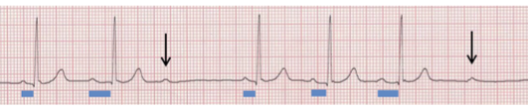  - Mobitz II: intermittent failure of atrial impulses to conduct to ventrickles but unlike mobitz I, there’s no preceding increase in PR interval and the PR intervals are all identical  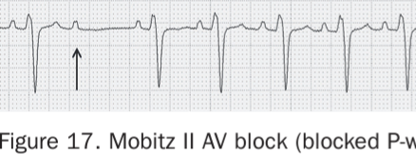  3rd degree/complete heart block: No atrial impulses conduct to ventricles; no relationship between atrial and ventricular impulses  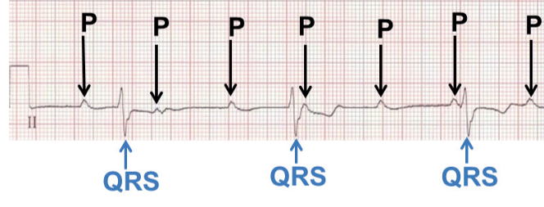 | 1st degree rarely requires treatment  2nd and 3rd degrees may require pacemaker
STEMI (full thickness)  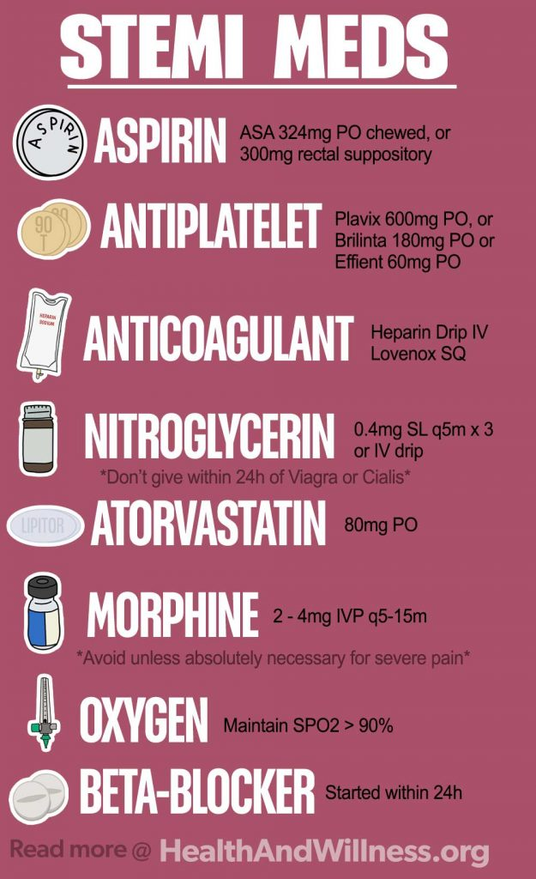 | ST-elevation in two or more contiguous leads; can be accompanied by new left bundle branch block (LBBB).  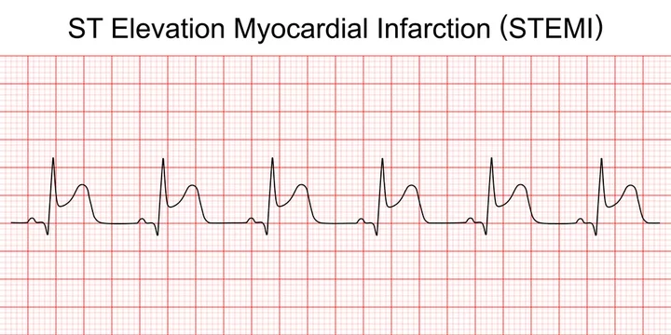 | Full-thickness infarction of the heart muscle; urgent revascularization (e.g., PCI); high risk of complications such as CHF, arrhythmias, and death.
NSTEMI (not full thickness) | ST depression, T-wave inversion, or other nonspecific changes, but no ST-elevation.  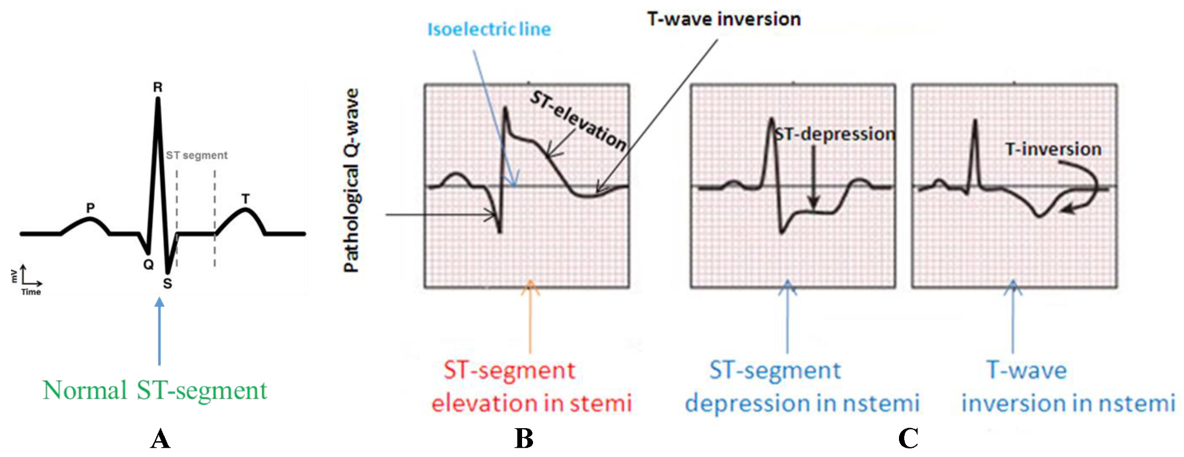 | Partial-thickness; requires medical therapy (e.g., antiplatelets, anticoagulants) and possibly revascularization

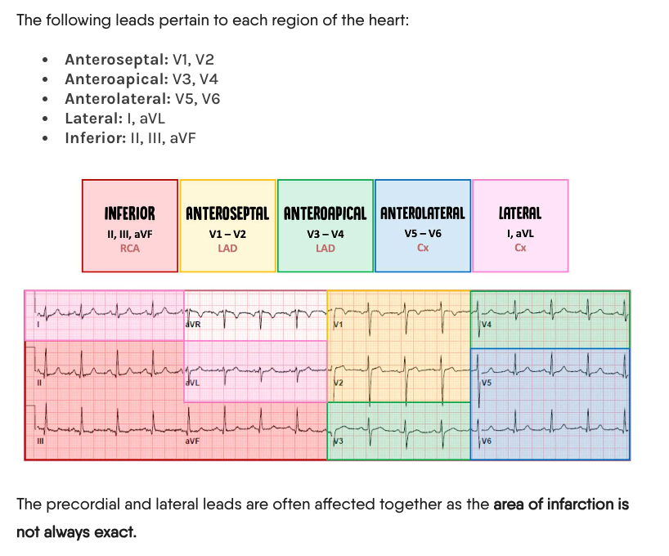

Arrhythmias
Risk Factors/Epidemiology | -SVT is most common arrhythmia presenting to HCP  -Afib is the most common cardiac tachydysrhythmia; affects 4.5% of general population with a lifetime risk of 25% among 40+ year olds  Risk factors: drugs, caffeine, thyroid issues, heart disease, smoking, stress, HTN,
Clinical Presentation  *Insert picture here* | -Palpitations, dizziness, LOC, dyspnea, CP, irregular heartbeat, diaphoresis, nausea  -Can also be asymptomatic
Hx/Key Questions | -Obtain accurate health and medical hx; explore precipitating factors (stress, ETOH, drugs, hot tubs), OPQRST  -Assess for noncomitant weight loss, mood changes, tremors (often assoc with hyperthyroid)  -Determine number of previous episode of palpitations or symptoms and what treatment was previously initiated  - Review meds incl Rx, OTC, and herbal products
Physical Exam | VS, check regularity of pulse  -Inspect: general appearance, SOB, anxiety, flush/pallorous skin, JV distention  -Auscultate: carotid arteries for bruits and heart for abnormal heart sounds
Diagnostics/Labs | ECG, Drug screen (digitalis, aminophylline, illicit drugs), electrolytes, blood gases if indicated
Red flags | - Hemodynamic compromise
Differential Diagnoses
Treatment/Management | Treatment: can try valsalva maneuver if rapid HR; remove as many predisposing factors as possible  Counseling/Education: stop smoking, decrease or stop caffeine use  Non-pharm therapies:
Referrals | -Hemodynamic instability > 911  -Clients unable to tolerate their dysrhythmia should be hospitalized  -Cardiologist if client has abnormal ECG, refractory AF, suspicion of Wolf parkinson white syndrome, or sick sinus syndrome, or when questions arise about difference between a narrow and wide QRS complex
Follow-up | -Clients who have their first episode of afib should F/U in 24-48 h for re-evaluation  -Clients on antiarrhythmic agents should have liver enzymes measured during first 4-8 weeks of therapy  -Clients with risk factors for developing cardiac complications to therapy like QT prolongation should have ECG during first weeks of therapy and every 3-6 months after  -Monitor clients on digoxin for toxicity

Coronary Artery Disease & MI
Short definition/ description | Acute MI is a prolonged lack of myocardial oxygenation leading to necrosis of the heart muscle. Caused by atherosclerotic coronary artery disease. Important to be able to distinguish between angina, MI and non-ischemic pain
Pathology/cause | Most MIs are caused by abrupt occlusion of a coronary artery due to atherosclerotic plaque, intracoronary thrombus formation, or an arterial spasm
Epidemiology | MI is the leading cause of death in Canada
Risk Factors | - Hypercholesterolemia (increased LDL, lower HDL)  - Hypertriglyceridemia  - Premature familial onset of coronary heart disease/artery disease before age 55  - Smoking  - Hypertension  - Sedentary lifestyle  - Obesity  - Diabetes mellitus  - Aging  - Stress
Screening
Clinical Presentation  (Subjective Symptoms & Objective Signs) | HALLMARK of MI= pain somewhere in the chest that is the worst pain ever experienced. MI Pain is typically precordial, substernal, severe/crushing pain that squeezes and lasts longer than 15 minutes. Oxygen precipitates the pain, and it is NOT relieved by nitroglycerin. MI can cause an S3 or S4 sound, tachy/bradycardia, pericardia, friction rubs, and changes in BP.  Common findings:  - Nausea, vomiting, diaphoresis, indigestion  Other signs and symptoms:  - Pain in the abdomen, arm, back, jaw, and neck  - Chest heaviness and tightness  - Anxiety, cough, dyspnea, HTN/hypotension, weakness, syncope, pallor, orthopnea, fatigue, malaise  Consider MI in atypical presentations with women and elderly clients
Hx/Key Questions | What brought on the symptoms or preceded their start?  Duration, time of day when they began, where the sensation began, does it radiate? Rate pain 1-10. Palliating and aggravating symptoms. Medications?  Describe the symptoms (crushing, stabbing, burning, aching, SOB, etc,)
Physical Exam | Same as palpations basically:  VITALS: pulse, respirations, BP, oxygen, ECG  INSPECT: dyspnea, weakness, pallor, sweating, edema, pulsations, JVD, cyanosis  PALPATE: organomegaly, peripheral leg pulses, femoral pulses  AUSCULTATE: carotid arteries, abdomen for bruits, complete heart and lung examination  MENTAL STATUS: confusion and anxiety
Red Flags | Clients presenting with acute symptoms should be assessed for need for emergency services
Differential Diagnosis | Unstable angina, stable angina, aortic dissection, PE, pericarditis, esophageal spasm, pancreatitis, biliary tract disease, anxiety, chest trauma, pneumonia, MSK pain
Diagnostics:  Labs & Imaging | Laboratory tests  - ECG, CBC, lytes, lipids, trops, CK, coronary angiogram  - Troponins increase 3-4 hours and can stay elevated for 1-2 weeks  - CK-MB levels increase 3-12 hours after chest pain, peak at 24h, and return to normal in 48-72 hours  - Myoglobin; urine myoglobin levels rise after 1-4 hours (not as common)  - CBC, chemistry profile, lipid profile  Diagnostic tests and/or Imaging  - ECG: inverted T-waves and ST elevation, Q-waves  - Normal ECG does not always rule out MI, should do serial ECG  - Coronary angiogram  - 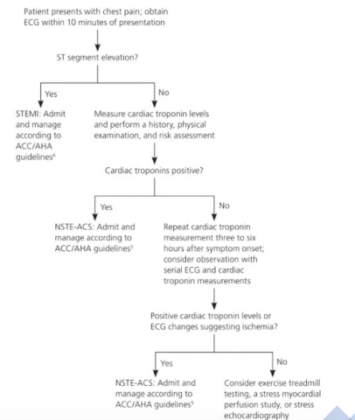
Treatment/ Management | Counseling/Education  - Modify controllable risk factors (diabetes, HTN under control, diet and exercise, smoking cessation)  Complementary Therapies (non-pharmacological)  - Encourage CPR training for all family members  - Encourage a routine walking regimen  - Advise smoking cessation  - Dietary management (low-fat, low-cholesterol, low-sodium diets like the DASH diet)
Medical management | ASA chewed or swallowed ASAP (not enteric coated)
Advise clients when to RTC or call for help | Clients with coronary heart disease should have a plan for seeking medical help/dialing 911 if signs and symptoms of MI occur.  - Carry nitroglycerin at all times and take at first signs of chest pain; call 911 if no relief after 5 minutes, and repeat q 5 mi for up to 3 doses
Referrals | ●
Follow-up | ●
Common Complications | Arrhythmias, heart failure, cardiogenic shock, rupture of lv papillary muscle, pericarditis, ventricular aneurysm, thromboembolism, death
1° and 2° Prevention | Primary prevention: lifestyle/behaviour modifications

ANGINA
Short definition/ description | Intermittent chest pain that occurs frequently and predictably (in stable cases), and is relieved by rest and nitroglycerin
Pathology/cause | Atherosclerosis, but partial blockage causing intermittent blood flow limitations.
Epidemiology | Seen in males over 45 and females over 55
Risk Factors | - Family history of CAD in first degree relatives  - See above table for complete list
Screening
Clinical Presentation  (Subjective Symptoms & Objective Signs) | HALLMARK: typically a gradual onset of substernal, dull/achy pain with pressure that can last longer than 15 minutes in some cases, but usually 2-10 minutes.  - Unstable angina is not related to exercise and is not relieved by rest  Common findings:  - Onet during exercise, xertion, or emotional stress  - Cardiac stable angina can be precipitated by exertion, the cold, or emotional stress  - Relieved by nitroglycerin and the valsalva maneuver  - Prinzmetal angina can occur at night, and awakens patients from sleep  - Relieved by nitroglycerin  Other signs and symptoms:
Hx/Key Questions | See above. Specifically focus on what the patient was doing when the pain set in, if this has happened before, and if they were able to do anything to alleviate it.
Physical Exam | Focused cardiac assessment, evidence for atherscerlsosis (bruits), vitals  Angina causes tachycardia, bradycardia, xanthomas, and signs of heart failure  Common findings= diaphoresis, shortness of breath, transient S4 gallop during an episode of pain
Red Flags | Pain that is not relieved by rest or nitroglycerin, pain that is worse from previous episodes of the same etiology
Differential Diagnosis | Esophagitis pain is also relieved by nitroglycerin; cannot diagnose angina by whether or not nitroglycerine treated the pain.
Diagnostics:  Labs & Imaging | Laboratory tests  ● Troponin levels would be normal, CBC lytes, glucose, Ur, Cr, ECG, lipid, CK  Diagnostic tests and/or Imaging  - ECG during an episode may show ST depression and t-wave inversions or normal findings
Treatment/ Management | ● Counseling/Education  ○ see above table!
Medical management | Rest and sublingual nitroglycerin
Advise clients when to RTC or call for help | Chest pain that is worse than ever before, not able to be alleviated with rest/nitroglycerin/usual alleviating factors.
Referrals | ● Cardiology: Referral to a cardiologist is often indicated for further evaluation and management, especially if the angina is new, worsening, or atypical.
Follow-up | ●
Common Complications | ●
1° and 2° Prevention | Primary prevention: lifestyle/behaviour modificatins

SYNCOPE
Description | A common cardiovascular presentation; a symptom that occurs in many settings with many underlying causes. A brief, sudden loss of consciousness and muscle tone secondary to cerebral ischemia or inadequate oxygen/glucose delivery to brain tissue. Spontaneous recovery will occur.
Pathology | Cause ranges from benign to life-threatening  - Non-cardiac syncope  - Vasovagal, situational, carotid sinus syndrome  - May be caused by medications  - Vasodilators, antiarrhythmics, diuretics, neurologic status, glucose-regulating drugs, impotence therapy  - Orthostatic intolerance  - Dehydration, medications, neurogenic, postural orthostatic tachycardia, initial orthostatic hypotension  - Cardiac syncope  - Arrhythmic  - Structural (aortic, pulmonic, mitral stenosis)  - Cardiopulmonary  - Psychiatric illnesses (panic attacks, MDD, anxiety)  Most common cause is inadequate cerebral perfusion
Epidemiology | Lifetime occurrence is underreported in the literature (est. 32-35%)  - Higher rates of prevalence/incidence in women, increases with age  - 15% of children will experience it before adulthood (less common in children unless due to a seizure disorder)  - Syncope in children may be due to breath holding from pain, anger, frustration etc.  - Most adults who experience syncope do not seek medical attention
Risk Factors | Poor prognosis predictors…  - Older age; heart disease; abnormal ECG; abnormal lab values (hgb, hct, troponin, natriuretic peptides); presumed etiology, abnormal vital signs  - Predisposing factors= advanced age, medication use
Clinical Presentation  (Subjective Symptoms & Objective Signs) | HALLMARK: dizziness, light-headedness, fainting with no memory of the event  Other signs and symptoms:  - Neuroanatomic regulations (changing position, turning the head, wearing tight collars)  - Nausea, warmth, sweating, weakness after eating  - Cardiac causes  - Exercise-induced palpitations, chest pain, shortness oof breath, no warning before the episode  - Neurologic causes  - Vertigo, diplopia, facial paresthesias, ataxia, auditory/visual or vestibular disturbances  - Metabolic or endocrine causes  - Restlessness, anxiety, confusion, no recent food intake/low glucose levels  - Psychiatrics: graceful fainting in the presence of an audience
Hx/Key Questions | History questions…  - Similar symptoms experienced before and at what age?  - Detailed description from the client or witness  - Was the LOC complete, for how long? What was the posture? Was it an abrupt onset?  - How was recovery obtained? Any associated symptoms like loss of function?  - Any precipitating events?  - Seizures are not usually precipitated by pain, exercise, urination, defecation, stressful events  - If it occurred with rest or when supine already, more likely to be linked to seizures  - Medication history and medical history  Figure out if it was actually syncope: was there a true LOC, were there warning signs, did the limbs jerk during the event?  - Dizziness, vertigo, and presyncope do not result in LOC or postural tone  - Syncope episodes lasting .10 min are rarely physiologic  Low-risk features…  - Prodrome of typical reflex syncope  - Vertigo, nausea, yawning  - Vs. for a seizure, it may be an aura or tongue biting  - Migraines also have aura associated  - Triggers or specific situations typical of reflex syncope  - Positional syncope  - Absence of cardiovascular disease  High-risk features…  - Cardiac disease symptoms; syncope with exertion or supine without prodrome; history of CVD; trauma; family hx of sudden cardiac death <50; abnormal vitals; abnormal cardiac exam; any brady/tachy arrhythmia or conduction disease; elevated cardiac biomarkers or other abnormal relevant blood tests
Physical Exam | Orthostatic vitals→ BP and HR changes in lying and standing positions, on immediate standing, and after 3 min of upright posture  VITALS: temp, pulse, respirations, BP  - BP between both arm and both legs; measure several times during a 2-minute period while standing  - Unequal Bps between arms may indicate cardiac concern  - Blood flow to the brain may be compromised with bradycardia below 35-40 bpm  INSPECT: appearance, skin colour, range of motion in neck, look for JVVD  AUSCULTATE: heart with position changes (from squat to standing to reveal systolic ejection murmur), carotid arteries, abdomen (bruits)  PALPATE: abdomen (any pulsatile expansion?)  - Never palpate both carotid arteries at the same time, this may result in syncope  NEUROLOGIC: CN 2-12, Babinski reflexes, gait, Romberg test, PEARLA  MENTAL STATE: mental health as indicated
Differentials | - Irregular neuroanatomic regulations  - Neurocardiogenic causes  - Situational causes like coughing, defecation, diving, micturition, sneezing, swallowing, trumpet playing, vagal stimulation, weight lighting, postprandial state  - Orthostatic causes like hyperadrenergic state, hypoadrenergic state, carotid sinus syncope, cardioinhibitory state, vasodepressor stimulation, and mixed causes  - Cardiac causes  - Mechanical causes: aortic dissection, aortic stenosis, atrial myxoma, cardiac tamponade, global myocardial ischemia, hypertrophic cardiomyopathy, mitral stenosis, MI, prosthetic valve dysfunction, pulmonary embolism, HTN, pulm stenosis, Takayasu’s arteritis  - Electrical causes: AV block, long QT syndrome, pacemaker, sick sinus syndrome, SVT, Vtach  - Neurologic causes  - Neuralgias  - Normal pressure hydrocephalus  - Subclavian steal  - Vertebrobasilar artery disease (Compression, migraine, TIA)  - Metabolic causes: hypoadrenalism, hypoglycemia, hyponatremia, hypothyroidism, hypoxia  - PPsychiatric causes: anxiety, hysteria, MDD, panic disorder, somatization, hyperventilation syndrome  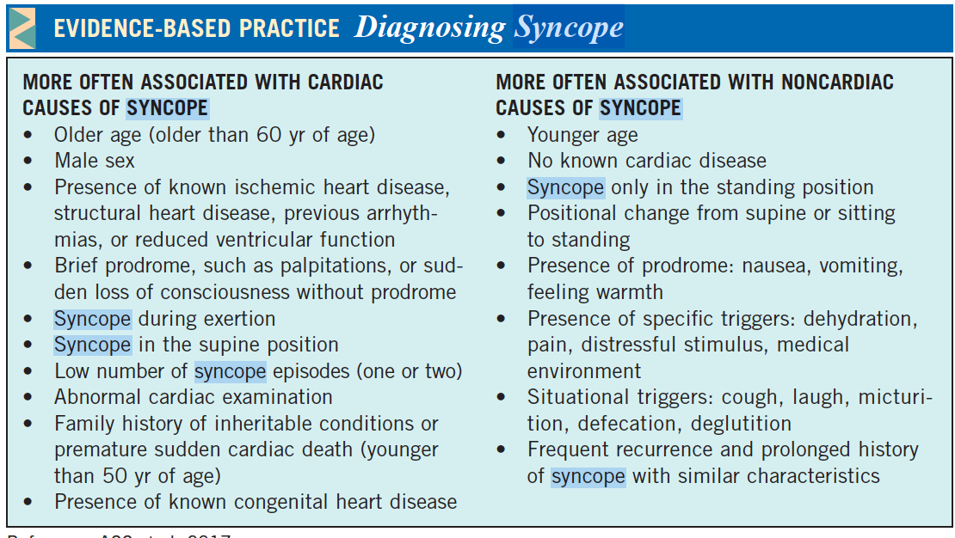
Diagnostics:  Labs & Imaging | Laboratory tests: tailor based on ddx  Diagnostic tests and/or Imaging  - 12-lead ECG to determine potential underlying cause***  - Regular stress testing in patients who present with syncope before/during/after exertion  - Consider a tilt-table test…  - Atypical presentations, older patients with few clues in health history, determining convulsive syncope vs epilepsy, and non-hemodynamic collapses  - Neurologic testing for routine syncope is not recommended by Choosing Wisely  - Cardiac monitoring: 15 days identified 92% of arrhythmic outcomes  - Exercise stress test to evaluate exercise-associated arrhythmias and syncope  - Echo iss underlying structural cardiac disease is suspected  - E.g., valvular disease, hypertrophic cardiomyopathy, tumor/thrombus, lv failure
Management | Vasovagal Syncope…(usually benign)  NON-PHARM  - Education and reassurance  - Avoidance of triggers (coughing, micturition, defecation, laughing, dehydration, crowded environments) and education on recognizing early prodrome to prevent episodes  - Increase water and salt intake (limited evidence)  - Lie down quickly with onset of presyncope  - In patients with a clear prodrome, try leg-crossing, abdo contractions, and squatting  PHARM  - No single therapy has been proven to be most effective  - Treatment on the basis of a low BP phenotype of SBP </=110  - For recurrent, refractory vasovagal syncope  - Fludrocortisone or midodrine as first-lie options  - Beta blockers for patients over 42 years as second-line therapy  - Cardiac pacing may be used in patients >40 with highly symptomatic recurrent VVS and…  - Documented symptomatic asystole >3s or asymptomatic >6s OR  - Tilt-induced asystole >3s or HR <40 for >10s  Orthostatic Hypotension…(frequent in older adults)  - Most commonly caused by a neurogenic etiology and drug-induced  - For postural decrease of 20/10 or more, consider OH as a cause of syncope  NONPHARM  - Education, lifestyle, adequate salt and water intake  - Stop or adjust levels of vasoactive agents like ACE/ARB, thiazides, diuretics, CCBs, B-blockers  - Compression garments and head-up tilt sleeping in persistent symptoms despite counter-pressure maneuvers  PHARM  - Midodrine & fludrocortisone as first lie (droxidopa not available in Canada)
Referrals | If there is serious medical conditions present or high-risk features, consider admission to hospital/send patient to ED with an urgent cardiology referral
Red Flags | History of heart disease or congenital heart problem→ increases risk of sudden death. Requires hospitalization  Chest pain & SOB→ obstructive blockage may be caused by a pE, ischemia or MI with pump failure  Palpitations→ may be due to SVT or V tach; chaotic ventricular activity needs to be reversed with electrical defibrillation  Occurrence during or after exercise→ syncope after exercise should be considered cardiac origin unless otherwise proven (if in a well-trained athlete, likely vasovagal)
Common Complications | Adversely affects independence: DRIVING  - Some methods exist to calculate fitness to drive, but there is a lack of data (also how do you quantify “type of vehicle”??)  - In VVS, risk of syncope while driving is <1%/year  - No driving restrictions for patients with single VVS event unless they had the event while driving or had no prodrome  - May be reasonable to restrict driving for 1 month in patients with an unexplained episode of syncope or frequent VVS with limited prodrome

